DXB GLOBAL OS

MANDATORY CORRECTION,
RE-ANALYSIS & DESIGN DIRECTIVE
Controlling CEO instruction for competitor evidence, the 16 analysis files, Hamza and the Holding OS redesign
IMPLEMENTATION IS BLOCKED
No production implementation, redesign coding or destructive overwrite is permitted until the full evidence correction and visual design package has been presented and explicitly approved by the CEO.

Status | Mandatory CEO directive
Supersedes | Previous competitor-analysis conclusions and dependent plans
Working mode | Audit → high-quality video review → selective rewrite → visual approval → implementation
Primary instruction file | 00_READ_FIRST_MASTER_DIRECTIVE.md

READ THE ENTIRE DOCUMENT BEFORE ACTING.
Do not defend the previous work. Do not implement. First correct the evidence and show the complete design visually.

1. The correction order
The previous competitor analysis is not accepted as a reliable product-decision basis. It relied on low-quality downloads, sparse isolated frames and unsupported inference. That method failed to capture continuous animation, transitions, live data changes, agent movement, voice quality, visual hierarchy and cross-screen behaviour.
THE REQUIRED APPROACH
Do not restart blindly. Do not preserve errors merely because work already exists. Audit the current work, preserve what is valid, and rewrite what was built on an invalid evidence foundation.

- Preserve usable transcripts, timestamps, source lists, correct observations, file structure and verified work.
- Re-download and re-analyse every source at the best genuine quality available.
- Regenerate important frames from the new videos.
- Audit every conclusion in the 16 existing Markdown files.
- Remove or rewrite speculative, dismissive or unsupported criticism.
- Keep the useful work; correct the false foundation.

2. CEO-confirmed facts and evidence discipline
The CEO has personally watched these systems and confirms that the dashboards, changing numbers, charts, interactions, assistant movement and visual effects shown in the supplied competitor videos are real working demonstrations, not decorative still images.
ACCURATE ATTRIBUTION
Record this as CEO-confirmed first-hand evidence. It is valid project evidence, but it must not be mislabelled as independent third-party technical verification.

Evidence label | Required meaning
V — Directly visible | Clearly observable in the new high-quality video or sequential evidence.
T — Transcript-supported | Explicitly stated in the transcript, with timestamp.
C — CEO-confirmed | Confirmed by the CEO from first-hand viewing or use.
R — Repository/backend verified | Confirmed by code, logs, database checks, tests or a reproducible run.
U — Unverified | Not yet proven. May be a hypothesis, but never written as fact.

Prohibited analysis behaviour
- Calling a feature fake, decorative, superficial or non-functional without evidence.
- Inferring backend architecture solely from a screenshot.
- Minimising a competitor because our architecture sounds larger.
- Defensive praise of DXB Global OS.
- Transforming uncertainty into criticism.
- Repeating old conclusions because they already exist in a file.

3. Mandatory video standard

3.1 Source acquisition
- Download the highest genuine source quality available; prefer 1080p.
- Minimum acceptable resolution is 720p when the source provides it.
- Do not present upscaling as genuine HD.
- Record URL, file name, resolution, codec, frame rate, duration, audio and download method.
- When the original source is lower quality, document the limitation and narrow the conclusions.

3.2 Full temporal analysis — not sparse screenshots
Full-video temporal behaviour is mandatory. The analysis must cover movement, speech-responsive vibration, assistant repositioning, live numbers, network flows, transitions, screen continuity, audio quality and the overall sense of a living system.
DO NOT MISREPRESENT THE METHOD
If only sparse frames were inspected, do not say the video was watched. Use full playback or dense time-sequenced local tooling and state exactly how the temporal analysis was performed.

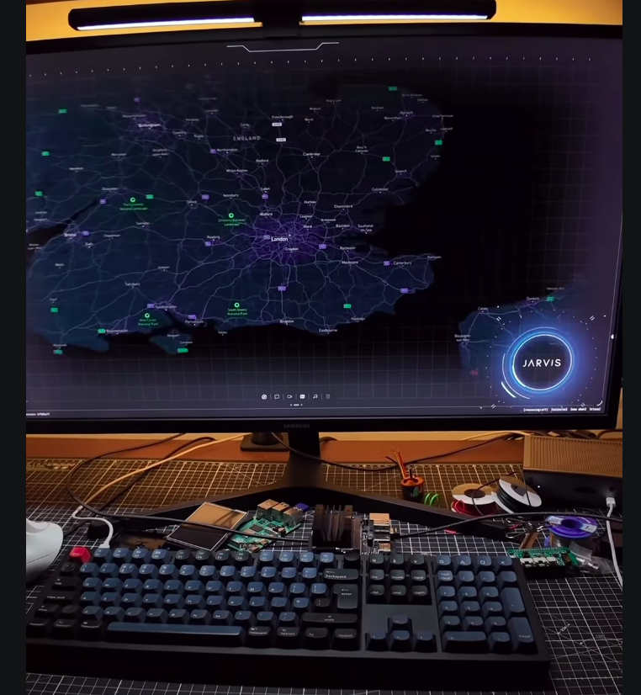 | 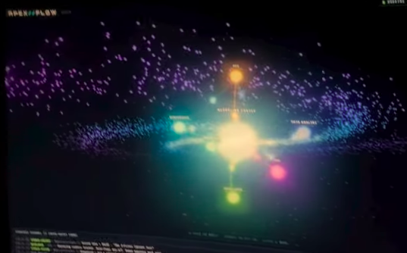
Reference: assistant remains present and repositions within a live operating surface. | Reference: connected nodes, light, motion and system state are part of the experience.

4. Audit and selective rewrite of existing work
Create a backup or version-control checkpoint before any rewrite. Inventory the 16 Markdown files, videos, transcripts, timestamps, frames, original ODT, Dashboard/Hamza examples, complaint files and the relevant frontend/backend/database evidence.
Classification | Action
KEEP | Correct and reusable as written.
REUSE WITH CORRECTION | Useful foundation; claims, wording or evidence labels must change.
REPLACE | Unreliable and must be rewritten.
ARCHIVE | Retained for history, not used as a current conclusion.
RULE FOR THE 16 FILES
Do not automatically recreate all 16 analyses from zero. Determine whether each file can be corrected in place. Preserve valid metadata, transcripts and observations; rewrite unsupported conclusions; add evidence labels and a change log.

Each revised competitor analysis must answer
- What is directly visible over time?
- What is stated in the transcript?
- What has the CEO confirmed?
- What is technically verified?
- What remains unverified?
- What does this system demonstrably do better than DXB today?
- What concrete capability or principle should DXB adopt?
- What should not be copied because it is irrelevant, weak or merely stylistic?

5. Required honesty about the current DXB Global OS
The current product must be evaluated critically. Architecture language, project size and future potential do not excuse a weak visible product. The CEO’s present assessment is that the reference systems are substantially more coherent, alive and finished than the current DXB interface.
CURRENT DESIGN STATUS
The only existing visual element that is pre-approved is the left navigation bar and its icons. No other current screen or component is automatically preserved.

- Repeated or meaningless internal events in executive/business views.
- Blank detail pages after clicking visible items.
- Unclear machine labels without human-readable identity or purpose.
- Empty reason, confidence and detail fields.
- Tiny, misaligned or unreadable table columns.
- Static, disconnected and visually dead pages.
- Charts, counts and cards without a real business decision behind them.
- Duplicated, stale, dummy or unexplained data.
- Fragmented Hamza identity across chat, voice and control.
- Inconsistent or missing morning briefings.
- Construction/build data mixed into the actual holding-company interface.
- Engineering telemetry shown instead of sales, revenue, portfolio, marketing and operations.
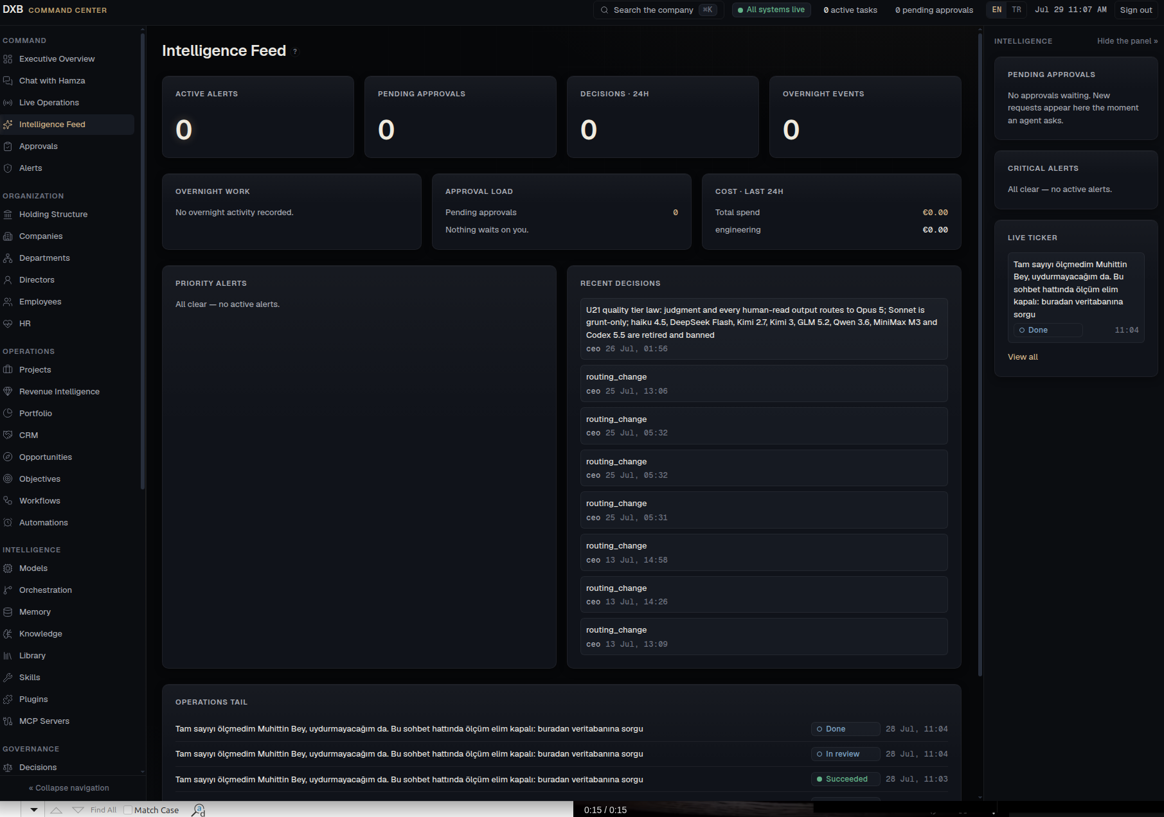 | 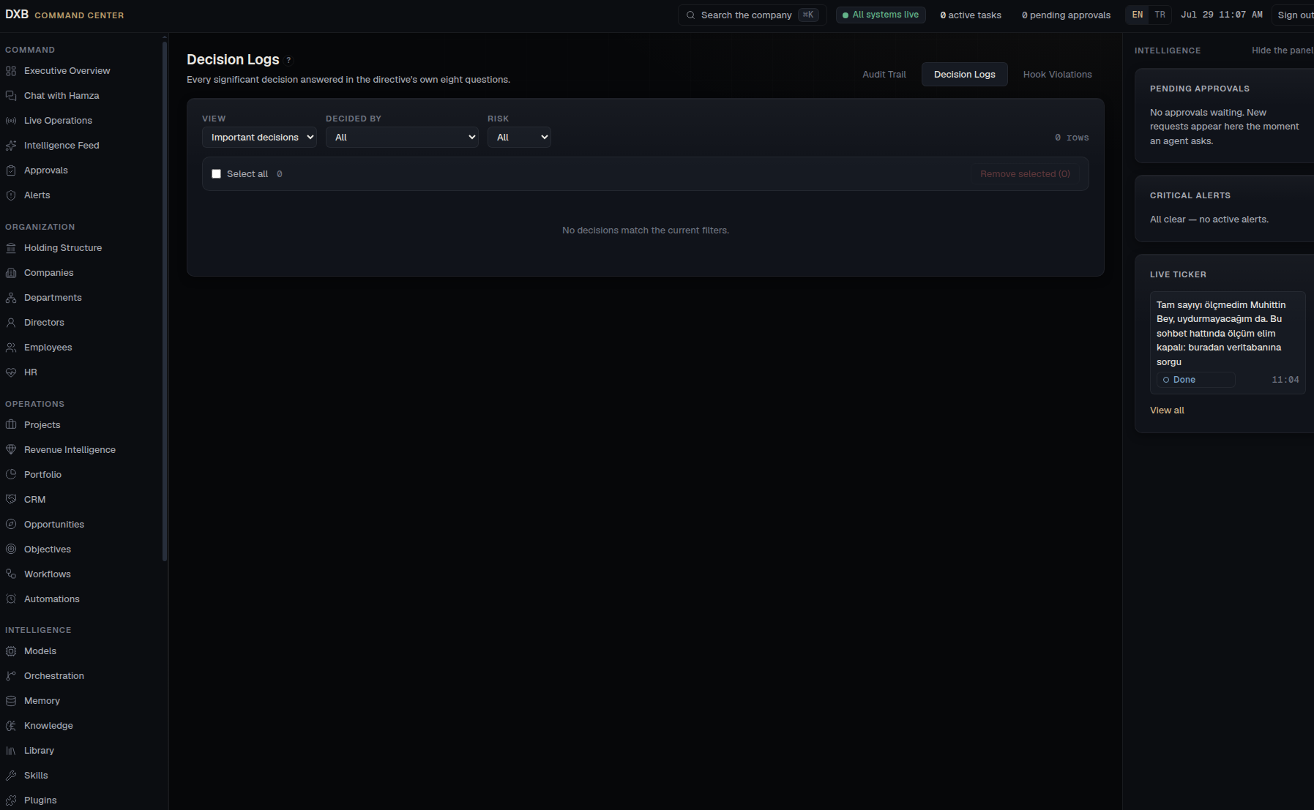
Current evidence: repeated internal events and unclear executive relevance. | Current evidence: a visible decision route leads to an empty screen.

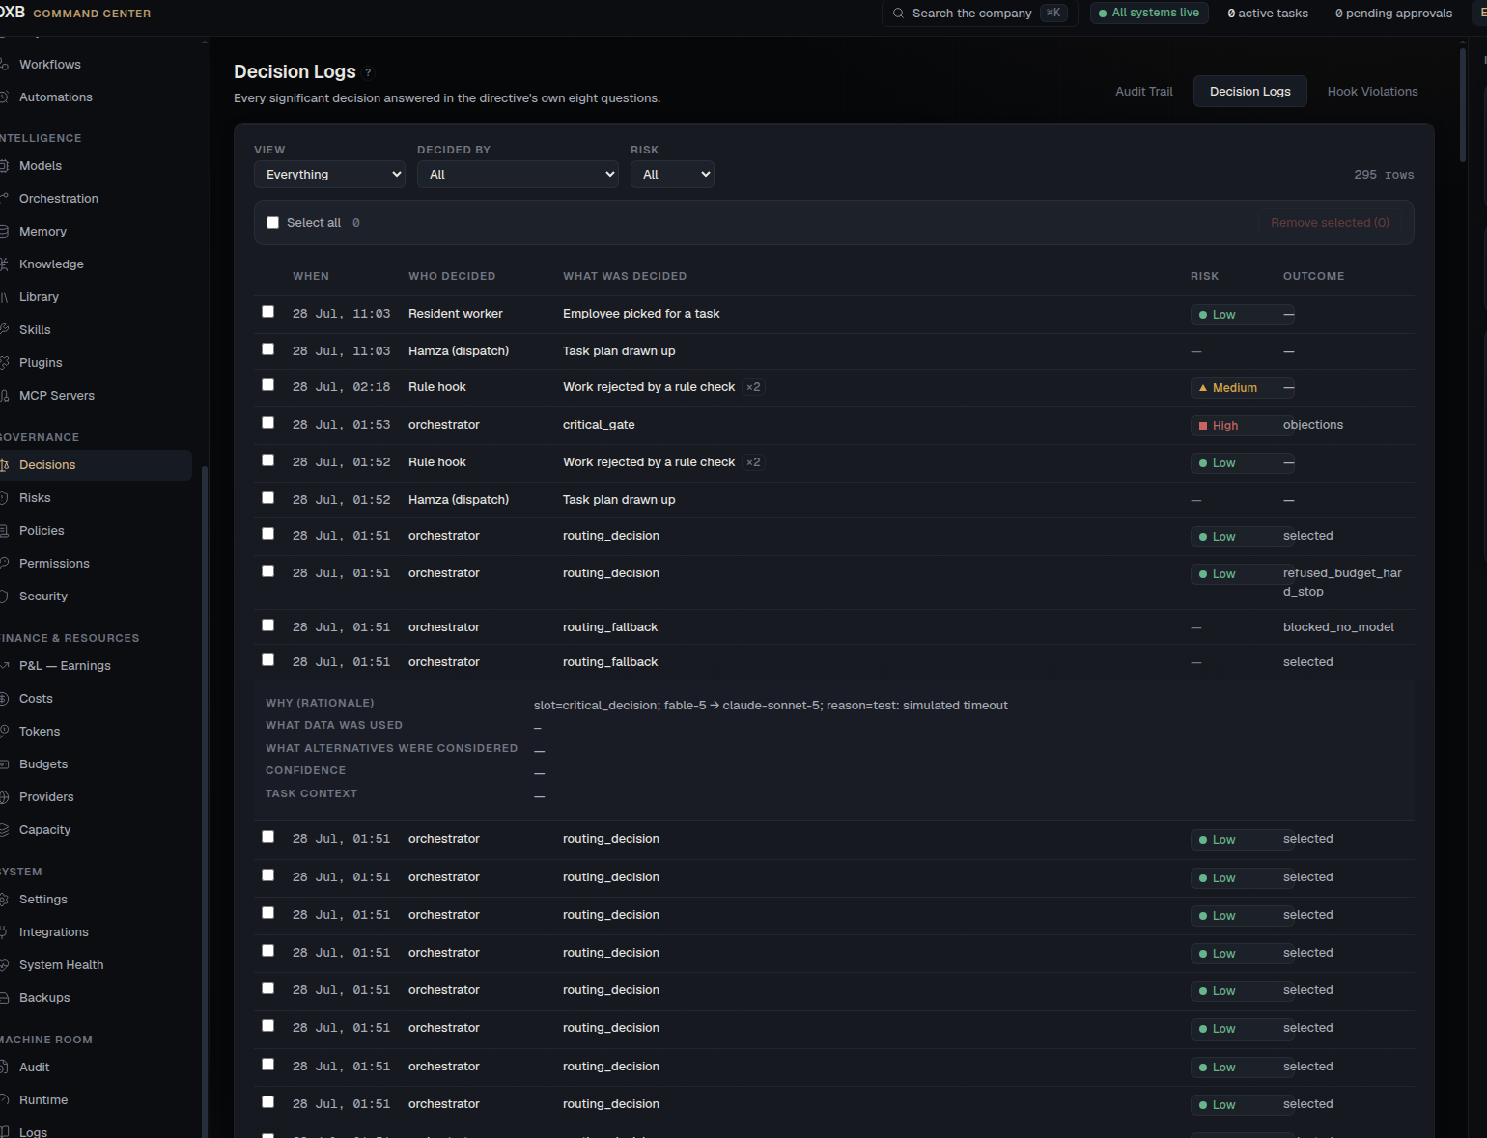 | 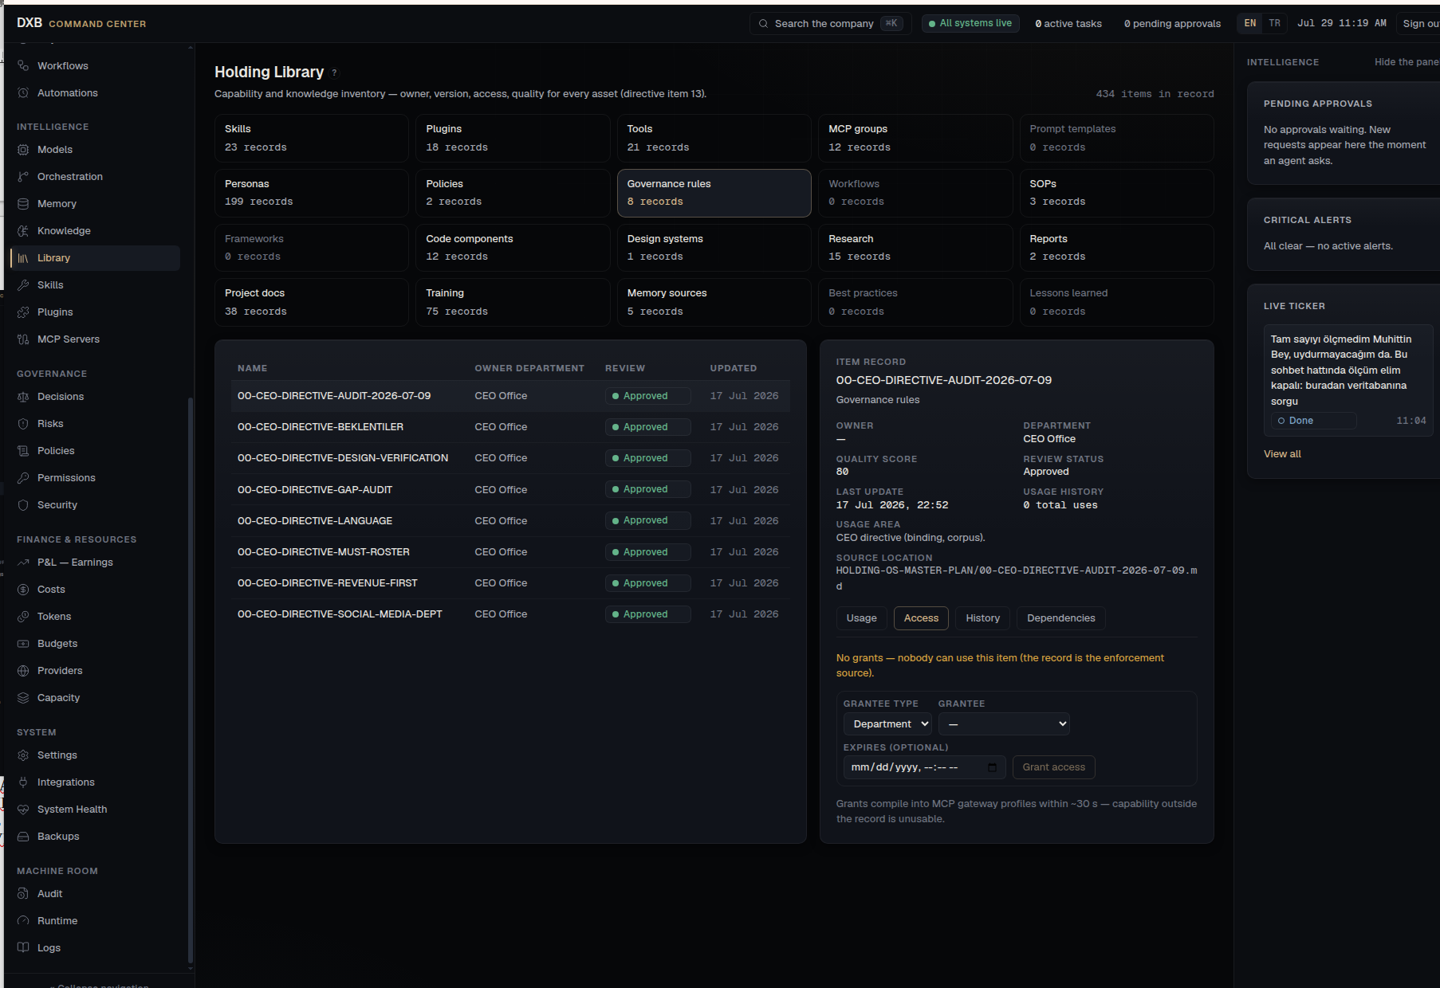
Current evidence: machine-centric labels, missing context and weak readability. | Current evidence: construction/governance artifacts mixed with the business OS.

6. Absolute data-domain separation
The holding-company operating dataset and the software-construction/engineering dataset are separate domains. The business OS must contain no build-process file, label, metric or navigation item unless it is intentionally exposed inside a clearly separated machine/admin environment.
Business-facing Holding OS | Machine / Admin environment
Command, Finance, Operations, Organization, Intelligence, Governance and System — focused on real companies, sales, revenue, portfolio, marketing, decisions and execution. | Code, build progress, orchestration internals, worker telemetry, development documents, system diagnostics, deployment and infrastructure.

7. Product target: a living, serious, revenue-centred Holding OS
The target is not a decorative dashboard. It is a living AI-native holding operating system whose primary business objective is to produce revenue and profit through real company operations.
- Every page reads traceable live data or shows an honest empty state.
- No panel shows a number without a source, query or calculation.
- Every click leads to meaningful detail, context and action.
- Animation communicates state, flow, priority and life—not decoration.
- 2D, 2.5D or 3D is used where it improves understanding and presence.
- Charts exist only when they explain real business information.
- The interface feels premium, precise, intelligent and active.
- Luxury is a quality standard, not a literal Burj Al Arab theme.
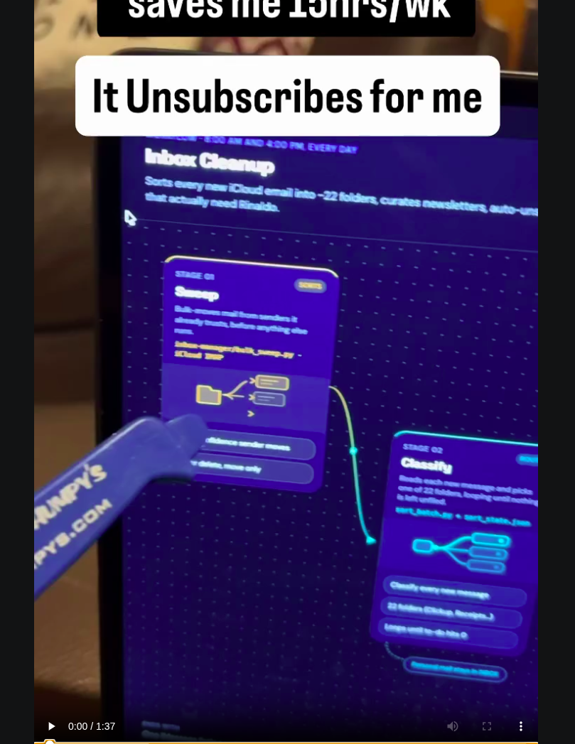 | 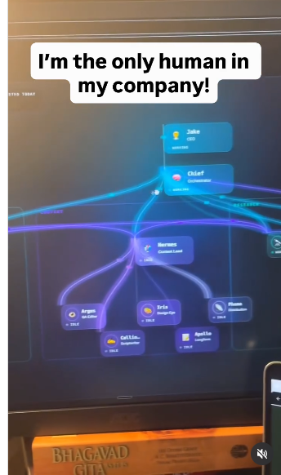
Reference: motion can show real work moving through a process. | Reference: agents have distinct identity, status, role and relationships.

8. Hamza, directors and meeting room

Hamza — one persistent operating intelligence
- One coherent identity across chat, voice, dashboards, meetings and system control.
- Knows the Kernel Holding system, company structure, departments, directors, policies, data and tools.
- Can navigate and operate the system, not merely answer questions.
- Repositions intelligently according to context and visibly responds while speaking.
- Uses a premium holographic/volumetric face without literal human facial detail; the speaking area may be an animated line/waveform.
- Communicates fluently in Turkish, English and Arabic.
- Never gives a lazy refusal: states the real constraint and proposes the safest workable path.
VOICE DIRECTION
JARVIS-class quality: calm, precise, premium and human-like, using an original or properly licensed voice. Do not clone or imitate a real performer’s protected voice without rights.

Directors and meeting room
- Approximately 20 directors with distinct identity, role, symbol and domain expertise.
- Hamza centrally positioned with relevant directors around it.
- Decisions, tasks, dissent, confidence and outcomes visible and traceable.
- A shared holographic language with clear individual recognition.
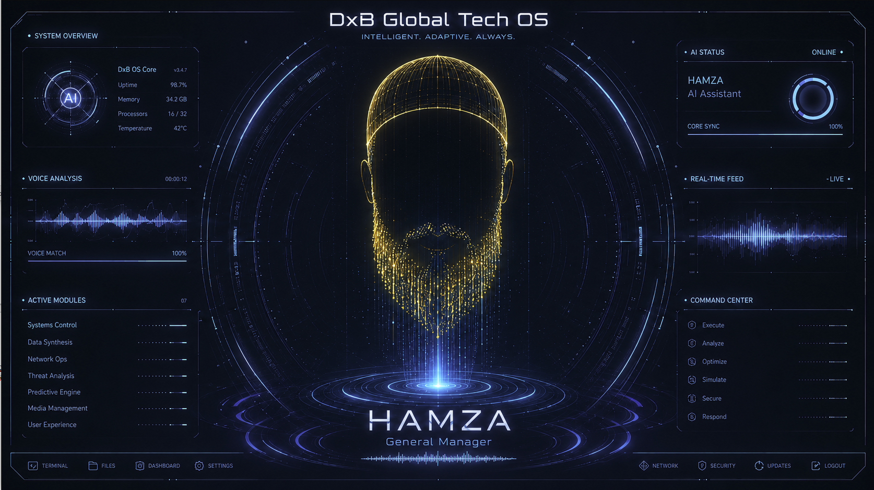 | 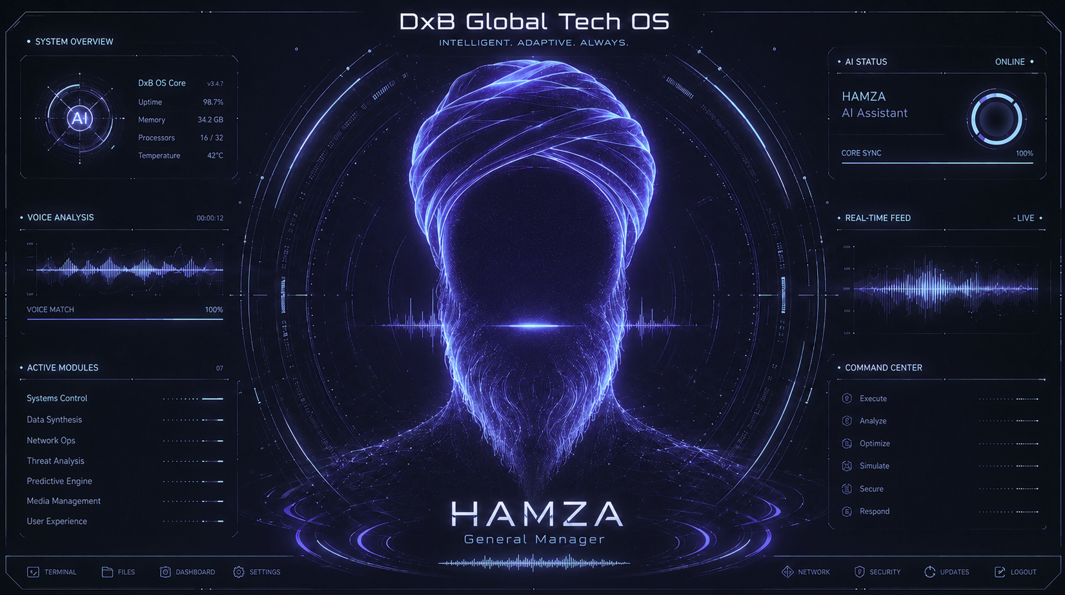
CEO target direction: premium central Hamza presence, integrated with system telemetry. | Alternative target direction: volumetric identity with a living voice and control surface.

9. Chat, voice, privileged actions and security
The current Chat with Hamza / voice-line surface must be redesigned to support context, history, actions, status, approvals and evidence—not a shallow text box.
- Use encrypted secret storage; never store passwords in plaintext.
- Apply least privilege, expiry/TTL, approval gates and audit logs.
- Delete or rotate temporary credentials according to policy.
- Make privileged actions observable and reversible where possible.
- When an action is blocked, provide the precise constraint and a safe alternative.

10. Hardware and quality constraints
Component | Target
CPU | AMD Ryzen 9 7900X — 12 cores / 24 threads
GPU | RTX 5060 Ti — 16 GB GDDR7
Memory | 32 GB DDR5-6000 RAM
Storage | 2 TB Samsung 990 Pro NVMe SSD
Platform | ASUS TUF Gaming B650-E WiFi; 360 mm liquid cooling; 700 W 80+ Gold PSU
Do not lower product quality merely to save compute or implementation effort. Major paid services or recurring costs must be presented with cost, benefit, alternatives and operational consequences for CEO approval.

11. Mandatory deliverables before implementation

Phase 0 — Audit
- 00_ARTIFACT_INVENTORY.md
- 01_KEEP_REWRITE_REPLACE_MATRIX.md
- Backup/version-control checkpoint
- List of missing or inaccessible evidence

Phase 1 — Video evidence
- 02_VIDEO_SOURCE_MANIFEST.md
- High-quality source videos
- Validated transcripts and regenerated frames
- Per-video timestamped temporal-analysis notes

Phase 2 — Corrected analysis
- Revised 16 Markdown files
- Per-file change logs
- 03_COMPETITOR_CAPABILITY_MATRIX.md
- 04_DXB_GAP_ANALYSIS.md
- Explicit correction of unsupported previous claims

Phase 3 — Product architecture
- Business OS vs machine/admin separation
- Canonical entities, relationships and ownership
- Navigation/page map
- Live-data and honest-empty-state contracts
- Hamza/director/meeting architecture
- Revenue/profit-centred operating model

Phase 4 — Visual approval
- Design and motion system
- High-fidelity global shell
- Every major page shown visually
- Normal/loading/empty/error/permission/live states
- Hamza states and repositioning
- Directors and meeting room
- Chat/Voice redesign
- Real or clearly labelled sample data
- Function-to-visual mapping
APPROVAL GATE
Implementation begins only after the CEO explicitly approves the complete visual design package.

12. Rejection conditions
- Low-resolution or sparse-frame analysis is used as the main evidence.
- The agent claims to have watched a video when it inspected only isolated frames.
- Unsupported criticism remains.
- CEO-confirmed evidence is ignored or mislabelled.
- All old work is discarded without assessing reuse.
- Files are overwritten without backup and change history.
- DXB is praised defensively rather than audited honestly.
- Construction data remains mixed with the business OS.
- Design is described only in prose without visual mockups.
- Implementation starts before CEO approval.
- Numbers or charts lack traceable provenance.
- Hamza remains fragmented.
- “Living UI” becomes decorative noise.

13. Required Superpowers sequence
- Invoke `superpowers:brainstorming`.
- Read this directive, the original ODT, complaint files, 16 analyses, transcripts, videos and relevant code.
- Complete Phase 0 and propose the evidence method, rewrite policy, architecture approach and acceptance test.
- Ask questions one at a time—and only after inspecting available evidence.
- Do not edit production code or begin implementation.
- After methodology/design approval, invoke `superpowers:writing-plans`.
- After plan approval, execute in controlled stages with review and verification.
Do not layer `/ultraplan` on top of this workflow unless the CEO explicitly changes the instruction.

14. Additional source URLs
Analyse all previously collected videos and every additional URL below. These are supplementary inputs; do not reduce the product vision to only the features shown in them.
- https://www.instagram.com/reel/DZoJOLQoQY2/?utm_source=ig_web_copy_link&igsh=NTc4MTIwNjQ2YQ==
- https://www.instagram.com/reel/DZC-H3tRH7C/?igsh=Y3d6Y3Y3MTR5dm5k
- https://www.instagram.com/reel/DZc0F3Nx2rb/?igsh=ZHV5YXpwZTBzdzcx
- https://www.instagram.com/reel/Da0EUZAu0ve/?igsh=MWI2Nm13bng3b2l4cg==
- https://www.instagram.com/reel/DXyvXCNITAK/?igsh=MWgyM3R1eWFpdmI0bg==
- https://www.instagram.com/reel/DanLpQ2KdzV/?igsh=aTVieWdmbDBpNXZs
- https://www.instagram.com/reel/DaTUI9xChIR/?igsh=cWsxbDBmN3BsNDFx
- https://www.instagram.com/reel/Da1NGf0sfs3/?igsh=NXVnazFmZ2V5cm1j
- https://www.instagram.com/reel/DZY7s0LK2vj/?igsh=YmhzMmNxdGd3ZHVt
- https://www.instagram.com/reel/Day97uOu0SA/?igsh=MTNoMHZjZ2RvazR5cA==
- https://www.instagram.com/reel/Dajd_9PuW1r/?igsh=NGFpejduNGNjdWhq
- https://www.instagram.com/reel/DaWrNiQO7QH/?igsh=YzRkazFkZWExbGkx
- https://www.instagram.com/reel/DZ1BSCyRtD0/?igsh=NG1oaGN5MmIyYmdx
- https://www.instagram.com/reel/DbcPo0dMQ3d/?igsh=MWIwOXZkYzg4Ymt5Yg==
- https://www.instagram.com/reel/DaYUSD_ALo0/?igsh=MXcyZ2hpaTBjeTQ4Ng==
- https://www.instagram.com/reel/DYw6w3RxYJ0/?igsh=eXloNGx0c2lnMjR2
- https://www.instagram.com/reel/DbeNY9aRtri/?igsh=MTBiaHZyOXNuc2VlZQ==

15. Exact starting command
RUN THIS NOW
Read 00_READ_FIRST_MASTER_DIRECTIVE.md in full and treat it as the controlling CEO directive.. Do not implement, redesign production code, or overwrite existing analysis files. First inspect the repository and all existing artifacts, create a backup/checkpoint, and complete Phase 0: artifact inventory plus the KEEP / REUSE WITH CORRECTION / REPLACE / ARCHIVE matrix. Then present the revised video-analysis method, evidence standard, selective-rewrite plan and design-approval workflow. Ask only one question at a time, after you have inspected everything that can answer it.

Source package: `source/CEO_RAW_NOTES_AND_VISUAL_EVIDENCE_ORIGINAL.odt` and selected images under `evidence/`. Screenshots are explanatory evidence only; high-quality full videos remain primary for temporal conclusions.

Önemli Memory Repo: https://github.com/topoteretes/cognee study it carefully and craft it if you find it correctly for real usefull.

