**Portfolio Management Project**

**Objective**: In this project, we aim to build stylized long-short equity factor mimicking portfolios using different fundamental variables from Ken French’s data library and explore empirically their univariate efficacy over time and across different size segments. We then go on to build multi-factor strategies using alternative weighting schemes and compare them to the static equally weighted multi-factor strategy. Two alternative top-down factor weighting schemes will be considered: 1) Equal risk contribution across factors 2) Weighting based on factor persistence

**Data**: Attached with the project description are 6 csv files containing the monthly time series of value- and equal-weighted returns for portfolios formed on size and different fundamental variables consisting of book-to-price, cashflow-to-price, dividend yield, investment, profitability, prior 1-month return and 12-1 price momentum. In addition, there is a csv file named “F-F_Research_Data_Factors” which houses the Fama-French 3 factor model returns.

**Programming language**: Matlab/ R

**Group size**: Divide the class into 5 groups

**Project description**:

1. For each of the six fundamental variables, construct long-short factor mimicking portfolios and plot their historical performance across different size segments. Taking the market return from Fama-French’s 3-factor model, calculate and plot the rolling 3-year market beta for these stylized portfolios. Considering both size segments, construct a beta-neutral factor mimicking portfolio for each fundamental variable. Comment on your results.
2. Calculate the full sample correlation matrix of unadjusted factor returns (i.e. not the beta-neutral version) derived from 1. Comment on your findings. Using a lookback period of 5 years, employ an equal risk contribution factor weighting strategy with monthly rebalancing. The monthly resultant portfolios should be dollar neutral with a long leg exposure of 100%. Plot the monthly factor weights over time and evaluate the strategy performance against the static equally weighted factor portfolio. Comment on your results. (Hint: Use Matlab’s fmincon function as detailed below)

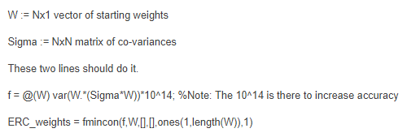

1. Using different lookback periods of 1,12 and 36 months to determine factor persistence, build adaptive multi-factor models that appropriately reflect your view on each factor. For example, you may want to consider a factor weighting approach such that the factor allocation is proportional to the historical Sharpe ratio for a given lookback period. Comment on your results.