双均线策略：

当短期均线上穿长期均线时，发出买入信号

当短期均线下穿长期均线时，发出卖出信号

应用方法：

当短期均线上穿长期均线时，平空并做多

当短期均线下穿长期均线时，平多并做空

回撤率=(当前利润 – 之后的最低利润)/(当前利润 + 20000)

5min数据 MA_SHORT=20, MA_LONG=60

|  |  |  |  |
| --- | --- | --- | --- |
|  | 最大回撤率 | 收益率 | 时间 |
| T1803 | 238.4615% | -104.50% | 2017-11-11 - 2018-02-11 |
| T1806 | 28.75% | 89.00% | 2018-02-11 - 2018-05-11 |
| T1809 | 43.75% | 79.75% | 2018-05-11 - 2018-08-11 |
| T1812 | 110.75% | -75.00% | 2018-08-11 - 2018-11-11 |

日线数据 MA_SHORT=5 MA_LONG=10

|  |  |  |  |
| --- | --- | --- | --- |
|  | 最大回撤率 | 收益率 | 时间 |
| T1803 | 98.0535% | -54.00% | 2017-11-11 - 2018-02-11 |
| T1806 | 16.9767% | 40.50% | 2018-02-11 - 2018-05-11 |
| T1809 | 510.7142% | -128.75% | 2018-05-11 - 2018-08-11 |
| T1812 | 11.50% | 49.50% | 2018-08-11 - 2018-11-11 |

凸组合优化：引入浮动止盈机制，将盈利最大化

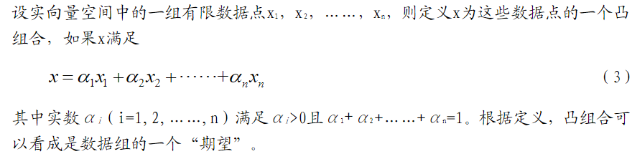

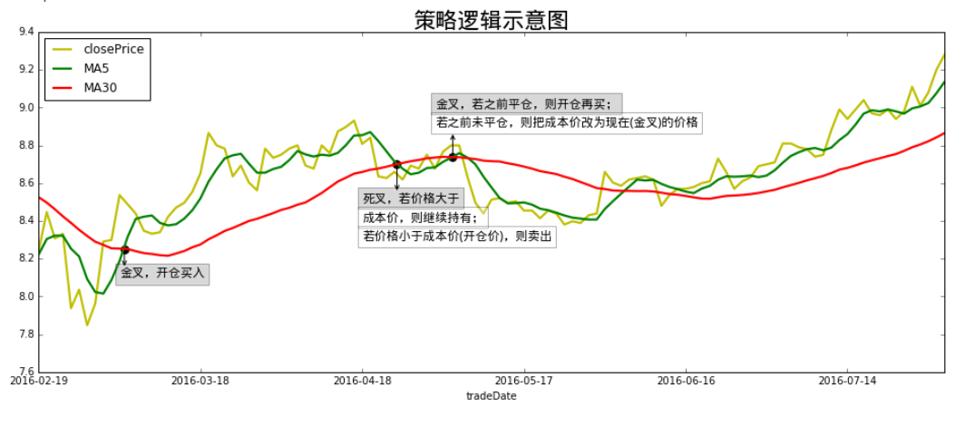

凸组合优化双均线策略：

当短期均线上穿长期均线时，做多

当短期均线下穿长期均线时，做空

第一次金叉，开仓买入，成本价设置为买入价

1. 死叉时，如果价格大于成本价，则继续持有，若价格小于成本价，则平多
2. 下一金叉，如果之前平仓过，则做多，如果之前没有平仓，则把成本价改为现在的金叉价格

凸组合通过改变平仓条件来对双均线策略进行优化。在金叉买入之后，股价可能在上涨，但是在此时如果遇到一个死叉，则双均线策略会进行平仓，我们根据开仓价格和当前价格的凸组合来改变平仓条件。而开仓价格和当前价格的凸组合可以看作是价格的期望。如果期望高则继续持有，如果期望低就卖出。这相当于给双均线策略增加了浮动止盈机制

5min数据，MA_SHORT=20, MA_LONG=60

|  |  |  |  |
| --- | --- | --- | --- |
|  | 最大回撤率 | 收益率 | 时间 |
| T1803 | 94.25% | -93.50% | 2017-11-11 - 2018-02-11 |
| T1806 | 23.433% | 121.25% | 2018-02-11 - 2018-05-11 |
| T1809 | 49.75% | 84.00% | 2018-05-11 - 2018-08-11 |
| T1812 | 78.5% | -14.000% | 2018-08-11 - 2018-11-11 |

在5min数据下，与不优化相比，使用同样的均线参数，75%的最大回撤率降低，同时所有的收益率都被提高

日线数据 MA_SHORT=5 MA_LONG=10

|  |  |  |  |
| --- | --- | --- | --- |
|  | 最大回撤率 | 收益率 | 时间 |
| T1803 | 63.75% | -27.00% | 2017-11-11 - 2018-02-11 |
| T1806 | 35.75% | 36.25% | 2018-02-11 - 2018-05-11 |
| T1809 | 77.75% | 77.75% | 2018-05-11 - 2018-08-11 |
| T1812 | 11.5% | 49.50% | 2018-08-11 - 2018-11-11 |

在日线数据下，与不优化相比，使用同样的均线参数，75%的最大回撤率降低，同时50%的收益率被提高

KAMA（卡夫曼自适应移动均线）策略：

参数 (len,short,long)

计算步骤如下：

价格方向:

direction = price – price[len] (当前价格 - len日前收盘价)

波动性(噪音):

volatility = @sum(@abs(price – price[1]), len) len日内每两天价格之差的总和

效率系数（ER）-方向移动对噪音之比：

Efficiency_Ratio = direction/volatility

趋势系数:

fastest SC = 2/(short+1)

slowest SC = 2/(long+1)

平滑指数:

SC（Smoothing Constant）= [ER x (fastest SC - slowest SC) + slowest]^2

过滤器设置:

过滤器filter = percentage*@std(AMA-AMA[1], n)

KAMA[t] = KAMA[t-1] + SC*(price – KAMA[t-1])

应用方法：

KAMA[t] – KAMA[t-1] > filter & KAMA[t-1] – KAMA[t-2] > filter时，发出多头信号

KAMA[t] – KAMA[t-1] > -filter & KAMA[t-1] – KAMA[t-2] > -filter时，发出空头信号

1min线数据 使用参数(10,2,30) 10是用于计算价格变化，2,30用于计算趋势速度，过滤器百分数取0.8

|  |  |  |  |  |  |  |
| --- | --- | --- | --- | --- | --- | --- |
|  | 胜率 | 多头胜率 | 空头胜率 | 最大回撤率 | 收益率 | 时间 |
| T1703 | 34.8684% | 26.3158% | 43.4211% | 23.9089% | 86.25% | 2016-11-11 – 2017-02-11 |
| T1706 | 34.4262% | 32.2404% | 36.612% | 55% | 1.250% | 2017-02-11 – 2017-05-11 |
| T1709 | 37.6470% | 36.1502% | 39.1509% | 52.5939% | -22.25% | 2017-05-11 - 2017-08-11 |
| T1712 | 33.2558% | 29.7674% | 36.7442% | 53.1418% | -30.50% | 2017-08-11 - 2017-11-11 |
| T1803 | 32.7868% | 32.6087% | 32.967% | 76.9685% | -70.75% | 2017-11-11 - 2018-02-11 |
| T1806 | 34.6883% | 34.0541% | 35.3261% | 30.8377% | 98.00% | 2018-02-11 - 2018-05-11 |
| T1809 | 34.9398% | 39.4231% | 30.4348 % | 92.2049% | -5.75% | 2018-05-11 - 2018-08-11 |
| T1812 | 33.1658% | 35.1758% | 31.1557% | 53.6741% | -18.25% | 2018-08-11 - 2018-11-11 |
| T1903 | 30.4207% | 32.3353% | 26.5060% | 78.9085% | -32.50% | 2018-11-11 – 2019-01-22 |

5min线数据 使用参数(10,2,30) 10是用于计算价格变化，2,30用于计算趋势速度，在测试之后发现，过滤器百分数取0.8时得到的收益率最高

|  |  |  |  |  |  |  |
| --- | --- | --- | --- | --- | --- | --- |
|  | 胜率 | 多头胜率 | 空头胜率 | 最大回撤率 | 收益率 | 时间 |
| T1703 | 34.5238% | 33.3333% | 35.7143% | 46.6725% | 96.500% | 2016-11-11 – 2017-02-11 |
| T1706 | 32.9268% | 29.2683% | 36.5854% | 4200% | -65.50% | 2017-02-11 – 2017-05-11 |
| T1709 | 37.2093% | 34.8837% | 39.5349% | 58.8419% | -17.00% | 2017-05-11 - 2017-08-11 |
| T1712 | 42.8571% | 35.8974% | 50.0% | 32.0866% | 61.250% | 2017-08-11 - 2017-11-11 |
| T1803 | 34.6939% | 36.7347% | 32.6531% | 614.2857% | -75.75% | 2017-11-11 - 2018-02-11 |
| T1806 | 33.7662% | 35.8974% | 31.5789% | 75.7282% | 23.75% | 2018-02-11 - 2018-05-11 |
| T1809 | 33.333% | 38.2979% | 28.2609% | 37.400% | 36.75% | 2018-05-11 - 2018-08-11 |
| T1812 | 42.2535% | 47.2222% | 37.1428% | 41.7969% | 37.75% | 2018-08-11 - 2018-11-11 |
| T1903 | 32.8125% | 35.4838% | 33.3333% | 35.9315% | 85.50% | 2018-11-11 – 2019-01-22 |

15min线数据 使用参数(10,2,30) 10是用于计算价格变化，2,30用于计算趋势速度，过滤器百分数取0.8

|  |  |  |  |  |  |  |
| --- | --- | --- | --- | --- | --- | --- |
|  | 胜率 | 多头胜率 | 空头胜率 | 最大回撤率 | 收益率 | 时间 |
| T1703 | 32.2581% | 25.0% | 40.0% | 99.5665% | -84.00% | 2016-11-11 – 2017-02-11 |
| T1706 | 35.7143% | 28.5714% | 42.8571% | 58.3697% | 64.5% | 2017-02-11 – 2017-05-11 |
| T1709 | 48.2759% | 53.3333% | 42.8571% | 40.6852% | 26.5 %% | 2017-05-11 - 2017-08-11 |
| T1712 | 26.667% | 26.6667% | 40.0% | 67.8487% | -66.0 %% | 2017-08-11 - 2017-11-11 |
| T1803 | 36.1111% | 33.3333% | 33.3333% | 150.8474% | -107.5% | 2017-11-11 - 2018-02-11 |
| T1806 | 42.8571% | 42.8571% | 42.8571% | 28.0227% | 112.5000% | 2018-02-11 - 2018-05-11 |
| T1809 | 39.2857% | 42.8571% | 35.7143% | 24.8134% | 66.250% | 2018-05-11 - 2018-08-11 |
| T1812 | 57.8947% | 72.7272% | 40.0% | 42.0289% | 36.2500% | 2018-08-11 - 2018-11-11 |
| T1903 | 40.7407% | 57.1428% | 23.0769% | 93.500% | --50.25% | 2018-11-11 – 2019-01-22 |

日线数据 使用参数(10,2,30) 10是用于计算价格变化，2,30用于计算趋势速度，在测试之后发现，过滤器百分数取0.8时得到的收益率最高

|  |  |  |  |  |
| --- | --- | --- | --- | --- |
|  | 胜率 | 最大回撤率 | 收益率 | 时间 |
| T1703 | 0% | 0.0% | 0.0% | 2016-11-11 – 2017-02-11 |
| T1706 | 50% | 44.500% | -12.500% | 2017-02-11 – 2017-05-11 |
| T1709 | 50% | 6.9915% | 9.7500% | 2017-05-11 - 2017-08-11 |
| T1712 | 50% | 37.00% | 59.25% | 2017-08-11 - 2017-11-11 |
| T1803 | 50% | 15.00% | -11.000% | 2017-11-11 - 2018-02-11 |
| T1806 | 100% | 0.0% | 72.75% | 2018-02-11 - 2018-05-11 |
| T1809 | 100% | 0.0% | 35.75% | 2018-05-11 - 2018-08-11 |
| T1812 | 100% | 0.0% | 44.25% | 2018-08-11 - 2018-11-11 |
| T1903 | 0% | 89.500% | -89.50% | 2018-11-11 – 2019-01-22 |

改变应用方法:

15min线数据 使用参数(10,2,30) 10是用于计算价格变化，2,30用于计算趋势速度，过滤器百分数取0.9c

|  |  |  |  |  |
| --- | --- | --- | --- | --- |
|  | 胜率 | 最大回撤率 | 收益率 | 时间 |
| T1703 | 68.4210% | 98.1818% | 6.250% | 2016-11-11 – 2017-02-11 |
| T1706 | 64.444444% | 72.7799% | -64.7500% | 2017-02-11 – 2017-05-11 |
| T1709 | 64.0% | 38.9473% | 75.0% | 2017-05-11 - 2017-08-11 |
| T1712 | 64.1025% | 60.0688% | -24.0% | 2017-08-11 - 2017-11-11 |
| T1803 | 74.4186% | 45.7142% | 56.5000% | 2017-11-11 - 2018-02-11 |
| T1806 | 61.7647% | 728.5714% | -109.750% | 2018-02-11 - 2018-05-11 |
| T1809 | 73.4693% | 32.5123% | 37.000% | 2018-05-11 - 2018-08-11 |
| T1812 | 60.5263% | 69.8564% | -31.2500% | 2018-08-11 - 2018-11-11 |
| T1903 | 50.0% | 57.2770% | -13.7500% | 2018-11-11 – 2019-01-22 |