survival_asmt.R

Donald Day

2021-12-02

**Performing a survival analysis on the pbc data shows that there is no significant difference between the treatment group (DCPA) and the placebo group. DPCA patients had a slightly higher average survival rate than the placebo, but the log rank test shows the probability of this happening if both groups were the same is 0.75. This does not come close to any significance levels that could be used. The Comparing Treatment and Placebo Groups plot confirms this assessment as well. Both distributions fall within each other’s confidence intervals throughout the survival time. The Cox Model also confirms our findings having around the same p-value of 0.75. When adding other variables into the mix, results become more significant. Using triglycerides and severity of damage to the liver gave p-values less than 0.0006. This shows that both have an impact on a patient’s survival rate regardless of which group they were in. Combining all three variables into the cox model gives us similar results as the individual triglycerides and impact on liver variables. From our results we can conclude that the DCPA was ineffective to a patient’s survival time, but having lower triglycerides and less liver damage both significantly increase the survival rate.**

library(tidyverse)

library(psych)

library(gmodels)

library(stargazer)

library(broom)

library(kableExtra)

library(gtsummary)

library(KMsurv)

library(ggfortify)

library(haven)

Loading the dataset and altering some of the variables

# Altering the dataset  
pbc_1_ <- read_csv("pbc(1).csv")

## Rows: 312 Columns: 23

pbc.data <- pbc_1_  
pbc.data$event[pbc.data$status == "Dead"] <- 1

pbc.data$event[pbc.data$status == "Censored"] <- 0  
pbc.data <- pbc.data %>%  
 mutate(months = years * 12)

Summary stats for continuous variables

describe(pbc.data$years)

## vars n mean sd median trimmed mad min max range skew kurtosis se  
## X1 1 312 5.49 3.08 5.04 5.35 3.08 0.11 12.47 12.36 0.37 -0.62 0.17

describe(pbc.data$trigli)

## vars n mean sd median trimmed mad min max range skew kurtosis se  
## X1 1 282 124.7 65.15 108 115.86 45.96 33 598 565 2.5 11.47 3.88

Breakdown table by treatment group

CrossTable(pbc.data$rx, pbc.data$event, digits = 3, dnn = c('Treatment Group', 'Event'))

##   
##   
## Cell Contents  
## |-------------------------|  
## | N |  
## | Chi-square contribution |  
## | N / Row Total |  
## | N / Col Total |  
## | N / Table Total |  
## |-------------------------|  
##   
##   
## Total Observations in Table: 312   
##   
##   
## | Event   
## Treatment Group | 0 | 1 | Row Total |   
## ----------------|-----------|-----------|-----------|  
## DPCA | 94 | 60 | 154 |   
## | 0.031 | 0.047 | |   
## | 0.610 | 0.390 | 0.494 |   
## | 0.503 | 0.480 | |   
## | 0.301 | 0.192 | |   
## ----------------|-----------|-----------|-----------|  
## Placebo | 93 | 65 | 158 |   
## | 0.030 | 0.046 | |   
## | 0.589 | 0.411 | 0.506 |   
## | 0.497 | 0.520 | |   
## | 0.298 | 0.208 | |   
## ----------------|-----------|-----------|-----------|  
## Column Total | 187 | 125 | 312 |   
## | 0.599 | 0.401 | |   
## ----------------|-----------|-----------|-----------|  
##   
##

Kaplan-Meier Estimation for all patients

pbc.surv_yrs <- Surv(pbc.data$years, pbc.data$event)  
  
km.all <- survfit(pbc.surv_yrs ~ 1, data = pbc.data)  
summary(km.all)

## Call: survfit(formula = pbc.surv_yrs ~ 1, data = pbc.data)  
##   
## time n.risk n.event survival std.err lower 95% CI upper 95% CI  
## 0.112 312 1 0.997 0.00320 0.991 1.000  
## 0.140 311 1 0.994 0.00452 0.985 1.000  
## 0.194 310 1 0.990 0.00552 0.980 1.000  
## 0.211 309 1 0.987 0.00637 0.975 1.000  
## 0.301 308 1 0.984 0.00711 0.970 0.998  
## 0.356 307 1 0.981 0.00778 0.966 0.996  
## 0.359 306 1 0.978 0.00838 0.961 0.994  
## 0.383 305 1 0.974 0.00895 0.957 0.992  
## 0.490 304 1 0.971 0.00948 0.953 0.990  
## 0.509 303 1 0.968 0.00997 0.949 0.988  
## 0.523 302 1 0.965 0.01044 0.944 0.985  
## 0.542 301 1 0.962 0.01089 0.940 0.983  
## 0.567 300 1 0.958 0.01131 0.936 0.981  
## 0.591 299 1 0.955 0.01172 0.932 0.978  
## 0.611 298 1 0.952 0.01211 0.928 0.976  
## 0.723 297 2 0.946 0.01285 0.921 0.971  
## 0.832 295 1 0.942 0.01320 0.917 0.969  
## 0.879 294 1 0.939 0.01354 0.913 0.966  
## 0.893 293 1 0.936 0.01387 0.909 0.963  
## 0.914 292 1 0.933 0.01418 0.905 0.961  
## 0.953 291 1 0.929 0.01449 0.902 0.958  
## 1.062 290 1 0.926 0.01479 0.898 0.956  
## 1.095 289 1 0.923 0.01509 0.894 0.953  
## 1.259 288 1 0.920 0.01537 0.890 0.950  
## 1.410 287 1 0.917 0.01565 0.887 0.948  
## 1.503 285 1 0.913 0.01592 0.883 0.945  
## 1.511 284 1 0.910 0.01619 0.879 0.943  
## 1.634 283 1 0.907 0.01644 0.875 0.940  
## 1.673 282 1 0.904 0.01670 0.872 0.937  
## 1.843 281 1 0.901 0.01695 0.868 0.934  
## 1.900 280 1 0.897 0.01719 0.864 0.932  
## 1.938 279 1 0.894 0.01742 0.861 0.929  
## 2.007 277 1 0.891 0.01766 0.857 0.926  
## 2.053 275 1 0.888 0.01789 0.853 0.923  
## 2.086 274 1 0.884 0.01811 0.850 0.921  
## 2.105 273 1 0.881 0.01833 0.846 0.918  
## 2.152 272 1 0.878 0.01855 0.842 0.915  
## 2.163 270 1 0.875 0.01877 0.839 0.912  
## 2.182 269 1 0.871 0.01898 0.835 0.909  
## 2.188 268 1 0.868 0.01918 0.831 0.907  
## 2.256 267 1 0.865 0.01938 0.828 0.904  
## 2.327 264 1 0.862 0.01958 0.824 0.901  
## 2.335 263 1 0.858 0.01978 0.820 0.898  
## 2.352 262 1 0.855 0.01998 0.817 0.895  
## 2.437 260 1 0.852 0.02017 0.813 0.892  
## 2.475 258 1 0.849 0.02036 0.810 0.889  
## 2.546 257 1 0.845 0.02055 0.806 0.886  
## 2.582 255 1 0.842 0.02073 0.802 0.884  
## 2.658 254 1 0.839 0.02091 0.799 0.881  
## 2.667 253 1 0.835 0.02109 0.795 0.878  
## 2.683 252 1 0.832 0.02127 0.791 0.875  
## 2.735 250 1 0.829 0.02144 0.788 0.872  
## 2.738 249 1 0.825 0.02161 0.784 0.869  
## 2.771 248 1 0.822 0.02178 0.780 0.866  
## 2.839 246 1 0.819 0.02194 0.777 0.863  
## 2.949 244 1 0.815 0.02211 0.773 0.860  
## 2.957 243 1 0.812 0.02227 0.769 0.857  
## 2.965 242 1 0.809 0.02243 0.766 0.854  
## 3.154 239 1 0.805 0.02259 0.762 0.851  
## 3.190 237 1 0.802 0.02275 0.758 0.848  
## 3.203 236 1 0.798 0.02291 0.755 0.845  
## 3.261 235 2 0.792 0.02321 0.747 0.838  
## 3.318 233 1 0.788 0.02336 0.744 0.835  
## 3.332 230 1 0.785 0.02350 0.740 0.832  
## 3.381 227 1 0.781 0.02365 0.736 0.829  
## 3.551 222 1 0.778 0.02381 0.733 0.826  
## 3.696 214 1 0.774 0.02397 0.729 0.823  
## 3.713 213 1 0.771 0.02413 0.725 0.819  
## 3.723 212 1 0.767 0.02429 0.721 0.816  
## 3.869 206 1 0.763 0.02446 0.717 0.813  
## 3.907 203 1 0.759 0.02462 0.713 0.809  
## 3.926 201 1 0.756 0.02479 0.709 0.806  
## 3.953 198 1 0.752 0.02496 0.704 0.802  
## 4.071 193 1 0.748 0.02513 0.700 0.799  
## 4.085 192 1 0.744 0.02530 0.696 0.795  
## 4.205 189 1 0.740 0.02547 0.692 0.792  
## 4.315 184 1 0.736 0.02565 0.687 0.788  
## 4.537 178 1 0.732 0.02583 0.683 0.784  
## 4.605 175 1 0.728 0.02602 0.679 0.781  
## 4.627 174 2 0.719 0.02639 0.669 0.773  
## 4.767 169 1 0.715 0.02657 0.665 0.769  
## 4.890 162 1 0.711 0.02677 0.660 0.765  
## 5.002 159 1 0.706 0.02697 0.655 0.761  
## 5.057 156 1 0.702 0.02718 0.650 0.757  
## 5.270 151 1 0.697 0.02739 0.645 0.753  
## 5.626 141 1 0.692 0.02764 0.640 0.748  
## 5.697 140 1 0.687 0.02788 0.635 0.744  
## 5.722 139 1 0.682 0.02812 0.629 0.740  
## 5.763 138 1 0.677 0.02834 0.624 0.735  
## 6.089 127 1 0.672 0.02862 0.618 0.730  
## 6.177 123 1 0.667 0.02890 0.612 0.726  
## 6.264 121 1 0.661 0.02918 0.606 0.721  
## 6.289 119 1 0.655 0.02946 0.600 0.716  
## 6.533 110 1 0.649 0.02979 0.594 0.711  
## 6.571 109 1 0.644 0.03011 0.587 0.705  
## 6.623 108 1 0.638 0.03041 0.581 0.700  
## 6.752 103 1 0.631 0.03074 0.574 0.695  
## 6.853 100 1 0.625 0.03108 0.567 0.689  
## 6.954 96 1 0.619 0.03143 0.560 0.683  
## 7.072 88 1 0.612 0.03185 0.552 0.677  
## 7.113 87 1 0.604 0.03225 0.544 0.671  
## 7.362 80 1 0.597 0.03272 0.536 0.665  
## 7.581 76 1 0.589 0.03322 0.527 0.658  
## 7.655 74 1 0.581 0.03371 0.519 0.651  
## 7.795 71 1 0.573 0.03421 0.510 0.644  
## 8.449 60 1 0.563 0.03495 0.499 0.636  
## 8.460 59 1 0.554 0.03564 0.488 0.628  
## 8.679 53 1 0.543 0.03646 0.476 0.620  
## 8.821 52 1 0.533 0.03723 0.465 0.611  
## 8.882 50 1 0.522 0.03798 0.453 0.602  
## 8.986 48 1 0.511 0.03872 0.441 0.593  
## 9.194 45 1 0.500 0.03949 0.428 0.584  
## 9.295 43 1 0.488 0.04025 0.416 0.574  
## 9.385 41 1 0.476 0.04099 0.403 0.564  
## 9.432 40 1 0.465 0.04166 0.390 0.554  
## 9.785 37 1 0.452 0.04238 0.376 0.543  
## 9.812 34 1 0.439 0.04317 0.362 0.532  
## 10.300 30 1 0.424 0.04414 0.346 0.520  
## 10.511 27 1 0.408 0.04522 0.329 0.507  
## 10.549 25 1 0.392 0.04626 0.311 0.494  
## 11.168 17 1 0.369 0.04895 0.285 0.479  
## 11.474 13 1 0.341 0.05278 0.251 0.461

Survival Plots

plot(km.all, main = 'Kaplan-Meier Estimator', xlab = 'Years', ylab = 'Survival %', yscale = 100,   
 col = 'indianred4', las = 1, bty = "]")  
grid()  
  
# Same plot using ggplot themes  
ggsurvplot(fit = survfit(pbc.surv_yrs ~ 1, data = pbc.data),  
 title = 'Kaplan-Meier Estimator', xlab = 'years', ylab = 'Survival %',  
 surv.scale = 'percent', theme = theme_bw(), palette = 'uchicago',  
 legend = 'none', legend.title = "All Patients", risk.table = TRUE)

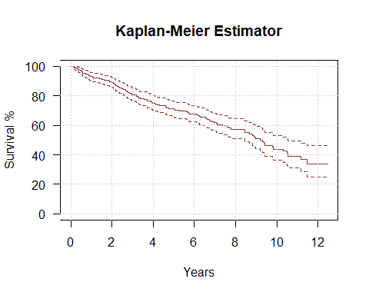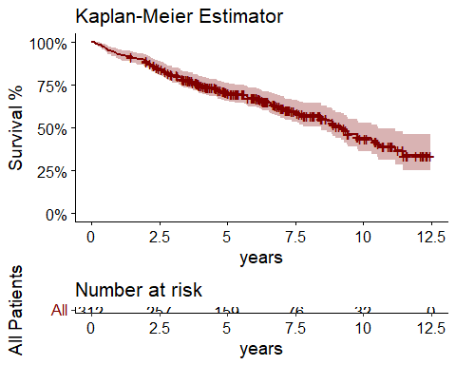

Kaplan-Meier stratified by treatment group

km.rx <- survfit(formula = pbc.surv_yrs ~ rx, data = pbc.data)  
summary(km.rx)

## Call: survfit(formula = pbc.surv_yrs ~ rx, data = pbc.data)  
##   
## rx=DPCA   
## time n.risk n.event survival std.err lower 95% CI upper 95% CI  
## 0.140 154 1 0.994 0.00647 0.981 1.000  
## 0.211 153 1 0.987 0.00912 0.969 1.000  
## 0.301 152 1 0.981 0.01114 0.959 1.000  
## 0.356 151 1 0.974 0.01282 0.949 0.999  
## 0.509 150 1 0.968 0.01428 0.940 0.996  
## 0.523 149 1 0.961 0.01559 0.931 0.992  
## 0.567 148 1 0.955 0.01679 0.922 0.988  
## 0.591 147 1 0.948 0.01788 0.914 0.984  
## 0.723 146 2 0.935 0.01986 0.897 0.975  
## 0.832 144 1 0.929 0.02075 0.889 0.970  
## 0.879 143 1 0.922 0.02160 0.881 0.965  
## 0.893 142 1 0.916 0.02240 0.873 0.961  
## 1.259 141 1 0.909 0.02317 0.865 0.956  
## 1.503 140 1 0.903 0.02389 0.857 0.951  
## 1.511 139 1 0.896 0.02459 0.849 0.946  
## 1.634 138 1 0.890 0.02525 0.841 0.941  
## 1.673 137 1 0.883 0.02589 0.834 0.935  
## 1.938 136 1 0.877 0.02650 0.826 0.930  
## 2.007 135 1 0.870 0.02709 0.819 0.925  
## 2.105 134 1 0.864 0.02765 0.811 0.920  
## 2.152 133 1 0.857 0.02820 0.804 0.914  
## 2.163 131 1 0.851 0.02873 0.796 0.909  
## 2.182 130 1 0.844 0.02925 0.789 0.903  
## 2.327 128 1 0.837 0.02975 0.781 0.898  
## 2.335 127 1 0.831 0.03024 0.774 0.892  
## 2.352 126 1 0.824 0.03071 0.766 0.887  
## 2.437 125 1 0.818 0.03116 0.759 0.881  
## 2.546 124 1 0.811 0.03160 0.751 0.875  
## 2.582 123 1 0.804 0.03203 0.744 0.870  
## 2.667 122 1 0.798 0.03244 0.737 0.864  
## 2.957 118 1 0.791 0.03286 0.729 0.858  
## 3.190 115 1 0.784 0.03328 0.722 0.852  
## 3.318 114 1 0.777 0.03370 0.714 0.846  
## 3.332 111 1 0.770 0.03411 0.706 0.840  
## 3.713 103 1 0.763 0.03459 0.698 0.834  
## 3.869 101 1 0.755 0.03506 0.690 0.827  
## 3.907 98 1 0.748 0.03554 0.681 0.821  
## 3.953 95 1 0.740 0.03603 0.672 0.814  
## 4.071 93 1 0.732 0.03651 0.664 0.807  
## 4.205 91 1 0.724 0.03698 0.655 0.800  
## 4.890 79 1 0.715 0.03763 0.645 0.792  
## 5.057 76 1 0.705 0.03829 0.634 0.784  
## 5.722 69 1 0.695 0.03908 0.622 0.776  
## 6.623 56 1 0.683 0.04030 0.608 0.766  
## 6.752 53 1 0.670 0.04155 0.593 0.756  
## 6.853 51 1 0.657 0.04276 0.578 0.746  
## 7.581 40 1 0.640 0.04473 0.558 0.734  
## 7.655 38 1 0.623 0.04662 0.538 0.722  
## 7.795 35 1 0.605 0.04857 0.517 0.709  
## 8.460 32 1 0.587 0.05060 0.495 0.695  
## 8.679 29 1 0.566 0.05275 0.472 0.680  
## 8.882 28 1 0.546 0.05460 0.449 0.664  
## 9.194 26 1 0.525 0.05640 0.425 0.648  
## 9.295 24 1 0.503 0.05814 0.401 0.631  
## 9.385 22 1 0.480 0.05983 0.376 0.613  
## 9.432 21 1 0.457 0.06119 0.352 0.595  
## 10.300 15 1 0.427 0.06427 0.318 0.573  
## 10.511 13 1 0.394 0.06719 0.282 0.551  
## 10.549 12 1 0.361 0.06916 0.248 0.526  
##   
## rx=Placebo   
## time n.risk n.event survival std.err lower 95% CI upper 95% CI  
## 0.112 158 1 0.994 0.00631 0.981 1.000  
## 0.194 157 1 0.987 0.00889 0.970 1.000  
## 0.359 156 1 0.981 0.01086 0.960 1.000  
## 0.383 155 1 0.975 0.01250 0.950 0.999  
## 0.490 154 1 0.968 0.01393 0.941 0.996  
## 0.542 153 1 0.962 0.01521 0.933 0.992  
## 0.611 152 1 0.956 0.01637 0.924 0.988  
## 0.914 151 1 0.949 0.01744 0.916 0.984  
## 0.953 150 1 0.943 0.01844 0.908 0.980  
## 1.062 149 1 0.937 0.01937 0.900 0.975  
## 1.095 148 1 0.930 0.02025 0.892 0.971  
## 1.410 147 1 0.924 0.02108 0.884 0.966  
## 1.843 145 1 0.918 0.02187 0.876 0.962  
## 1.900 144 1 0.911 0.02263 0.868 0.957  
## 2.053 141 1 0.905 0.02337 0.860 0.952  
## 2.086 140 1 0.898 0.02408 0.852 0.947  
## 2.188 139 1 0.892 0.02476 0.845 0.942  
## 2.256 138 1 0.885 0.02541 0.837 0.937  
## 2.475 134 1 0.879 0.02607 0.829 0.931  
## 2.658 132 1 0.872 0.02671 0.821 0.926  
## 2.683 131 1 0.866 0.02732 0.814 0.921  
## 2.735 130 1 0.859 0.02791 0.806 0.915  
## 2.738 129 1 0.852 0.02848 0.798 0.910  
## 2.771 128 1 0.846 0.02902 0.791 0.904  
## 2.839 127 1 0.839 0.02955 0.783 0.899  
## 2.949 126 1 0.832 0.03005 0.775 0.893  
## 2.965 125 1 0.826 0.03054 0.768 0.888  
## 3.154 124 1 0.819 0.03101 0.760 0.882  
## 3.203 122 1 0.812 0.03148 0.753 0.876  
## 3.261 121 2 0.799 0.03236 0.738 0.865  
## 3.381 117 1 0.792 0.03279 0.730 0.859  
## 3.551 114 1 0.785 0.03323 0.723 0.853  
## 3.696 111 1 0.778 0.03368 0.715 0.847  
## 3.723 110 1 0.771 0.03411 0.707 0.841  
## 3.926 105 1 0.764 0.03456 0.699 0.834  
## 4.085 100 1 0.756 0.03505 0.690 0.828  
## 4.315 97 1 0.748 0.03554 0.682 0.821  
## 4.537 93 1 0.740 0.03606 0.673 0.814  
## 4.605 92 1 0.732 0.03655 0.664 0.807  
## 4.627 91 2 0.716 0.03748 0.646 0.793  
## 4.767 87 1 0.708 0.03794 0.637 0.786  
## 5.002 82 1 0.699 0.03845 0.628 0.779  
## 5.270 78 1 0.690 0.03899 0.618 0.771  
## 5.626 72 1 0.681 0.03960 0.607 0.763  
## 5.697 71 1 0.671 0.04019 0.597 0.755  
## 5.763 70 1 0.661 0.04074 0.586 0.746  
## 6.089 65 1 0.651 0.04137 0.575 0.738  
## 6.177 63 1 0.641 0.04198 0.564 0.729  
## 6.264 61 1 0.630 0.04259 0.552 0.720  
## 6.289 60 1 0.620 0.04315 0.541 0.710  
## 6.533 54 1 0.608 0.04385 0.528 0.701  
## 6.571 53 1 0.597 0.04450 0.516 0.691  
## 6.954 47 1 0.584 0.04533 0.502 0.680  
## 7.072 42 1 0.570 0.04634 0.486 0.669  
## 7.113 41 1 0.556 0.04725 0.471 0.657  
## 7.362 38 1 0.542 0.04822 0.455 0.645  
## 8.449 28 1 0.522 0.05023 0.433 0.631  
## 8.821 24 1 0.501 0.05264 0.407 0.615  
## 8.986 22 1 0.478 0.05495 0.381 0.599  
## 9.785 18 1 0.451 0.05795 0.351 0.580  
## 9.812 17 1 0.425 0.06032 0.322 0.561  
## 11.168 8 1 0.372 0.07247 0.254 0.545  
## 11.474 7 1 0.319 0.07922 0.196 0.519

Survival Plots stratified by treatment groups

plot(km.rx, main = 'Kaplan-Meier Estimator by Treatment Group', xlab = 'Years', ylab = 'Survival %',  
 yscale = 100, col = c("springgreen4", "deeppink4"), las = 1, bty = "]")  
legend("topright", title = "Treatment Group", c("Placebo", "DPCA"),  
 fill = c('springgreen4', 'deeppink3'), cex = .75)  
grid()

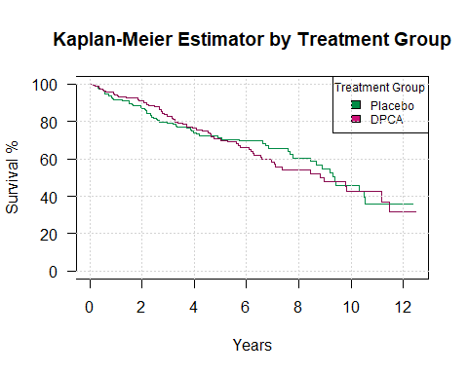

autoplot(survfit(pbc.surv_yrs ~ as.factor(pbc.data$rx)),   
 main = "Comparing Treatment and Placebo Groups", xlab = 'Survival',  
 ylab = 'Kaplan-Meier Estimator', las = 1)

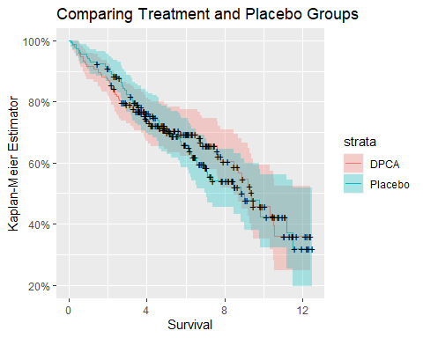

# Same Plot using ggplot themes  
ggsurvplot(fit = survfit(pbc.surv_yrs ~ pbc.data$rx, data = pbc.data),  
 title = 'Kaplan-Meier Estimator', xlab = 'years', ylab = 'Survival %',  
 surv.scale = 'percent', theme = theme_bw(), palette = 'simpsons',  
 conf.int = TRUE, pval = TRUE, risk.table = TRUE, legend.title = 'Treatment Groups',  
 legend.labs = c("DPCA", "Placebo"))

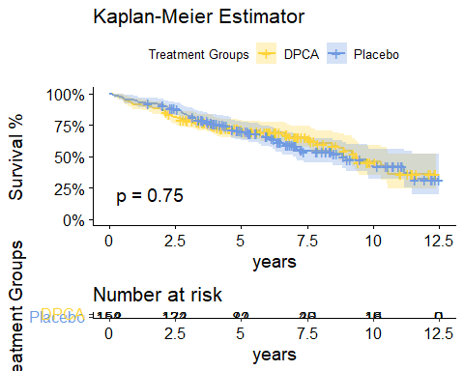

Log Rank Test

# Log Rank Test  
survdiff(formula = pbc.surv_yrs ~ rx, data = pbc.data)

## Call:  
## survdiff(formula = pbc.surv_yrs ~ rx, data = pbc.data)  
##   
## N Observed Expected (O-E)^2/E (O-E)^2/V  
## rx=DPCA 154 60 61.8 0.0513 0.102  
## rx=Placebo 158 65 63.2 0.0502 0.102  
##   
## Chisq= 0.1 on 1 degrees of freedom, p= 0.7

Cox Model

cox.surv_yrs <- coxph(pbc.surv_yrs ~ event, data = pbc.data)

## Warning in fitter(X, Y, istrat, offset, init, control, weights = weights, :  
## Loglik converged before variable 1 ; coefficient may be infinite.

cox.surv_yrs

## Call:  
## coxph(formula = pbc.surv_yrs ~ event, data = pbc.data)  
##   
## coef exp(coef) se(coef) z p  
## event 2.165e+01 2.536e+09 2.755e+03 0.008 0.994  
##   
## Likelihood ratio test=316.2 on 1 df, p=< 2.2e-16  
## n= 312, number of events= 125

summary(cox.surv_yrs)

## Call:  
## coxph(formula = pbc.surv_yrs ~ event, data = pbc.data)  
##   
## n= 312, number of events= 125   
##   
## coef exp(coef) se(coef) z Pr(>|z|)  
## event 2.165e+01 2.536e+09 2.755e+03 0.008 0.994  
##   
## exp(coef) exp(-coef) lower .95 upper .95  
## event 2.536e+09 3.943e-10 0 Inf  
##   
## Concordance= 0.845 (se = 0.013 )  
## Likelihood ratio test= 316.2 on 1 df, p=<2e-16  
## Wald test = 0 on 1 df, p=1  
## Score (logrank) test = 311.8 on 1 df, p=<2e-16

cox.surv_yrs %>%  
 tbl_regression()

## * Install 'flextable' with the code below.

## install.packages("flextable")

## Table printed with `knitr::kable()`, not {gt}. Learn why at  
## http://www.danieldsjoberg.com/gtsummary/articles/rmarkdown.html  
## To suppress this message, include `message = FALSE` in the code chunk header.

**Characteristic**

**log(HR)**

**95% CI**

**p-value**

event

22

-5,378, 5,422

>0.9

ggcoxdiagnostics(cox.surv_yrs, type = "deviance", ox.scale = 'time')

## Warning in ggcoxdiagnostics(cox.surv_yrs, type = "deviance", ox.scale = "time"):  
## ox.scale='time' works only with type=schoenfeld/scaledsch

## `geom_smooth()` using formula 'y ~ x'

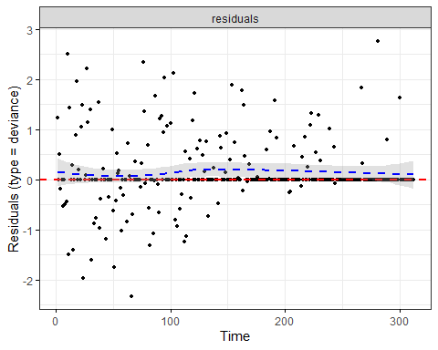

Cox model by treatment group

cox.rx <- coxph(pbc.surv_yrs ~ rx, data = pbc.data)  
cox.rx

## Call:  
## coxph(formula = pbc.surv_yrs ~ rx, data = pbc.data)  
##   
## coef exp(coef) se(coef) z p  
## rxPlacebo 0.05722 1.05889 0.17916 0.319 0.749  
##   
## Likelihood ratio test=0.1 on 1 df, p=0.7494  
## n= 312, number of events= 125

ggcoxdiagnostics(cox.rx, type = "deviance", ox.scale = 'time')

## Warning in ggcoxdiagnostics(cox.rx, type = "deviance", ox.scale = "time"):  
## ox.scale='time' works only with type=schoenfeld/scaledsch

## `geom_smooth()` using formula 'y ~ x'

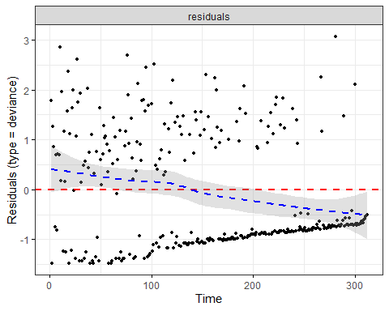

Cox model with triglycerides

cox.trigli <- coxph(pbc.surv_yrs ~ trigli, data = pbc.data)  
cox.trigli

## Call:  
## coxph(formula = pbc.surv_yrs ~ trigli, data = pbc.data)  
##   
## coef exp(coef) se(coef) z p  
## trigli 0.004213 1.004222 0.001079 3.905 9.43e-05  
##   
## Likelihood ratio test=11.72 on 1 df, p=0.0006193  
## n= 282, number of events= 113   
## (30 observations deleted due to missingness)

summary(cox.trigli)

## Call:  
## coxph(formula = pbc.surv_yrs ~ trigli, data = pbc.data)  
##   
## n= 282, number of events= 113   
## (30 observations deleted due to missingness)  
##   
## coef exp(coef) se(coef) z Pr(>|z|)   
## trigli 0.004213 1.004222 0.001079 3.905 9.43e-05 ***  
## ---  
## Signif. codes: 0 '***' 0.001 '**' 0.01 '*' 0.05 '.' 0.1 ' ' 1  
##   
## exp(coef) exp(-coef) lower .95 upper .95  
## trigli 1.004 0.9958 1.002 1.006  
##   
## Concordance= 0.599 (se = 0.03 )  
## Likelihood ratio test= 11.72 on 1 df, p=6e-04  
## Wald test = 15.25 on 1 df, p=9e-05  
## Score (logrank) test = 15.09 on 1 df, p=1e-04

ggcoxdiagnostics(cox.trigli, type = "deviance", ox.scale = 'time')

## Warning in ggcoxdiagnostics(cox.trigli, type = "deviance", ox.scale = "time"):  
## ox.scale='time' works only with type=schoenfeld/scaledsch

## `geom_smooth()` using formula 'y ~ x'

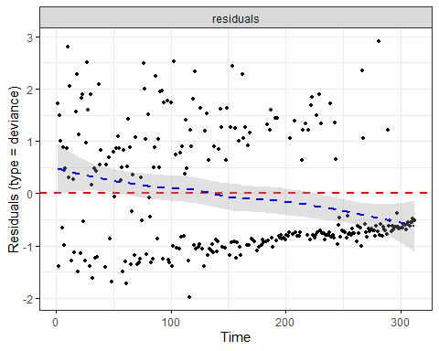

Cox model by severity of liver damage

cox.histol <- coxph(pbc.surv_yrs ~ histol, data = pbc.data)  
cox.histol

## Call:  
## coxph(formula = pbc.surv_yrs ~ histol, data = pbc.data)  
##   
## coef exp(coef) se(coef) z p  
## histol 0.8175 2.2649 0.1238 6.602 4.06e-11  
##   
## Likelihood ratio test=51.44 on 1 df, p=7.392e-13  
## n= 312, number of events= 125

summary(cox.histol)

## Call:  
## coxph(formula = pbc.surv_yrs ~ histol, data = pbc.data)  
##   
## n= 312, number of events= 125   
##   
## coef exp(coef) se(coef) z Pr(>|z|)   
## histol 0.8175 2.2649 0.1238 6.602 4.06e-11 ***  
## ---  
## Signif. codes: 0 '***' 0.001 '**' 0.01 '*' 0.05 '.' 0.1 ' ' 1  
##   
## exp(coef) exp(-coef) lower .95 upper .95  
## histol 2.265 0.4415 1.777 2.887  
##   
## Concordance= 0.702 (se = 0.022 )  
## Likelihood ratio test= 51.44 on 1 df, p=7e-13  
## Wald test = 43.58 on 1 df, p=4e-11  
## Score (logrank) test = 46.51 on 1 df, p=9e-12

ggcoxdiagnostics(cox.histol, type = "deviance", ox.scale = 'time')

## Warning in ggcoxdiagnostics(cox.histol, type = "deviance", ox.scale = "time"):  
## ox.scale='time' works only with type=schoenfeld/scaledsch

## `geom_smooth()` using formula 'y ~ x'

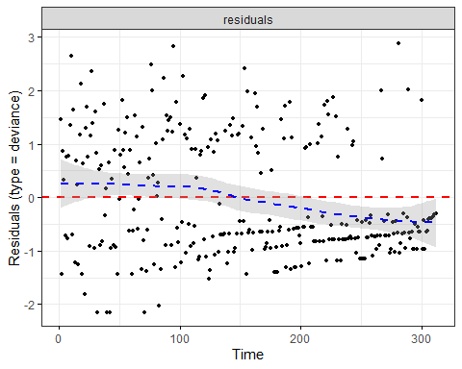

Cox model by all treatment group, triglycerides, and severity of liver damage

cox.combined <- coxph(pbc.surv_yrs ~ rx + trigli + histol, data = pbc.data)  
cox.combined

## Call:  
## coxph(formula = pbc.surv_yrs ~ rx + trigli + histol, data = pbc.data)  
##   
## coef exp(coef) se(coef) z p  
## rxPlacebo 0.158640 1.171916 0.192390 0.825 0.40961  
## trigli 0.003362 1.003368 0.001029 3.269 0.00108  
## histol 0.832041 2.298005 0.133520 6.232 4.62e-10  
##   
## Likelihood ratio test=56.64 on 3 df, p=3.07e-12  
## n= 282, number of events= 113   
## (30 observations deleted due to missingness)

summary(cox.combined)

## Call:  
## coxph(formula = pbc.surv_yrs ~ rx + trigli + histol, data = pbc.data)  
##   
## n= 282, number of events= 113   
## (30 observations deleted due to missingness)  
##   
## coef exp(coef) se(coef) z Pr(>|z|)   
## rxPlacebo 0.158640 1.171916 0.192390 0.825 0.40961   
## trigli 0.003362 1.003368 0.001029 3.269 0.00108 **   
## histol 0.832041 2.298005 0.133520 6.232 4.62e-10 ***  
## ---  
## Signif. codes: 0 '***' 0.001 '**' 0.01 '*' 0.05 '.' 0.1 ' ' 1  
##   
## exp(coef) exp(-coef) lower .95 upper .95  
## rxPlacebo 1.172 0.8533 0.8038 1.709  
## trigli 1.003 0.9966 1.0013 1.005  
## histol 2.298 0.4352 1.7689 2.985  
##   
## Concordance= 0.729 (se = 0.024 )  
## Likelihood ratio test= 56.64 on 3 df, p=3e-12  
## Wald test = 53.37 on 3 df, p=2e-11  
## Score (logrank) test = 55.35 on 3 df, p=6e-12

ggcoxdiagnostics(cox.combined, type = "deviance", ox.scale = 'time')

## Warning in ggcoxdiagnostics(cox.combined, type = "deviance", ox.scale = "time"):  
## ox.scale='time' works only with type=schoenfeld/scaledsch

## `geom_smooth()` using formula 'y ~ x'

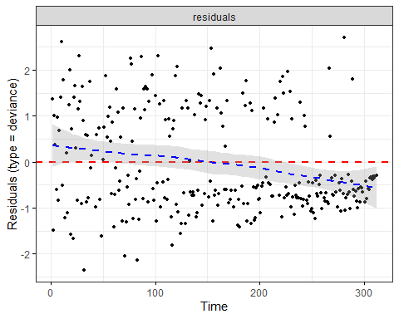

ggforest(cox.combined)

## Warning in .get_data(model, data = data): The `data` argument is not provided.  
## Data will be extracted from model fit.

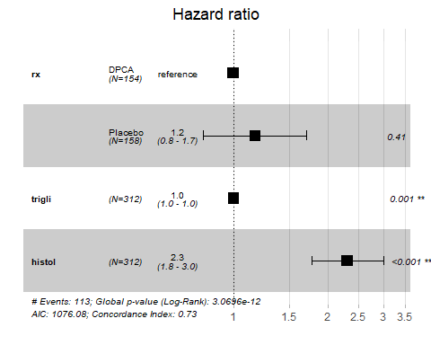

ggadjustedcurves(cox.combined, data = pbc.data, legend = 'none')

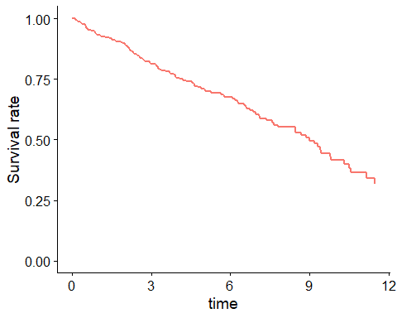

stargazer(cox.rx, cox.trigli, cox.combined, type = 'text')

##   
## =========================================================================  
## Dependent variable:   
## ----------------------------------------------------  
## pbc.surv_yrs   
## (1) (2) (3)   
## -------------------------------------------------------------------------  
## rxPlacebo 0.057 0.159   
## (0.179) (0.192)   
##   
## trigli 0.004*** 0.003***   
## (0.001) (0.001)   
##   
## histol 0.832***   
## (0.134)   
##   
## -------------------------------------------------------------------------  
## Observations 312 282 282   
## R2 0.0003 0.041 0.182   
## Max. Possible R2 0.983 0.982 0.982   
## Log Likelihood -639.915 -557.501 -535.041   
## Wald Test 0.100 (df = 1) 15.250*** (df = 1) 53.370*** (df = 3)  
## LR Test 0.102 (df = 1) 11.717*** (df = 1) 56.638*** (df = 3)  
## Score (Logrank) Test 0.102 (df = 1) 15.093*** (df = 1) 55.354*** (df = 3)  
## =========================================================================  
## Note: *p<0.1; **p<0.05; ***p<0.01

anova(cox.combined)

## Analysis of Deviance Table  
## Cox model: response is pbc.surv_yrs  
## Terms added sequentially (first to last)  
##   
## loglik Chisq Df Pr(>|Chi|)   
## NULL -563.36   
## rx -563.19 0.332 1 0.5644865   
## trigli -557.45 11.491 1 0.0006992 ***  
## histol -535.04 44.815 1 2.165e-11 ***  
## ---  
## Signif. codes: 0 '***' 0.001 '**' 0.01 '*' 0.05 '.' 0.1 ' ' 1

Years converted to months

describe(pbc.data$months)

## vars n mean sd median trimmed mad min max range skew kurtosis  
## X1 1 312 65.92 36.9 60.44 64.23 36.97 1.35 149.68 148.34 0.37 -0.62  
## se  
## X1 2.09

Kaplan-Meier with all patients

pbc.surv_months <- Surv(pbc.data$months, pbc.data$event)  
  
km.all_m <- survfit(pbc.surv_months ~ 1, data = pbc.data)  
summary(km.all_m)

## Call: survfit(formula = pbc.surv_months ~ 1, data = pbc.data)  
##   
## time n.risk n.event survival std.err lower 95% CI upper 95% CI  
## 1.35 312 1 0.997 0.00320 0.991 1.000  
## 1.68 311 1 0.994 0.00452 0.985 1.000  
## 2.33 310 1 0.990 0.00552 0.980 1.000  
## 2.53 309 1 0.987 0.00637 0.975 1.000  
## 3.61 308 1 0.984 0.00711 0.970 0.998  
## 4.27 307 1 0.981 0.00778 0.966 0.996  
## 4.30 306 1 0.978 0.00838 0.961 0.994  
## 4.60 305 1 0.974 0.00895 0.957 0.992  
## 5.88 304 1 0.971 0.00948 0.953 0.990  
## 6.11 303 1 0.968 0.00997 0.949 0.988  
## 6.28 302 1 0.965 0.01044 0.944 0.985  
## 6.51 301 1 0.962 0.01089 0.940 0.983  
## 6.80 300 1 0.958 0.01131 0.936 0.981  
## 7.10 299 1 0.955 0.01172 0.932 0.978  
## 7.33 298 1 0.952 0.01211 0.928 0.976  
## 8.67 297 2 0.946 0.01285 0.921 0.971  
## 9.99 295 1 0.942 0.01320 0.917 0.969  
## 10.55 294 1 0.939 0.01354 0.913 0.966  
## 10.71 293 1 0.936 0.01387 0.909 0.963  
## 10.97 292 1 0.933 0.01418 0.905 0.961  
## 11.43 291 1 0.929 0.01449 0.902 0.958  
## 12.75 290 1 0.926 0.01479 0.898 0.956  
## 13.14 289 1 0.923 0.01509 0.894 0.953  
## 15.11 288 1 0.920 0.01537 0.890 0.950  
## 16.92 287 1 0.917 0.01565 0.887 0.948  
## 18.04 285 1 0.913 0.01592 0.883 0.945  
## 18.14 284 1 0.910 0.01619 0.879 0.943  
## 19.61 283 1 0.907 0.01644 0.875 0.940  
## 20.07 282 1 0.904 0.01670 0.872 0.937  
## 22.11 281 1 0.901 0.01695 0.868 0.934  
## 22.80 280 1 0.897 0.01719 0.864 0.932  
## 23.26 279 1 0.894 0.01742 0.861 0.929  
## 24.08 277 1 0.891 0.01766 0.857 0.926  
## 24.64 275 1 0.888 0.01789 0.853 0.923  
## 25.03 274 1 0.884 0.01811 0.850 0.921  
## 25.26 273 1 0.881 0.01833 0.846 0.918  
## 25.82 272 1 0.878 0.01855 0.842 0.915  
## 25.95 270 1 0.875 0.01877 0.839 0.912  
## 26.18 269 1 0.871 0.01898 0.835 0.909  
## 26.25 268 1 0.868 0.01918 0.831 0.907  
## 27.07 267 1 0.865 0.01938 0.828 0.904  
## 27.93 264 1 0.862 0.01958 0.824 0.901  
## 28.02 263 1 0.858 0.01978 0.820 0.898  
## 28.22 262 1 0.855 0.01998 0.817 0.895  
## 29.24 260 1 0.852 0.02017 0.813 0.892  
## 29.70 258 1 0.849 0.02036 0.810 0.889  
## 30.55 257 1 0.845 0.02055 0.806 0.886  
## 30.98 255 1 0.842 0.02073 0.802 0.884  
## 31.90 254 1 0.839 0.02091 0.799 0.881  
## 32.00 253 1 0.835 0.02109 0.795 0.878  
## 32.20 252 1 0.832 0.02127 0.791 0.875  
## 32.82 250 1 0.829 0.02144 0.788 0.872  
## 32.85 249 1 0.825 0.02161 0.784 0.869  
## 33.25 248 1 0.822 0.02178 0.780 0.866  
## 34.07 246 1 0.819 0.02194 0.777 0.863  
## 35.38 244 1 0.815 0.02211 0.773 0.860  
## 35.48 243 1 0.812 0.02227 0.769 0.857  
## 35.58 242 1 0.809 0.02243 0.766 0.854  
## 37.85 239 1 0.805 0.02259 0.762 0.851  
## 38.28 237 1 0.802 0.02275 0.758 0.848  
## 38.44 236 1 0.798 0.02291 0.755 0.845  
## 39.13 235 2 0.792 0.02321 0.747 0.838  
## 39.82 233 1 0.788 0.02336 0.744 0.835  
## 39.98 230 1 0.785 0.02350 0.740 0.832  
## 40.57 227 1 0.781 0.02365 0.736 0.829  
## 42.61 222 1 0.778 0.02381 0.733 0.826  
## 44.35 214 1 0.774 0.02397 0.729 0.823  
## 44.55 213 1 0.771 0.02413 0.725 0.819  
## 44.68 212 1 0.767 0.02429 0.721 0.816  
## 46.42 206 1 0.763 0.02446 0.717 0.813  
## 46.88 203 1 0.759 0.02462 0.713 0.809  
## 47.11 201 1 0.756 0.02479 0.709 0.806  
## 47.44 198 1 0.752 0.02496 0.704 0.802  
## 48.85 193 1 0.748 0.02513 0.700 0.799  
## 49.02 192 1 0.744 0.02530 0.696 0.795  
## 50.46 189 1 0.740 0.02547 0.692 0.792  
## 51.78 184 1 0.736 0.02565 0.687 0.788  
## 54.44 178 1 0.732 0.02583 0.683 0.784  
## 55.26 175 1 0.728 0.02602 0.679 0.781  
## 55.52 174 2 0.719 0.02639 0.669 0.773  
## 57.20 169 1 0.715 0.02657 0.665 0.769  
## 58.68 162 1 0.711 0.02677 0.660 0.765  
## 60.02 159 1 0.706 0.02697 0.655 0.761  
## 60.68 156 1 0.702 0.02718 0.650 0.757  
## 63.24 151 1 0.697 0.02739 0.645 0.753  
## 67.52 141 1 0.692 0.02764 0.640 0.748  
## 68.37 140 1 0.687 0.02788 0.635 0.744  
## 68.67 139 1 0.682 0.02812 0.629 0.740  
## 69.16 138 1 0.677 0.02834 0.624 0.735  
## 73.07 127 1 0.672 0.02862 0.618 0.730  
## 74.12 123 1 0.667 0.02890 0.612 0.726  
## 75.17 121 1 0.661 0.02918 0.606 0.721  
## 75.47 119 1 0.655 0.02946 0.600 0.716  
## 78.39 110 1 0.649 0.02979 0.594 0.711  
## 78.85 109 1 0.644 0.03011 0.587 0.705  
## 79.47 108 1 0.638 0.03041 0.581 0.700  
## 81.02 103 1 0.631 0.03074 0.574 0.695  
## 82.23 100 1 0.625 0.03108 0.567 0.689  
## 83.45 96 1 0.619 0.03143 0.560 0.683  
## 84.86 88 1 0.612 0.03185 0.552 0.677  
## 85.36 87 1 0.604 0.03225 0.544 0.671  
## 88.34 80 1 0.597 0.03272 0.536 0.665  
## 90.97 76 1 0.589 0.03322 0.527 0.658  
## 91.86 74 1 0.581 0.03371 0.519 0.651  
## 93.54 71 1 0.573 0.03421 0.510 0.644  
## 101.39 60 1 0.563 0.03495 0.499 0.636  
## 101.52 59 1 0.554 0.03564 0.488 0.628  
## 104.15 53 1 0.543 0.03646 0.476 0.620  
## 105.86 52 1 0.533 0.03723 0.465 0.611  
## 106.58 50 1 0.522 0.03798 0.453 0.602  
## 107.83 48 1 0.511 0.03872 0.441 0.593  
## 110.32 45 1 0.500 0.03949 0.428 0.584  
## 111.54 43 1 0.488 0.04025 0.416 0.574  
## 112.62 41 1 0.476 0.04099 0.403 0.564  
## 113.18 40 1 0.465 0.04166 0.390 0.554  
## 117.42 37 1 0.452 0.04238 0.376 0.543  
## 117.75 34 1 0.439 0.04317 0.362 0.532  
## 123.60 30 1 0.424 0.04414 0.346 0.520  
## 126.13 27 1 0.408 0.04522 0.329 0.507  
## 126.59 25 1 0.392 0.04626 0.311 0.494  
## 134.01 17 1 0.369 0.04895 0.285 0.479  
## 137.69 13 1 0.341 0.05278 0.251 0.461

Kaplan-Meier by treatment group

km.rx_m <- survfit(formula = pbc.surv_months ~ rx, data = pbc.data)  
summary(km.rx_m)

## Call: survfit(formula = pbc.surv_months ~ rx, data = pbc.data)  
##   
## rx=DPCA   
## time n.risk n.event survival std.err lower 95% CI upper 95% CI  
## 1.68 154 1 0.994 0.00647 0.981 1.000  
## 2.53 153 1 0.987 0.00912 0.969 1.000  
## 3.61 152 1 0.981 0.01114 0.959 1.000  
## 4.27 151 1 0.974 0.01282 0.949 0.999  
## 6.11 150 1 0.968 0.01428 0.940 0.996  
## 6.28 149 1 0.961 0.01559 0.931 0.992  
## 6.80 148 1 0.955 0.01679 0.922 0.988  
## 7.10 147 1 0.948 0.01788 0.914 0.984  
## 8.67 146 2 0.935 0.01986 0.897 0.975  
## 9.99 144 1 0.929 0.02075 0.889 0.970  
## 10.55 143 1 0.922 0.02160 0.881 0.965  
## 10.71 142 1 0.916 0.02240 0.873 0.961  
## 15.11 141 1 0.909 0.02317 0.865 0.956  
## 18.04 140 1 0.903 0.02389 0.857 0.951  
## 18.14 139 1 0.896 0.02459 0.849 0.946  
## 19.61 138 1 0.890 0.02525 0.841 0.941  
## 20.07 137 1 0.883 0.02589 0.834 0.935  
## 23.26 136 1 0.877 0.02650 0.826 0.930  
## 24.08 135 1 0.870 0.02709 0.819 0.925  
## 25.26 134 1 0.864 0.02765 0.811 0.920  
## 25.82 133 1 0.857 0.02820 0.804 0.914  
## 25.95 131 1 0.851 0.02873 0.796 0.909  
## 26.18 130 1 0.844 0.02925 0.789 0.903  
## 27.93 128 1 0.837 0.02975 0.781 0.898  
## 28.02 127 1 0.831 0.03024 0.774 0.892  
## 28.22 126 1 0.824 0.03071 0.766 0.887  
## 29.24 125 1 0.818 0.03116 0.759 0.881  
## 30.55 124 1 0.811 0.03160 0.751 0.875  
## 30.98 123 1 0.804 0.03203 0.744 0.870  
## 32.00 122 1 0.798 0.03244 0.737 0.864  
## 35.48 118 1 0.791 0.03286 0.729 0.858  
## 38.28 115 1 0.784 0.03328 0.722 0.852  
## 39.82 114 1 0.777 0.03370 0.714 0.846  
## 39.98 111 1 0.770 0.03411 0.706 0.840  
## 44.55 103 1 0.763 0.03459 0.698 0.834  
## 46.42 101 1 0.755 0.03506 0.690 0.827  
## 46.88 98 1 0.748 0.03554 0.681 0.821  
## 47.44 95 1 0.740 0.03603 0.672 0.814  
## 48.85 93 1 0.732 0.03651 0.664 0.807  
## 50.46 91 1 0.724 0.03698 0.655 0.800  
## 58.68 79 1 0.715 0.03763 0.645 0.792  
## 60.68 76 1 0.705 0.03829 0.634 0.784  
## 68.67 69 1 0.695 0.03908 0.622 0.776  
## 79.47 56 1 0.683 0.04030 0.608 0.766  
## 81.02 53 1 0.670 0.04155 0.593 0.756  
## 82.23 51 1 0.657 0.04276 0.578 0.746  
## 90.97 40 1 0.640 0.04473 0.558 0.734  
## 91.86 38 1 0.623 0.04662 0.538 0.722  
## 93.54 35 1 0.605 0.04857 0.517 0.709  
## 101.52 32 1 0.587 0.05060 0.495 0.695  
## 104.15 29 1 0.566 0.05275 0.472 0.680  
## 106.58 28 1 0.546 0.05460 0.449 0.664  
## 110.32 26 1 0.525 0.05640 0.425 0.648  
## 111.54 24 1 0.503 0.05814 0.401 0.631  
## 112.62 22 1 0.480 0.05983 0.376 0.613  
## 113.18 21 1 0.457 0.06119 0.352 0.595  
## 123.60 15 1 0.427 0.06427 0.318 0.573  
## 126.13 13 1 0.394 0.06719 0.282 0.551  
## 126.59 12 1 0.361 0.06916 0.248 0.526  
##   
## rx=Placebo   
## time n.risk n.event survival std.err lower 95% CI upper 95% CI  
## 1.35 158 1 0.994 0.00631 0.981 1.000  
## 2.33 157 1 0.987 0.00889 0.970 1.000  
## 4.30 156 1 0.981 0.01086 0.960 1.000  
## 4.60 155 1 0.975 0.01250 0.950 0.999  
## 5.88 154 1 0.968 0.01393 0.941 0.996  
## 6.51 153 1 0.962 0.01521 0.933 0.992  
## 7.33 152 1 0.956 0.01637 0.924 0.988  
## 10.97 151 1 0.949 0.01744 0.916 0.984  
## 11.43 150 1 0.943 0.01844 0.908 0.980  
## 12.75 149 1 0.937 0.01937 0.900 0.975  
## 13.14 148 1 0.930 0.02025 0.892 0.971  
## 16.92 147 1 0.924 0.02108 0.884 0.966  
## 22.11 145 1 0.918 0.02187 0.876 0.962  
## 22.80 144 1 0.911 0.02263 0.868 0.957  
## 24.64 141 1 0.905 0.02337 0.860 0.952  
## 25.03 140 1 0.898 0.02408 0.852 0.947  
## 26.25 139 1 0.892 0.02476 0.845 0.942  
## 27.07 138 1 0.885 0.02541 0.837 0.937  
## 29.70 134 1 0.879 0.02607 0.829 0.931  
## 31.90 132 1 0.872 0.02671 0.821 0.926  
## 32.20 131 1 0.866 0.02732 0.814 0.921  
## 32.82 130 1 0.859 0.02791 0.806 0.915  
## 32.85 129 1 0.852 0.02848 0.798 0.910  
## 33.25 128 1 0.846 0.02902 0.791 0.904  
## 34.07 127 1 0.839 0.02955 0.783 0.899  
## 35.38 126 1 0.832 0.03005 0.775 0.893  
## 35.58 125 1 0.826 0.03054 0.768 0.888  
## 37.85 124 1 0.819 0.03101 0.760 0.882  
## 38.44 122 1 0.812 0.03148 0.753 0.876  
## 39.13 121 2 0.799 0.03236 0.738 0.865  
## 40.57 117 1 0.792 0.03279 0.730 0.859  
## 42.61 114 1 0.785 0.03323 0.723 0.853  
## 44.35 111 1 0.778 0.03368 0.715 0.847  
## 44.68 110 1 0.771 0.03411 0.707 0.841  
## 47.11 105 1 0.764 0.03456 0.699 0.834  
## 49.02 100 1 0.756 0.03505 0.690 0.828  
## 51.78 97 1 0.748 0.03554 0.682 0.821  
## 54.44 93 1 0.740 0.03606 0.673 0.814  
## 55.26 92 1 0.732 0.03655 0.664 0.807  
## 55.52 91 2 0.716 0.03748 0.646 0.793  
## 57.20 87 1 0.708 0.03794 0.637 0.786  
## 60.02 82 1 0.699 0.03845 0.628 0.779  
## 63.24 78 1 0.690 0.03899 0.618 0.771  
## 67.52 72 1 0.681 0.03960 0.607 0.763  
## 68.37 71 1 0.671 0.04019 0.597 0.755  
## 69.16 70 1 0.661 0.04074 0.586 0.746  
## 73.07 65 1 0.651 0.04137 0.575 0.738  
## 74.12 63 1 0.641 0.04198 0.564 0.729  
## 75.17 61 1 0.630 0.04259 0.552 0.720  
## 75.47 60 1 0.620 0.04315 0.541 0.710  
## 78.39 54 1 0.608 0.04385 0.528 0.701  
## 78.85 53 1 0.597 0.04450 0.516 0.691  
## 83.45 47 1 0.584 0.04533 0.502 0.680  
## 84.86 42 1 0.570 0.04634 0.486 0.669  
## 85.36 41 1 0.556 0.04725 0.471 0.657  
## 88.34 38 1 0.542 0.04822 0.455 0.645  
## 101.39 28 1 0.522 0.05023 0.433 0.631  
## 105.86 24 1 0.501 0.05264 0.407 0.615  
## 107.83 22 1 0.478 0.05495 0.381 0.599  
## 117.42 18 1 0.451 0.05795 0.351 0.580  
## 117.75 17 1 0.425 0.06032 0.322 0.561  
## 134.01 8 1 0.372 0.07247 0.254 0.545  
## 137.69 7 1 0.319 0.07922 0.196 0.519