P RO G R A M M E

Master of Ceremony: - Collins Kaunda

Congregation song: - Kumtegemea Mwokozi..

Opening Prayer: - Francis Macharia

Reading the Eulogy - Family

Speeches:
- Family representative -
- Tribute : - Denis Mutuku
- Friends - Florence Mucheru
- Union Official - Josphat Malala -
- Catering Manager -
- DVC (Admin) -
- Vice Chancellor -

Scripture Readings: - 1st Corinthians 1:1-13
Catherine Kamau

Congregation Song: - Cha kutumaini sina

Message: - Fr. Prof. Lawrence Njoroge

Prayers for the family: - Chaplaincy

Congregation Song: - What a friend we have…

Vote of Thanks: - Alice Mwangi

Announcements: - Family

Closing prayer: - Thuphosa Nyando

KUMTEGEMEA MWOKOZI

- Kumtegemea Mwokozi,
Kwangu tamu kabisa,
Kukubali neno lake,
Nina raha moyoni.

Yesu, Yesu namwamini,
Nimemwona thabiti;
Yesu,Yesu,yu thamani,
Ahadi zake kweli.
- Kumtegemea Mwokozi,
Kwangu tamu kabisa,
Kuamini damu yake,
Nimeoshwa kamili.

- Kumtegemea Mwokozi,
Kwangu tamu kabisa,
Kwake daima Napata,
Uzima na amani.

- Nafurahi kwa sababu,
Nimekutegemea,
Yesu, Mpendwa na Rafiki,
Uwe nami dawamu.

CHA KUTUMAINI SINA
- Cha kutumaini sina, ila damu yake Bwana
Sina wema wa kutosha, dhambi zangu kuziosha

Kwake Yesu nasimama, ndiye Mwamba ni salama
Ndiye Mwamba ni salama, ndiye Mwamba ni salama

- Damu yake na sadaka, nategemea daima
Yote chini yakiisha, Mwokozi atanitosha.

- Njia yangu iwe ndefu, Yeye hunipa wokovu
Mawimbi yakinipiga, nguvu zake ndiyo nanga

- Nikiitwa hukumuni, rohoni nina amani
Nikivikwa haki yake, sina hofu mbele yake

WHAT A FRIEND WE HAVE IN JESUS

- What a friend we have in Jesus
All our sins and griefs to bear!
What a privilege to carry
Everything to God in prayer!
Oh what peace we often forfeit
Oh what needless pain we bear
All because we do not carry
Everything to God in prayer

- Have we trials and temptations?
Is there trouble anywhere?
We should never be discouraged
Take it to the Lord in prayer
Can we find a friend so faithful
Who will all our sorrows share?
Jesus knows our every weakness
Take it to the Lord in prayer

- Are we weak and heavy laden,
Cumbered with a load of care?
Precious Savior, still our refuge
Take it to the Lord in prayer
Do thy friends despise, forsake thee?
Take it to the Lord in prayer!
In his arms he'll take and shield thee
Thou wilt find a solace there

MEMORIAL SERVICE
FOR
LILIAN WANGUI MATHENGE

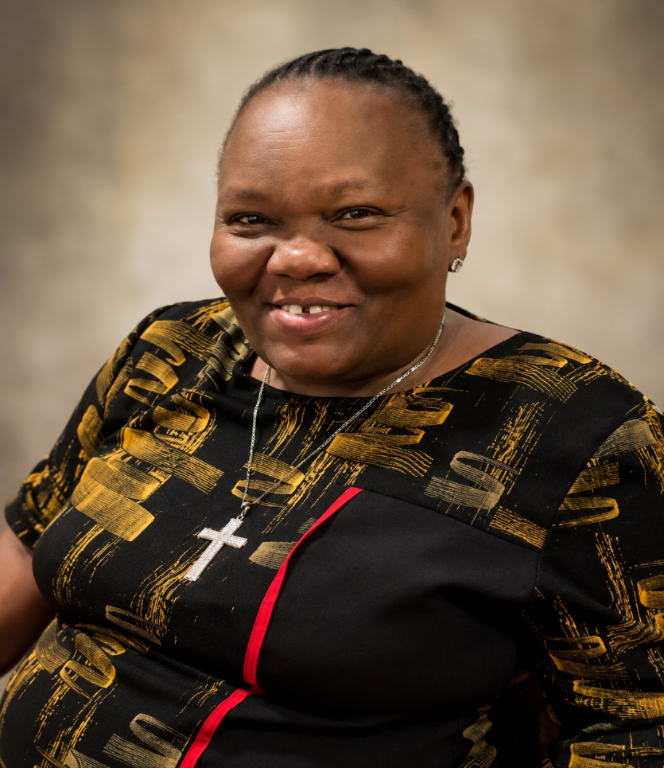

DATE: 4TH SEPTEMBER, 2026
VENUE: SCC 100
TIME: 10:00 AM

ALL ARE WELCOME

