HW5

Dietrich Kruse

|  |  |  |
| --- | --- | --- |
| **Algorithm** | **Computation Time (s)** | **Cost (Distance)** |
| Dijkstra’s | 00:00 | 14.49 |
| A* | 00:00 | 14.49 |
| RRT | 00:00 | 18.00 |

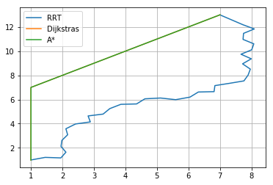

|  |  |  |
| --- | --- | --- |
| **Algorithm** | **Computation Time (s)** | **Cost (Distance)** |
| Dijkstra’s | 00:00 | 14.49 |
| A* | 00:00 | 14.49 |
| RRT | 00:00 | 19.00 |

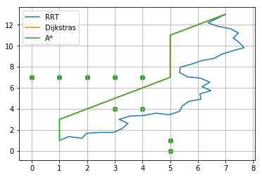

|  |  |  |
| --- | --- | --- |
| **Algorithm** | **Computation Time (s)** | **Cost (Distance)** |
| Dijkstra’s | 00:00 | 49.80 |
| A* | 00:00 | 49.80 |
| RRT | 00:29 | 65.50 |

