**Supporting Information/materials**

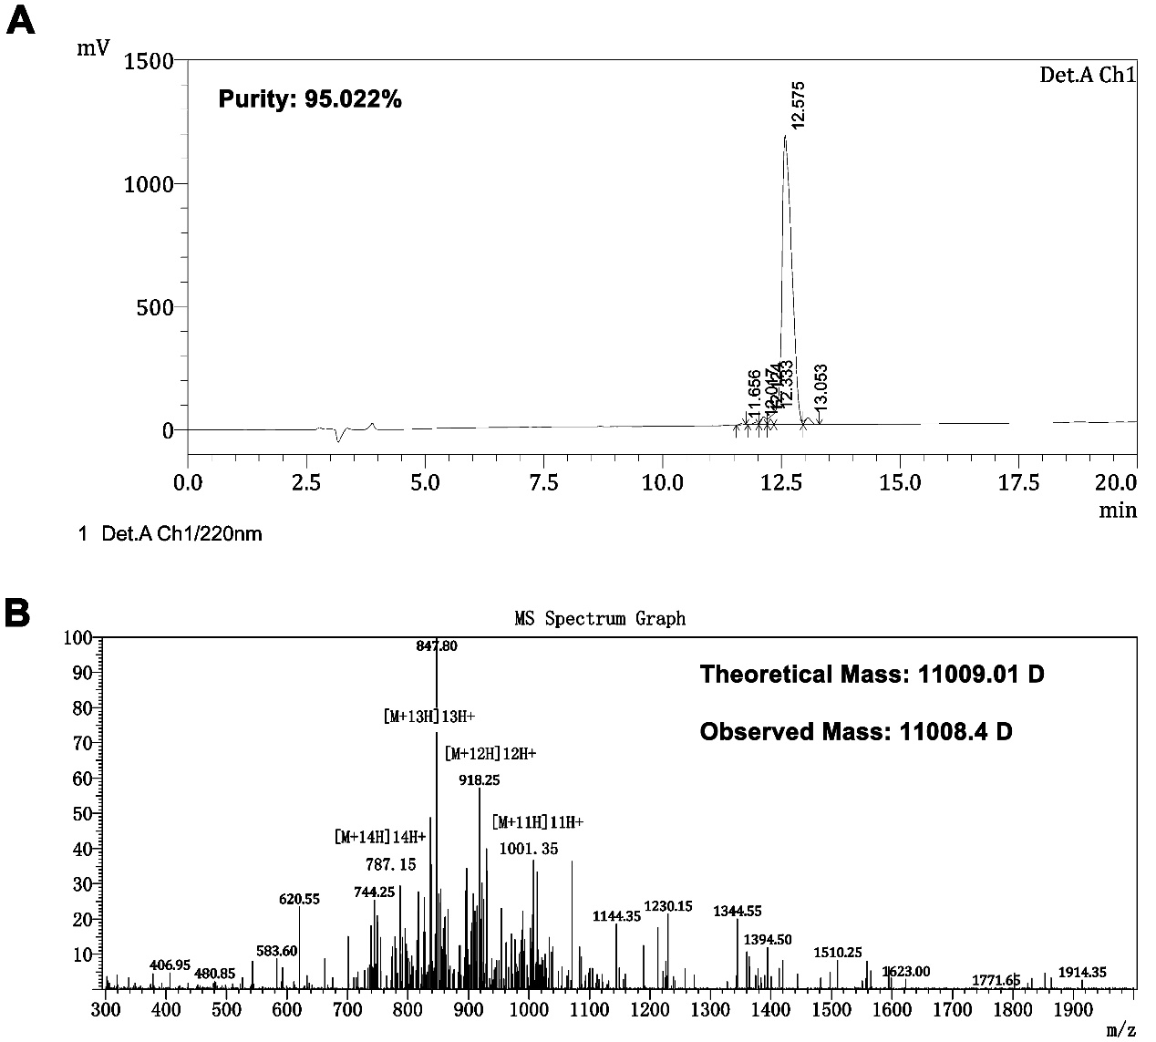

**Figure S1 Purity and molecular mass of CV-N.** (A) The chromatographic data was obtained at 40˚C on a Phenomenex/Luna C18 (2) column (5 µm, 4.6 × 150 mm) applying a linear gradient of 20-40% buffer B (buffer A: 0.1% trifluoroacetic acid in water; buffer B: 0.09% trifluoroacetic acid in (80% acetonitrile plus 20% water)) at a flow rate of 1 mL/min over 20 min. (B) The molecular mass was measured by electrospray ionization mass spectrometry (Chiron Mimotopes, Victoria, Australia).

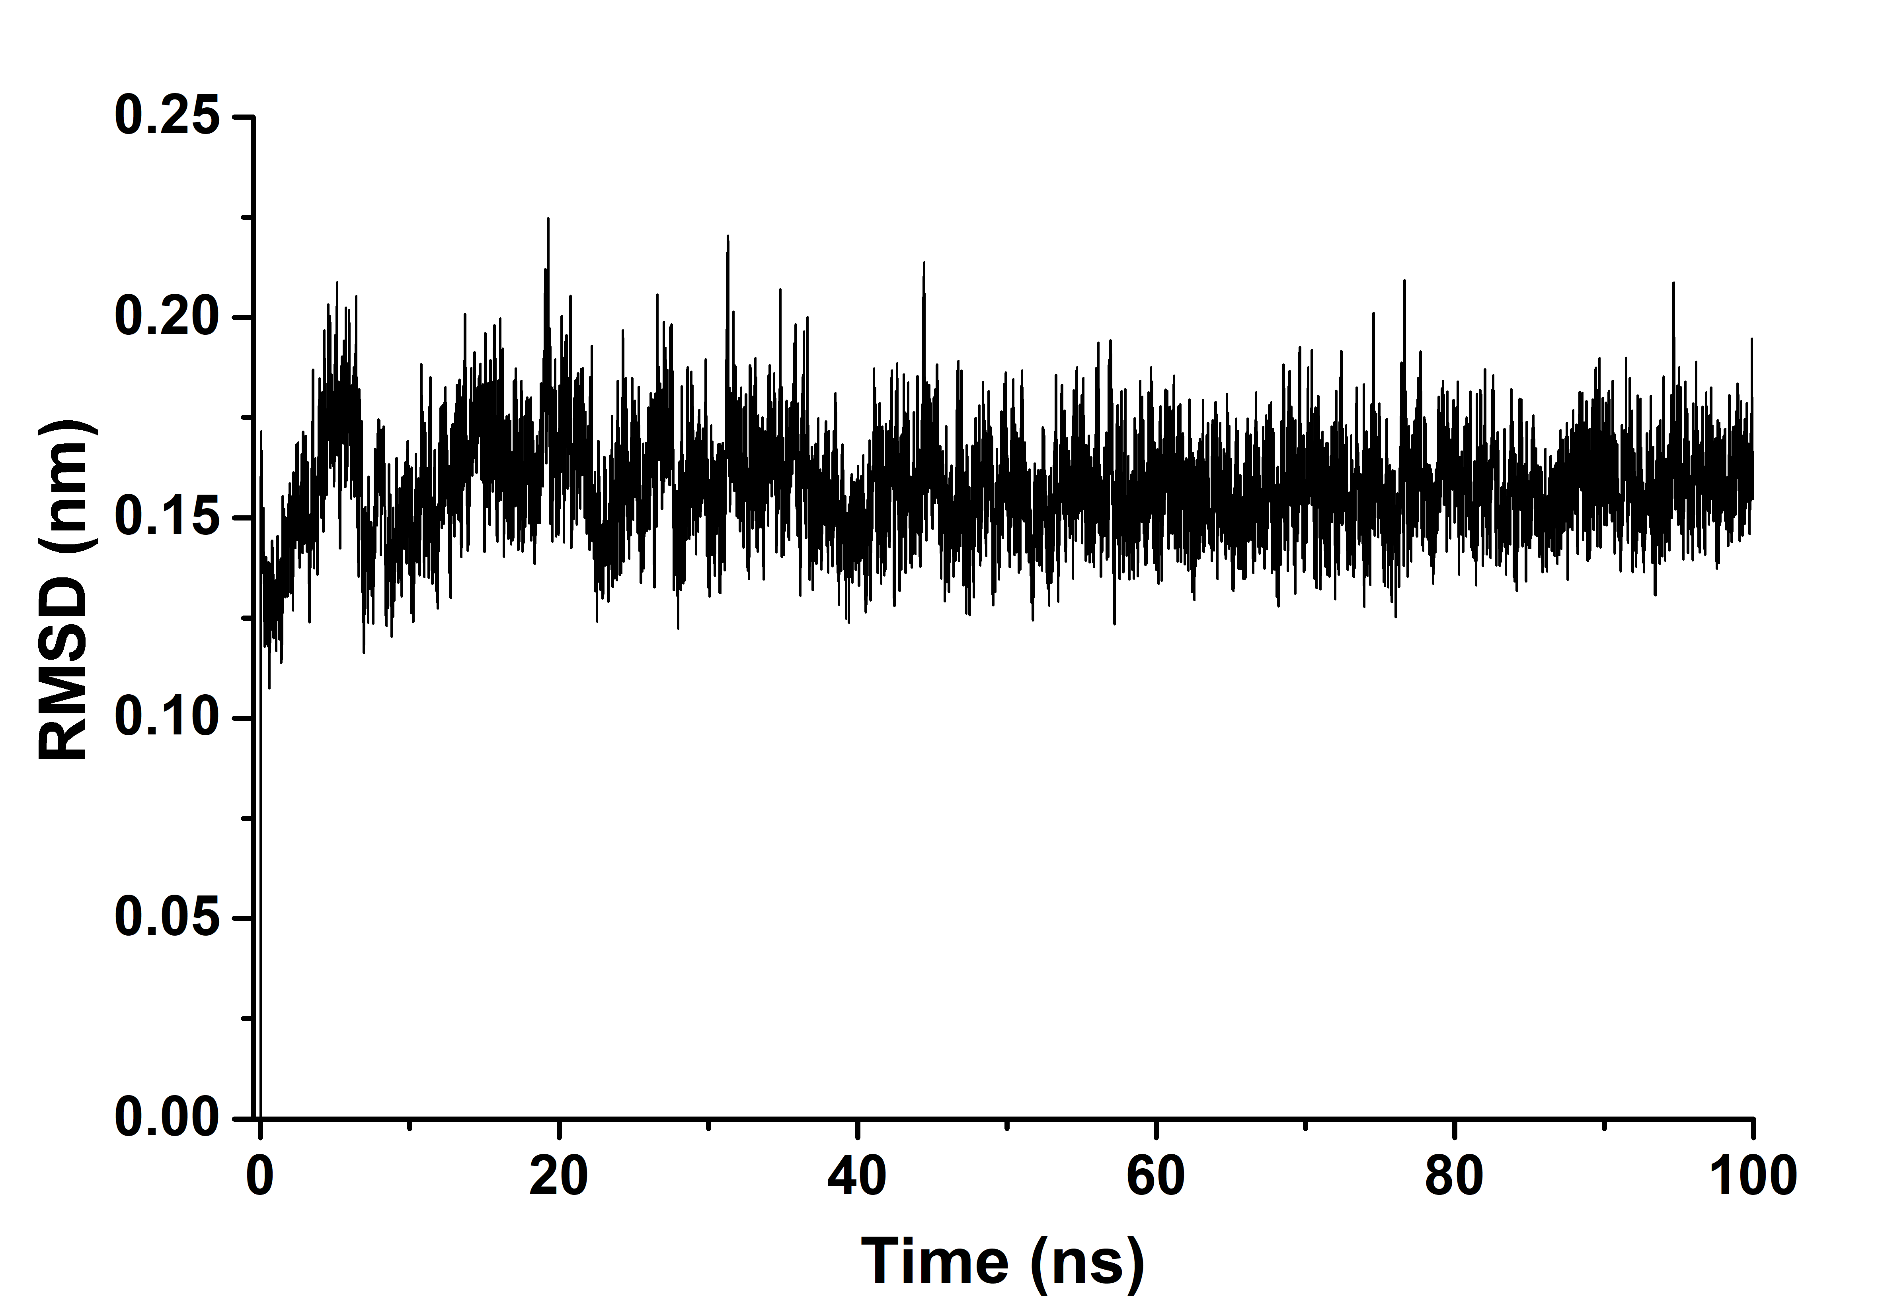

**Figure S2 Protein Backbone RMSD curve of the RBD-CV-N complex.** The backbone RMSD of the RBD-CV-N complex is drawn after a duration of 100 ns that reveals the stable nature of the complex throughout the course of simulation.