**Supporting Information/materials**

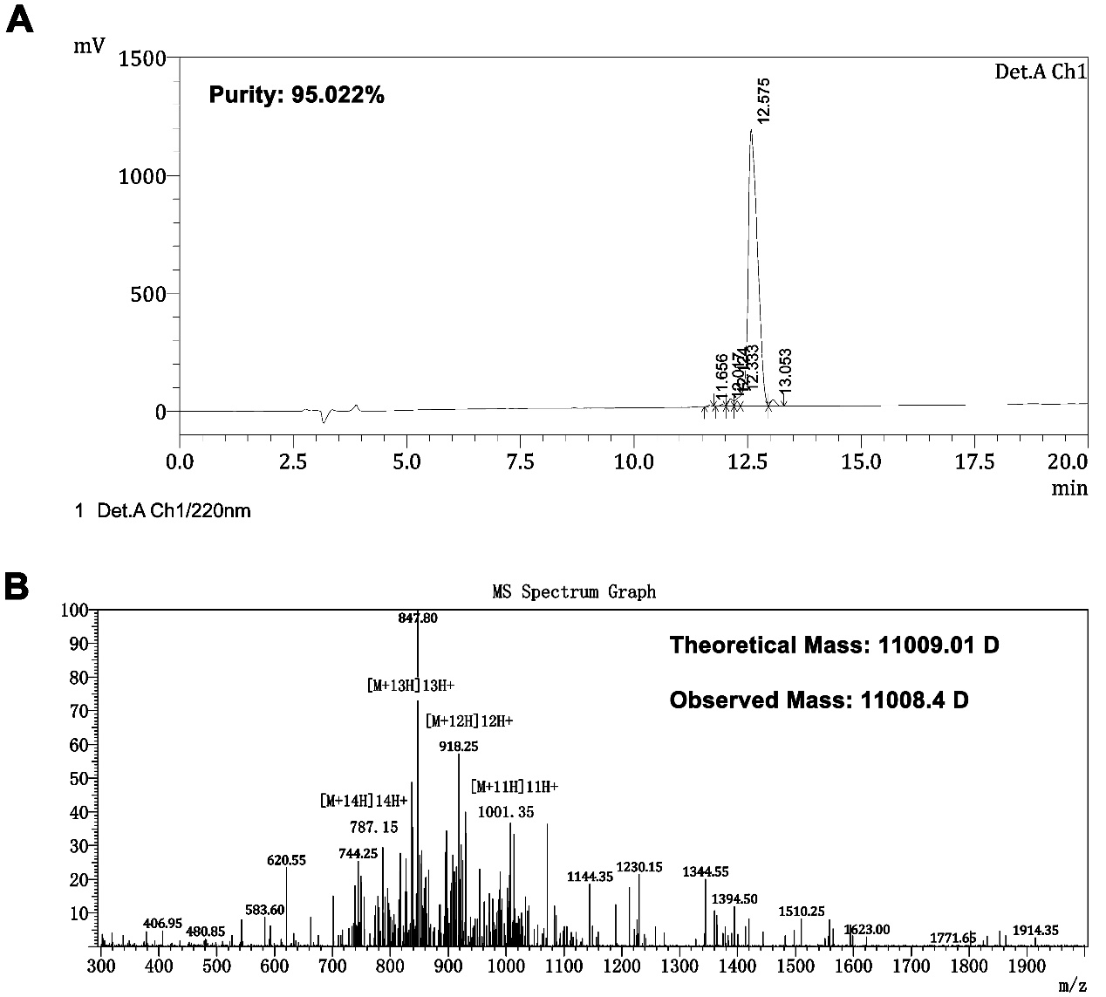

**Figure S1 Purity and molecular mass of CV-N.** (A) The chromatographic data was obtained at 40˚C on a Phenomenex/Luna C18 (2) column (5 µm, 4.6 × 150 mm) applying a linear gradient of 20-40% buffer B (buffer A: 0.1% trifluoroacetic acid in water; buffer B: 0.09% trifluoroacetic acid in (80% acetonitrile plus 20% water)) at a flow rate of 1 mL/min over 20 min. (B) The molecular mass was measured by electrospray ionization mass spectrometry (Chiron Mimotopes, Victoria, Australia).

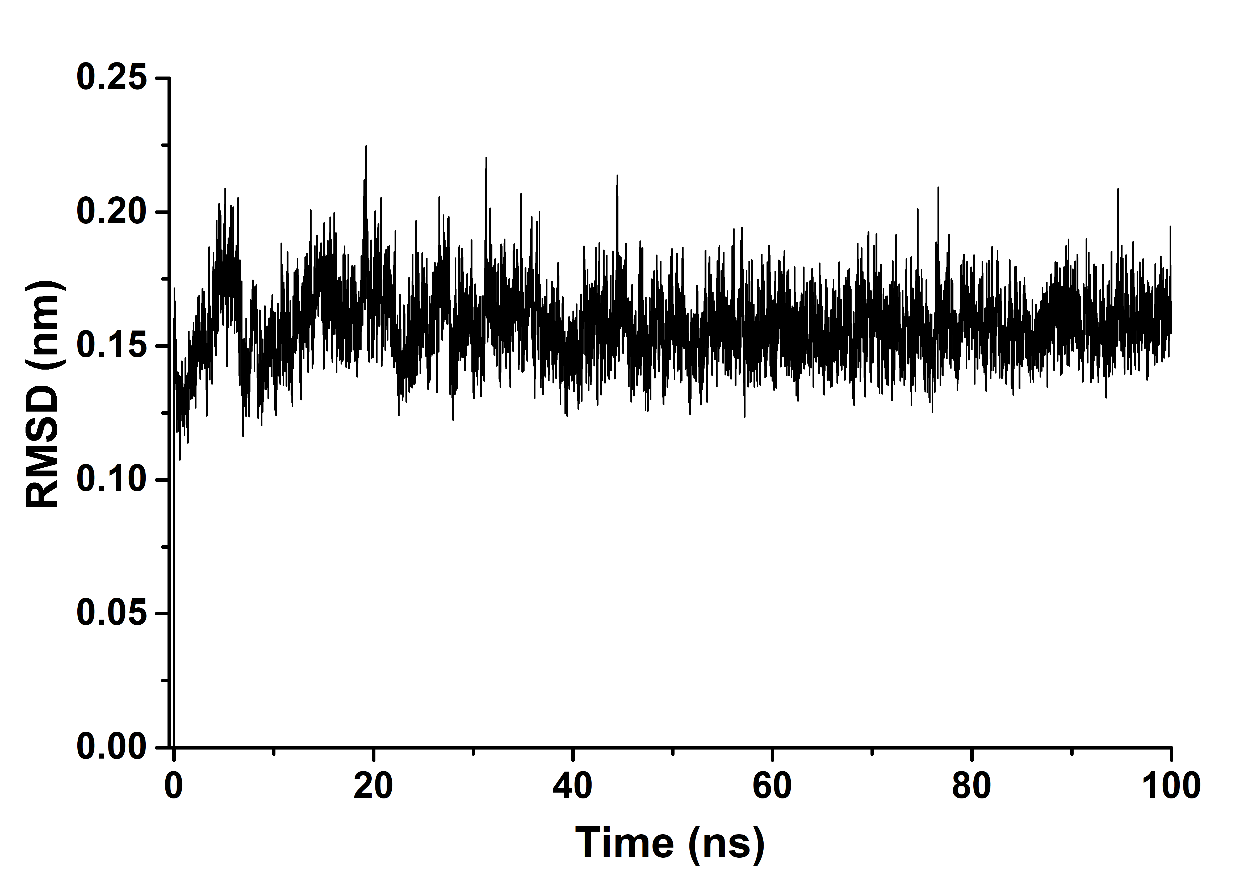

**Figure S2 Protein Backbone RMSD curve of the RBD-CV-N complex.** The backbone RMSD of the RBD-CV-N complex is drawn after a duration of 100 ns that reveals the stable nature of the complex throughout the course of simulation.

**Table S1 The Antiviral peptides selected for drug screening**

|  |  |  |  |  |
| --- | --- | --- | --- | --- |
| **No.** | **AVP ID** | **PDB ID** | **Designation** | **Source** |
| 1 | AP00013 | 1VM5 | Aurein 1.2 | Frog |
| 2 | AP00026 | 1LFC | Lactoferricin B | Bos Taurus |
| 3 | AP00028 | 1RPB | Tricyclic Peptide RP 71955 | Actinomycete Sp9440 |
| 4 | AP00029 | 1F0F | Cecropin a-magainin 2 | Synthetic |
| 5 | AP00060 | [6HZ2](http://www.rcsb.org/structure/6HZ2) | Maximin 3 | Chinese Red Belly Toad |
| 6 | AP00061 | 2MHW | Maximin 4 | Chinese Red Belly Toad |
| 7 | AP00094 | 2MAA | Temporin A | Frog |
| 8 | AP00095 | 6GIL | Temporin B | Frog |
| 9 | AP00102 | 8TFV | Thanatin | Podisus Maculiventris |
| 10 | AP00144 | 2MAG | Magainin 2 | Frog |
| 11 | AP00146 | 2MLT | Melittin | Apis Mellifera |
| 12 | AP00150 | 1G89 | Indolicidin | Bos Taurus |
| 13 | AP00160 | 2DD6 | Dermaseptin-S4 | Frog |
| 14 | AP00176 | 3GNY | Human neutrophil peptide-1 | Human |
| 15 | AP00178 | 1DFN | Human neutrophil peptide-3 | Human |
| 16 | AP00179 | 1ZMM | Human neutrophil peptide-4 | Human |
| 17 | AP00180 | 1ZMP | Human defensin-5 | Human |
| 18 | AP00180 | 4RBX | E21R-HD5 | Human |
| 19 | AP00181 | 1ZMQ | Human defensin-6 | Human |
| 20 | AP00195 | 1PG1 | Protegrin-1 | Pig |
| 21 | AP00211 | 1RKK | Polyphemusin I | Limulus Polyphemus |
| 22 | AP00214 | 1WO1 | Tachyplesin I | Carcinoscorpius Rotundicauda |
| 23 | AP00218 | 2MUH | protegrin-2 | Pig |
| 24 | AP00219 | 2MZ6 | protegrin-3 | Pig |
| 25 | AP00221 | 2NC7 | protegrin-5 | Pig |
| 26 | AP00274 | 1BH4 | Circulin A | Chassalia Parviflora |
| 27 | AP00275 | 2ERI | Circulin B | Chassalia Parviflora |
| 28 | AP00283 | 1KJ6 | Human beta-defensin 3 | Human |
| 29 | AP00333 | 2EEM | Mytilin | Mytilus Edulis |
| 30 | AP00366 | 2KET | Cathelicidin-6, Bmap-27 | Bos Taurus |
| 31 | AP00399 | 1ZRV | Spinigerin | Pseudacanthotermes Spiniger |
| 32 | AP00445 | 2LYF | reptilian theta-defensin 1 | Rhesus Monkey |
| 33 | AP00451 | 1E4S | Human beta-defensin 1 | Human |
| 34 | AP00473 | 2JOS | Piscidin | Morone Saxatilis |
| 35 | AP00474 | 2MCX | Piscidin 3 | Morone Saxatilis |
| 36 | AP00499 | 1MAG | Gramicidin A | Bacillus Brevis |
| 37 | AP00524 | 1FD3 | Human beta-defensin 2 | Human |
| 38 | AP00549 | 1ZFU | Plectasin | Pseudoplectania Nigrella |
| 39 | AP00708 | 2L5M | Gf-17 | Ll37 Derivative |
| 40 | AP00729 | 4TTM | Kalata B1 | Oldenlandia Affinis |
| 41 | AP00730 | 1K48 | Kalata B1 | Oldenlandia Affinis |
| 42 | AP01010 | 2PCO | Latarcin-1 | Spider |
| 43 | AP01034 | 1R1F | Palicourein | Plants |
| 44 | AP01049 | 1PT4 | Kalata B2 | Oldenlandia Affinis |
| 45 | AP01065 | 2GJ0 | Cycloviolacin O14 | Viola Odorata |
| 46 | AP01136 | 1YP8 | Tricyclon A | Viola Arvensis |
| 47 | AP01208 | 2LZI | Human theta-defensin 2 | Human Pseudogenes |
| 48 | AP01382 | 2B5B | reptilian defensin | Caretta Caretta |
| 49 | AP01580 | 2REL | R-Elafin | Homo Sapiens |
| 50 | AP02099 | 4A2O | Eosinophil Cationic Protein | Human |
| 51 | AP02130 | 2QT4 | Scytovirin | Cyanobacterium |
| 52 | AP02131 | 2EZM | Cyanoviran-N | Nostoc Ellipsosporum |

**Table S2. Comparison of Binding Energy Components (kJ/mol) Obtained from MM-PBSA**

|  |  |  |  |  |  |  |  |  |  |  |  |  |
| --- | --- | --- | --- | --- | --- | --- | --- | --- | --- | --- | --- | --- |
| **No.** | **PDB ID** | **ΔG_binding** | **error** | **ΔE_binding** | **ΔE_vdw** | **error** | **ΔE_ele** | **error** | **ΔE_p** | **error** | **ΔE_np** | **error** |
| 1 | 2EZM | -356.979 | 4.704 | -978.880 | -343.715 | 0.974 | -635.165 | 1.826 | 921.945 | 3.616 | -300.140 | 3.792 |
| 2 | 1PT4 | -332.539 | 2.864 | -356.963 | -224.632 | 0.797 | -132.331 | 0.868 | 186.635 | 1.314 | -162.183 | 2.424 |
| 3 | 2MHW | -300.683 | 6.678 | -405.262 | -320.538 | 3.167 | -84.724 | 8.505 | 349.529 | 9.073 | -245.021 | 4.793 |
| 4 | 4TTM | -274.229 | 9.220 | -311.712 | -222.660 | 3.091 | -89.052 | 4.180 | 237.185 | 4.725 | -200.051 | 5.045 |
| 5 | 1YP8 | -262.039 | 3.443 | -307.196 | -197.147 | 1.190 | -110.049 | 1.679 | 219.023 | 2.328 | -173.894 | 2.811 |
| 6 | 1K48 | -242.816 | 7.303 | -247.208 | -206.316 | 1.498 | -40.892 | 1.801 | 160.320 | 6.318 | -155.049 | 5.190 |
| 7 | 6HZ2 | -206.814 | 7.075 | -305.480 | -273.445 | 3.538 | -32.035 | 4.569 | 353.076 | 6.895 | -254.648 | 5.350 |
| 8 | 6GIL | -154.973 | 8.299 | -317.241 | -176.166 | 5.636 | -141.075 | 11.208 | 319.838 | 16.821 | -157.282 | 6.705 |
| 9 | 1BH4 | -122.971 | 7.039 | -157.448 | -258.677 | 2.154 | 101.229 | 3.269 | 243.173 | 4.689 | -209.000 | 5.541 |
| 10 | 2JOS | -100.214 | 6.996 | -324.596 | -317.001 | 3.454 | -7.595 | 6.389 | 501.106 | 8.211 | -276.615 | 5.533 |
| 11 | 3GNY | -97.290 | 4.065 | -208.375 | -226.341 | 2.232 | 17.966 | 1.311 | 319.775 | 3.099 | -208.907 | 3.555 |
| 12 | 1VM5 | -96.676 | 5.490 | -349.296 | -153.344 | 3.227 | -195.952 | 2.086 | 385.156 | 3.526 | -132.566 | 4.436 |
| 13 | 1ZMQ | -86.549 | 5.917 | -223.334 | -285.854 | 1.357 | 62.520 | 3.131 | 375.619 | 3.646 | -239.057 | 5.352 |
| 14 | 2REL | -85.850 | 11.692 | -275.107 | -297.081 | 2.825 | 21.974 | 5.318 | 435.873 | 9.247 | -247.043 | 7.064 |
| 15 | 2QT4 | -81.626 | 9.606 | -221.314 | -334.999 | 2.084 | 113.685 | 3.452 | 411.775 | 6.396 | -272.300 | 8.099 |
| 16 | 2MCX | -74.161 | 5.129 | -31.148 | -296.394 | 1.920 | 265.246 | 4.784 | 198.069 | 6.012 | -240.900 | 5.168 |
| 17 | 1ZMM | -71.007 | 6.711 | -224.548 | -256.072 | 2.362 | 31.524 | 5.125 | 366.299 | 7.049 | -213.084 | 5.629 |
| 18 | 2MAA | -55.516 | 6.454 | -206.588 | -121.906 | 2.217 | -84.682 | 5.425 | 261.462 | 9.087 | -110.624 | 4.167 |
| 19 | 2ERI | -51.302 | 7.525 | -205.241 | -155.401 | 2.819 | -49.840 | 9.541 | 276.288 | 11.898 | -123.054 | 4.669 |
| 20 | 2MAG | -44.669 | 10.855 | -50.162 | -219.482 | 2.240 | 169.320 | 8.432 | 185.939 | 6.488 | -180.956 | 5.461 |
| 21 | 1MAG | -23.351 | 4.577 | -234.656 | -101.824 | 0.910 | -132.832 | 3.066 | 292.405 | 6.387 | -81.555 | 2.045 |
| 22 | 1DFN | -22.755 | 9.654 | -145.357 | -138.856 | 6.247 | -6.501 | 5.666 | 225.725 | 13.142 | -102.965 | 7.691 |
| 23 | 1ZMP | -5.056 | 3.275 | -321.667 | -212.545 | 1.912 | -109.122 | 3.745 | 513.871 | 6.368 | -197.390 | 2.952 |
| 24 | 1G89 | -3.720 | 8.359 | -253.884 | -168.039 | 2.092 | -85.845 | 6.308 | 405.011 | 6.081 | -154.861 | 6.799 |
| 25 | 215M | 2.939 | 6.669 | 10.272 | -191.006 | 2.428 | 201.278 | 8.622 | 153.264 | 6.731 | -160.548 | 4.586 |
| 26 | 1ZFU | 13.676 | 8.808 | -21.839 | -126.883 | 1.709 | 105.044 | 3.191 | 132.812 | 7.510 | -96.475 | 5.597 |
| 27 | 1R1F | 20.510 | 12.762 | -14.724 | -0.056 | 0.027 | -14.668 | 0.296 | 6.162 | 1.676 | 28.912 | 13.221 |
| 28 | 1RPB | 22.158 | 8.330 | -18.161 | -0.353 | 0.019 | -17.808 | 0.536 | 38.817 | 3.670 | 1.853 | 7.888 |
| 29 | 2LZI | 22.522 | 5.394 | -159.836 | -247.914 | 1.020 | 88.078 | 3.744 | 372.089 | 4.429 | -189.378 | 3.730 |
| 30 | 1PG1 | 35.058 | 5.731 | -54.856 | -279.383 | 3.067 | 224.527 | 8.799 | 353.306 | 11.498 | -262.682 | 5.998 |
| 31 | 1E4S | 45.808 | 4.181 | -61.936 | -227.639 | 1.369 | 165.703 | 1.438 | 292.209 | 4.187 | -184.418 | 2.464 |
| 32 | 2MLT | 54.621 | 7.563 | -59.764 | -224.941 | 2.281 | 165.177 | 6.105 | 329.615 | 6.465 | -214.951 | 5.734 |
| 33 | 1RKK | 65.714 | 6.613 | -70.751 | -325.656 | 2.724 | 254.905 | 5.093 | 406.024 | 3.681 | -269.351 | 5.584 |
| 34 | 2GJ0 | 78.989 | 7.594 | -146.564 | -159.145 | 4.145 | 12.581 | 5.631 | 357.177 | 6.687 | -131.851 | 5.096 |
| 35 | 1ZRV | 81.203 | 8.526 | -68.255 | -206.392 | 1.479 | 138.137 | 4.319 | 322.131 | 6.409 | -171.666 | 5.509 |
| 36 | 8TFV | 97.347 | 5.982 | 51.038 | -210.972 | 1.146 | 262.010 | 2.675 | 259.632 | 4.815 | -212.964 | 4.009 |
| 37 | 1FD3 | 104.645 | 4.613 | 80.815 | -220.427 | 1.278 | 301.242 | 2.421 | 224.448 | 3.450 | -200.740 | 2.751 |
| 38 | 2DD6 | 105.644 | 11.066 | 100.528 | -0.002 | 0.000 | 100.530 | 0.453 | 15.322 | 4.992 | -10.268 | 10.884 |
| 39 | 2MUH | 121.418 | 6.800 | -10.368 | -111.402 | 1.098 | 101.034 | 2.455 | 242.433 | 4.681 | -110.325 | 5.284 |
| 40 | 2KET | 122.191 | 8.637 | -46.652 | -212.506 | 2.281 | 165.854 | 5.321 | 343.250 | 7.756 | -174.394 | 7.195 |
| 41 | 2MZ6 | 124.292 | 7.751 | -7.248 | -242.489 | 1.953 | 235.241 | 2.966 | 313.515 | 4.997 | -182.114 | 4.472 |
| 42 | 2NC7 | 138.859 | 8.385 | -118.880 | -135.675 | 1.578 | 16.795 | 5.118 | 369.058 | 7.887 | -110.967 | 5.141 |
| 43 | 2B5B | 159.022 | 8.239 | 135.742 | -102.711 | 1.052 | 238.453 | 3.086 | 122.082 | 4.203 | -98.588 | 6.785 |
| 44 | 4RBX | 198.244 | 8.889 | -54.261 | -162.890 | 1.565 | 108.629 | 3.403 | 379.850 | 6.673 | -127.075 | 5.689 |
| 45 | 2EEM | 207.975 | 10.105 | 18.529 | -257.192 | 1.729 | 275.721 | 8.763 | 434.919 | 12.015 | -245.971 | 5.588 |
| 46 | 1WO1 | 214.108 | 8.239 | 80.147 | -193.872 | 2.941 | 274.019 | 5.901 | 301.502 | 5.488 | -167.613 | 5.843 |
| 47 | 1F0F | 223.056 | 8.772 | 127.877 | -216.738 | 3.630 | 344.615 | 7.062 | 293.303 | 9.399 | -198.756 | 5.518 |
| 48 | 21YF | 241.452 | 8.414 | 154.491 | -109.917 | 1.274 | 264.408 | 3.961 | 198.140 | 7.920 | -111.403 | 5.327 |
| 49 | 1LFC | 294.061 | 9.059 | 59.462 | -129.055 | 1.497 | 188.517 | 5.252 | 340.321 | 5.793 | -107.107 | 6.560 |
| 50 | 2PCO | 340.777 | 8.026 | 225.045 | -213.049 | 1.611 | 438.094 | 3.912 | 287.393 | 4.608 | -172.186 | 5.604 |
| 51 | 4A2O | 386.657 | 7.641 | 295.513 | -235.978 | 1.711 | 531.491 | 3.852 | 280.704 | 3.476 | -188.856 | 7.058 |
| 52 | 1KJ6 | 404.194 | 6.620 | 255.844 | -218.482 | 2.011 | 474.326 | 4.852 | 348.534 | 4.110 | -200.315 | 3.997 |