**Name: Maddikunta Dakshyani**

**Student Id: 700666204**

**Code:**

**https://github.com/dxm62040ucm/Assignment8/blob/main/Autoencoders.ipynb**

**Video:**

**https://drive.google.com/file/d/14nIhI-O0N0Y8N-QZm4hWHkzjH4WbTfxT/view?usp=drive_link**

Intially Fetching the AutoEncoders Information.

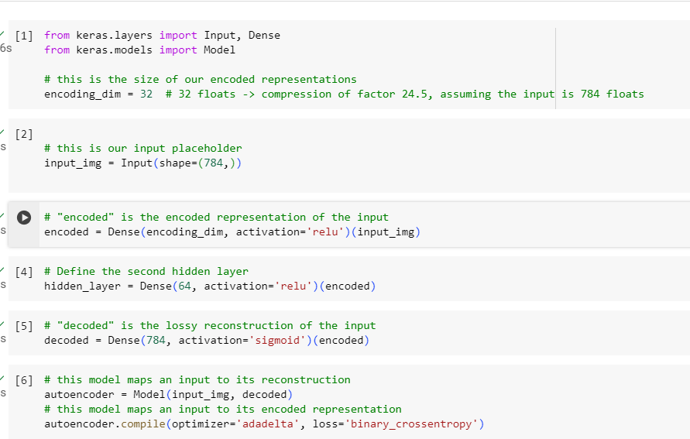

1. Add one hidden layer to autoencoder and Applyed one more Hidden Layer on Encoded data.

Dividing the data into test and train data.

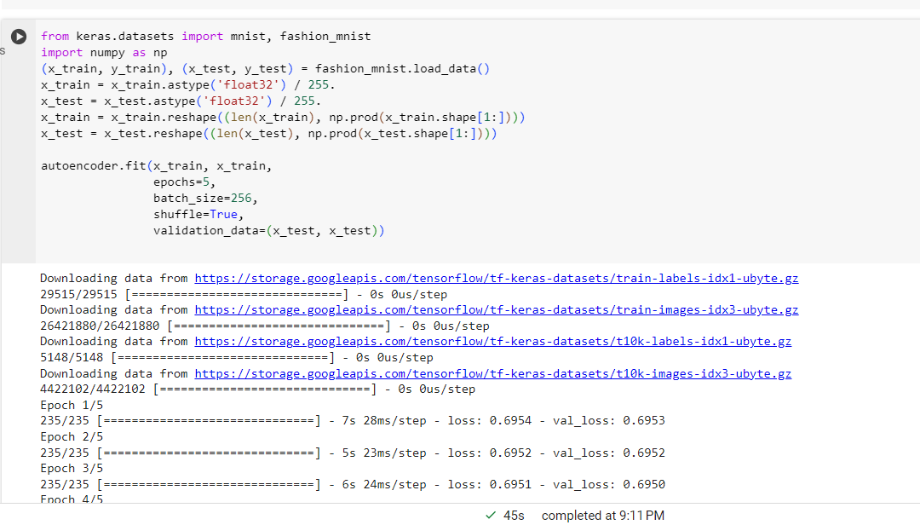

2. Do the prediction on the test data and then visualize one of the reconstructed version of that test data. Also, visualize the same test data before reconstruction using Matplotlib

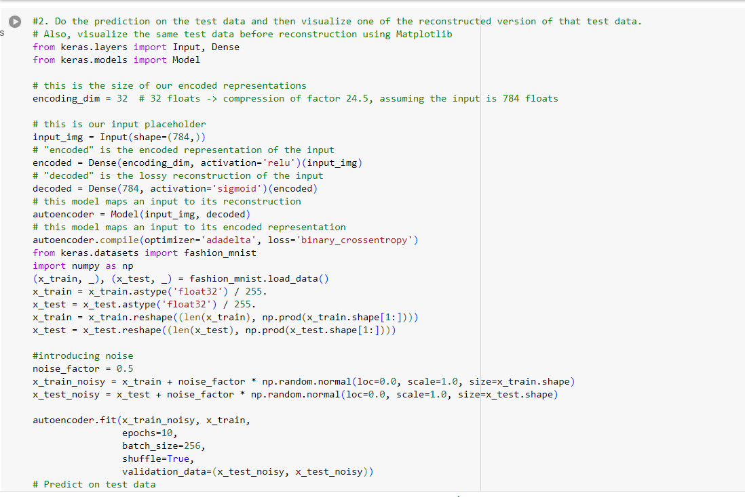

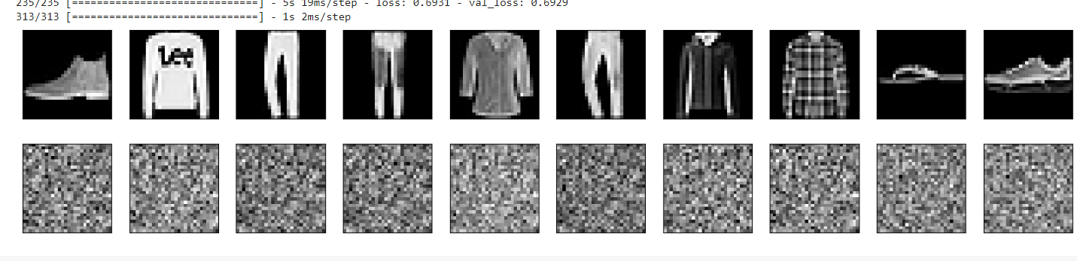

3. Repeat the question 2 on the denoisening autoencoder

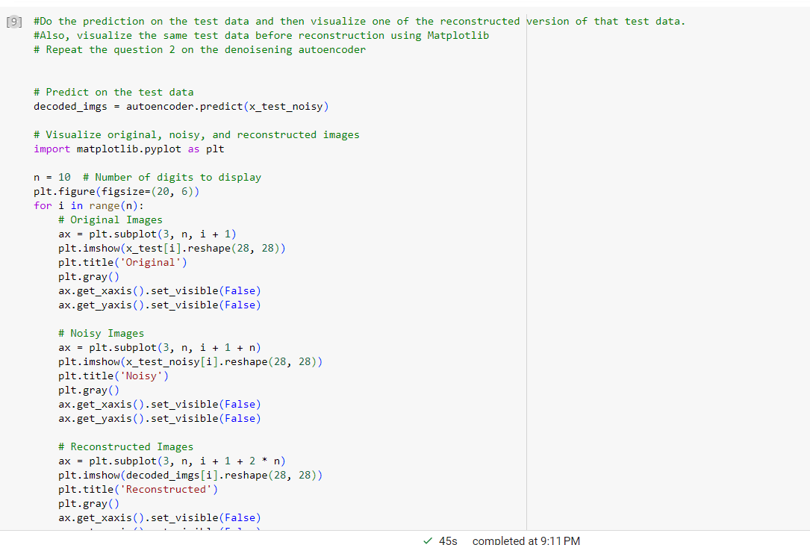

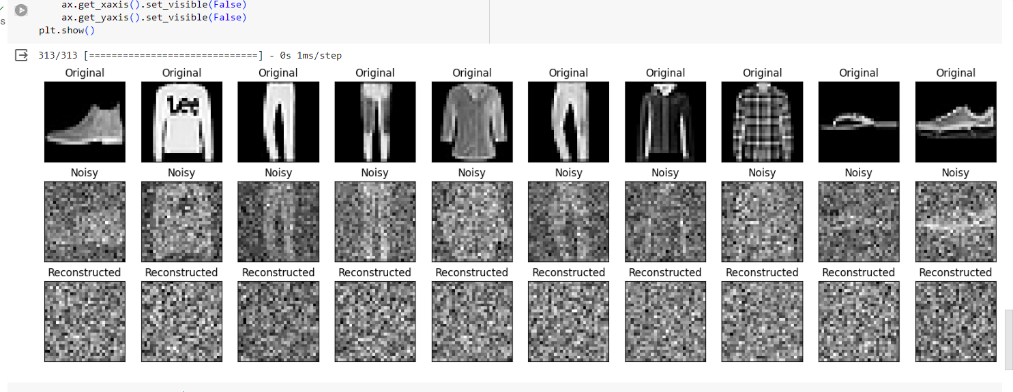

4. plot loss and accuracy using the history object

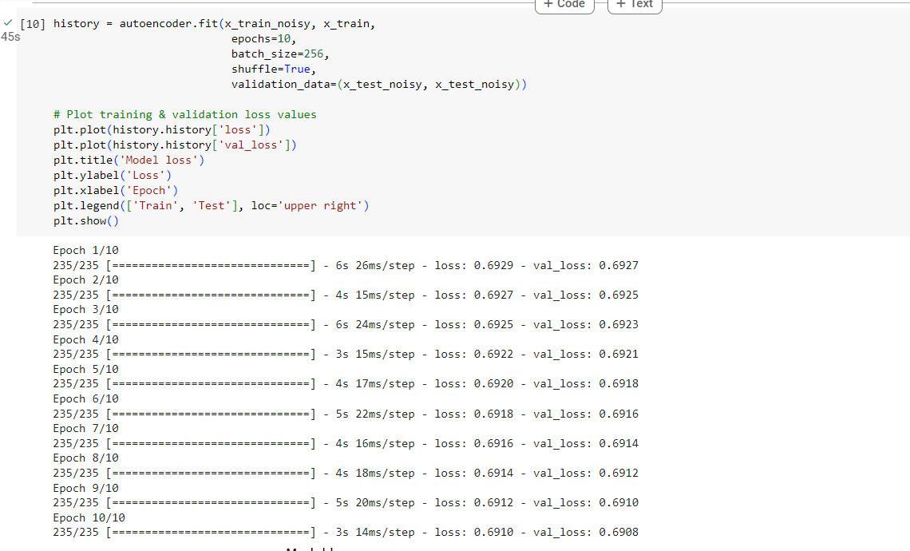

Below Matplot Explains the History of the d enoisening autoencoder data.

