Diet Manager/ version 1

Project Design Document

G2

Adam Jozic <aj2201@rit.edu>

Zvonimir Tancinec <zt2958@rit.edu>

Dora Beronico <[db3901@rit.edu](mailto:db3901@rit.edu)>

Dominik Maric<[dxm8969@rit.edu](mailto:dxm8969@rit.edu)>

Zadro Ljubo<zl4619[@rit.edu](mailto:dxm8969@rit.edu)>

# 

# Project Summary

This project consists of an application in which a user enters what he/she ate. The application calculates how many calories, proteins, etc. the person ate.

The application has some predefined foods, however, the user can enter new food and its data. The application also helps the user to keep track not only of his/her food intake but also their weight.

# Design Overview

# The first design sketch did not have the Controller class and the FoodFactory class. We separated the View class into View and Controller, this way we reinforce the separation of concerns principle.

# Also, we added the FoodFactory class this way we use the simple factory pattern which supports a program to interface not implementation, separation of concerns and DRY principles.

# We also created a Food interface to store both recipes and basic food items so they could be stored in a single collection which is Foods.

# This design sketch did not specify how to reach basic food items inside the recipe therefore we implemented a composite pattern and made recipes collection of recipes and BasicFood.

# System Structure

# Subsystems

## **Subsystem FoodManagment**

|  |  |
| --- | --- |
| **Class** Foods | |
| **Responsibilities** | Supports access to BasicFood and Recipes in the collection.  Add, load, save and delete.  Provides a virtual collection for the entire FoodItem/ Recipe collections. |
| **Collaborators**  **(uses)** | Food - the basic type for all different media in the collection. |

|  |  |
| --- | --- |
| **Class** Food (interface) | |
| **Responsibilities** | Stores common methods of BasicFood and Recipe |

|  |  |
| --- | --- |
| **Class** FoodFactory | |
| **Responsibilities** | Creates new BasicFood or Recipe and stores it in Foods |
| **Collaborators** | Food - stores created items  ResourceHandler - provides the data for creating new Objects. |

|  |  |
| --- | --- |
| **Class** BasicFood | |
| **Responsibilities** | Represents a BasicFood in the collection.  Provides access to food name, calories, fat, carb, protein for the BasicFood. |
| **Collaborators (inheritance)** | Food |
| **Class** Recipe | |
| **Responsibilities** | Represents a Recipe in the collection.  Provides access to data from Recipe and BasicFood’.  Stores a collection of subRecipe and FoodItems. |
| **Collaborators (inheritance)** | Food |

# 

## **Subsystem View**

|  |  |
| --- | --- |
| **Class** View | |
| **Responsibilities** | Displays the UI to the user.  Sends user input to the Controller.  Displays data Controller returned. |
| **Collaborators**  **(uses)** | Controller - to get data from the model |

# 

# 

# 

# Subsystem Controller

|  |  |
| --- | --- |
| **Class** Controller | |
| **Responsibilities** | Sends a collection of data from the intake IntakeManagement sends it to the view.  Gets data and selected Food from FoodManagement.  Sends new food to ResourceHandler. |
| **Collaborators**  **(uses)** | IntakeManagement  FoodManagment  ResourceHandler |

# 

# 

# 

# 

# Subsystem ResourceHandler

|  |  |
| --- | --- |
| **Class** Controller | |
| **Responsibilities** | Sends a collection of data from the intake IntakeManagement sends it to the view.  Gets data and selected Food from IntakeManagement.  Sends new food to ResourceHandler. |
| **Collaborators**  **(uses)** | IntakeManagement  FoodManagment  ResourceHandler |

# 

# 

# 

# Subsystem IntakeManagement

|  |  |
| --- | --- |
| **Class** DailyIntake | |
| **Responsibilities** | Stores collection of all Intake entries.  Calculates sum of calories, carbs, proteins, etc. |
| **Collaborators**  **(uses)** | Intake  Controller |

|  |  |
| --- | --- |
| **Class** Intake | |
| **Responsibilities** | Stores collection of all Food from a single entry. |
| **Collaborators**  **(uses)** | DailyIntake  Food |

# 

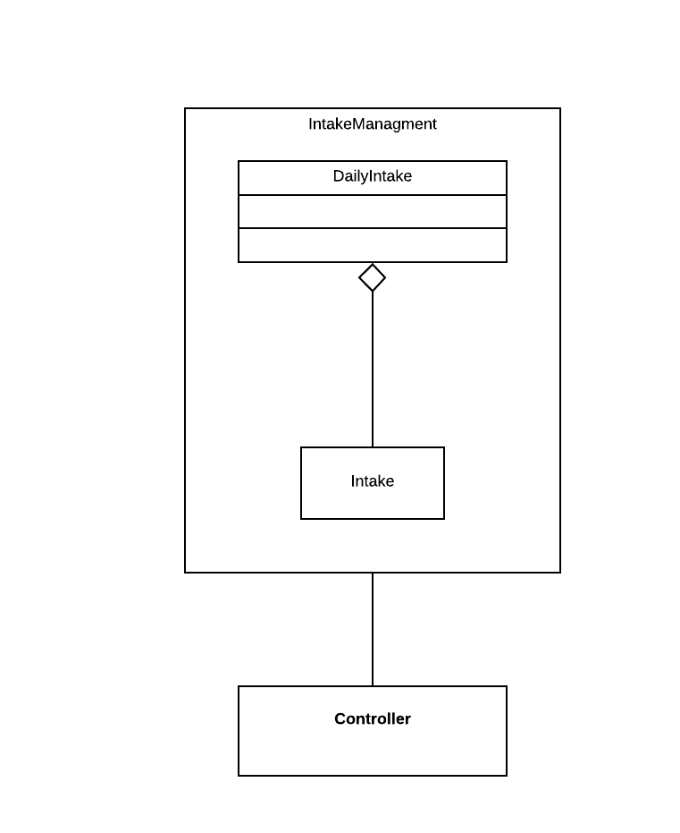

# Sequence Diagrams

**Creating a New BasicFood Sequence Diagram**

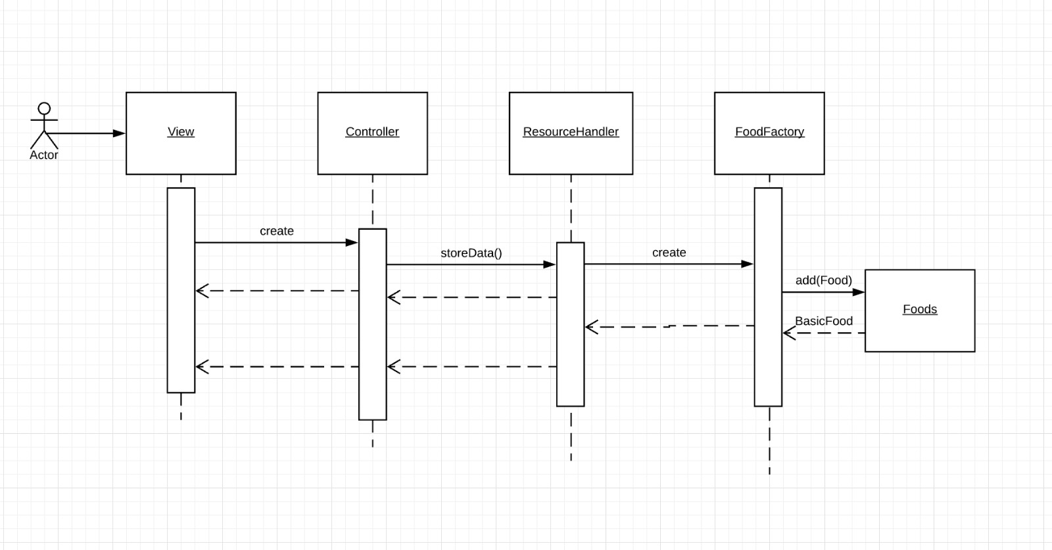

**Getting Number of Calories Sequence Diagram**

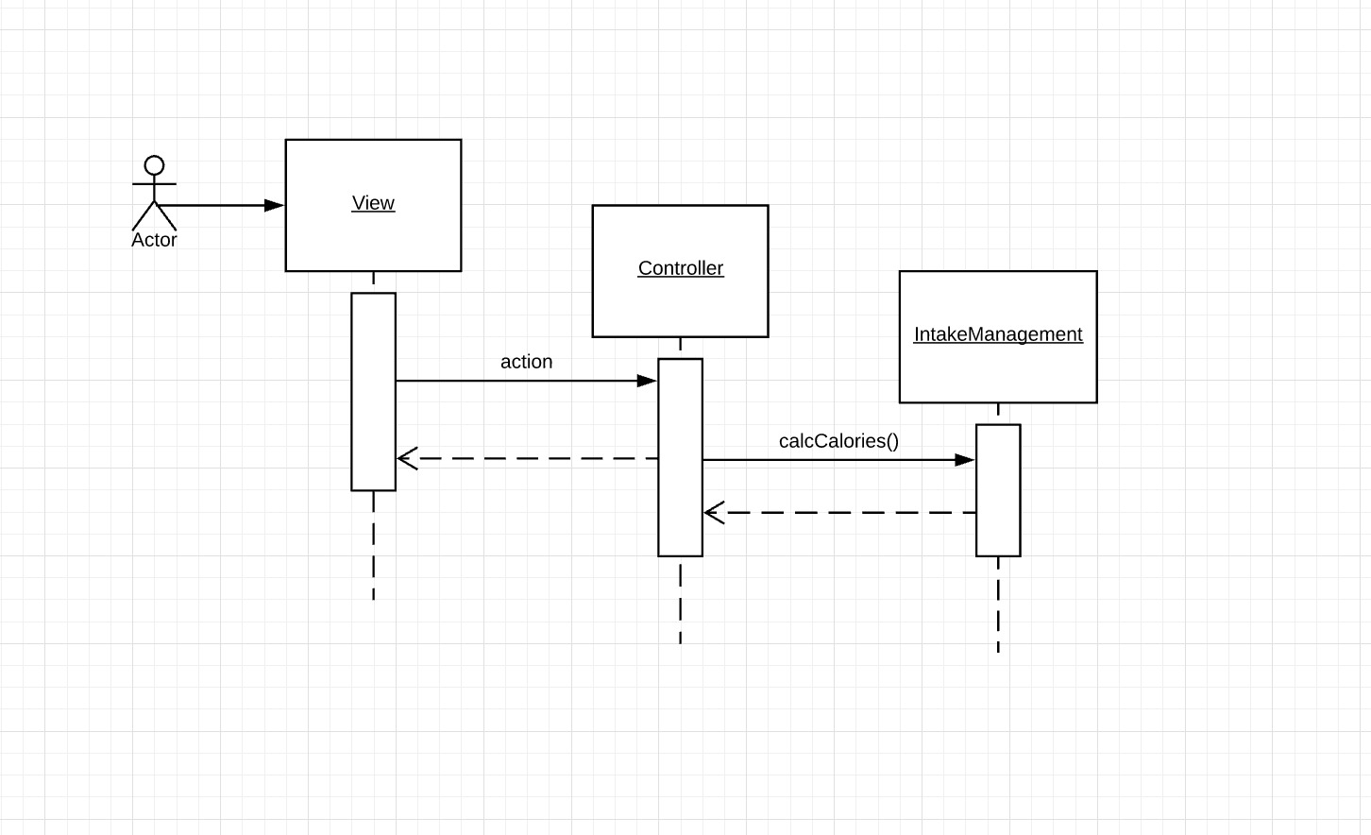

**Getting Data Sequence Diagram**

# Pattern Usage

## **Pattern #1 Simple Factory Pattern**

|  |  |
| --- | --- |
| **Simple Factory Pattern** | |
| **Simple Factory** | FoodFactory |
| **Interface** | Food |
| **Concrete classes** | BasicFood  Recipe |

## **Pattern #2 Composite Pattern**

|  |  |
| --- | --- |
| **Composite Pattern** | |
| **Primitive object(s)** | BasicFood |
| **Composite object(s)** | Recipe |

## **Pattern #3 MVC Pattern**

|  |  |
| --- | --- |
| **MVC Pattern** | |
| **View** | View |
| **Controller** | Controller |
| **Model** | Foods, DailyIntake |

## **Pattern #4 Singleton Pattern**

|  |  |
| --- | --- |
| **MVC Pattern** | |
| **Singleton** | Foods |