Overview of SEM Oxford X-Ray System Integration with Science Studio
Dylan Maxwell | January 28, 2010

Introduction
The purpose of this document is to describe the proposed modifications to the configuration of the Oxford X-Ray System computer to enable integration with Science Studio. Integrating the Oxford X-Ray System, specifically the INCA software, as a component of Science Studio will allow users to access the system remotely, using the Internet, with a Java enabled Firefox web browser. Although these are minor modifications to the computer, it is important that the operators of the Western Nanofabrication Facility are aware of these changes and agree to them.

Implementation
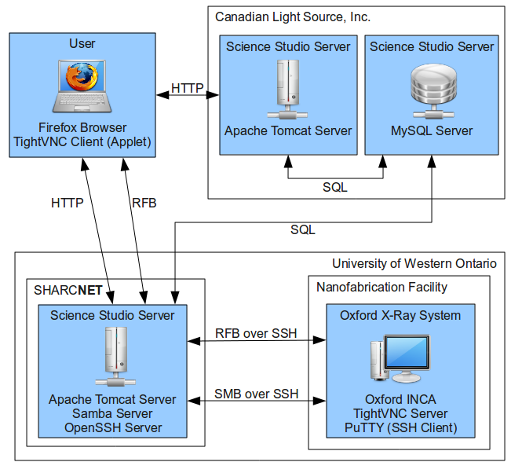

Hardware

Microsoft Loopback Adapter
This component is required to enable Windows File Sharing over SSH Tunnels. This is not a physical device, but simply a software network adapter that provides another loopback interface on which the required ports can be bound to SSH Tunnels. This loopback interface does not provide another connection to the network because by design it is only available from the computer on which it is installed. More Information can be found on the Microsoft Support website. (http://support.microsoft.com/kb/839013)

DemoForge Mirage Driver for TightVNC
This component is optional, but will provide a dramatic improvement in the performance of TightVNC Server on Windows XP. Again, this is not a physical device, but a low level Display Adapter that provides an efficient method for TightVNC to detect which area of the screen needs to be updated, instead of updating the entire screen. This reduces the amount of data that needs to be transferred over the network and allows for a smoother more responsive remote desktop. More information can be found on the DemoForge website. (http://www.demoforge.com/dfmirage.htm)

Software

TightVNC
This software provides Remote Desktop functionality, both server and client, on a variety of platforms, including Windows XP. The standard distribution also includes a Java version of the client that can be embedded into web pages as a Java Applet. The TightVNC Server does not need to be registered as a Windows Service and will only be running when the system is purposefully enabled for remote operation. For more information see the TightVNC website. (http://www.tightvnc.com)

PuTTY
This software is a Secure Shell (SSH) client for Windows XP that allows secure connections to be established between two computers on a network. This is a common, and secure, way to connect computers through firewalls and over untrusted networks. Both the Windows File Sharing and Remote Desktop will operate using these secure connections. For more information visit the PuTTY website. (http://www.chiark.greenend.org.uk/~sgtatham/putty)

New User Account
In order to manage and secure remote access to this computer, it is recommended that a new user account be created on the system specifically for use with Science Studio. This will allow customization of the desktop and restricted privileges to be configured for the remote user.

Installation
These modifications will require administrative access to the Oxford X-Ray System computer and should require no more than two hours to complete.

