PRACTICAL No.-2
AIM:-
Displaying Time over 4-Digit 7-Segment Display using Raspberry Pi
Introduction:-
For displaying small amount of data we prefer to use 4-digit 7-Segment display.
7-Segment and 4-Digit 7-Segment Display Module:
7 Segment Display has seven segments in it and each segment has one LED inside it to display the numbers by lighting up the corresponding segments. Like if you want the 7-segment to display the number "5" then you need to glow segment a, f, g, c, and d by making their corresponding pins high. There are two types of 7-segment displays: Common Cathode and Common Anode, here we are using Common Cathode seven segment display.

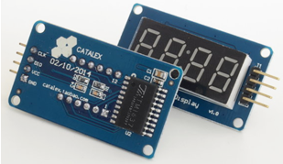
TM1637 4-DIGIT Seven Segment Display

Components Required:-
- Raspberry Pi with Power Supply
- TM1637 4-DIGIT Seven Segment Display
- Jumper wire

Wiring Up the TM1637 4-DIGIT Seven Segment Display:-

TM1637 BOARD PIN | PHYSICAL PIN Number | GPIO PIN Number
CLK | 38 | GPIO 20
DI0 (Data IN) | 40 | GPIO 21
VCC | 2 | DC POWER 5V
GND | 6 | Ground

Circuit Design:-
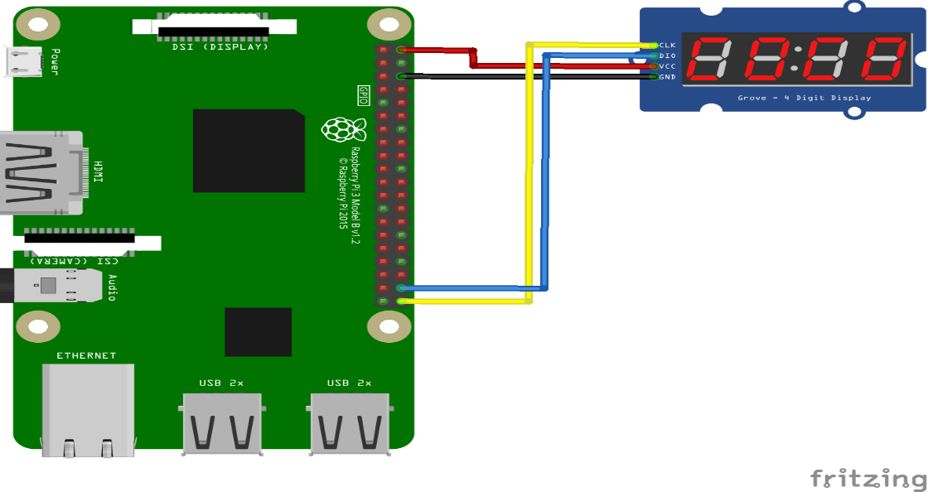

Python Source Code:-
Note:
For Displaying the clock and IP Address on the 4-Digit 7 Segment display we will download the special python scripts with predefine functions.
Various types of operation or function available to control the LED in that scripts.
Steps to Perform 4-Digit 7 Segment Display:-
Step1:
Create Folder under /home/pi/Documents/ 7segment by using following command
mkdir 7segment
Step2:
Download the Following file by using wget command
For Clock
wget https://github.com/timwaizenegger/raspberrypi-examples/blob/master/actor-led-7segment-4numbers/clock.py
For IP Address
wget https://github.com/timwaizenegger/raspberrypi-examples/blob/master/actor-led-7segment-4numbers/displayIP.py

OR

To download this library on to your Raspberry Pi do the following steps:
1. Open the browser on your PC and download a zip from from the given link:
https://github.com/timwaizenegger/raspberrypi-examples/tree/master/actor-led-7segment-4numbers
2. Unzip the file, copy the file on to an usb drive and copy paste the same into the /home/pi/Documents/7segment folder of your RPi.

Step3:
Open the Source Code of clock.py and displayIP.py simultaneous by using Python IDLE (3.5.6) and run the code and see the output.
Source Code:
#For Display the time
from time import sleep
import tm1637
try:
import thread
except ImportError:
import _thread as thread

# Initialize the clock (GND, VCC=3.3V, Example Pins are DIO-20 and CLK21)
Display = tm1637.TM1637(CLK=21, DIO=20, brightness=1.0)
try:
print ("Starting clock in the background (press CTRL + C to stop):")
Display.StartClock(military_time=False)
print ('Continue Python script and tweak Display!')
sleep(5)
Display.ShowDoublepoint(False)
sleep(5)
loops = 3
while loops > 0:
for i in range(0, 10):
Display.SetBrightness(i / 10.0)
sleep(0.5)
loops -= 1
Display.StopClock()
thread.interrupt_main()
except KeyboardInterrupt:
print ("Properly closing the clock and open GPIO pins")
Display.cleanup()

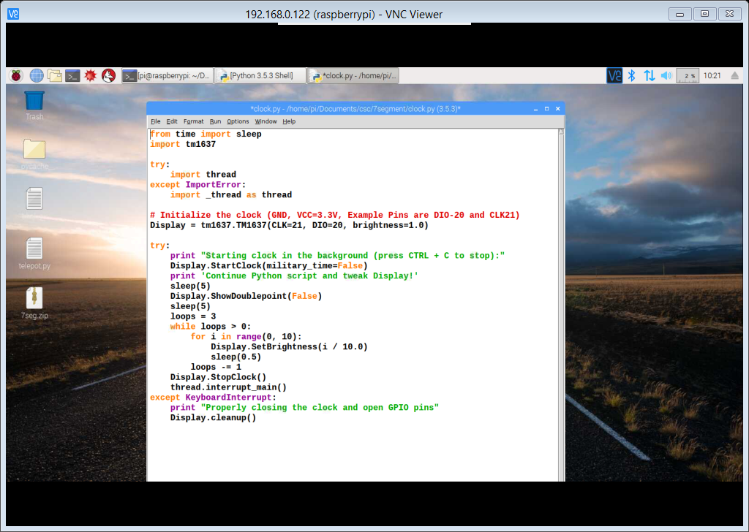

Run the Code:-
sudo python clock.py
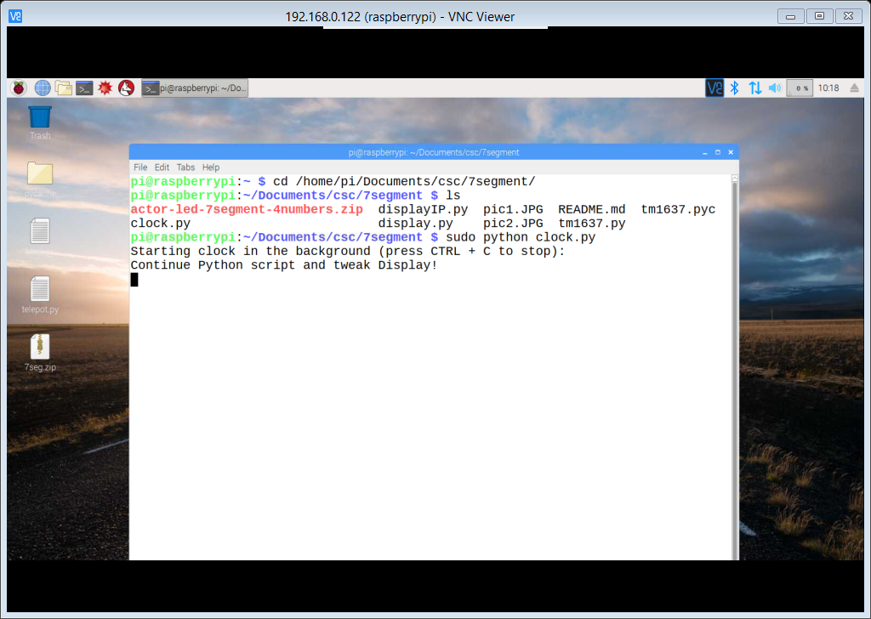
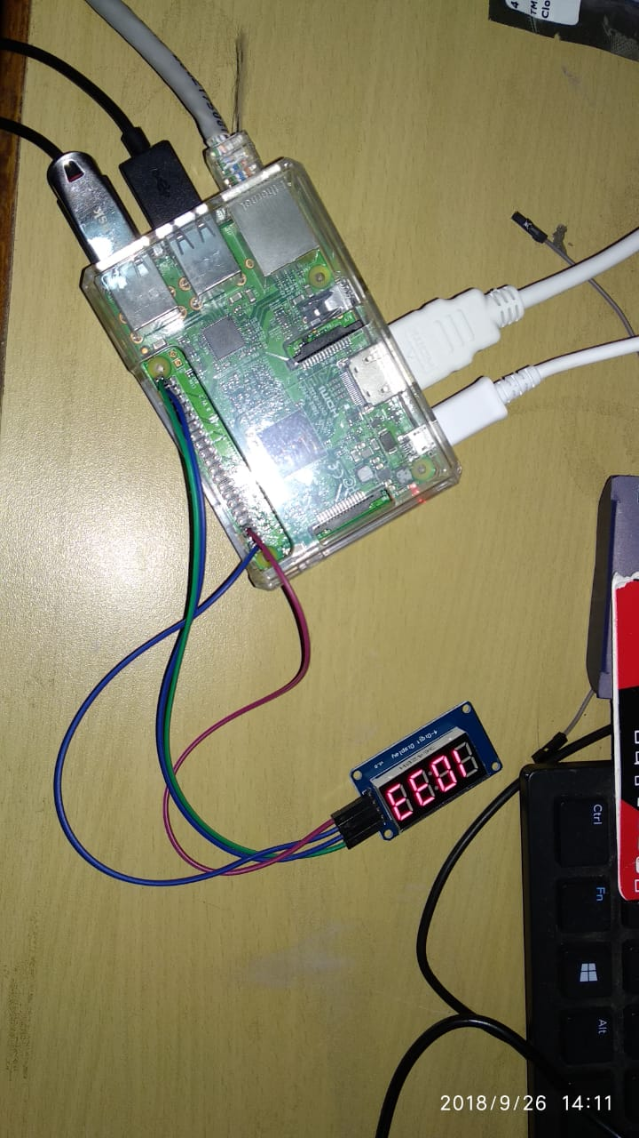

For Displaying IP Address
displayIP.py
import time
import tm1637
import socket

# Initialize the display (GND, VCC=3.3V, Example Pins are DIO-20 and CLK21)
Display = tm1637.TM1637(CLK=21, DIO=20, brightness=0.3)
s = socket.socket(socket.AF_INET, socket.SOCK_DGRAM)
s.connect(("gmail.com", 80))
IP = s.getsockname()[0]
s.close()
print ("IP of RasPi is")
print IP
# Separate on comma.
numbers = IP.split(".")
# Loop and print each city name.
loops = 3
while loops > 0:
for number in numbers:
Display.ShowInt(number)
time.sleep(2)
loops -= 1
Display.Clear()
time.sleep(2)
print('done.')
Display.cleanup()
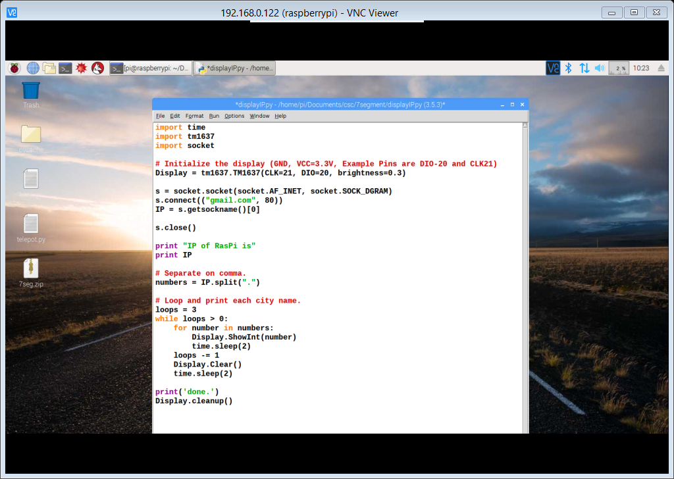

Run the Scripts:
sudo python displayIP.py
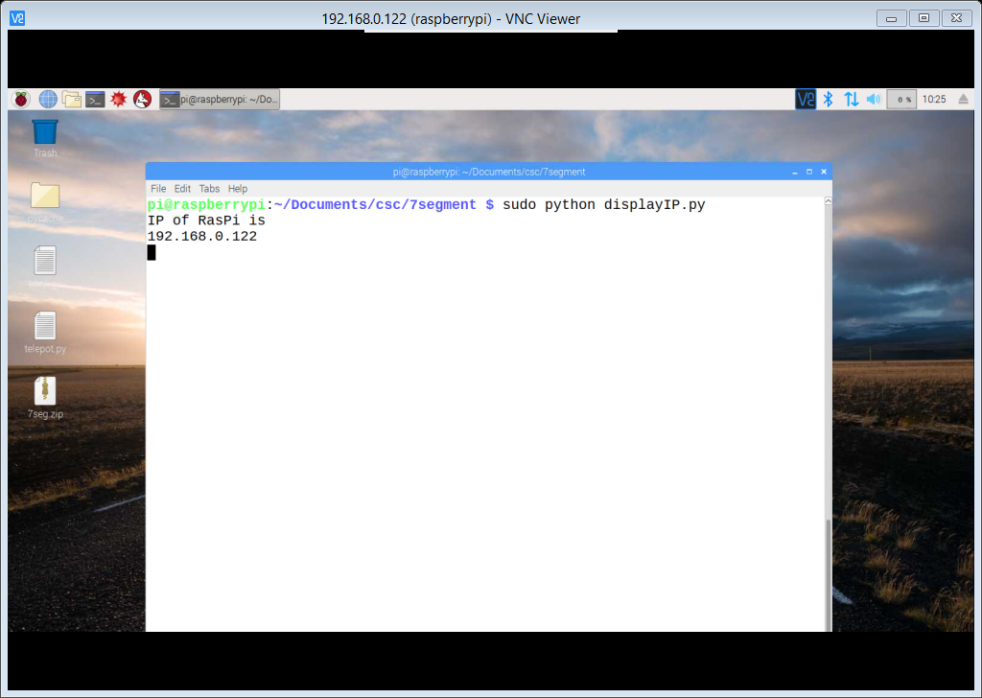
On Display it will showing first 192. Then 168. Then 0. Then 122 Continuously

