Everardo Villasenor

GT User: evillasenor3

GT ID: 903389317

CS 4646/7646

Martingale Report

# Experiment 1

1. The probability of winning $80 within 1000 sequential bets is 100% given that in Figures 1-3, the gambler would win $80 by the 250th spin and alleviated by the fact that the gambler has an infinite bankroll. Mathematically, with $1 bets the gambler would have to hit black 80 times in 1000 spins which means that the probability of not hitting black at least 80 times (non-sequentially) means that the gambler would hit green or red sequentially at least 921 times. The probability of this happening is (10/19)921 , which is so small that the probability is effectively 0%. Therefore, the probability to win $80 within 1000 sequential bets is 100% with an infinite bankroll.
2. For the expected value of the Martingale method with an infinite bankroll and 1000 sequential spins stopping if we win $80 is $80. This can be easily seen in Figure 2 as the expected value is just the mean of a simulation that converges under the law of large numbers (Wikipedia). This means that 1000 simulations are a sufficiently large number and it clearly shows that the mean converges on $80 after about 200 sequential spins.
3. The standard deviation of this strategy is exemplified in Figures 2 and 3. It is obvious that it is a very variable strategy because the standard deviation does not seem to converge until the gambler starts reaching $80 and hits multiple maximums away from the mean. This makes sense because the gambler is doubling down on each loss therefore his potential loss on each subsequent spin can be exponential while his gain at each subsequent spin is capped at $1. The standard deviation would converge to $0 because the expected value is $80 for this experiment and the probability is 100% for 1000 spins, but on the way there it is highly variable.

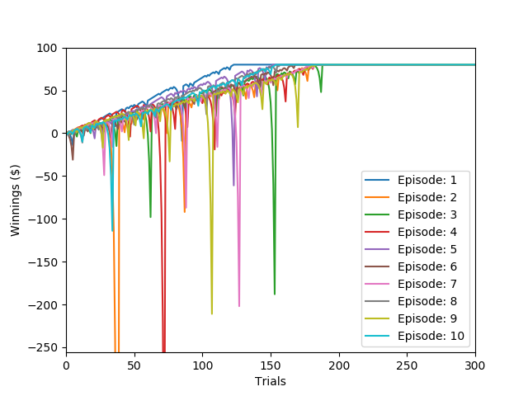

Figure 1: Martingale Results for 10 Episodes of betting $1 to get to $80 with Experiment 1

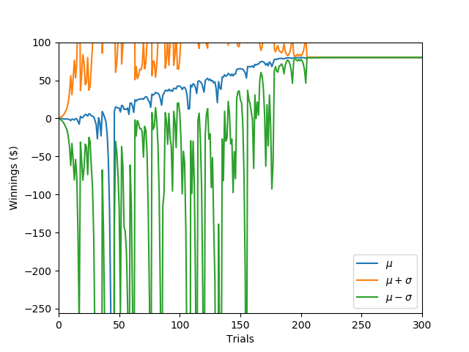

Figure 2: Mean value of each spin and the standard deviations associated with Experiment 1

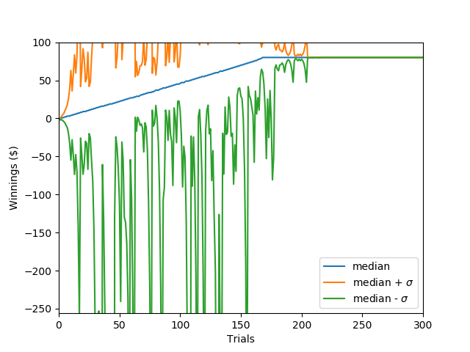

Figure 3: Median value of each spin and standard deviations associated with Experiment 1

# Experiment 2

1. The probability of winning $80 with 1000 sequential bets is reliant on the probability that the gambler can sustain a losing streak equal to his bankroll. Because the bets double for this method the gambler with a bankroll of $256 can sustain a maximum of 8 consecutive spins before losing ($255 loss) and having to restart the martingale bet with the rest of his bankroll. (maximum $80). For the sake of simplicity to estimate, the probability of losing 8 times in a row is (10/19)8 or 0.59% meaning a good estimate for winning $1 with 1000 sequential bets and a bankroll of $256 is 99.4%. If we multiply this probability for 80 times it must happen then the overall probability is (0.994)80 = 61.8%. If we look at the simulation (1000 sequential bets) I get the following results:
   1. Win $80: 63.6%
   2. Lose $256: 36.3%
   3. Other Result: 0.1%

This means that the mathematical estimate was close to the observed events.

1. The expected value of the bets would be the mean value, which in Figure 4 is approximately a loss of $42. This makes sense because given the previous percentages:
   1. $80*(0.636) + (-$256)*0.363 = -$42.05.

*Not accounting for the very small other winning amount.

1. The standard deviation as seen in Figures 4 and 5 reach a maximum value of about $150 away from the mean and for each successive spin grows logarithmically and does not converge. It does not converge because the different episodic events do not have the same result at the end of the 1000 spins. Therefore since the end episodic winnings are spread out there is a maximum standard deviation reached.

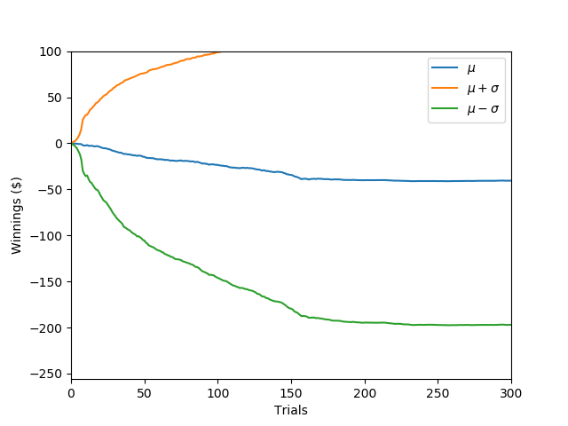

Figure 4: Mean value of each spin and the standard deviations associated with Experiment 2

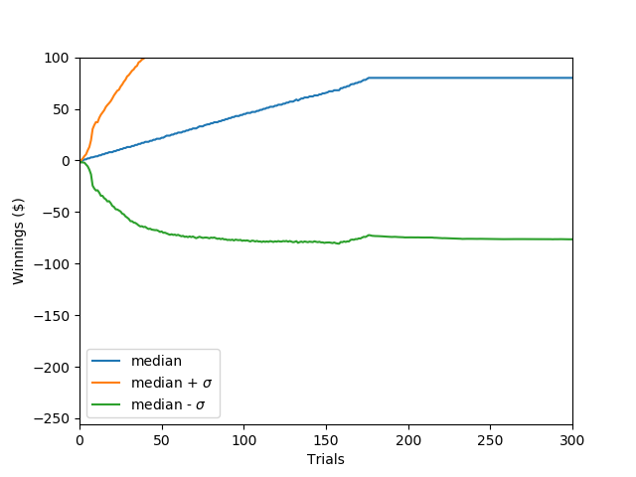

Figure 5: Median value of each spin and standard deviations associated with Experiment 2

Works Cited

Wikipedia contributors. "Expected value." *Wikipedia, The Free Encyclopedia*. Wikipedia, The Free Encyclopedia, 26 Aug. 2018. Web. 30 Aug. 2018.