rule-based trading strategy

Allan Reyes, reyallan@gatech.edu

# **Introduction**

Technical analysis is the basis of quantitative trading and allows investors to generate indicators, measurements that describe particular behavior in the price of a stock and the market, which can be combined to make trading decisions. Automatic trading can be achieved using either a manually-created or an automatically-created strategy. The focus of this report is to present a rule-based trading strategy, along with the indicators that comprise it, and compare it to a predefined benchmark over different periods of time to assess its effectiveness in the market.

# Technical indicators

For this rule-based strategy four indicators were used: momentum, price/SMA ratio, Bollinger Bands® and Money Flow Index (MFI). A description of each of these indicators is given in the following subsections.

## Momentum

Momentum is an indicator that describes how much the price has changed over a certain period of time. In other words, it gives the investor an idea of how the price has been oscillating and whether it is trending up or down. Momentum can be computed as follows:

1. Define a lookback period ***n***
2. Obtain all the historical ***prices***for the stock over a certain period of time
3. Calculate the **momentum** for each trading day: *momentum[t] = (prices [t] / prices [t – n]) – 1*

Momentum is of interest because it provides a raw estimation of how strong the price of a stock is moving. In a trading strategy, this can signal BUY opportunities when the momentum is positive since the investor can expect, roughly, that the price will continue to increase. A similar reasoning signals SELL opportunities when the momentum is negative.

One of the main issues with momentum, however, is that it is sensitive to price *whips*, i.e. sudden changes in prices from one period to the next, that are not reflected immediately because the value is smoothed out over the lookback period. This limitation is the reason why this indicator should be used in combination with other ones.

The following figure shows the prices of the stock symbol **JPM** and its 10-day momentum for the period of January 1st, 2008 to December 31st, 2009 (in-sample period). Notice how it describes changes in price. For example, between March and April 2009 there was a big increase in the price of the stock, and this is captured by the large value that momentum shows around the same time.

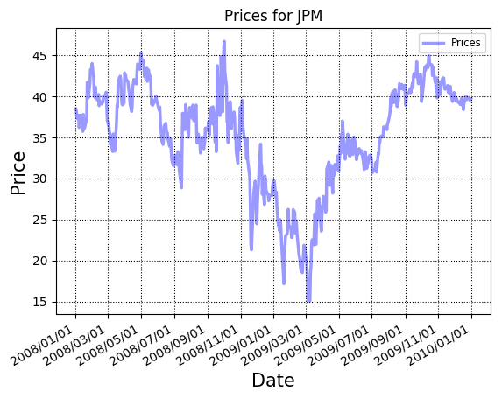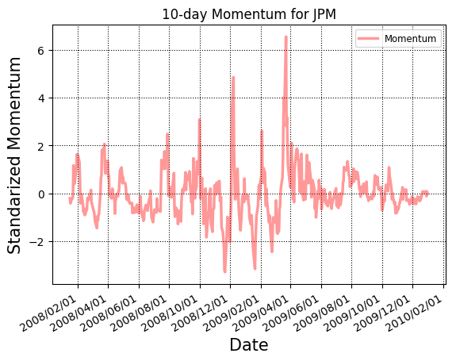

## Price/SMA ratio

Simple Moving Average (SMA) can be defined as the *rolling* average over a window of time of the price of a stock. In other words, it describes the mean of the price over a lookback period. Now, price/SMA ratio is a technical indicator that measures how much the price has diverged from its rolling average, and it can be computed as follows:

1. Define a lookback period ***n***
2. Obtain all the historical ***prices***for the stock over a certain period of time
3. Calculate the **price/SMA** for each trading day: *ratio[t] = (prices[t] / prices[t-n:t].mean()) – 1*

The Simple Moving Average serves as an estimation of the *true* value of a stock so, in a trading strategy, an investor can look for instances where the price of a stock crosses the SMA that can signal particular trading opportunities. In particular, situations where the price went above the SMA and down which suggests the price is regressing back to the mean, and vice versa.

Price/SMA ratio is precisely measuring this, and a SELL opportunity arises for an above-and-down instance since the price is trending down, and a BUY opportunity, for a below-and-up instance since the price is trending up. To improve the effectiveness of the signal, price/SMA ratio can be used in combination with momentum in order to increase the confidence of the upwards or downwards trend.

The following figure shows the prices and the price/SMA ratio of the stock symbol **JPM** using a lookback window of 10 days for the in-sample period. Notice how it captures changes in price by crossing up and then down whenever there is a drop in price; for example, the big drop between March and April 2009 which is shown as a cross above zero and then back down below it in the price/SMA ratio chart around the same dates.

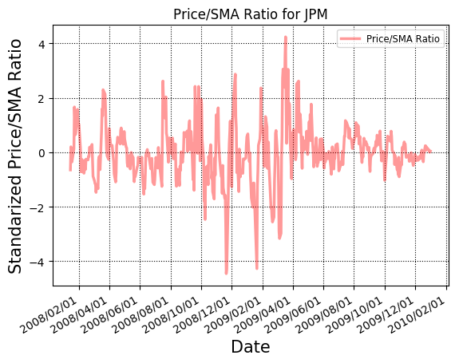

## Bollinger Bands®

Bollinger Bands® (BBands) are, as the name implies, *bands* two standard deviations above and beyond the Simple Moving Average (SMA). For this project, the BBands values were used as a technical indicator to measure the difference between the SMA and the price with respect to two standard deviations of the mean. The BBands values can be computed as follows:

1. Define a lookback period ***n***
2. Obtain all the historical ***prices*** for the stock over a certain period of time
3. Calculate the ***SMA****,* as previously described
4. Calculate the **BBands** for each trading day: *bbands[t] = (prices[t] - sma[t]) / (2 * sma[t].std()*

In a trading strategy, the Bollinger Bands® values serve as an indication of whether the stock appears to be **oversold** (the value seems to be underrated) or **overbought** (the value seems to be overrated). In terms of the BBands values, a stock can be flagged as oversold if the price goes below the bottom band and then crosses up; and flagged as overbought if the price goes up the top band and then crosses back down.

The reason behind this is that if the difference between the price and the SMA is negatively larger than two standard deviations, then the value of the stock is too low from what it actually is (recall that SMA serves as indication of the *true* value), and it is expected to regress up to the mean. In this case, a BUY opportunity arises. On the other hand, a SELL opportunity arises when the difference is positively larger because it is can be seen as too high from what it actually is and it is expected to regress down to the mean.

The following figure shows the prices, SMA and Bollinger Bands®, along with the BBands values of the stock symbol **JPM** using a lookback window of 10 days for the in-sample period. Notice how the values correspond to increases and decreases in the price of the stock. In particular, as noted in the graph, instances where the values oscillate between 1 and -1 present trading opportunities as these values indicate oversold/overbought instances.

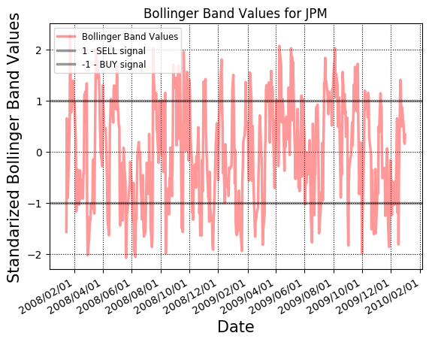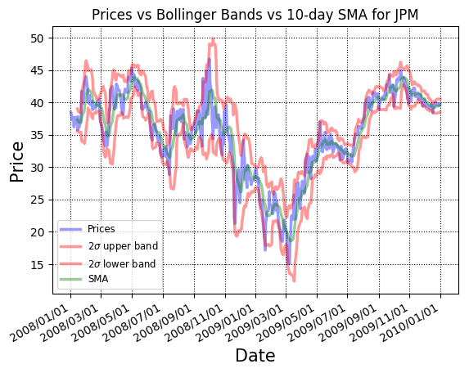

## Money Flow Index

The Money Flow Index (MFI)[1] is a technical indicator that measures the flow of incoming and outcoming money over a particular period of time. In other words, the MFI uses the price and volume of a stock to measure buy and sell pressure to produce the index. The MFI is computed as follows:

1. Define a lookback period ***n***
2. Obtain all historical ***high, low*** and ***closing prices***, as well as, the ***volume***for the stock
3. Calculate the ***typical price*** as: *typical[t] = (high[t] + low[t] + close[t]) / 3*
4. Calculate the ***raw money flow*** as: *raw[t] = typical[t] * volume[t]*
5. Calculate the ***n-day positive money***by summing up all of the raw money flow on days where the typical price is higher than the day before
6. Calculate the ***n-day negative money*** by summing up all of the raw money flow on days where the typical price is lower than the day before
7. Calculate the ***money flow ratio*** as: *ratio[t] = positive[t] / negative[t]*
8. Calculate the ***MFI*** as: *mfi[t] = 100 – (100 / (1 + ratio[t]))*

Money Flow Index is used in a trading strategy as leading indication of **oversold** or **overbought** instances for a particular stock. As described in the previous section, these instances can signal BUY and SELL opportunities, respectively. According to the creators of this index, Gene Quong and Avrum Soudack, an MFI of over 80 suggests the stock is overbought, while a value lower than 20 suggests that it is oversold. For the purposes of this project, values of 70 and 30 were found to produce better results as they were not as strict (*see rule-based strategy section*). To increase the confidence of this signal, this indicator can be combined with the BBands values described in the previous section.

The following figure shows the prices and the MFI values of the stock symbol **JPM** using a lookback window of 10 days for the in-sample. It also shows those instances where the stock can be flagged as oversold or overbought which correspond to price increases and decreases.

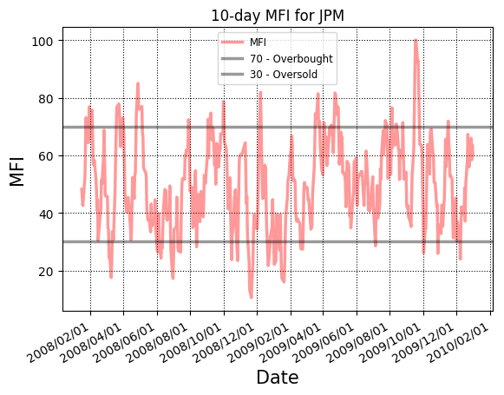

# Best possible strategy

To provide an upper band on performance, the best possible strategy was developed first. This strategy assumes that *tomorrow’s* prices are known to the trader. It was comprised of two actions: shorting or going long on the stock. The decision was made simply by looking at tomorrow and today’s prices. If the price is going to decrease tomorrow, then order a SELL and short the stock today. If the price is going to increase then order a BUY and go long.

The overall effectiveness of this best possible strategy was measured against a benchmark strategy that consisted on buying the stock the first day and then holding it. The following figure shows a graph with the performance of these two strategies, as well as, a table with other key portfolio statistics. As it can be seen this strategy never lost and outperformed the benchmark by around 7x times.

|  |  |  |  |  |
| --- | --- | --- | --- | --- |
| Strategy | Portfolio Value | Cumulative Return | Daily returns (avg) | Daily returns (std) |
| Best possible | $678,610.0 | 5.7861 | 0.00381678615086 | 0.00454782319791 |
| Benchmark | $101,230.0 | 0.0123 | 0.000168086978191 | 0.0170043662712 |

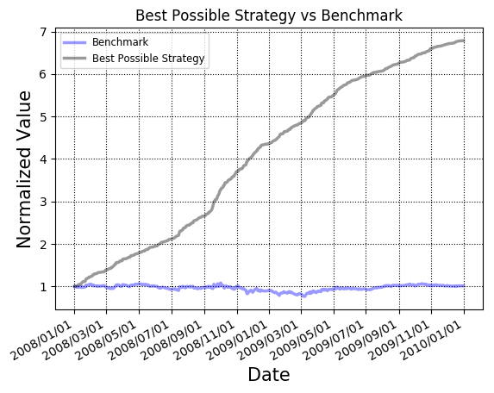

# Rule-based strategy

The main strategy created for this project is a rule-based strategy consisting of four different decisions: **shorting**, going **long**, **closing** a **short** position and **closing** a **long** position. Each decision was made by using a combination of the technical indicators mentioned in the first sections of this report. Following are the rules that were used to generate each particular order.

## Entering a long position

The idea for this rule was to look for instances where the stock seemed to be oversold, i.e. an opportunity to BUY enough shares to go long. To achieve this, two indicators were used: Money Flow Index (MFI) and Bollinger Bands®. As previously explained, the combination of these two indicators strongly identified the value of the stock as being underrated and thus expected to increase.

Concretely, the rule was described as follows: *MFI < 30 && BBands < -1.0*, where the value for the MFI comes from the direct definition of the index, as mentioned before, and the value for the Bollinger Bands® indicates the difference between the price and the SMA is negatively larger than two standard deviations, but it is trending up.

It is important to mention that due to the limitations imposed as part of this project, entering a long position was only possible if the current of shares held was not greater than the maximum allowed, i.e. 1000 shares.

## Enterting a short position

In this case, the idea for this rule was to look for instances where the stock seemed to be overbought, i.e. an opportunity to SELL enough shares to short the stock. As with the previous rule, Money Flow Index (MFI) and Bollinger Bands® were used as technical indicators. The combination of the two also strongly identified the value of the stock as being overrated and thus expected to decrease.

The rule was generated as follows: *MFI > 70 && BBands > 1.0*, where the value for the MFI again comes from its definition, and the value of Bollinger Bands® indicates the difference between the price and the SMA is positively larger than two standard deviations, but trending down.

As with the rule for going long, this one also considered the limitations of this project, and entering a short position was only possible if the current shares held was not greater than the maximum allowed, i.e. negative 1000 shares.

## Closing a long position

Going long indefinitely, or until a short position is available, is not effective as the price can decrease without reaching the measure for strong short signals, but still generate losses for holding that long position on the stock. In order to avoid this, a third rule allowed the trader to identify situations where holding that long position was not going to generate any more profits and thus *closing* would be smarter. For this case, two different indicators were used: price/SMA ratio and momentum. However, these indicators were used *independently* in contrast to the first two rules described above.

In the case of price/SMA ratio, the idea was to identify if the price is regressing down to the mean by noticing crosses from above the SMA and down. On the other hand, momentum was used to identify drops in the movement of the price which could signal of downwards trends. Note that in the case of momentum, the raw value was not used, but rather the **percent of change** between yesterday’s and today’s momentum. This allowed the trader to take into account sudden changes in price and avoid the problems mentioned in the first sections of this document (*see Technical Indicators section*).

The rule was created as follows:

* *sma_trending_down = sma_yesterday > 1 and sma_today <= 1*
* *drop_in_momentum = momentum_today < momentum_yesterday*
* *percent_drop = (momentum_yesterday – momentum_today) / momentum_yesterday*
* *sma_trending_down || (drop_in_momentum && percent_drop > 0.50)*

where a value greater than 1 for price/SMA ratio means the price is above the SMA, and a value less than or equal to 1, means it is below or at the SMA; and in terms of the change in momentum, a value of 0.50 was used to only consider changes greater than 50% because that increased the confidence of a downwards trends[2].

## Closing a short position

As with a long position, shorting a stock indefinitely, or until a long position is available, is also not effective as the price can increase and generate losses for holding that short position without ever reaching the limits for strong long signals. A fourth rule was created to identify this kind of situation and *close* the short position. For this rule, price/SMA ratio and momentum were also used.

The idea was for the trader to identify if the price was regressing up to the mean by noticing crosses from below the SMA and up. In the case of momentum, it was used to identify upwards trends in the movement of the price of the stock. As with the previous rule, a **percent of change** between the previous and current day was used instead of the raw momentum value.

The rule was created as follows:

* *sma_trending_up = sma_yesterday < 1 and sma_today >= 1*
* *increase_in_momentum = momentum_today > momentum_yesterday*
* *percent_increase = (momentum_today – momentum_yesterday) / momentum_yesterday*
* *sma_trending_up || (increase_in_momentum && percent_increase > 0.50)*

where the values for price/SMA ratio and the percent of change in momentum follow the same rationale as with the rule for closing a long position.

## Performance

The effectiveness of this rule-based strategy was measured against the same benchmark strategy as described in previous sections; however, a commission of $9.95 and a market impact of 0.005 were added.

The following figure shows a graph with the performance (where green lines indicate the trader entered a LONG position and red, that it entered a SHORT position), as well as, a table with other key portfolio statistics.

|  |  |  |  |  |
| --- | --- | --- | --- | --- |
| Strategy | Portfolio Value | Cumulative Return | Daily returns (avg) | Daily returns (std) |
| Rule-based | $136,557.25 | 0.3655725 | 0.000666083096356 | 0.00978090198654 |
| Benchmark | $101,027.0 | 0.0123249333401 | 0.000168759162146 | 0.0170412470682 |

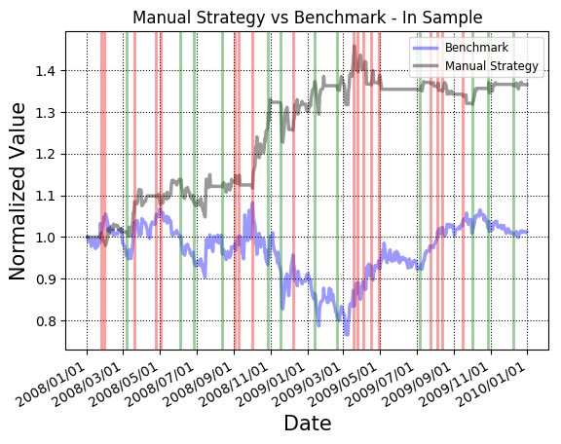

As it can be seen from the graph, this rule-based strategy was able to outperform the benchmark generating a cumulative return over the in-sample period of 36%. This proves that the rules generated for this strategy were indeed effective as they were able to correctly identify instances where the stock was overbought or oversold, as well as, situations where closing either position was better than holding it.

# Comparative analysis

A strategy cannot be called effective if it is not tested on *unseen* data. The rule-based and benchmark strategies were applied to the out-of-sample period from January 1st 2010 to December 31st 2011. The following figure shows the performance of the manual strategy with respect to the benchmark for both the in-sample and out-of-sample periods, the prices for the stock during both periods, as well as, a table with key portfolio statistics.

|  |  |  |  |  |
| --- | --- | --- | --- | --- |
| Period | Portfolio Value | Cumulative Return | Daily returns (avg) | Daily returns (std) |
| In-sample | $136,557.25 | 0.3655725 | 0.000666083096356 | 0.00978090198654 |
| Out-of-sample | $111,404.1 | 0.114041 | 0.000231729061093 | 0.00584239915918 |

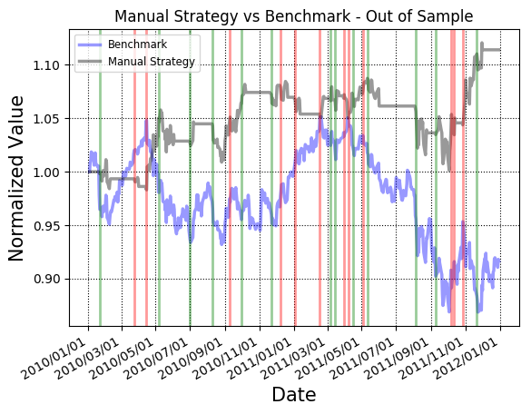

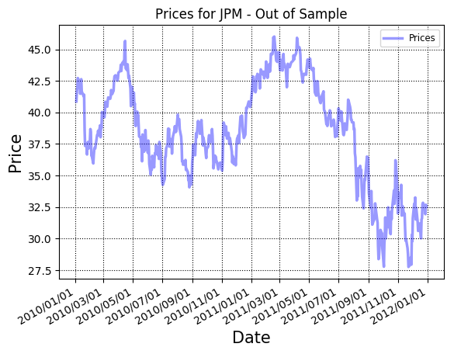



Notice how the rule-based strategy still performed reasonably well on the out-of-sample period beating the benchmark again meaning this strategy can be considered effective! However, its performance is clearly not as great as it is in the in-sample period: in the out-of-sample period, the trader generated only 11% cumulative return in contrast to the 36% of the in-sample period.

From the graphs, it can be noticed that one of the key differences is that, during the out-of-sample period, the trader entered more LONG positions; however, the prices of the stock during that time happened to have more drops which means that the strategy was not making the right decisions. This suggests that the rules that looked for SHORT positions were not indicative enough. One possible solution to this problem is to introduce more *momentum-based* indicators that can detect and increase the confidence that the price will drop.

# Conclusion

In this project, four technical indicators were implemented and used to develop a manual rule-based strategy to detect LONG/SHORT and closing positions. By testing the strategy against in-sample and out-of-sample periods, it was shown that it is effective, beating the benchmark and generating revenue. Nevertheless, the strategy is not perfect, showing weaknesses in identifying shorting opportunities during continuous drops in prices. This provides area for improvement, by possibly introducing other momentum-based indicators, in hopes of getting closer to the idealistic upper-bound performance.

1. http://www.investopedia.com/terms/m/mfi.asp
2. This value was chosen arbitrarily and does not correspond to any formal definition.