Exercise 4: Form validation
import React, { useState, useEffect } from "react";
import { Form, Button } from "react-bootstrap";

const validateInput = (value) => value.length >= 5;

function ValidatedInput() {
const [value, setValue] = useState("");
const [isValid, setIsValid] = useState(true);
const [errorMessage, setErrorMessage] = useState("");

useEffect(() => {
const check = validateInput(value);
setIsValid(check);
setErrorMessage(check ? "" : "Ít nhất 5 ký tự!");
}, [value]);

return (
<Form>
<Form.Group>
<Form.Label>Input cần ≥ 5 ký tự</Form.Label>
<Form.Control
type="text"
value={value}
onChange={(e) => setValue(e.target.value)}
isValid={isValid}
isInvalid={!isValid}
/>
<Form.Control.Feedback type="invalid">{errorMessage}</Form.Control.Feedback>
</Form.Group>
<Button variant="primary" type="submit" disabled={!isValid} className="mt-2">Gửi</Button>
</Form>
);
}

export default ValidatedInput;

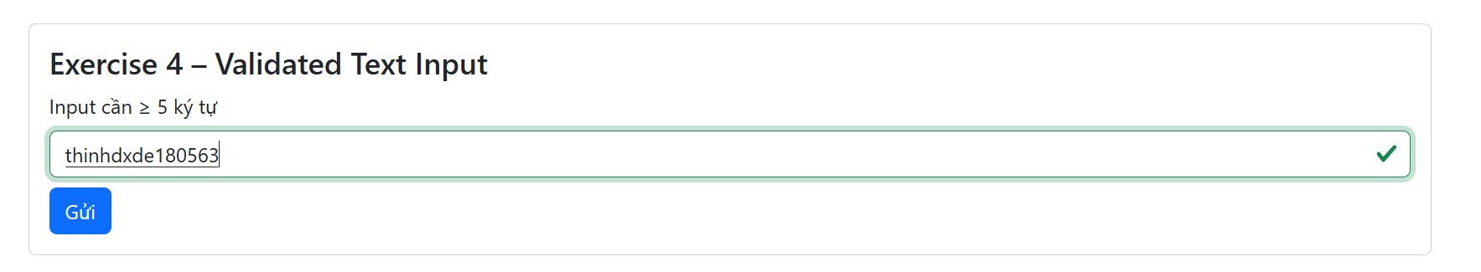

Exercise 5:
import React, { useState, useEffect } from "react";
import { Form, Button } from "react-bootstrap";

const isValidEmail = (email) => /^\S+@\S+\.\S+$/.test(email);
const isValidPassword = (pwd) => pwd.length >= 8;

const EmailPasswordForm = () => {
const [email, setEmail] = useState("");
const [password, setPassword] = useState("");
const [validEmail, setValidEmail] = useState(true);
const [validPassword, setValidPassword] = useState(true);

useEffect(() => {
if (email !== "") setValidEmail(isValidEmail(email));
if (password !== "") setValidPassword(isValidPassword(password));
}, [email, password]);

const allValid = validEmail && validPassword && email && password;

return (
<Form>
<Form.Group>
<Form.Label>Email</Form.Label>
<Form.Control
type="email"
value={email}
onChange={(e) => setEmail(e.target.value)}
isInvalid={!validEmail}
/>
<Form.Control.Feedback type="invalid">Email không hợp lệ</Form.Control.Feedback>
</Form.Group>

<Form.Group>
<Form.Label>Mật khẩu</Form.Label>
<Form.Control
type="password"
value={password}
onChange={(e) => setPassword(e.target.value)}
isInvalid={!validPassword}
/>
<Form.Control.Feedback type="invalid">Ít nhất 8 ký tự</Form.Control.Feedback>
</Form.Group>

<Button variant="success" type="submit" disabled={!allValid} className="mt-2">Đăng nhập</Button>
</Form>
);
};

export default EmailPasswordForm;
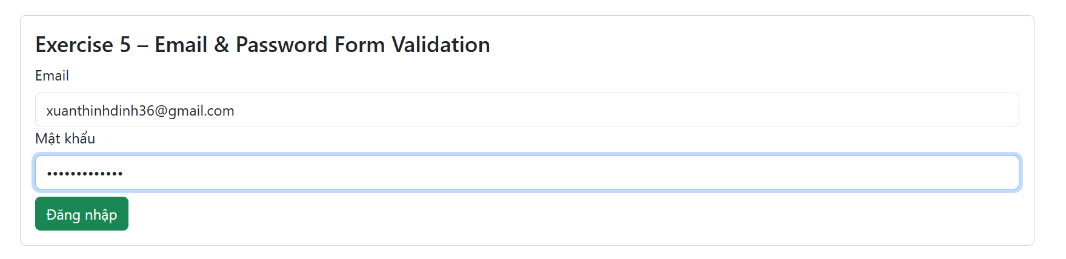

Exercise 6: Yêu cầu tạo form như sau:
import React, { useState, useEffect } from "react";
import { Form, Button } from "react-bootstrap";

const FullForm = () => {
const [name, setName] = useState("");
const [gender, setGender] = useState("");
const [country, setCountry] = useState("");
const [agree, setAgree] = useState(false);

const isNameValid = name.trim().length > 0;
const isGenderValid = gender !== "";
const isCountryValid = country !== "";
const isAgreeValid = agree;

const formValid = isNameValid && isGenderValid && isCountryValid && isAgreeValid;

return (
<Form>
<Form.Group>
<Form.Label>Họ tên</Form.Label>
<Form.Control
type="text"
value={name}
onChange={(e) => setName(e.target.value)}
isInvalid={!isNameValid && name !== ""}
/>
<Form.Control.Feedback type="invalid">Vui lòng nhập tên</Form.Control.Feedback>
</Form.Group>

<Form.Group>
<Form.Label>Giới tính</Form.Label><br />
<Form.Check
inline label="Nam" name="gender" type="radio" id="male"
onChange={() => setGender("Nam")}
/>
<Form.Check
inline label="Nữ" name="gender" type="radio" id="female"
onChange={() => setGender("Nữ")}
/>
</Form.Group>

<Form.Group>
<Form.Label>Quốc gia</Form.Label>
<Form.Select value={country} onChange={(e) => setCountry(e.target.value)}>
<option value="">-- Chọn quốc gia --</option>
<option value="vn">Việt Nam</option>
<option value="us">Mỹ</option>
<option value="jp">Nhật Bản</option>
</Form.Select>
</Form.Group>

<Form.Group className="mt-2">
<Form.Check
type="checkbox"
label="Tôi đồng ý với điều khoản"
checked={agree}
onChange={(e) => setAgree(e.target.checked)}
/>
</Form.Group>

<Button variant="primary" type="submit" disabled={!formValid} className="mt-2">Gửi thông tin</Button>
</Form>
);
};

export default FullForm;

