The automatic Nerf gun incorporates two DC motors to fire bullets: one which spins a set of counter rotating wheels, and one which actuates a piston that pushes darts out of the magazine and into the wheels, launching them out of the barrel of the gun. We had originally planned to incorporate a DC motor driver to control them directly, but upon inspecting the internals of the Nerf gun recognized that there was additional control circuitry. Instead, we opted to simply replace the two switches used as triggers with small signal relays.

Additionally, we observed that in automatic fire mode, the accuracy of the Nerf gun was significantly reduced, and the fire rate was potentially too fast to move our assembly in time to fire each dart in the correct location. To facilitate single fire mode, we would need to “hold” the fire trigger just long enough to fire a single dart, and no longer so that multiple darts weren’t fired by accident. To facilitate this, we implemented an IR breakbeam sensor at the end of the Nerf gun’s barrel. When a dart is fired, the sensor pulls a GPIO pin low, and we can detect this on the MCU via an interrupt. This enabled us to fire a single dart at a time, as well as detect when a misfire or jam occurred, as the dart would not have been detected in a specified time period.

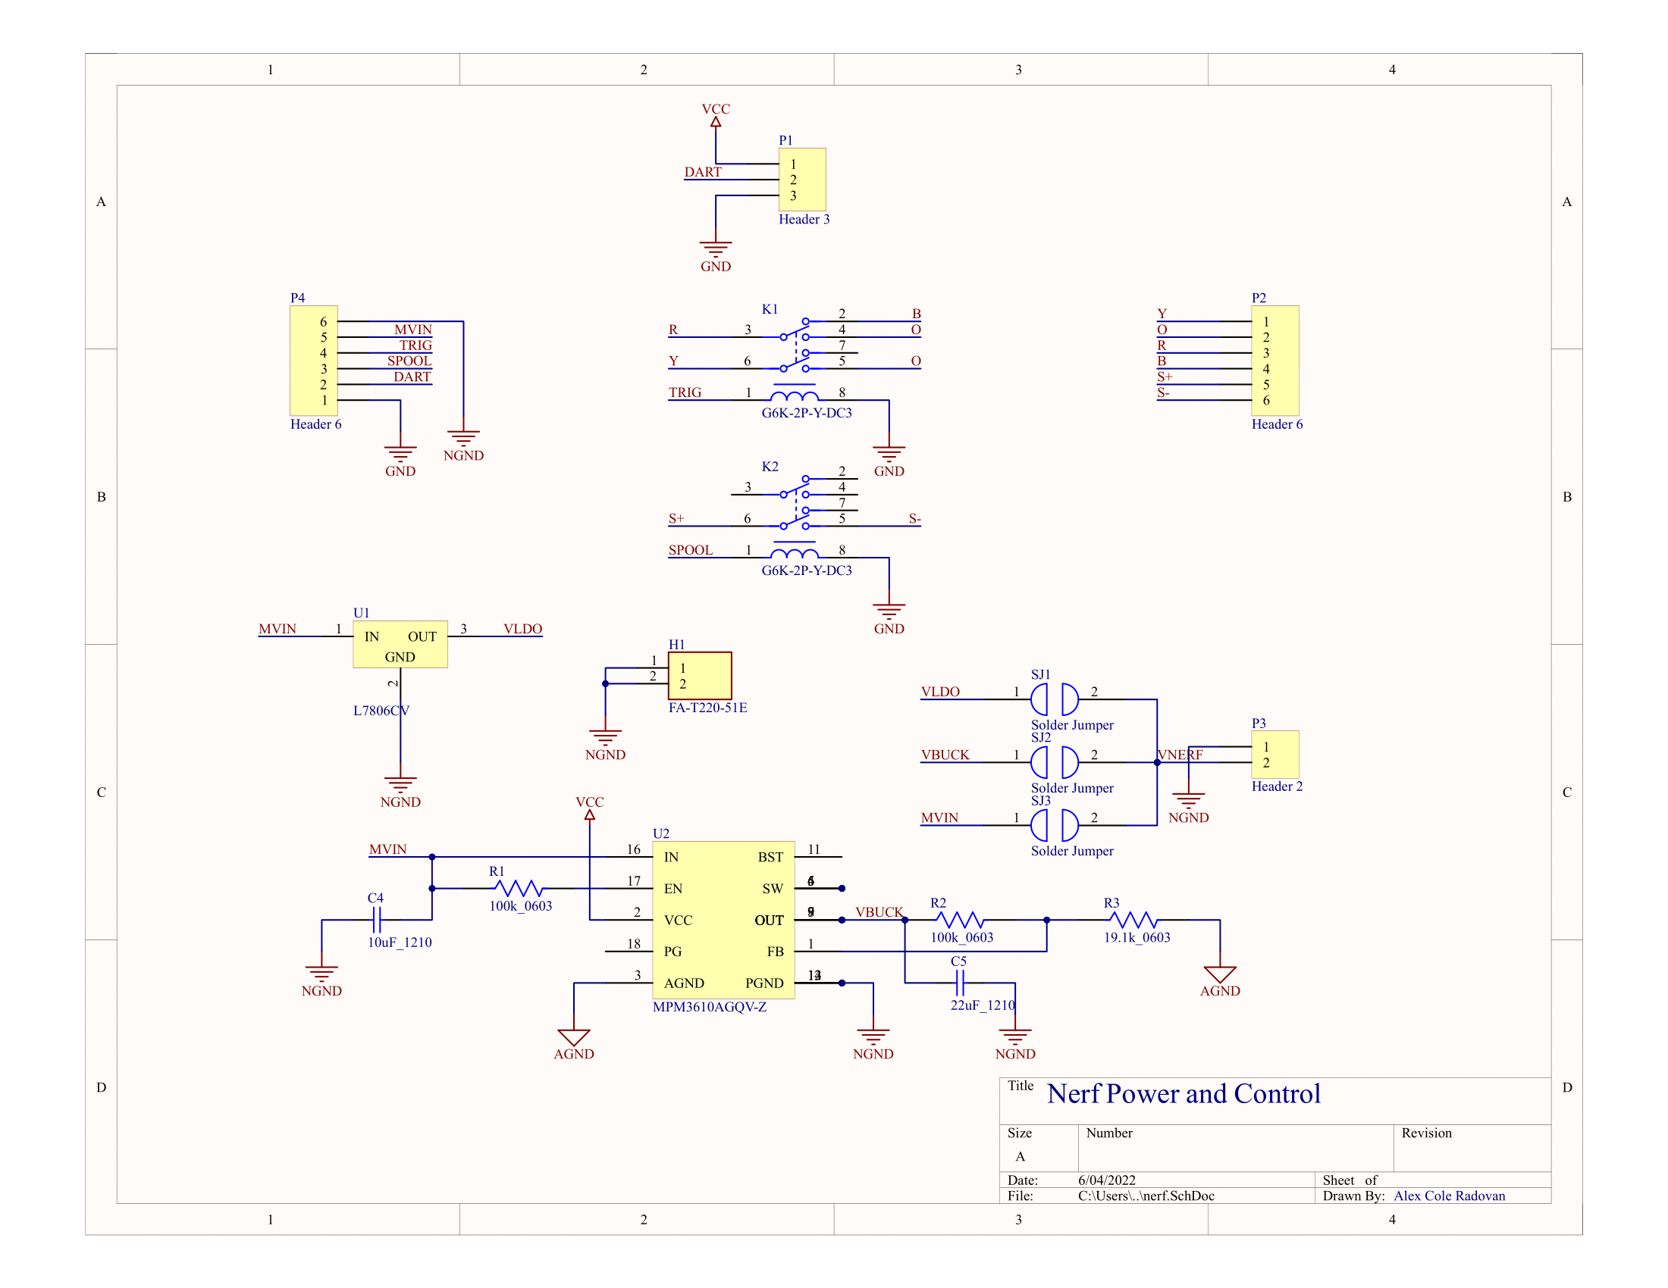

Figure X: Nerf control board schematic

Figure X shows the electrical design of the Nerf control board. In addition to the two double-pull double-throw small signals relays used to control the gun, headers for connecting to the IR sensor, Nerf gun internal circuitry, and MCU are included. The board additionally provides power to the Nerf gun, stepping down the 12 volts used to power the stepper motors to 5 volts via the DC-DC converter, and to 6 volts via the linear voltage regulator. While the Nerf gun uses 4 D-cell batteries, totaling 6 volts, we found that it was able to operate at 5V, albeit with slightly higher current draw. The DC-DC converter is able to provide 1.2 amps, while the LDO theoretically provide 1.5 amps, but require a substantial heatsink to achieve this power output. Solder jumpers allow us to select between the two voltage sources, as well as a direct voltage input for use with a second 6 volt power supply.

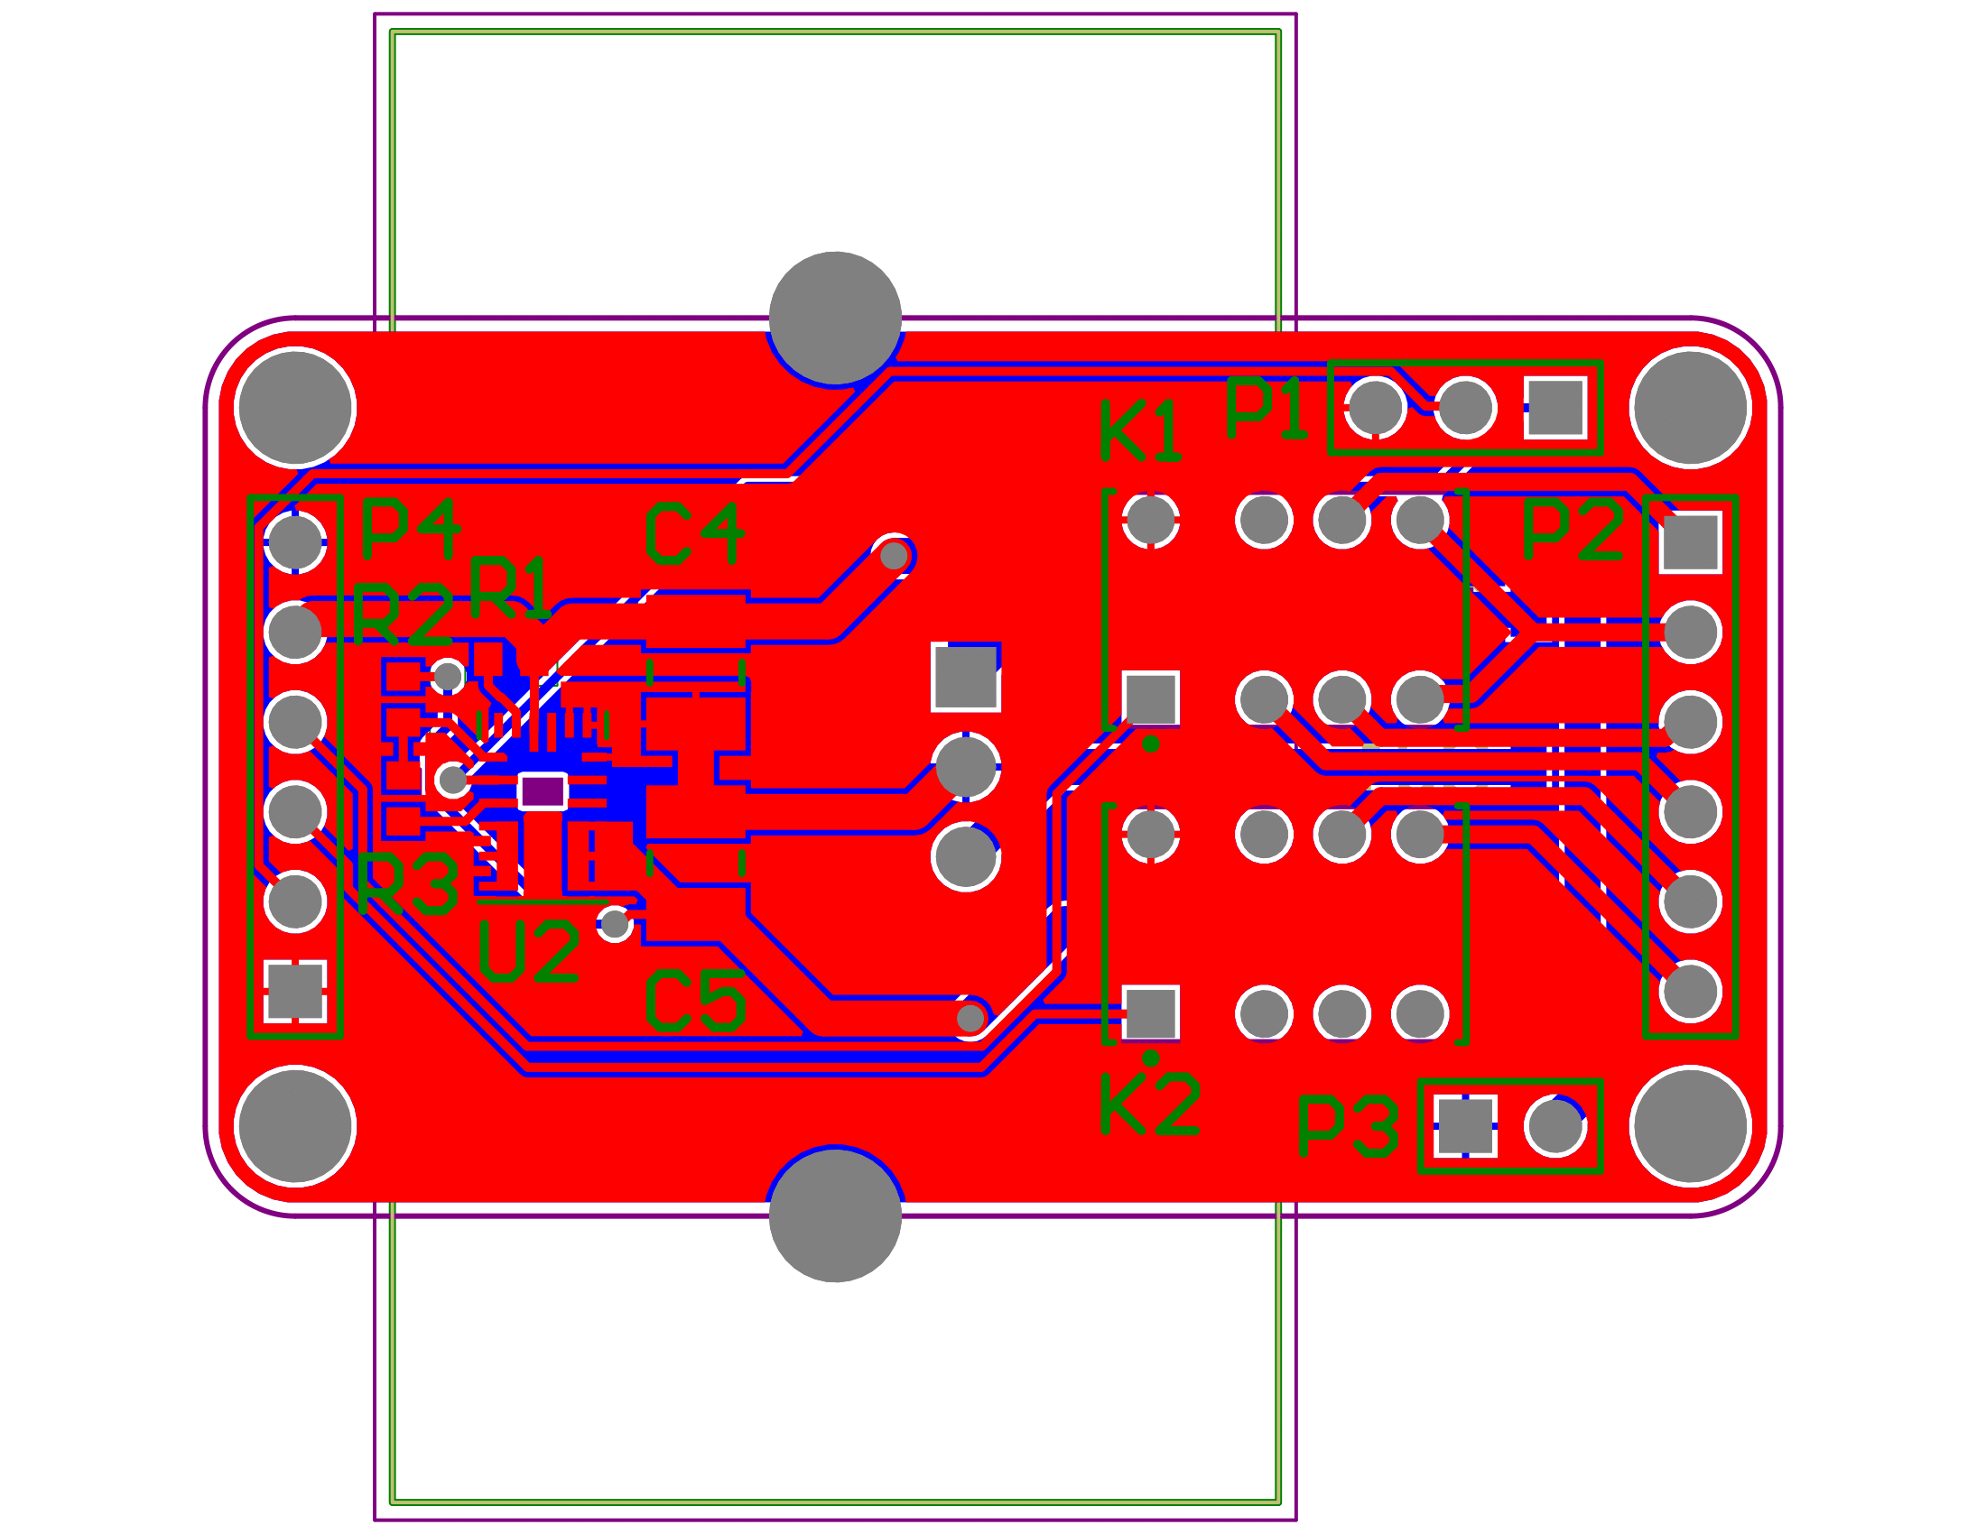

Figure X: 2-D layout of Nerf control board PCB

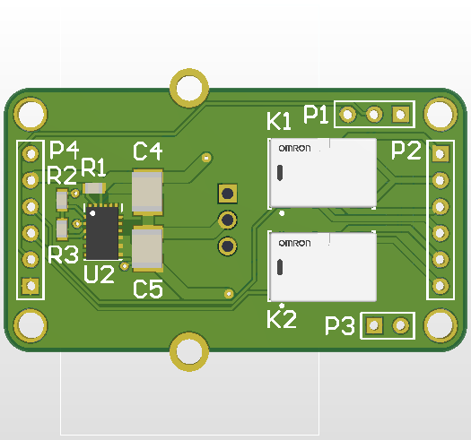

Figure X: 3D Render of Nerf control board PCB

The schematic and PCB were designed in Altium Designer. Figure X shows the PCB layout in 2-dimensions, while Figure X shows a 3D render of the board, including the component bodies. We ordered the PCBs from Osh Park and got SMD stencils from Osh Stencils. Our electronic components were sourced from Mouser, as well as the manufacturer of the DC-DC converter, Monolithic Power Systems. We assembled the boards by hand using a hot air rework station and soldering iron.