De Vo - (1080326)
Wireshark Lab 1

- List 3 different protocols that appear in the protocol column in the unfiltered packet-listing window in step 7 above.

3 different protocols: TCP, DNS and TLSv1.2
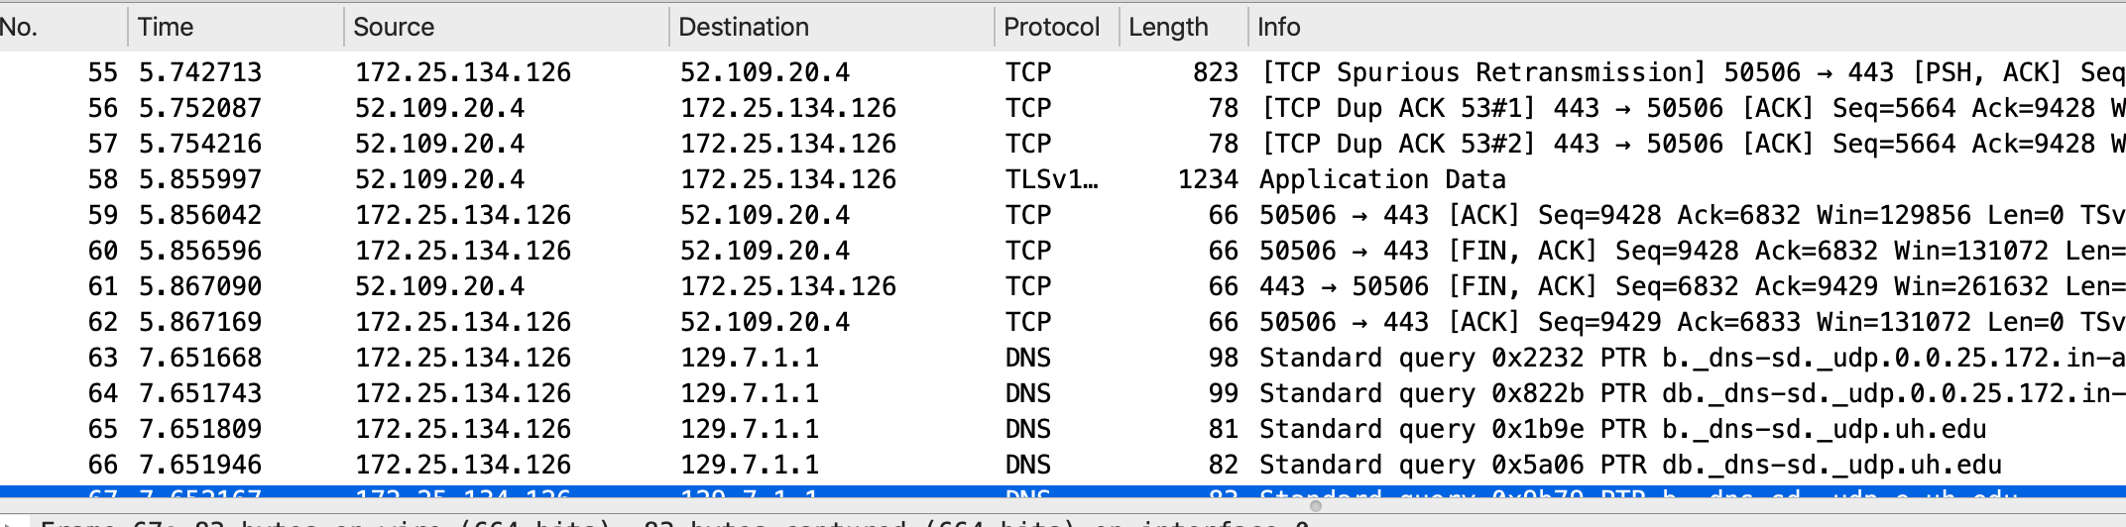

- How long did it take from when the HTTP GET message was sent until the HTTP OK reply was received? (By default, the value of the Time column in the packet-listing window is the amount of time, in seconds, since Wireshark tracing began. To display the Time field in time-of-day format, select the Wireshark View pull down menu, then select Time Display Format, then select Time-of-day.)

- HTTP GET received:
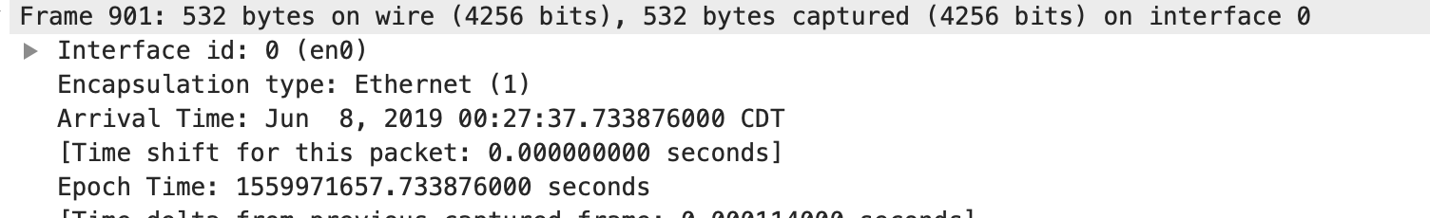

- HTTP OK received:
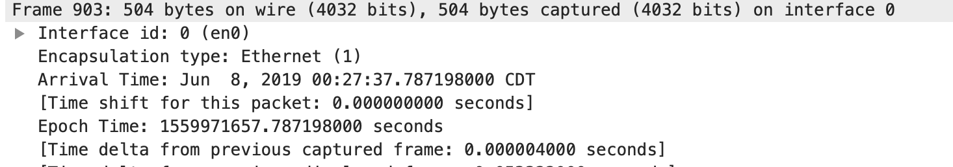

- Total time: 0.787198 - 0.733876 = 0.0533

- What is the Internet address of the gaia.cs.umass.edu (also known as www-net.cs.umass.edu)? What is the Internet address of your computer?

- Gaia.cs.umass.edu address: 128.119.245.12
- My Computer address: 172.25.134.126
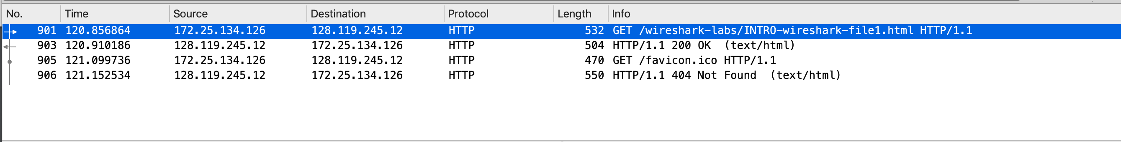

- Print the two HTTP messages (GET and OK) referred to in question 2 above. To do so, select Print from the Wireshark File command menu, and select the “Selected Packet Only” and “Print as displayed” radial buttons, and then click OK.

HTTP GET message

No. Time Source Destination Protocol Length Info
901 120.856864 172.25.134.126 128.119.245.12 HTTP 532 GET /wireshark-
labs/INTRO-wireshark-file1.html HTTP/1.1
Frame 901: 532 bytes on wire (4256 bits), 532 bytes captured (4256 bits) on interface 0
Ethernet II, Src: Apple_3f:da:f5 (f0:18:98:3f:da:f5), Dst: HewlettP_9c:a5:5c (e8:f7:24:9c:a5:5c)
Internet Protocol Version 4, Src: 172.25.134.126, Dst: 128.119.245.12
Transmission Control Protocol, Src Port: 50512, Dst Port: 80, Seq: 1, Ack: 1, Len: 466
Hypertext Transfer Protocol
GET /wireshark-labs/INTRO-wireshark-file1.html HTTP/1.1\r\n
Host: gaia.cs.umass.edu\r\n
Connection: keep-alive\r\n
Upgrade-Insecure-Requests: 1\r\n
User-Agent: Mozilla/5.0 (Macintosh; Intel Mac OS X 10_14_5) AppleWebKit/537.36 (KHTML, like
Gecko) Chrome/74.0.3729.169 Safari/537.36\r\n
Accept: text/html,application/xhtml+xml,application/xml;q=0.9,image/webp,image/apng,*/
*;q=0.8,application/signed-exchange;v=b3\r\n
Accept-Encoding: gzip, deflate\r\n
Accept-Language: en-US,en;q=0.9\r\n
\r\n
[Full request URI: http://gaia.cs.umass.edu/wireshark-labs/INTRO-wireshark-file1.html]
[HTTP request 1/2]
[Response in frame: 903]
[Next request in frame: 905]

HTTP OK message
No. Time Source Destination Protocol Length Info
903 120.910186 128.119.245.12 172.25.134.126 HTTP 504 HTTP/1.1 200 OK
(text/html)
Frame 903: 504 bytes on wire (4032 bits), 504 bytes captured (4032 bits) on interface 0
Ethernet II, Src: HewlettP_9c:a5:5c (e8:f7:24:9c:a5:5c), Dst: Apple_3f:da:f5 (f0:18:98:3f:da:f5)
Internet Protocol Version 4, Src: 128.119.245.12, Dst: 172.25.134.126
Transmission Control Protocol, Src Port: 80, Dst Port: 50512, Seq: 1, Ack: 467, Len: 438
Hypertext Transfer Protocol
HTTP/1.1 200 OK\r\n
Date: Sat, 08 Jun 2019 05:27:37 GMT\r\n
Server: Apache/2.4.6 (CentOS) OpenSSL/1.0.2k-fips PHP/5.4.16 mod_perl/2.0.10 Perl/v5.16.3\r\n
Last-Modified: Sat, 08 Jun 2019 05:27:01 GMT\r\n
ETag: "51-58ac9326297fb"\r\n
Accept-Ranges: bytes\r\n
Content-Length: 81\r\n
Keep-Alive: timeout=5, max=100\r\n
Connection: Keep-Alive\r\n
Content-Type: text/html; charset=UTF-8\r\n
\r\n
[HTTP response 1/2]
[Time since request: 0.053322000 seconds]
[Request in frame: 901]
[Next request in frame: 905]
[Next response in frame: 906]
[Request URI: http://gaia.cs.umass.edu/favicon.ico]
File Data: 81 bytes
Line-based text data: text/html (3 lines)

