COSC 4377 – Networking - Kevin B Long

# interlocking-uh-m-186.eps

De Vo (1080326) - Homework #2

Due 11:59am, Monday, 10 June 2019

Multiple submissions accepted.

1. (15 pts) Socket Programming

Please see server.py file submission

1. (10 pts) Complete the third Wireshark lab on SSL. SSL is more or less defunct, replaced by TLS. So you will probably need the pcap file to complete this lab.

Please see Lab3_SSL file submission

1. (30 pts, 15x3) Traceroute
2. Paste your traceroute below:

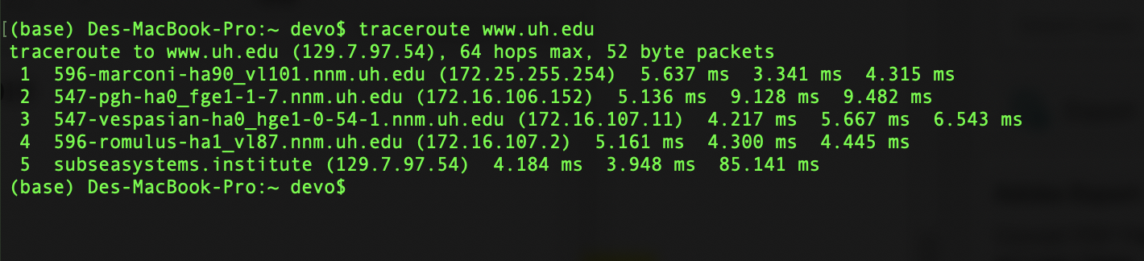

1. How many steps did your traceroute require? 5
2. What type of device is responding (or not) in each row? router
3. Each numbered row has three numbers followed by “ms”. What exactly are these?

Those numbers in ms are measurements round trip time of test packets.

1. Why are there 3? Why do they differ in some rows?

Because you are looking at 3 different round trip of test packets sent. Also, their distant may not be same.

1. Were there rows of just asterisks? If so, what does that represent?

* There were not in my case.
* However, if there was, it’s because the router did not respond.

1. Why do you think you can have asterisks and yet still reach your destination?

* Asterisks simply means router does not want to respond to request. This may be due to firewall of the server

1. Were there some rows whose times were greater than the times of later rows? How can this be? For an example, see the last two rows of the last rice traceroute. Note how in row 15 it’s reported to require 131.134 to reach that row in one instance, and 127.256 to reach the destination which is one step further away.

* Yes, row 1 and row 2
* This may due to the randomness of packet delay on the path to destination

1. What is the average time to reach your destination and how did you calculate that value?

* By averaging time of last row.
* In this case it’s 30.75 ms
* Quickly (not later in the day) traceroute from the same place to just [the](http://itesm.mx/) domain name (remove www).

1. Ignoring any change in the values at the end of each row, are the traceroutes the same?

________(Yes or No). Why do you think this is the case?

* In my case, there are pretty much same because I am using uh wifi !
* There are some cases that the traceroutes maybe because the hosts are different.

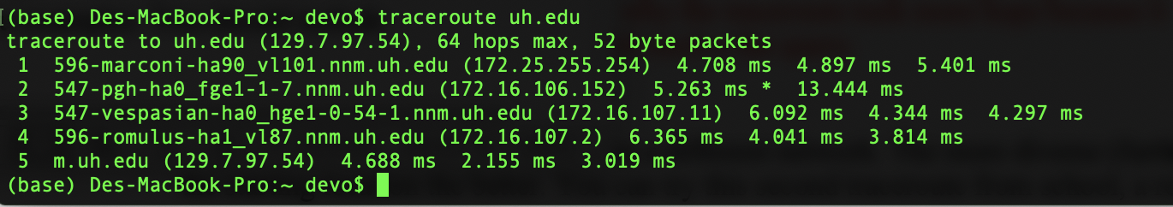

* Second traceroute

1. Paste your screen dump below:

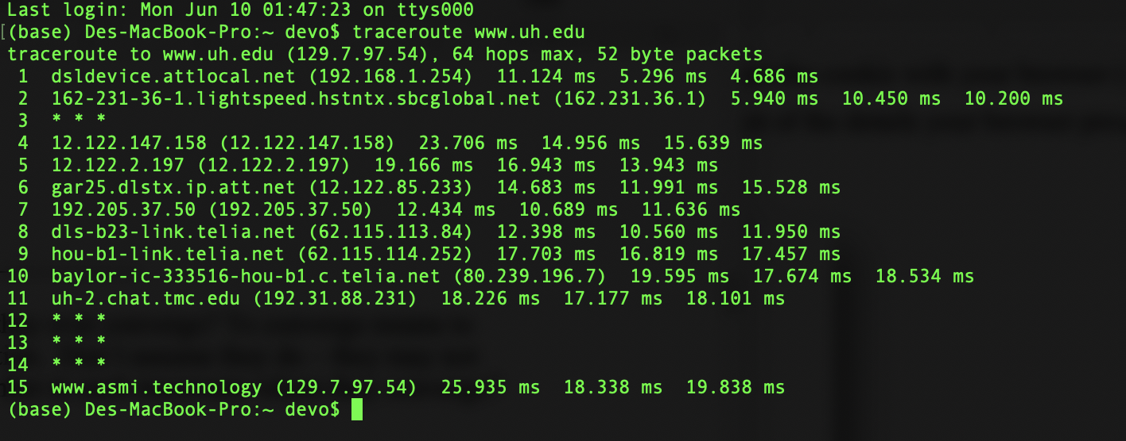

1. How many steps did your traceroute require? 15
2. Examine the routes in the two traceroutes. Do they ever converge? To converge means to share the path from that point on to the destination. Don’t assume they do – they may not even converge at the end. What is the row number in each traceroute where they converge?

No, they did not converge.

Use the tools and methods shown above to determine the first ISP in sequence handling your traceroute to your destination. Provide the domain name or the name of the organization to whom the IP is assigned, not the IP address. Your own internal organization is not an ISP.

It’s a local ATT private net (I was at home) !

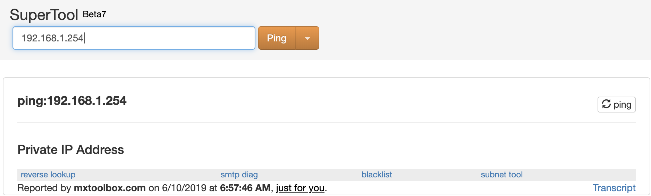

1. Who is the ISP at the end of the path for each traceroute (or from the last line with information in it)?

First trace: 129.7.97.54 - University of Houston (AS7276)

Second trace: also 129.7.97.54 - University of Houston (AS7276)

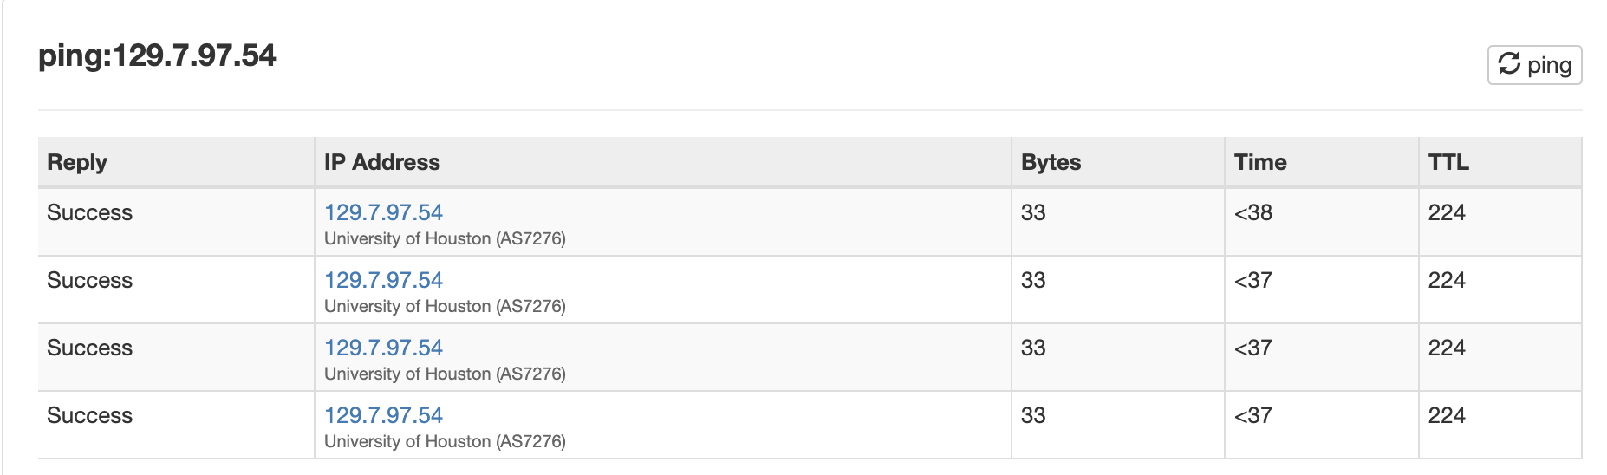

1. **(10 pts, 2x5) Layers**

When you pass a packet through a router (letting it do its normal job), at which of the five TCP/IP layers is the software running that makes the routing/forwarding decisions? Give the number and name. Names are Physical, Data Link, Network, Transport and Application.

Layer 3 - Network layer

1. So when you run a traceroute, and you are receiving responses from the device on row 5, is the software you mentioned in (a) what is running in hops 2, 3, and 4?

Y/N: YES - Explain: Because network destination is not router 2,3,4. They are just packets that need to be sent out

1. Suppose the device in row 5 had a small web server used to configure the router remotely, protected of course with a password. At what layer is the software running in that device that interacts with our browser? Remember, if you don’t know what layer it’s at, we discussed what answer you should assume is correct.

#:__Layer 5___ Name:____Application_____

Defend this answer: the router is destination of packet in this case. Packet no longer needs to be transported!

1. (24 pts, 8x3) Cookies
2. So what’s the site you’re chose? ____________________________________

<https://www.nike.com/>

1. Go to the site’s home page. Consult the cookie manager again in your browser and search again for cookies for this site. Were cookies created by just opening their home page?

* Yes
* 27 cookies

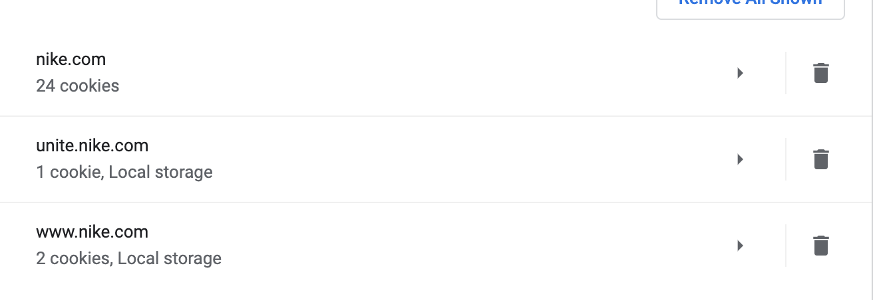

1. Click on a product on the web page. Observe the URL in your browser after you have clicked on the product. Paste it here. Here’s the one I got for jcpenney.com:

Your URL: <https://www.nike.com/t/epic-react-flyknit-2-rabid-panda-mens-running-shoe-0KFRGP/BQ8928-001>

Do you see a pattern of variables and values encoded in the URL? For example, separated by ampersand symbols (&’s)?

* Yes, I see pattern separated by ‘ – ‘

1. Examine one of the cookies. If navigating did not produce a cookie, check your settings, try another browser, or another site. Choose a cookie that looks like it has something that identifies you – you can get a good hint by looking at the name of the cookie – good candidates include a session ID, or a guest ID. Inspect the cookie with your browser (most provide a cookie inspector tool), and paste a snapshot of the details your browser provides.

What about the value of the cookie you chose to inspect?

* It has the random session ID number
* It also mentions when the session expires.

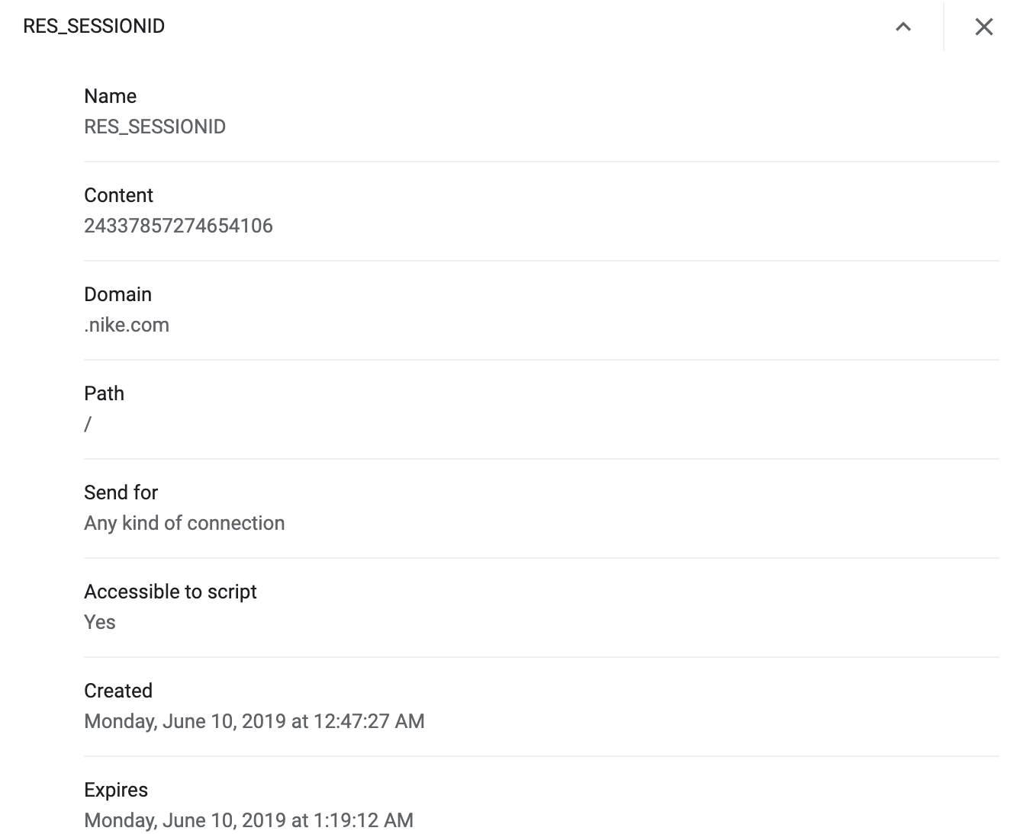

1. Add the product you were browsing above to your cart, and then clear the cache again for the domain while that web page is still displayed and the item is still in your cart. Now refresh the page. Is the item still in the cart?

The total balance stays the same but the items are cleared out

1. Examine the cookies again. Look for the same cookie from (d). Was it replaced? Does it still have the same unique identifier as before? Mine changed:

It changed to different ID

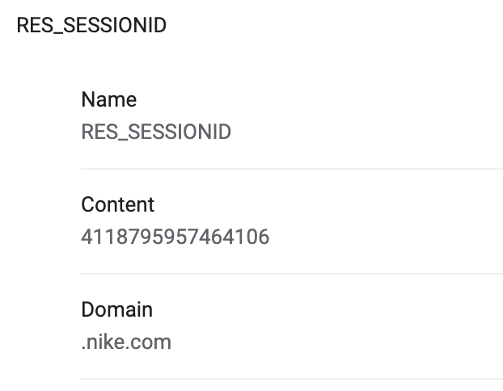

1. Wait a few minutes and go to a site with google ads, like nytimes.com. Did you see your cart item in one of the ads? I happened to need to go to aboutus.com/Gvt3.com (sort of random site) and look what ads I got! Lol. My browser might not remember what I put in my cart, but Google did!

* Well I know for a fact that it will soon or later appears lol

1. Does the site you chose use custom URLs or cookies or both or neither to maintain state?

Both