1. Dataset

**Dataset:** Economic Data - 9 Countries (1980-2020)

**Link:** https://www.kaggle.com/datasets/pratik453609/economic-data-9-countries-19802020

**Explanation:** This data set collects the economic data from 9 countries from 1980 to 2020, like GDP, income per capita, index prices and so on. This dataset can show the economic change and development of 9 famous countries in the world.

**Reasons of choosing this dataset:** This dataset can display information about the economic in the countries, including the basic information and the change in recent years. It is interesting because by visualization, we can see the development in years and at the same time we can compare the different countries.

|  |  |
| --- | --- |
| **Column Name** | **Description** |
| stock index | the index(id) of the stock of the country |
| country | country name |
| year |  |
| index price |  |
| log_indexprice | index price |
| inflationrate | the rate of inflation |
| oil_prices |  |
| exchange_rate |  |
| gdppercent | the gdp percentage occupied in the world |
| percapitaincome | average income of citizens |
| unemploymentrate |  |
| manufacturingoutput |  |
| tradebalance |  |
| USTreasury |  |

2. Purpose of Visualization

In this project, by observation of the economic index in different years in the 9 countries, we want to know the development of these countries, like the increasing rate of economic, the life conditions of citizens in these years. This index can give us mint to find the answers by visualization.

3. Visualization

1. the unemployment rate.

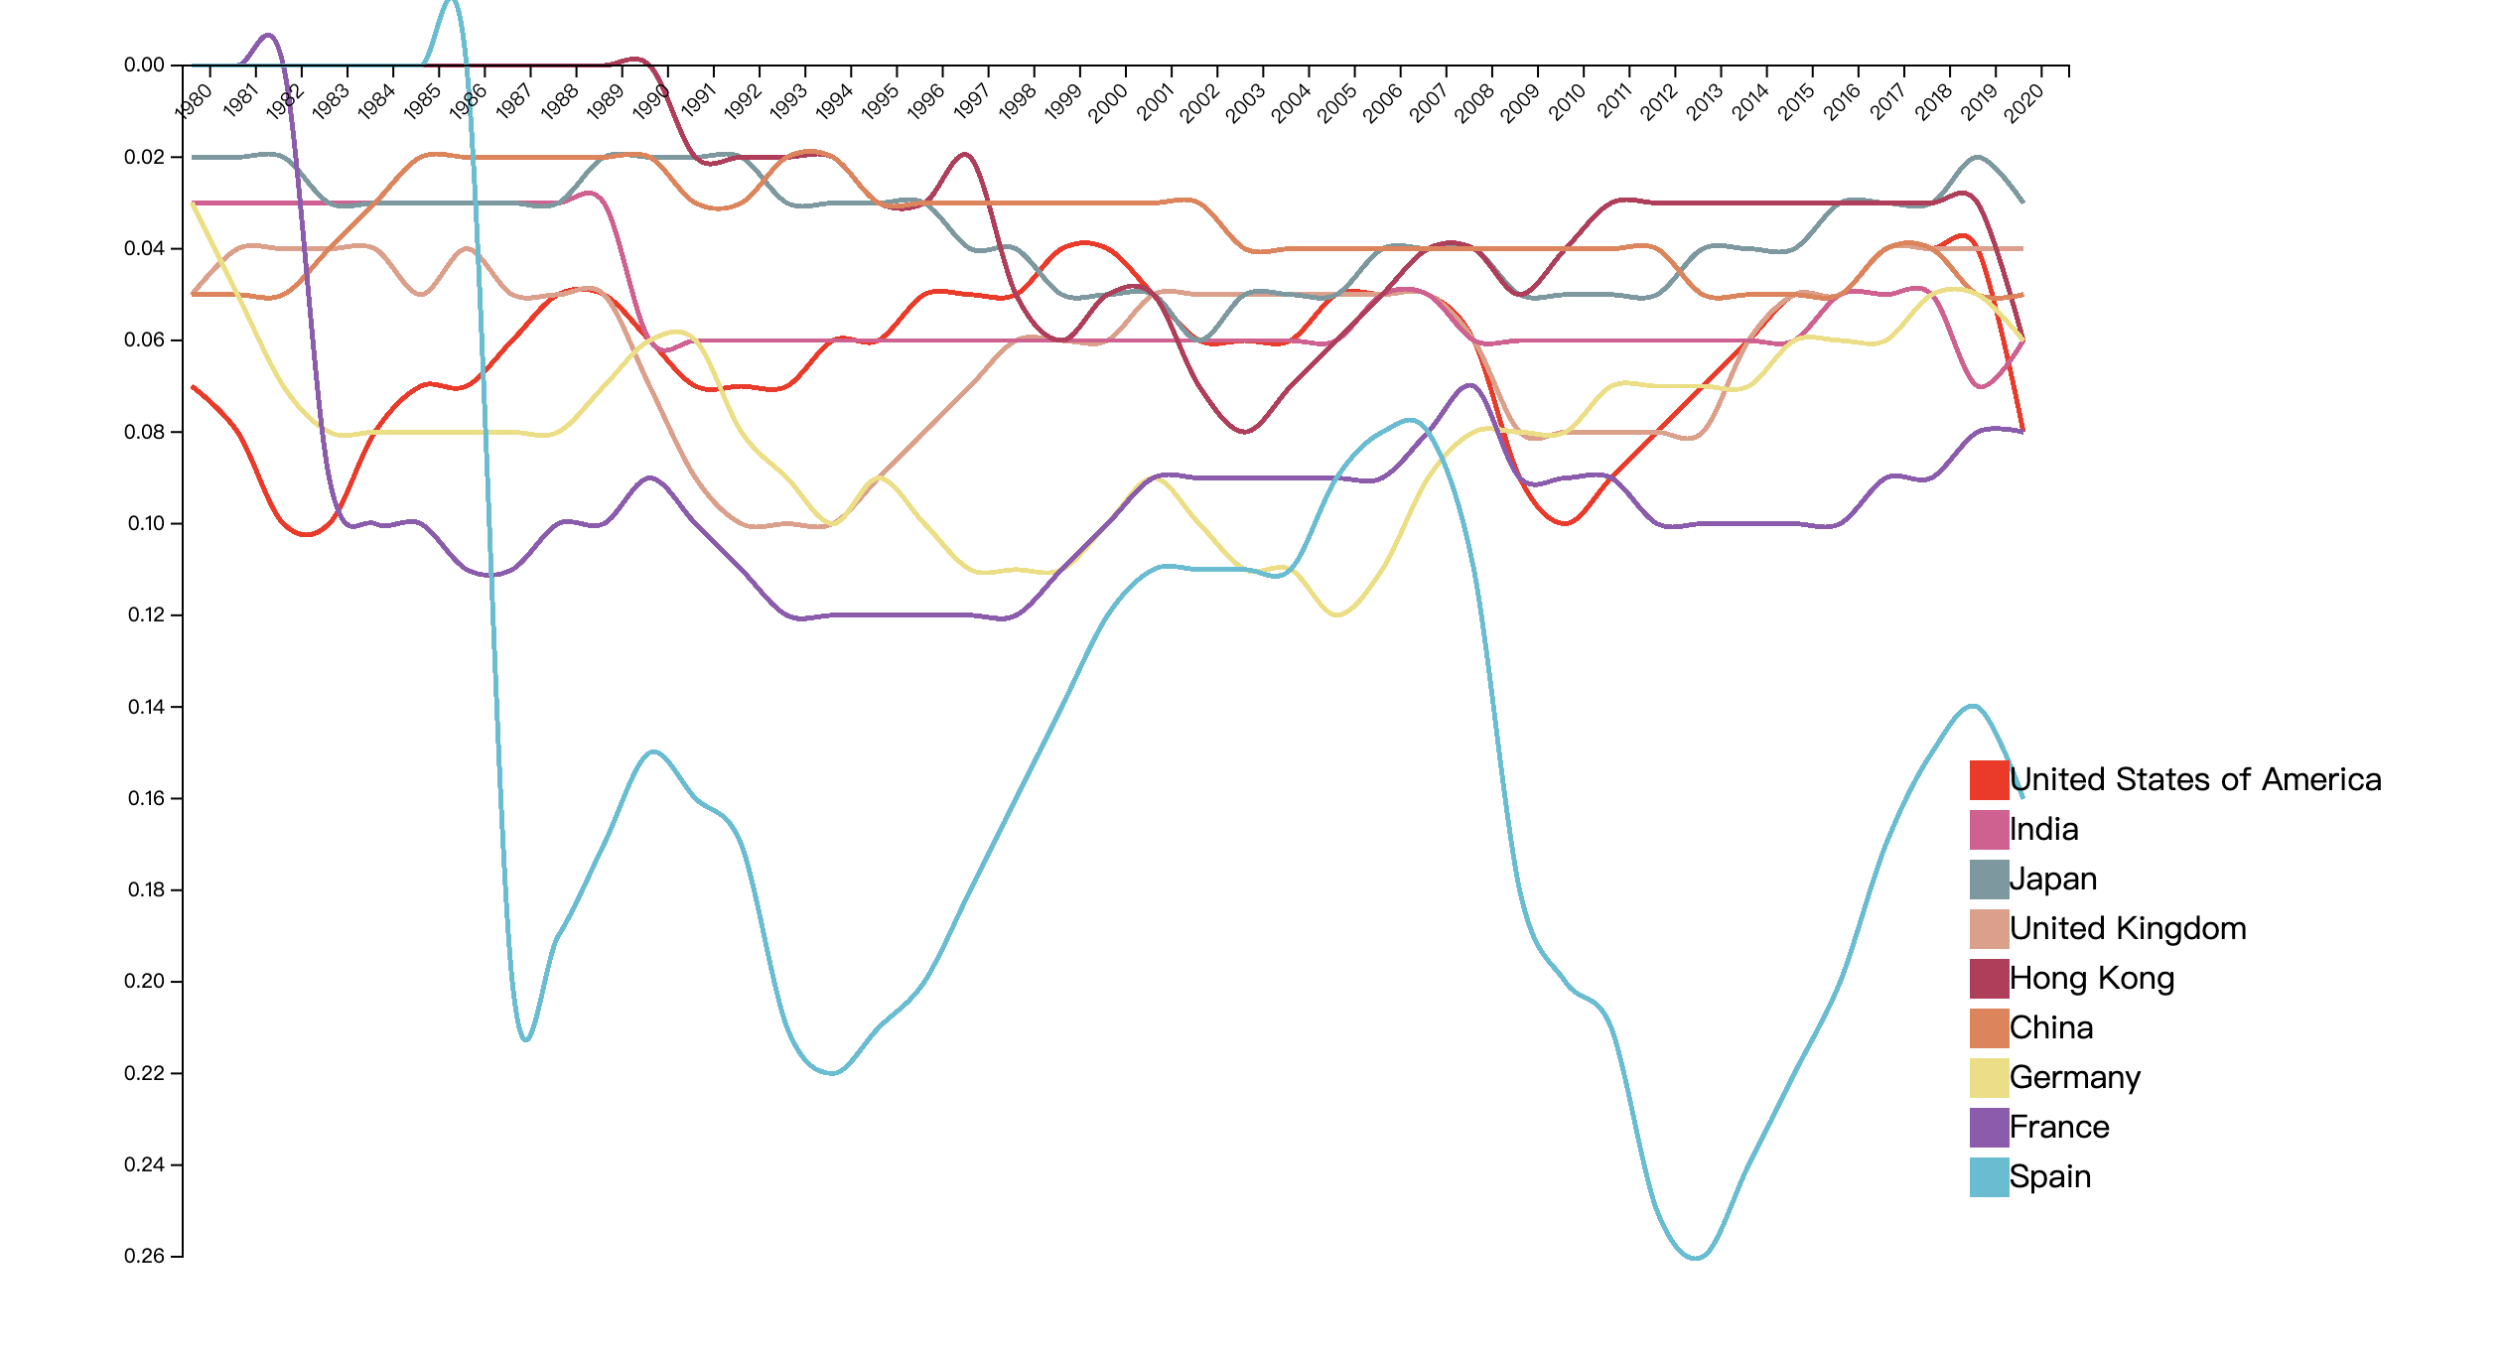

As a whole, we can see in Spain, the unemployment rate is highest in recent years and the unemployment rate in France and Germany is the also very high. All the countries experienced fluctuation in unemployment. In contrast, we can see the unemployment in Japan and China is always very low.

2. some economic index in these 20 years in different countries

xValue: percapitaincome

yValue: gdppercent

rValue: log_indexprice

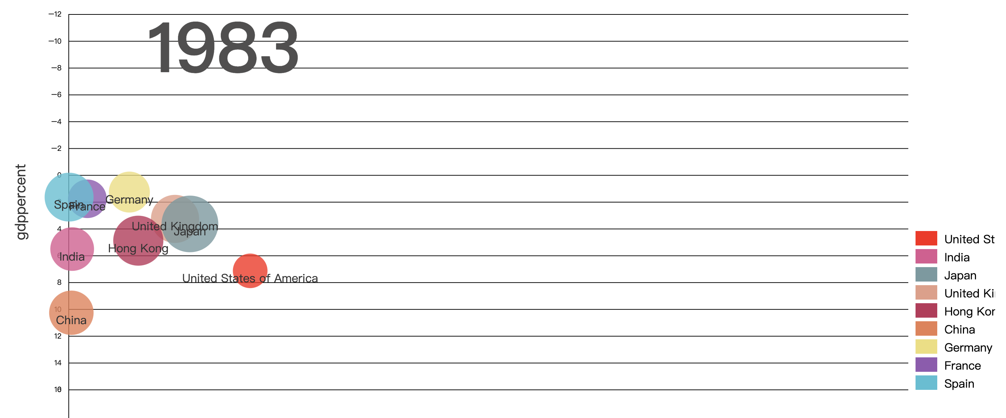

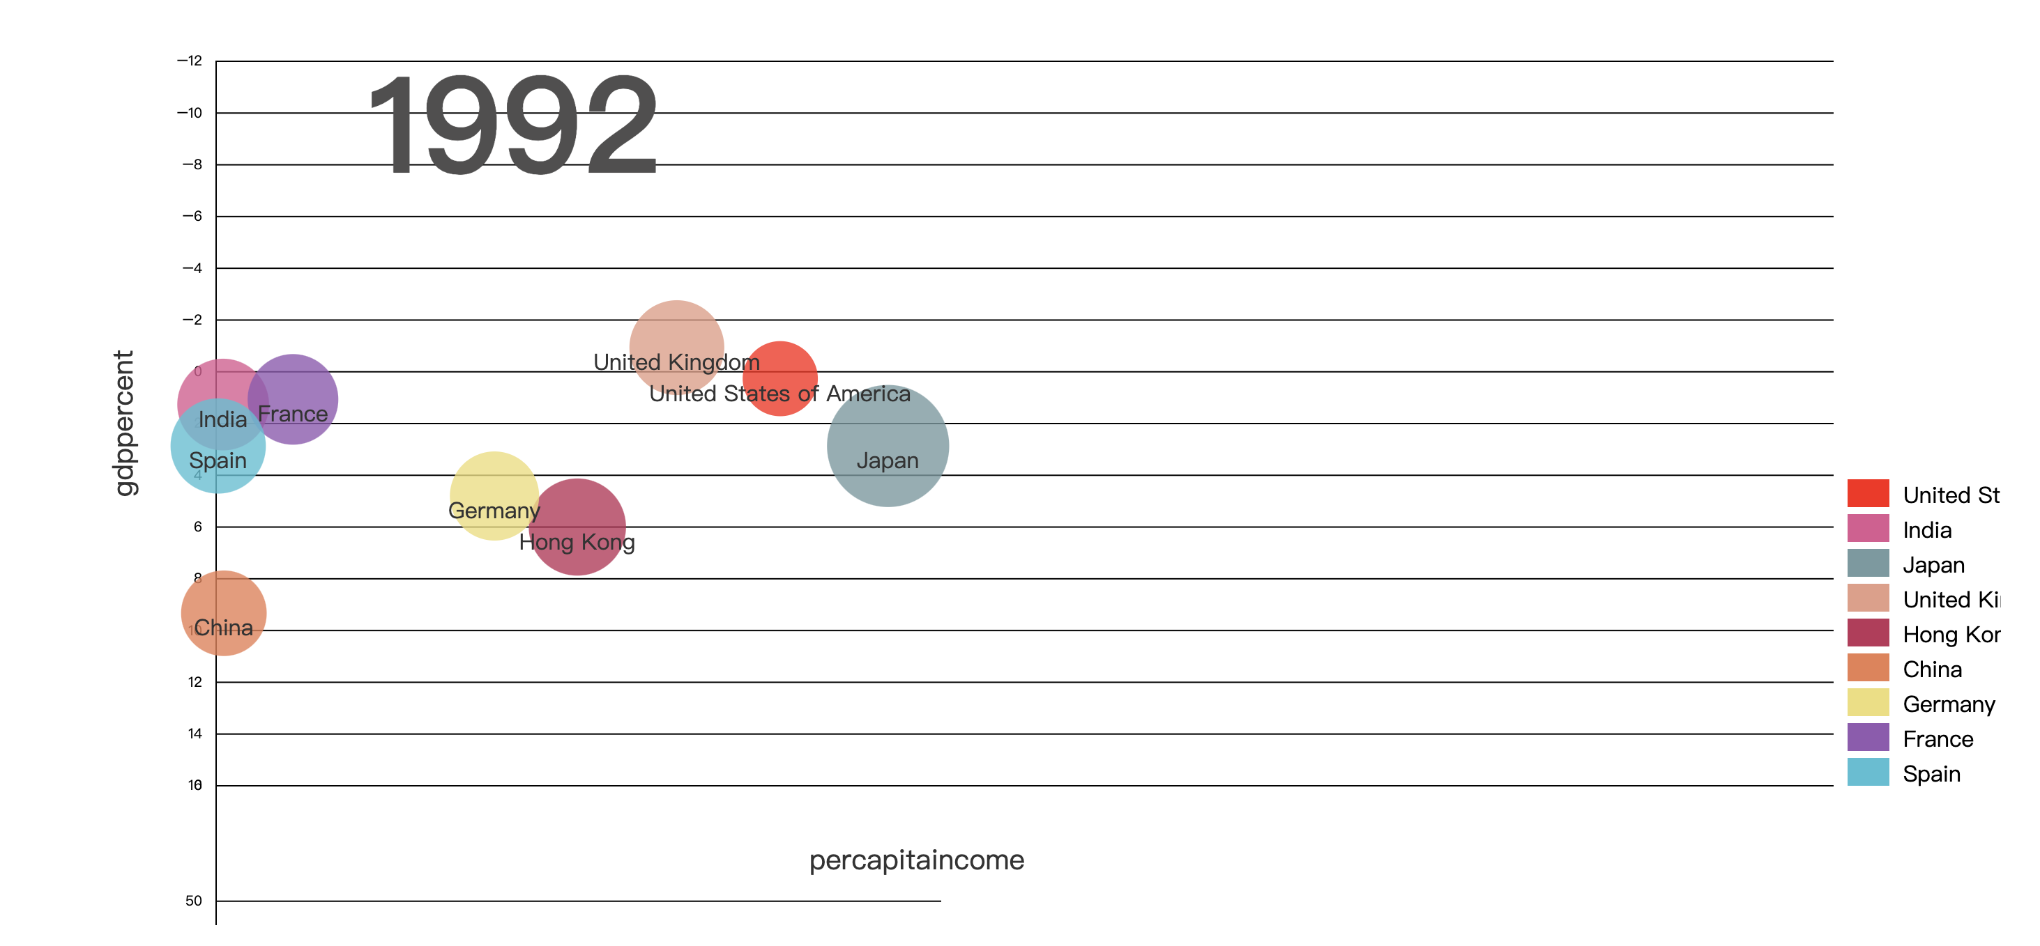

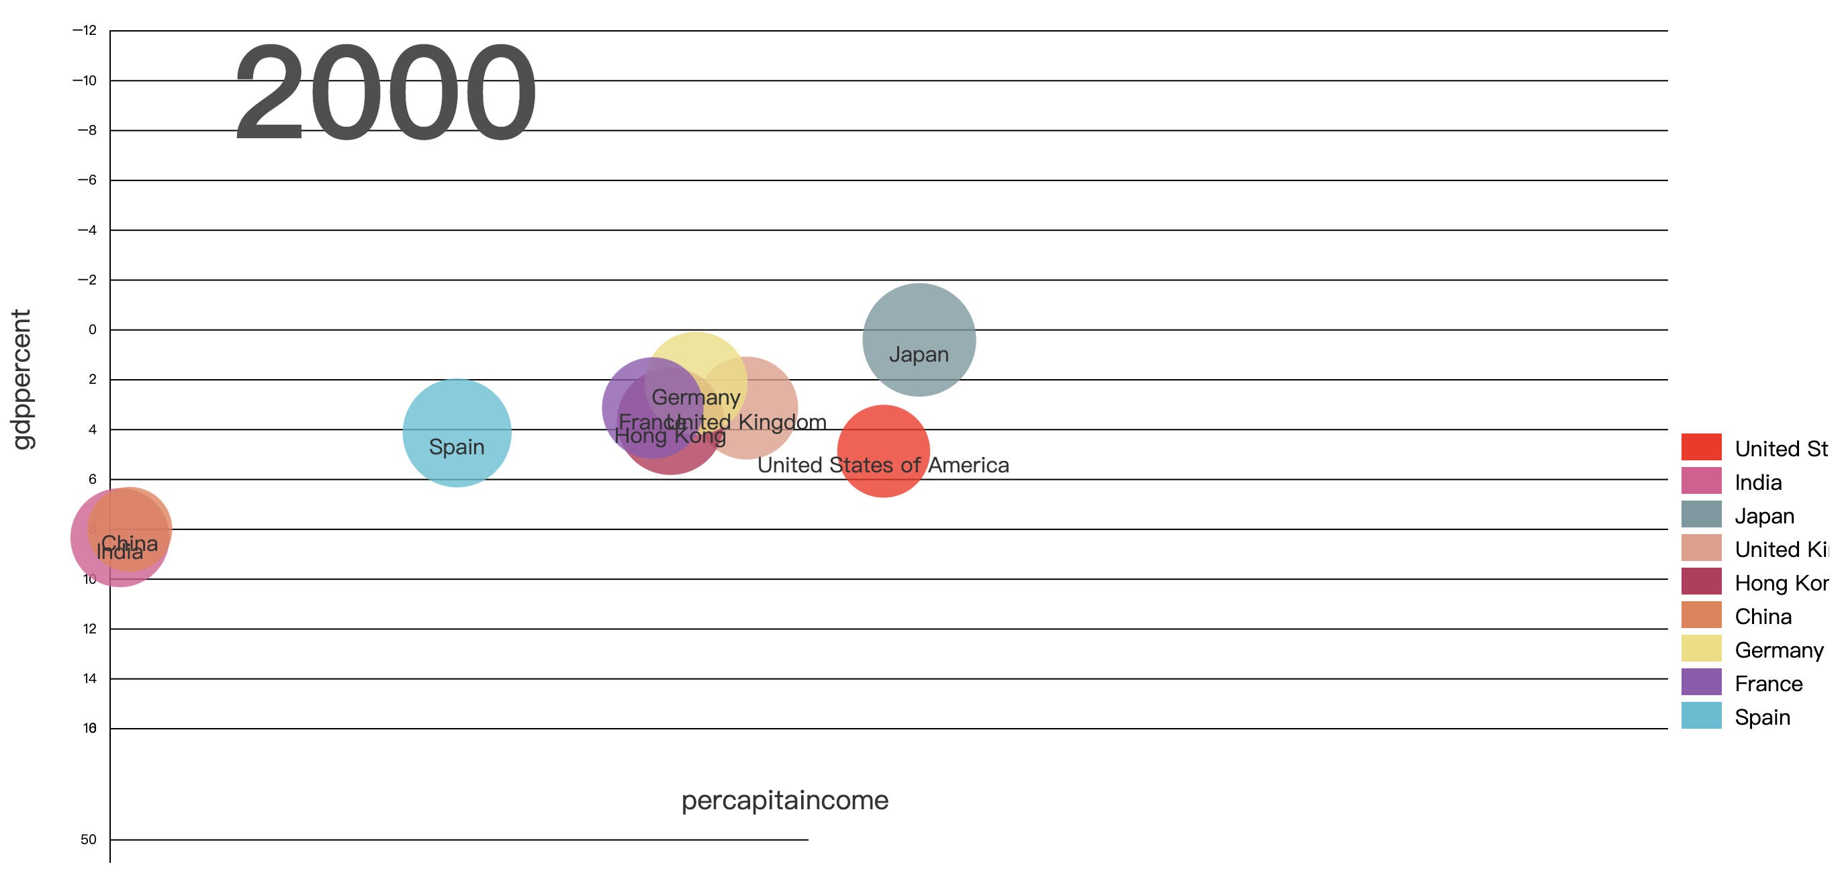

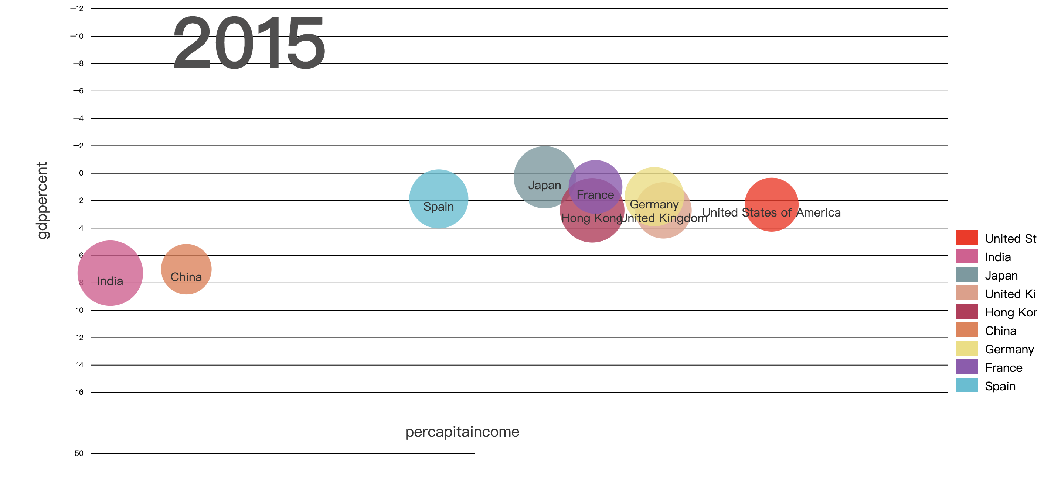

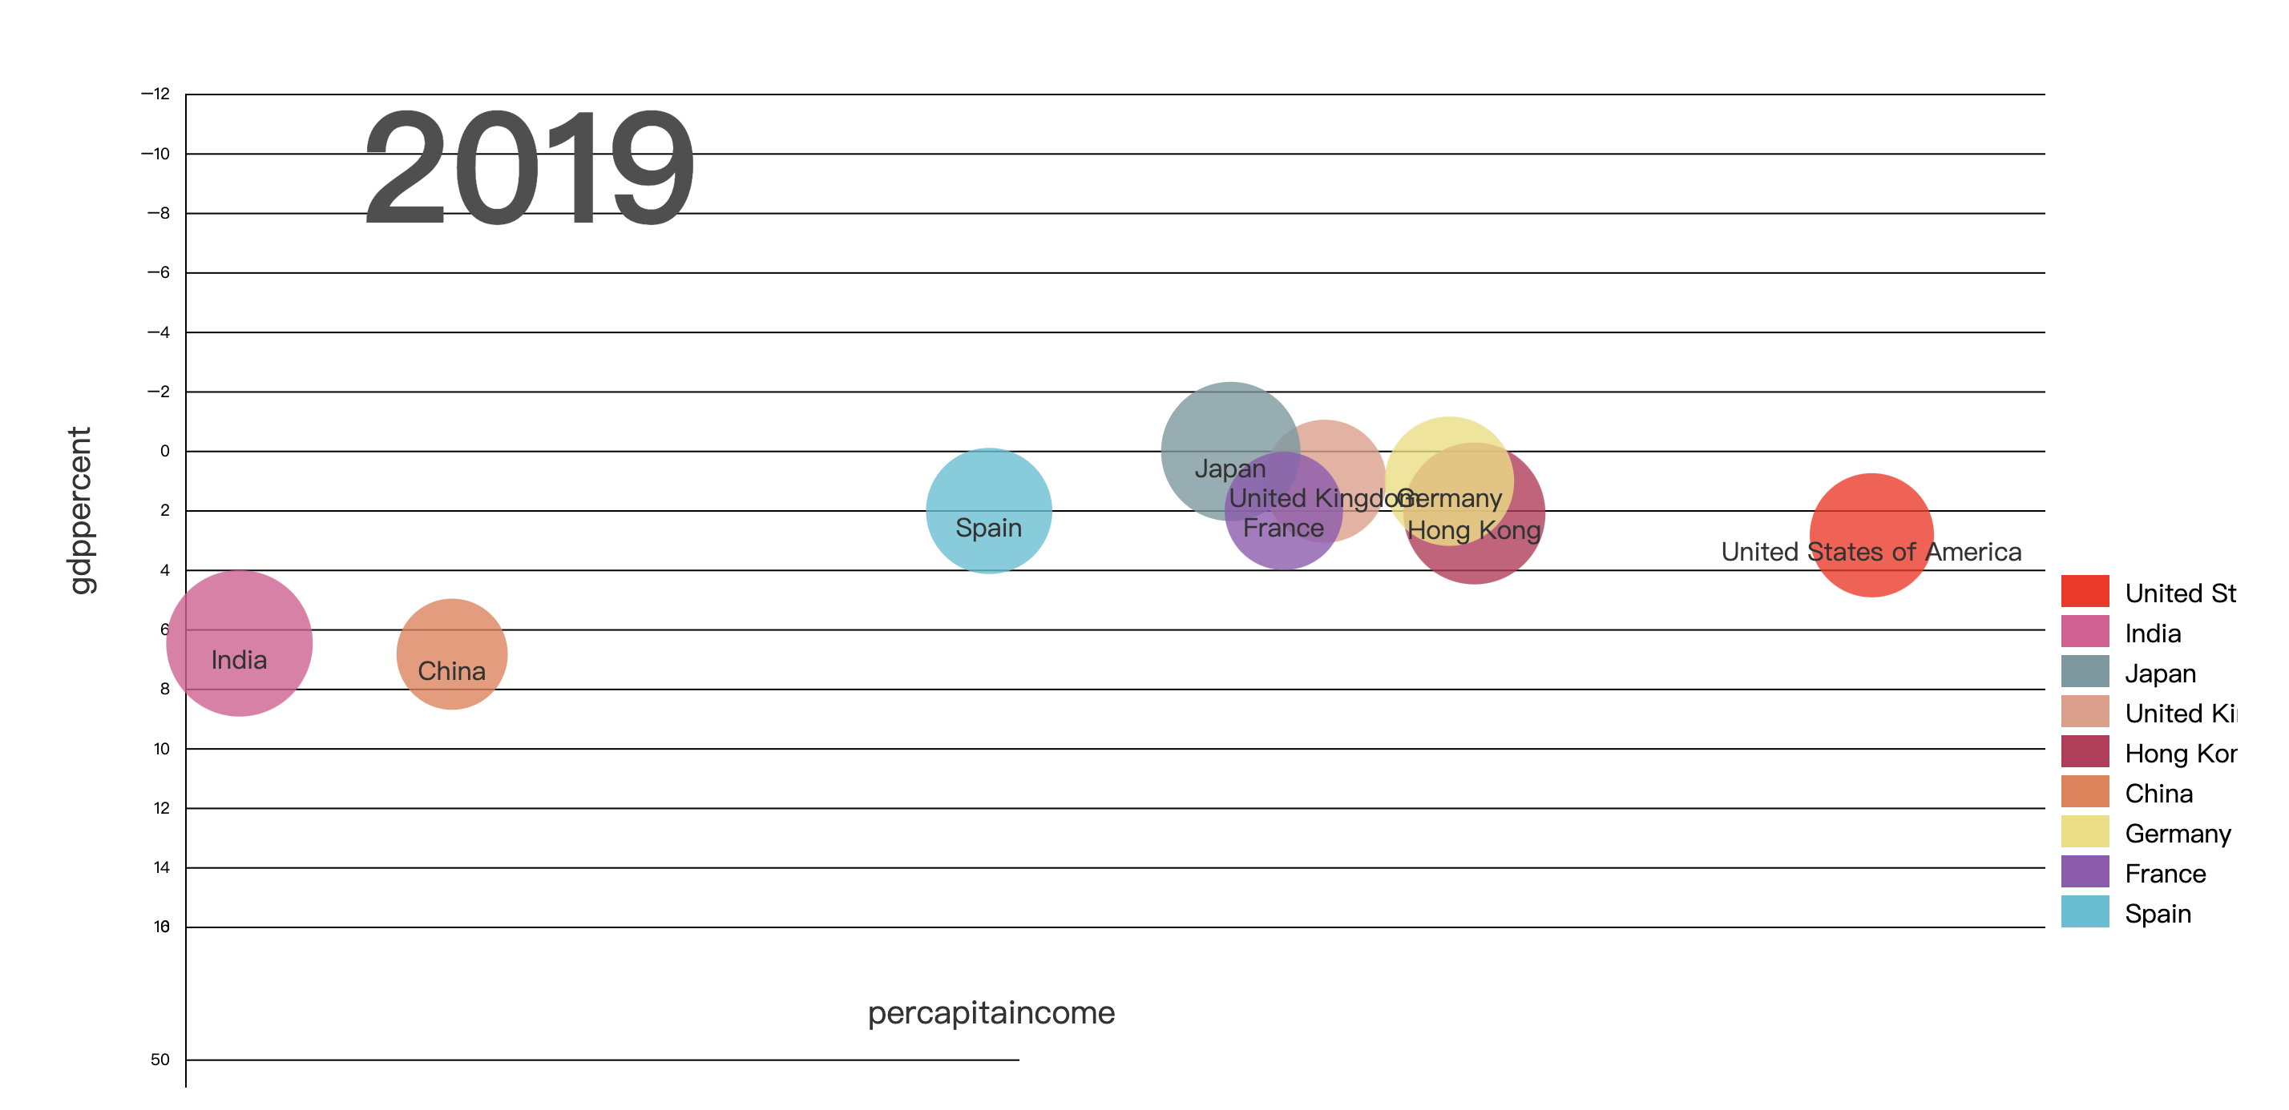

It is an dynamic diagram showing the per capita income, GDP in countries and stock price in the 9 countries. the screen shots shows in some years the situations of these factors. We can see in India and China, the per capita income is always although the GDP is high. It might because the population in the two countries is very high. In earlier years, the citizens in USA have the highest income and in 1990s, Japan developed quickly and the income improved to the highest. Recently, the income in USA improved to the first again, great more than other countries.

3. number of rooms in different part

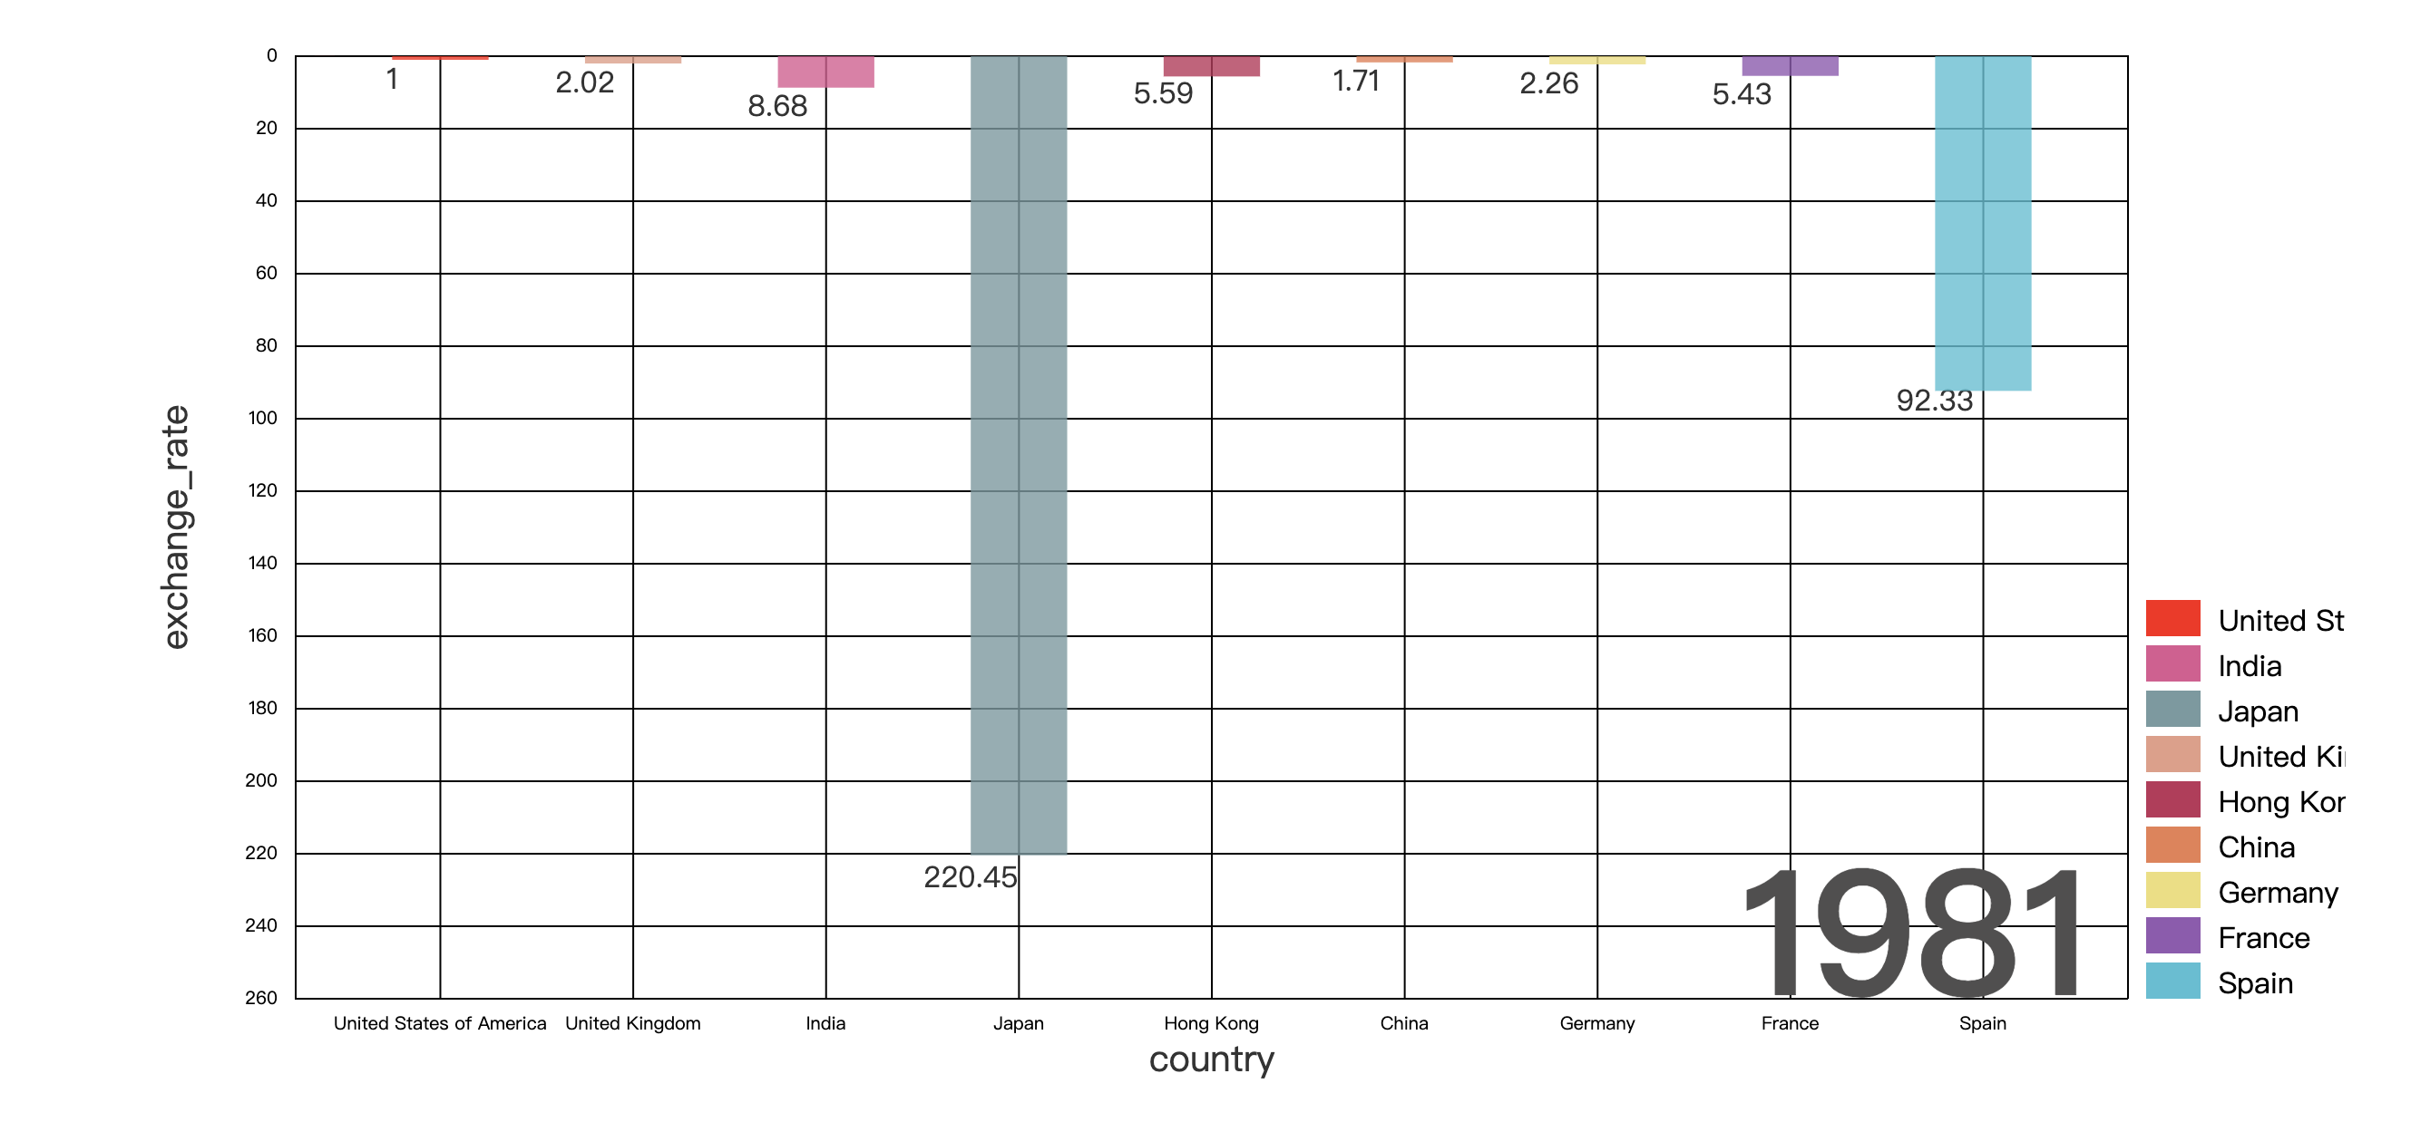

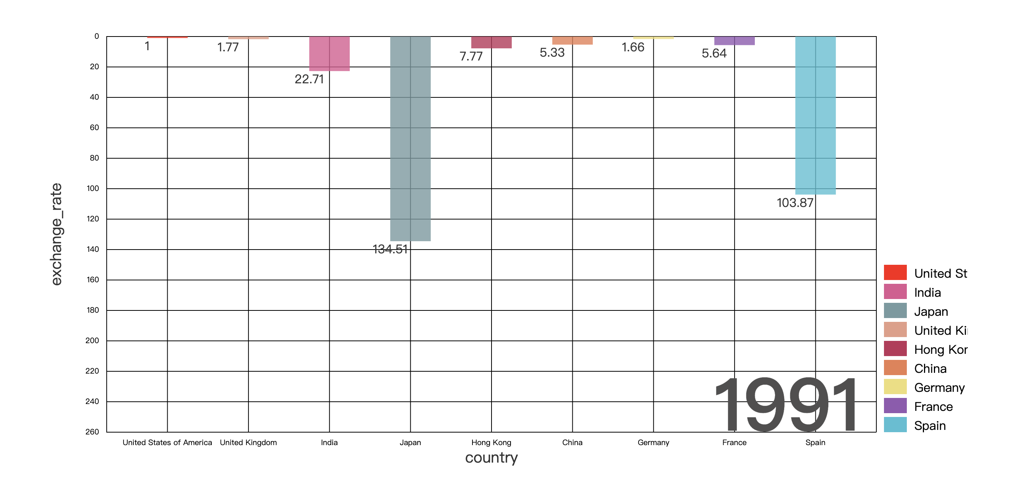

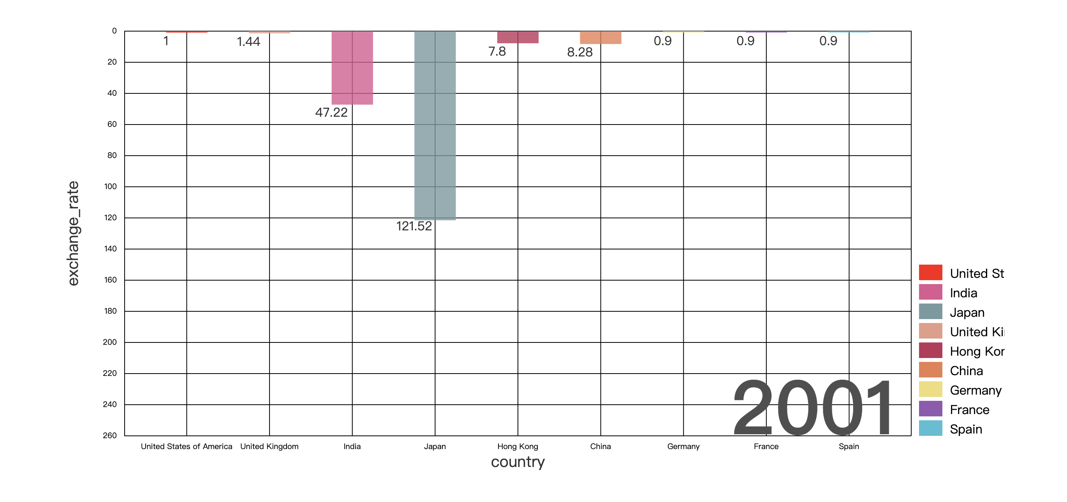

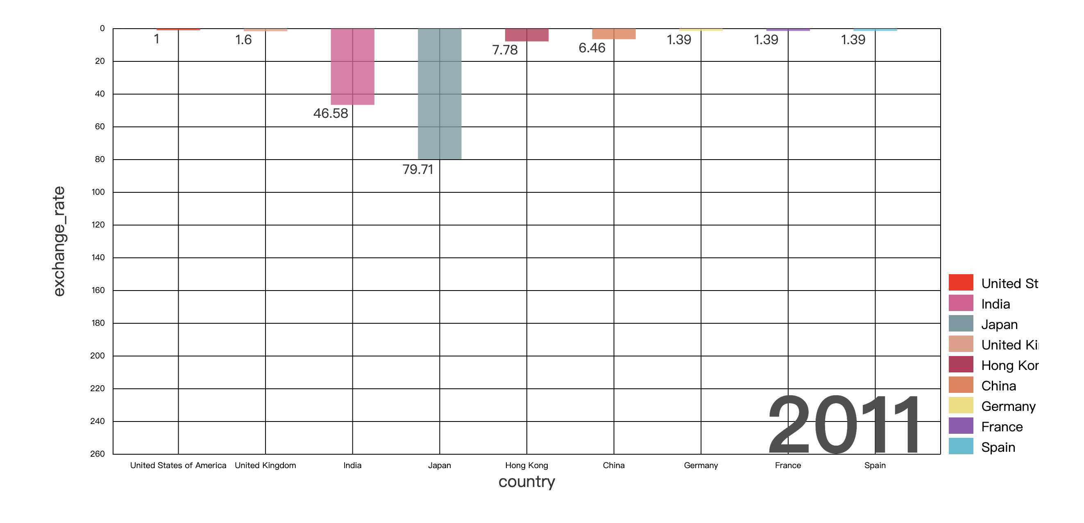

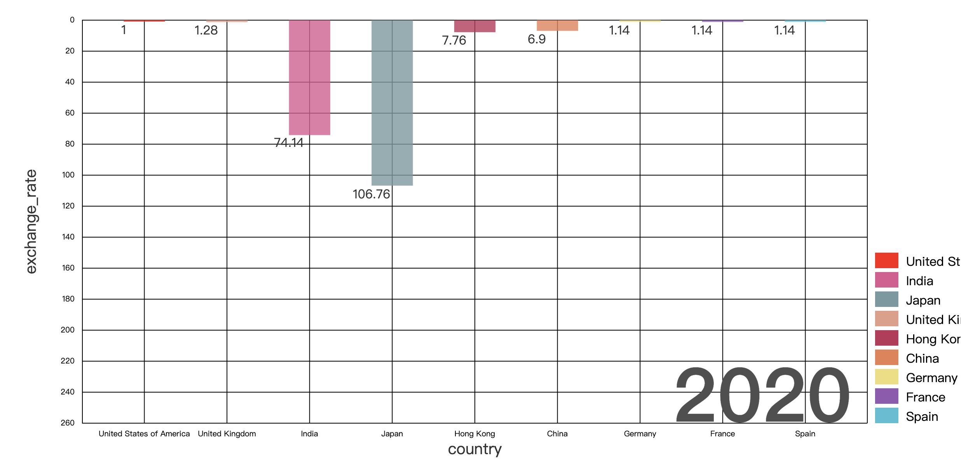

From the perspective of exchange rates, if the exchange rate of the US dollar is 1, compared with the US dollar in other countries, it can be seen that the exchange rates of most countries have changed significantly in the past 40 years. Some countries' currencies have appreciated, while others have experienced significant depreciation.

It is a dynamic plot showing the exchange rate of the 9 countries. From these plots, we can see that the Japanese yen has experienced appreciation and then depreciation, the RMB has experienced severe depreciation, the Spanish currency has appreciated significantly, and the Hong Kong dollar, pound, etc. are basically stable.