**Dated: 06-Mar-2018**

**Checking Version Info**

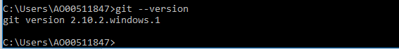

**Setup your name and email id, this helps in keeping track of who did what when we work in team.**



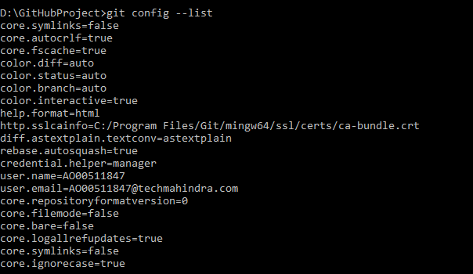

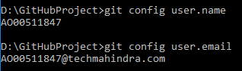

1. **Creating local repository (directory in which you will be creating your project.**
2. **Initializing a git repository in the root of the folder, it will create a folder named “.git(hidden folder)” in your local repository**

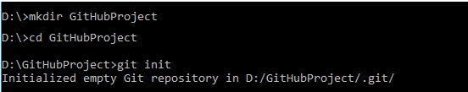

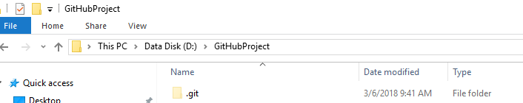

**Adding a new file to the local repository**

* We can add our project files (manually) to the local repository. However, “git” would NOT be able to keep track of the file unless we explicitly tell it to via “git add…” command. After adding/creating a file in the local repository, we can make use of the “git status” command to view the status of the file.

Manually added the file “batchSetup.py” to the local repository

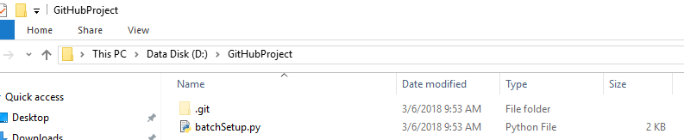

Getting the repository status

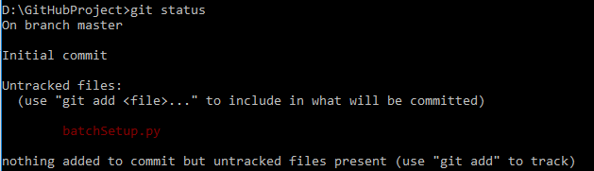

* When NO file is added to the local Repository & we execute the command **“git status”** then it will produce the following output:-



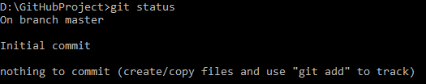

**Adding a file to the Staging environment**

* To add a file to a commit, we first need to add it to the staging environment. To do this, we can use the git add**<filename>**command.

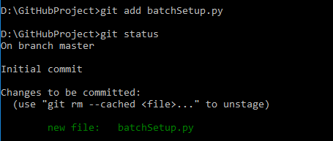

**Creating a Commit**

### Run the command git commit -m "Your message about the commit"

### 

**Creating a new Branch**

Branches allow you to move back and forth between 'states' of a project.

* To create a new branch, use the following command



* To confirm that the new branch is created.

### Note: The branch name with the asterisk next to it indicates which branch you are pointing to at that given time.



* To move to the new branch (i.e. check out to your new branch).

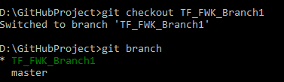

**Note:** Creating a branch and moving to that branch can be club together in a single command as mentioned below-

[**git checkout -b <my branch name>**](http://git-scm.com/docs/git-checkout)

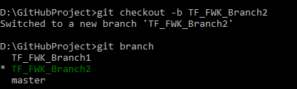

* Now, to **Merge** changes made to a new branch, we need to perform the following:-
  + Commit the changes on New Branch (i.e. TF_FWK_Branch1).
  + Checkout to the Master Branch.
  + Merge the New Branch with the Master Branch.
* Once the use of New Branch is over then we can delete this Branch.