Abstract

This is the project proposal for Cultural / Entertainment problem

24S1-C-NYP-ITI105 - MACHINE LEARNING PROJECT

Final Report

Lye Suh Jeng (7487427Y)  
Lee Li Neng (6203055B)

Lim Chan Boon (9704541M)

Date: 11 August 2024

Table of Contents

1. Project 2

2. ML Formulation 2

3. High Level steps in Machine Learning 3

4. Data Preparation & Feature Engineering 3

4.1 Data Preparation & Feature engineering steps 3

4.2 Lesson Learnt in Data Preparation & Feature engineering 6

5. Modelling and Experiments 7

5.1 Modeling and performance measurement 7

5.2 Lesson Learnt in Modeling 9

6. Deployment 9

7. Alternative to Machine Learning 11

# 1. Project

4. Cultural/Entertainment

a) The success of the song can often been measured by whether the song is on the Hit Chart such as Billboard Hot 100. It is important for music labels to know what makes a song successful so that they can focus their budget on making songs that has the highest chance of being successful.

# ML Formulation

We would like to create a machine learning solutions that can predict the song’s popularity score using dataset gotten from <https://www.kaggle.com/datasets/yasserh/song-popularity-dataset>.

This is a regression problem with target as song_popularity, which represent the song popularity score.

The output of the solutions will be:

1. Song_popularity score (range from 0 t o100). Score closer to 100 will be most popular and score near to 0 is less popular.
2. Interpretation of the score as follows:
   * ‘Very popular and has high potential to be top10’ if song_popularity >= 75
   * ‘Moderate popularity’ if song_popularity >= 50
   * ‘Low popularity’ if song_polarity < 50

The input of the solutions will be all or some of the features in song_data.csv depends on the outcome of the feature engineering as follows:

* + song_duration_ms
  + acousticness,
  + danceability,
  + energy,
  + instrumentalness,
  + key
  + liveness
  + loudness
  + audio_mode
  + speechiness
  + tempo time_signature
  + audio_valence

# High Level steps in Machine Learning

The following steps are taken in the machine learning:

1. Load dataset
2. Discover & visualize data to gain insights
3. Prepare data
4. Feature engineering
5. Split data into train and test datasets
6. Train, fine tune and evaluate models
7. Compare performance of models
8. Choose the best Model
9. Visualize the prediction outcome using residual plots
10. Deploy the model

# 4. Data Preparation & Feature Engineering

## 4.1 Data Preparation & Feature engineering steps

The following are the steps taken in data preparation:

1. Identify target as song_popularity (range from 0 to 100. Higher score means more popular)
2. Check & confirm no missing data and no non-numeric data.
3. Remove ‘song_name’ (which represent name of songs) which doesn’t contribute to song_popularity score.
4. Remove outliners:
   * As in box plots below, there are outliners in song_durations, dancebility, liveness, loudness, speechiness and tempo

* In order not to remove too much data, we try to remove outliners in ‘tempo’, ‘danceability’ and ‘energy’ feature. Data in these 3 featues which are outside of 40% of IQR for both Q1 and Q3 ends will be removed.
* A total of 521 records are removed. After removal, 18314 data remained.
* This approach improve the performance of the model trained using Random Forrest (best model) as the Adjusted R2 (test) increase after removing the outliners.

|  |  |  |
| --- | --- | --- |
|  | Without Removing any Outliner | Remove Outliners |
| Adjusted R2 (Train) | 0.970398 | 0.968838 |
| Adjusted R2 (Test) | 0.857966 | 0.862545 |

1. Identify 13 features as in other columns in the song_data.csv.
2. From the 13 features, identify 10 numeric and 3 categorical features.
   * Numeric features: 'song_duration_ms', 'acousticness', 'danceability', 'energy', 'instrumentalness', 'liveness', 'loudness', 'speechiness', 'tempo', 'audio_valence'
   * Categorical features: 'audio_mode', 'time_signature', 'key'
3. Encode categorical features using dummy enconding. Additional features introduced due to encording are:
   * 'audio_mode_0', 'audio_mode_1', 'time_signature_0', 'time_signature_1', 'time_signature_3', 'time_signature_4', 'time_signature_5', 'key_0', 'key_1', 'key_2', 'key_3', 'key_4', 'key_5', 'key_6', 'key_7', 'key_8', 'key_9', 'key_10', 'key_11'.
4. Handle Imbalanced datasets:
   * Majority of the data are with song_popularity in score range from 50 to 75 (third quartile, Q3)
   * The spread of song_popularity of the total 18835 records are:
     + Q1 (song_popularity score <= 25): 2316
     + Q2 (song_popularity score > 25 & <=50): 5030
     + Q3 (song_popularity score > 50 & <=75):8063
     + Q4 (song_popularity score <= 25): 2382: 2563
   * Records in Q1, Q2 and Q4 are upsampled (duplicate some records using ‘resample’ function in sklern.utils) to the same amout of records as in Q3.
   * This approach prevent ML learning from being weaker in predicting song_popularity in minitory quartiles, especially Q1.
   * This approach significantly improve the performance of the best trained model (Random Forrest) as showed in table below:

|  |  |  |
| --- | --- | --- |
|  | Without handling of imbalanced dataset | With handling of imbalanced dataset |
| Adjusted R2 (Train) | 0.263 | 0.970 |
| Adjusted R2 (Test) | 0.049 | 0.858 |

1. Feature reduction
   * 2 approaches are used:
     + Using Lasso Regression
       - GridSearch is used to fine the best alpha parameter.
       - Using alpha = 0.008, it’s found that ‘time_signature_0’ and ‘time_signature_5 has Zero value (0) of coef_ parameter ventor, which means tht these 2 features can be removed.
     + Using Variance Inflation Factor (VIF)
       - We use threshold of VIF value > 5 as the guidelines to remove a feature.
       - It’s found that 'time_signature_3', 'time_signature_4', 'key_10', 'key_9', 'key_8', 'key_7', 'key_6', 'key_5', 'key_4', 'key_3', 'key_2', 'key_1', 'key_0', 'time_signature_5', 'key_11', 'time_signature_1', 'time_signature_0', 'audio_mode_1', 'audio_mode_0' have VIF value of inf (Infinite) which is greater than 5.
   * We decided to remove features as recommeded by VIF. With this, 10 featues are remained, which are:
     + 'song_duration_ms', 'acousticness', 'danceability', 'energy', 'instrumentalness', 'liveness', 'loudness', 'speechiness', 'tempo', 'audio_valence'
   * This approach improve the performance of the best trained model (Random Forrest) as showed in table below:

|  |  |  |
| --- | --- | --- |
|  | Without removing categorical features | With removing categorical features |
| Adjusted R2 (Train) | 0.970 | 0.970 |
| Adjusted R2 (Test) | 0.694 | 0.858 |

## 4.2 Lesson Learnt in Data Preparation & Feature engineering

We learnt the following during the data prepration and feature engineering:

* Handling Imbalanced data sets in regression problem is a must! Without it, we won’t train a good model at all despite doing any other feature engineering.
* Besides using Lasso Regression and VIF, we tried PCA (Principle Components Analysis) as well in feature or dimensionality reduction. (We tried before handle the imbalanced data sets). We found that PCA won’t be efficient for this case. As shown in the graph below, the need to added up many PC components in order to reach 95% of variance ratio, which end up didn’t reduce number of features.

* MinMaxScaler is better than StandardScaler in model trained using Random Forrest algorithms as showned in the table below. Model trained using MinMaxScaler has higher Adjusted R2 (test) compared to model trained using StandardScaler. We think it’s due to the dataset is not normally distributed and have outliers. Thus MinMaxScaler is a better choice than StandardScaler.

|  |  |  |
| --- | --- | --- |
|  | Use of MinMaxScaler | Use of StandardScaler |
| Adjusted R2 (Test) | 0.858 | 0.605 |

* Removing outliners help in improve the performance of model training. However, detecting outliners and the challenge of having too little data after removing outliners are challenge. Plotting box plot helps us to to see the distributing of data. However, some trial and error tests are required in order to confirm removing too many data.

# 5. Modelling and Experiments

## 5.1 Modeling and performance measurement

The following algorithms has been tried to train the regression model:

* Polynomial Regression (PR)
* Multiple Linear Regression (MLR)
* Elastic Net Regression (ENR)
* Adaboost (ADA)
* Gradient Boosting Regressor (GBR)
* Support Vector Regression wth RBF kernel (RBF)
* Random Forest Regressor (RF)

Table below shows the performance comparision of various models

|  |  |  |  |  |  |  |  |
| --- | --- | --- | --- | --- | --- | --- | --- |
| **Performance**  **Measurement** | **PR** | **MLR** | **ENR** | **ADA** | **GBR** | **RBF** | **RF** |
| **r2_train** | 0.170854 | 0.076067 | 0.076063 | 0.124957 | 0.971575 | 0.407133 | 0.970408 |
| **r2_test** | 0.154709 | 0.073771 | 0.073816 | 0.117043 | 0.850182 | 0.321603 | 0.858158 |
| **adj_r2_train** | 0.170574 | 0.075755 | 0.075751 | 0.124661 | 0.971566 | 0.406933 | 0.970398 |
| **adj_r2_test** | 0.153566 | 0.072518 | 0.072563 | 0.115849 | 0.849979 | 0.320685 | 0.857966 |
| **mse_train** | 631.327147 | 703.49917 | 703.502735 | 666.274002 | 21.643143 | 451.419624 | 22.531548 |
| **mse_test** | 644.244912 | 705.932196 | 705.898034 | 672.952206 | 114.18526 | 517.045512 | 108.105886 |

Legend of Performance Measurements:

* R2_train: coefficient of determination, R2  of train data
* R2_test: coefficient of determination, R2  of test data
* adj_r2_train: Adjusted R2  of train data
* adj_r2_test: Adjusted R2  of test data
* mse_train: Mean squared error of train data
* mse_test: Mean squared error of test data

Among all the performance measurement, we use adjusted R2  of test data (adj_r2_test) as bench mark. GBR and RF are the best models as both have high adj_r2_test(adj_r2_test) . RF has slighly higher adjusted_R2_test compared to GBR. Thus, we choose RF as the best model to predict the song_popularity score.

Hyperparameter tuninig is performed using either Random search or Grid search to find out the best parameter in all models except PR models.

In order to visualise the performance of the trained model, we plot histograms and Residual plot of the best model trained using Random Forrest as shown below:

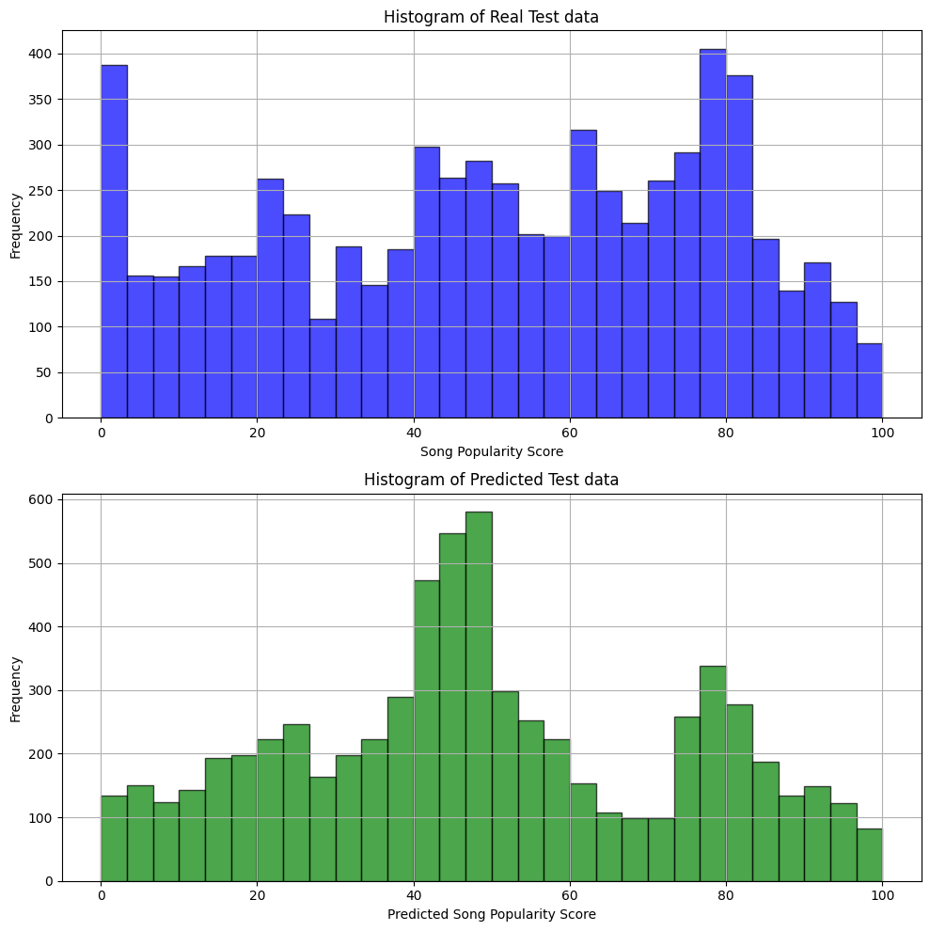

Both plots give us a rough idea how good is the trained models. We obeserve that:

- From histogram, we can see some discrepancy between predicted data and real test data. For instance, the model predicted less number of song_popularity score for score range from 0 to 3 (predicted ~ 130 records) compared to real test data ( ~> 370 records).

- From the residual plot, each dot represent (x = predicted data, y= real test data). Majority of the ‘dots’ are in linear line and many data are in range of 50 song_popularity score.

- Majority of the predictions are quite close to real value of test data. Of course, the predictions are not totally 100% accurate!

## 5.2 Lesson Learnt in Modeling

We observed that:

* Hyperparameter tunning and cross-validatation helps to improve the performance of the models.
* Non-parametric algorithms such as Random Forrest and Gradient Boosting Regressor can trained a better models compare to parametric algorithms such as Polynomial Regressor. However, non-parametric algorithms require more compute resource. Without GPU, it’s time-consuming to train a model using

non-parametric algorithm.

# 6. Deployment

We use Gradio to create an intuitive web-based user interface and use Hugging Face to host the machine learning model. The following is the snapshot of the GUI for music label to key in song’s feature and predict the Song’s Popularity score.

The url of the deployed application in Hugging Face space is: <https://huggingface.co/spaces/suhjeng/Song_Popularity_Predictor>

Here’re the high level procedures in our deployment:

* Use pickle framework to save MinMaxScaler to a .pkl file (as in <https://huggingface.co/spaces/suhjeng/Song_Popularity_Predictor/blob/main/mm_scaler.pkl>) and save the trained modle to another .pkl ( as in https://huggingface.co/spaces/suhjeng/Song_Popularity_Predictor/blob/main/model.pkl) .
* Write a python code to use Gradio module to create a GUI interface
* Prepare ‘requirements.txt’ file that list down out the required modules and library required to install and run the model, as in <https://huggingface.co/spaces/suhjeng/Song_Popularity_Predictor/blob/main/requirements.txt>. We also need to find out the python module version used in model training and specify the exact version of respective modules in requirements.txt, other we hit error during deployment. Here’re the content of requirments.txt:
  + numpy==1.26.4
  + gradio==4.41.0
  + scipy
  + scikit-learn==1.3.2
  + joblib==1.4.2
  + pandas==2.1.4
  + pickle5

# 7. Alternative to Machine Learning

Heuristic approach is…

Heuristic apprroach can be used as baseline to compare with ML performance.

To be done by Gary!

# 8. Code