**ME365D - Task 3**

**Dyab Asdi**

The first thing I did was drop duplicate data in the data frame, and then for certain categories that had strings for data, I converted them to numbers for grouping using Label Encoding.

Next, I ran an optimization sweep for different parameters for the Decision Tree Regressor as well as the train and test split:

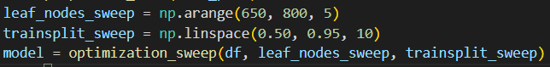

From this, whichever combination of these led to the smallest mean absolute error was printed:

I was only able to get as low as 20.91% for the MAE using this strategy.