**ME365D - Task 4**

**Dyab Asdi**

The first step was to look at the data within the tables and understand what it is showing. From there, I realized that there were a lot of column values that couldn’t be decimal points, meaning that using a regression model would not have worked the best for this.

I needed to convert object columns that were integers into strings, as shown below:

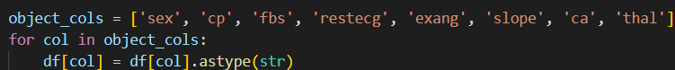

Now that the data was ready, I decided to use a random forest classification algorithm to predict heart disease.

This was able to get me **82.89%** accuracy for the model, meaning we can predict heart disease most of the time.