1. LE1-1-P1.py

1. LE1-1-P2.py

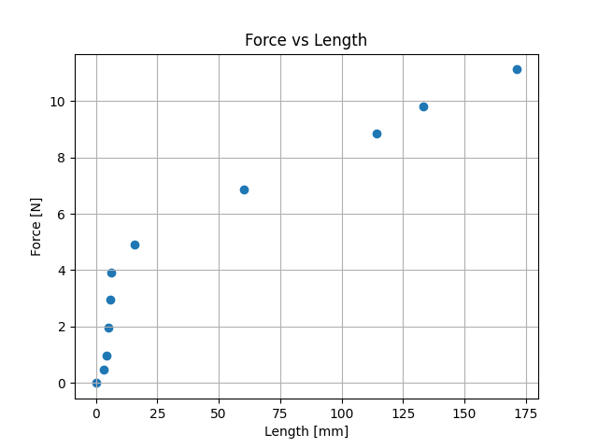

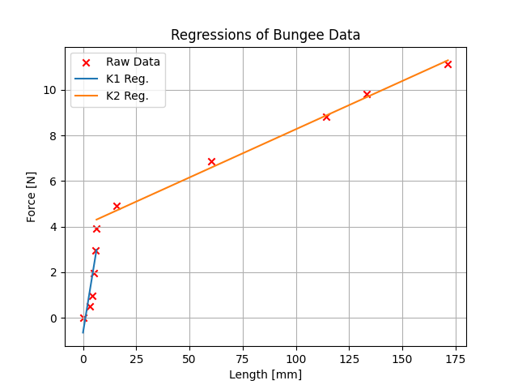

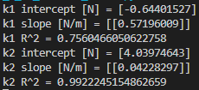

If we had only used one linear regression, the data would be inaccurate. Using two linear regression models makes it much more accurate when there are big slope changes at certain points, as shown in the graph for part 2.