|  |  |  |  |
| --- | --- | --- | --- |
| **Integer [Volts]** | 1.25 | 2.67 | 4.09 |
| **Angular Displacement [deg]** | -90 | 0 | 90 |

|  |  |
| --- | --- |
| **Slope [deg/V]** | 63.38 |
| **Intercept [deg]** | -169.23 |
| **R^2** | 1.0 |

The slope signifies that with each 1-volt change, the angular displacement increases by 63.38 degrees. The intercept indicates the angular displacement at zero voltage. An R^2 value of 1.0 indicates a perfect fit and signifies a precise linear calibration representation.

|  |  |
| --- | --- |
| **Coefficient Name** | **Value** |
| Linear Coefficient (b0) | 0.00001 |
| Torque Coefficient (t0) | 0.007 |

The above values for the linear coefficient and torque coefficient allowed me to match my simulation to my measured response.

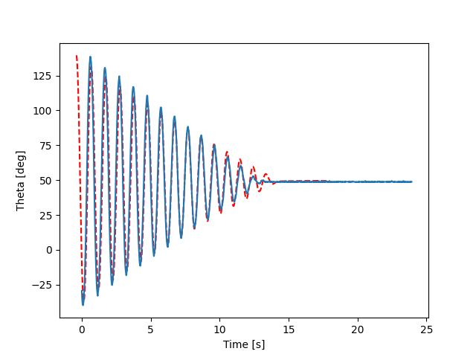

|  |  |
| --- | --- |
| **Parameter** | **Value** |
| Mass | 0.157 kg |
| Gravity | 9.81 m/s^2 |
| Moment of Inertia | 0.00675 |
| Length to CG | 0.19925 |

1. To determine the dominant form of friction, we used both t0 and b0 for adjustments. The torque coefficient t0, however, had the greatest impact on the system, and the linear coefficient b0 had a smaller effect. We made sure to just adjust the middle of the system the best we could rather than the ends, because the ends are more prone to errors.