# Component - Video Clipper

## ∆ Purpose

The purpose of this c# app is to convert all different kinds of music video to 576*1024 size while maintaining the quality within appropriate bitrate for streaming.

## ∆ Workflow

Start

Input

1st Pass

Scale

Clip

Encoding

Decoding

Gather Information

2nd Pass

Scale

Clip

Encoding

Decoding

Output

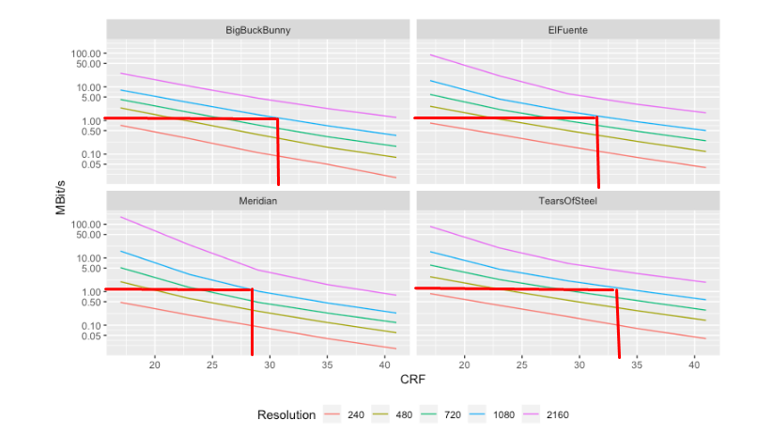

## ∆ Analysis

1. Video

-Codec: H.264

-bitrate: 1000k

-resolution: 576*1024

-CRF: average 25

Between 28 and 33

for 1080

-Lanczos interpolation

-Deblocking Filter

-Fps 30

-Scanning mode: Progressive (default)

We use 2 pass encoding, however we can use CRF

2. Audio

-codec: aac

-bitrate: 128kbps/channel

## ∆ Future Work

To increase the video quality more, we can use more advanced codec – H.265 or H.266 If our intended users’ devices support them, it can be implemented asap.

Can customize framing for music video. Currently based on gopsize 12 which is default for all kinds of video and as our video is music video and quite fast changing, we can improve the quality by reducing gopsize and customizing framing.

But need much time for this