**Coding Troll's Group, May 2017**

**TrollApp messaging app, version 1.0 readme file.**

NOTE: Please make sure you are following this document to set up the environment before testing.

To run this project you will need to do the following:

1. Download and install Spring Tool Suite from <https://spring.io/tools/sts/all>
2. Download and install MySql from <https://www.apachefriends.org/download.html>
3. Apache Tomcat for hosting the web application from <https://tomcat.apache.org/download-60.cgi>
4. Create a database ‘*eatrolls’* (The TrollsAppResrServer includes the populate.sql file that will populate the initial set of data once it started).
5. Download the project files.

* TrollAppClient
* TrollAppRestServer
* TrollAppMqServer

1. *TrollAppClient is* configured to run as two clients at the same time, just on different ports and for safety on different browsers. Thus you need to configure the ports as described in the next step
2. Open an instances of the STS. Create 3 servers in STS with the ports as follows:

* RestServer with the default port **8080**
* TrollAppClientOne with the post **48080**
* TrollAppClientTwo with the post **58080**

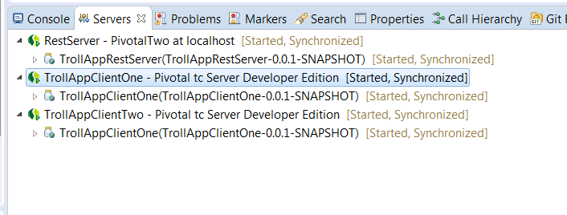

**NOTE**: when creating a server specifically for each package – change the port!

1. Import the project zips files to the STS as specified:
2. Add each project to their server as follows:

TrollAppRestSever to the RestServer Pivotal instance

TrollAppClient to TrollAppClientOne

TrollAppClient to TrollAppClientTwo

Right click on the server instance and add the appropriate application as show in the picture.

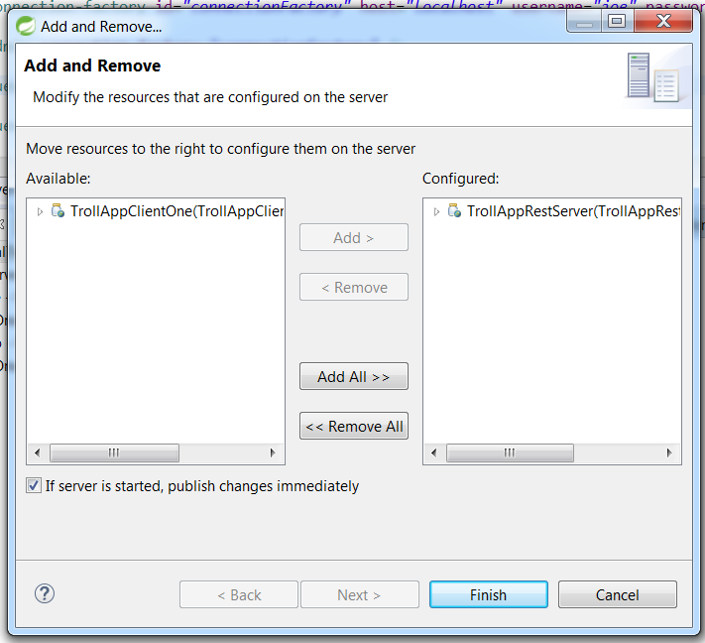

For the TrollAppClients you will have to add JVM properties. Please follow these steps:

**Configure TrollAppClientOne server**

* Run the TrollAppClientOne server.
* Once it is started or even if it gives an error, no problem.
* Stop the server.
* Right click on the project and select Run as -> Run configurations…
* Then click on the Arguments tab and add the following like:

-Dspring.profiles.active="clientone" -Dsender="clientOne" -Dreceiver="clientTwo"

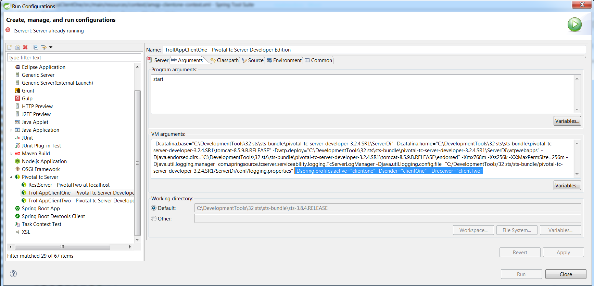

Click apply and you are done with TrollAppClientOne.

**Configure TrollAppClientTwo server**

* Run the TrollAppClientTwo server.
* Once it is started or even if it gives an error, no problem.
* Stop the server.
* Right click on the project and select Run as -> Run configurations…
* Then click on the Arguments tab and add the following like:

-Dspring.profiles.active="clienttwo" -Dsender="clientTwo" -Dreceiver="clientOne"

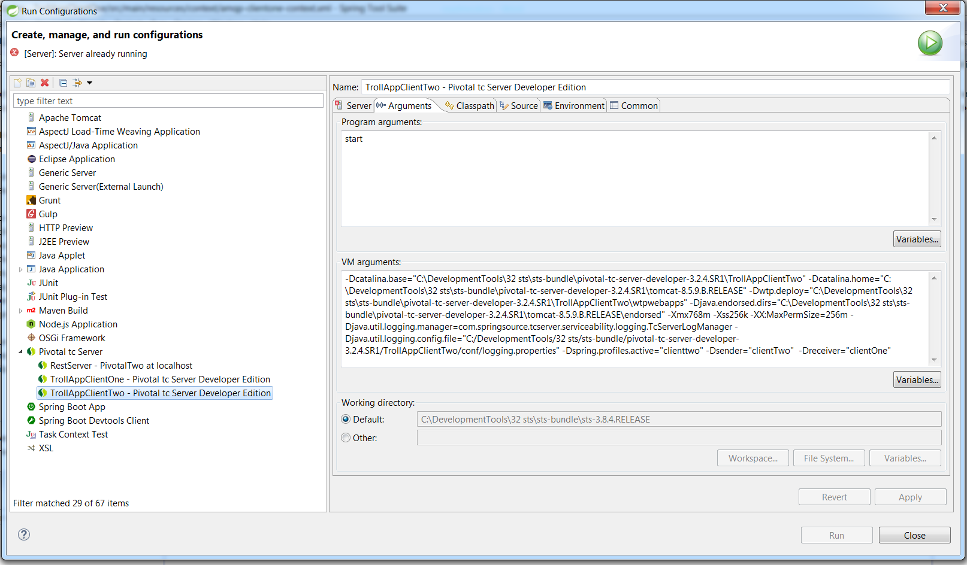

Click apply and you are done with TrollAppClientTwo.

1. To access and run TrollAppClientOne enter this URL in one browser (Chrome for example): <http://localhost:48080/TrollAppClient>
2. To access and run TrollAppClientTwo enter this URL in another browser (Mozilla for example):

<http://localhost:58080/TrollAppClient>

NOTE: Please have clients use different browsers (Chrome and Mozilla for example).

1. When the application starts in the Browser you can log in with name: “admin” and pass: “admin” for one client and ‘guest’/ ‘guest.