Contents

Development Setup 2

How to Test? 2

Screenshots 3

1. Home Page 3

2. View All Instance 3

3. View Single Instance 4

4. Delete an Instance 5

5. Add Coherence Data Tier 6

6. Delete Coherence Tier 7

7. View Compute Status 8

Important 9

## Development Setup

1. Unzip CloudManagementApp.zip file to your Jdeveloper Workspace Location
2. Use JDeveloper & Open the project & give the above unzipped location.
3. Open Resource Folder, Right Click on pom.xml & select “Run Maven Phase Project”

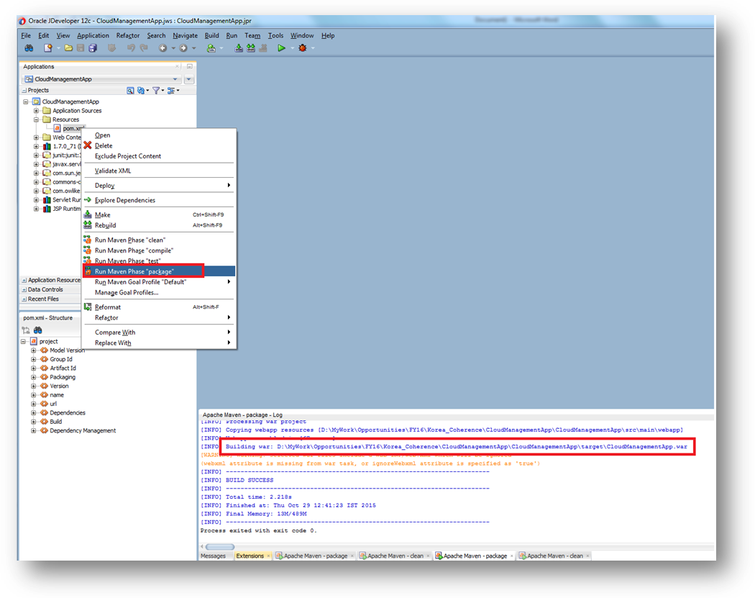

1. Copy the WAR file location from the log window & deploy it on tomcat or Weblogic.
2. Additionally the war has also been provided separately.

## How to Test?

1. Once deployed use the below link in any web browser & refer to the below screenshots.

http://<ip>:<port>/CloudManagementApp/cloudmgmt.jsp

## Screenshots

### Home Page

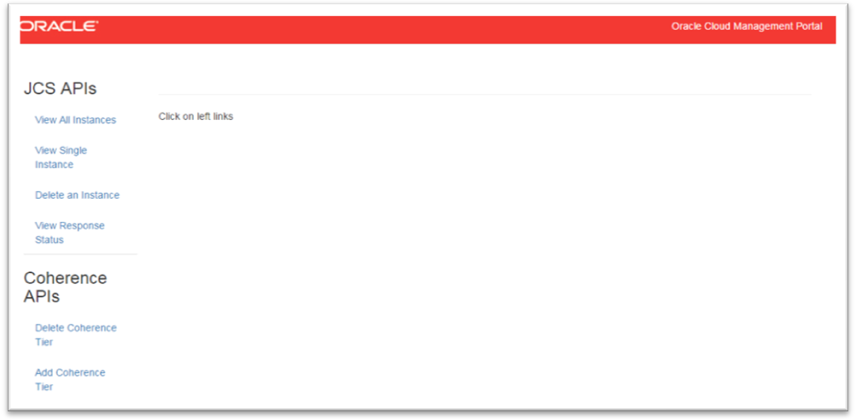

### View All Instance

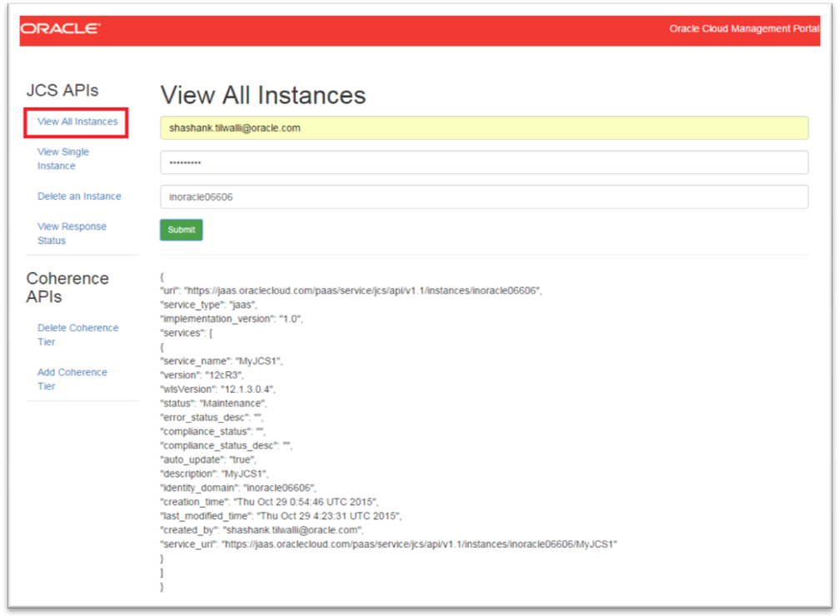

### View Single Instance

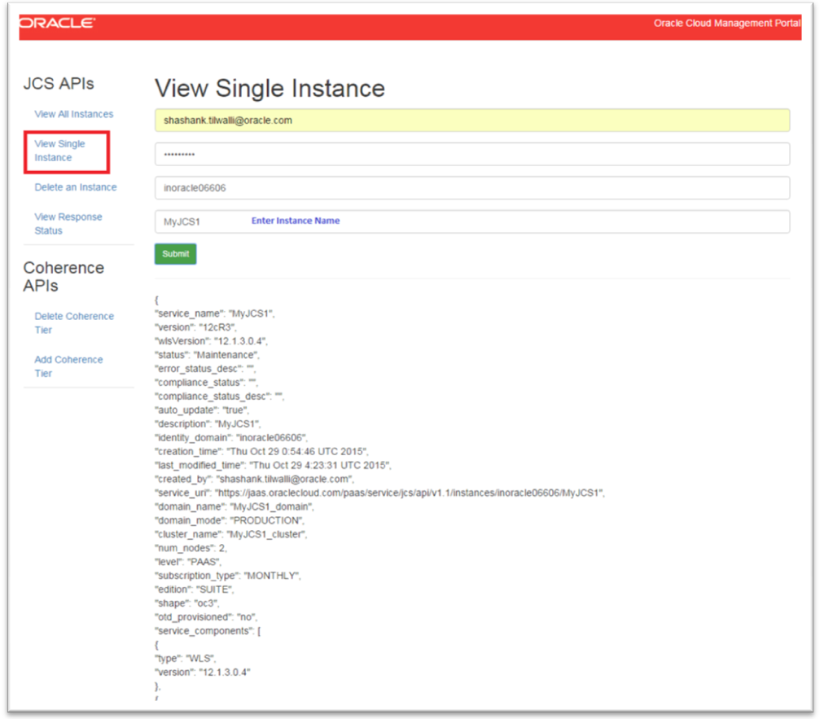

### Delete an Instance

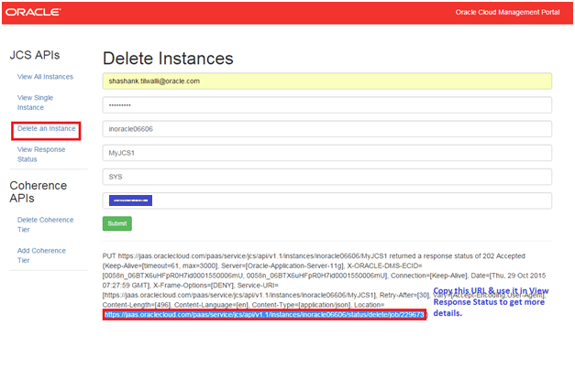

### Add Coherence Data Tier

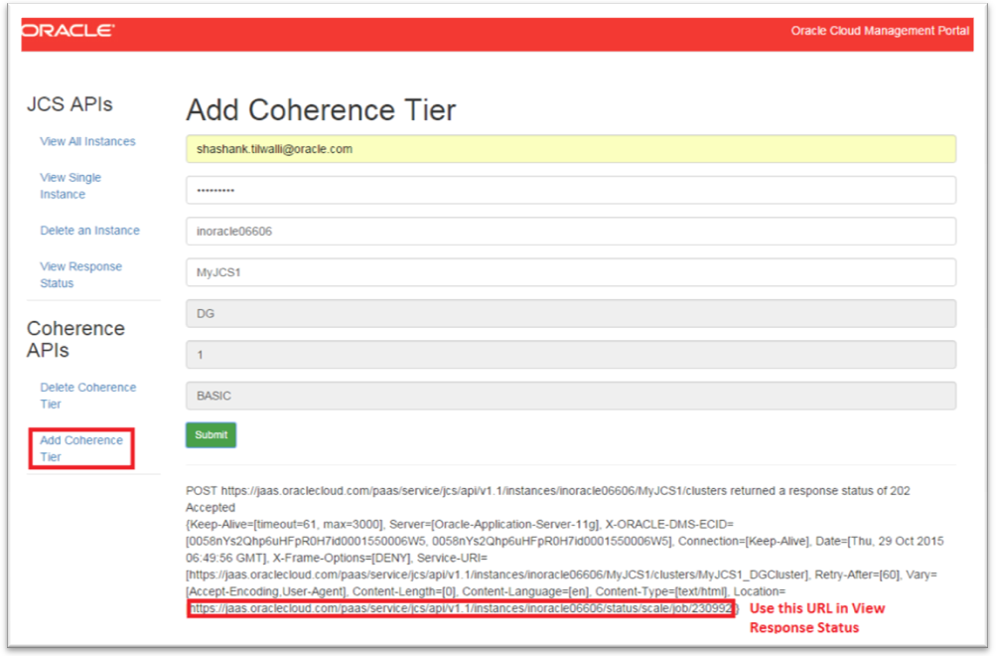

### Delete Coherence Tier

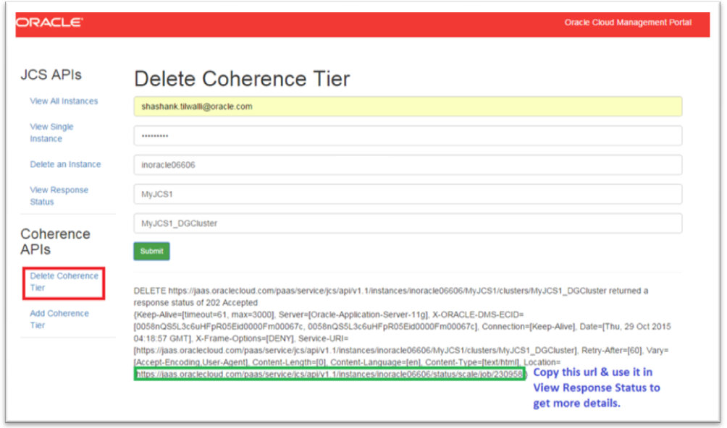

### View Compute Status

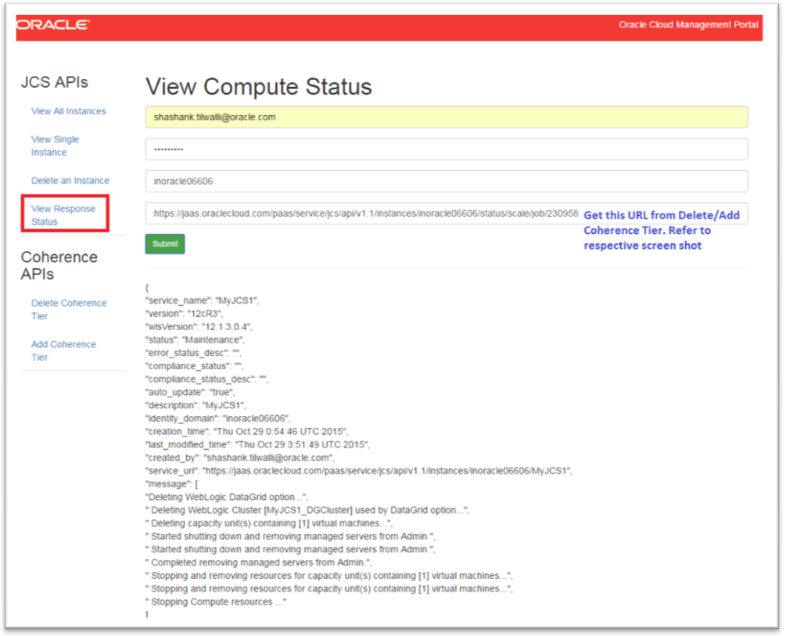

## Important

1. Make sure there is internet access on the machine you are trying to deploy.
2. Make sure you give correct cloud account details while testing the application.
3. Exercise caution while using Add Coherence Data Tier operation since it may breach your cloud trial account quota. For instance if you Add Coherence data tier and you don’t have enough resource, you may get “Quota Breach Error”.
4. Exercise caution while using Delete Coherence Tier/Delete an instance since it may delete your existing data.