1.

5. 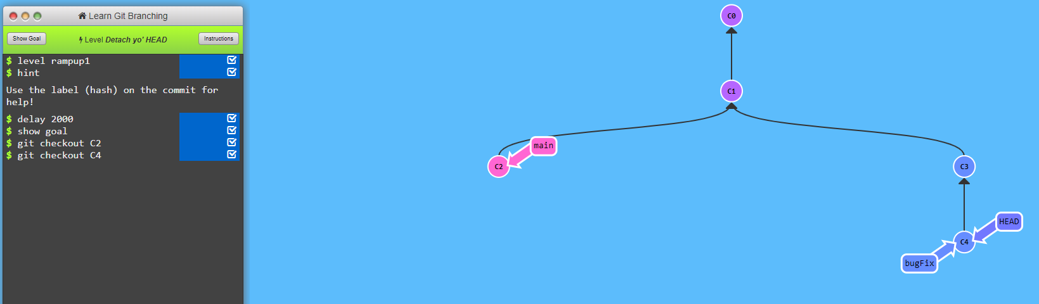

12. 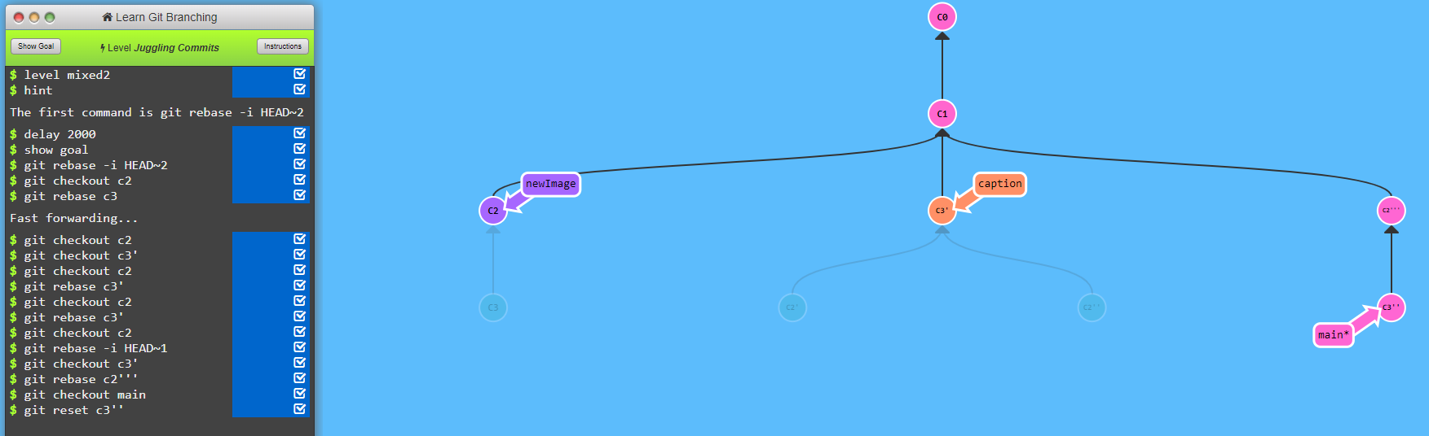

16

