Attacks

1. SQL Injection
An attack where someone inserts malicious SQL into input fields.
How it works:
- App takes user input → puts it into SQL query
- No validation → attacker injects SQL
- Database executes it
Example:
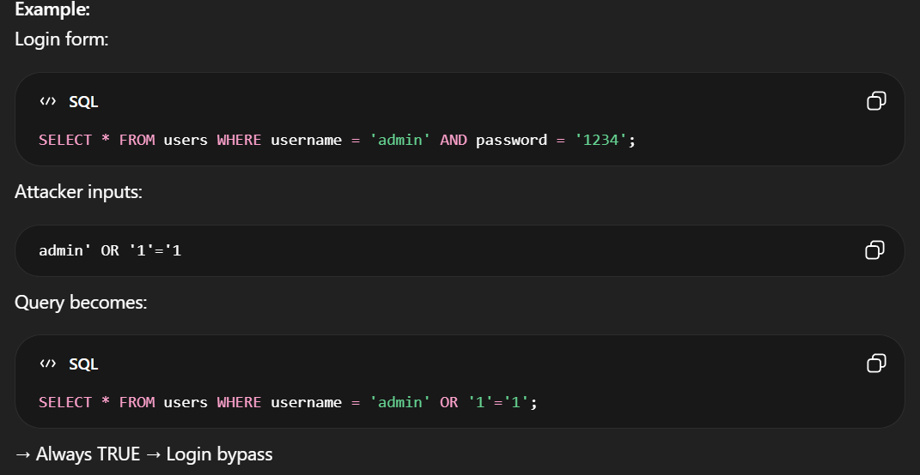
Root cause:
Trusting user input blindly
Impact:
Data leak, login bypass, full DB compromise
Prevention:
Prepared statements, input validation
Analogy:
Like giving someone a form and they rewrite the rules instead of filling it

2. Types of cyber attacks on Each OSI layer

Layer 1 - Physical
✔ Traffic eavesdropping

Layer 2 - Data Link
✔ MAC spoofing
✔ ARP spoofing
✔ VLAN hopping
✔ DHCP spoofing
✔ Rogue access points

Layer 3 - Network
✔ IP spoofing
✔ Manipulating routing tables
✔ ICMP redirect
✔ TCP/UDP flood (DDoS)
✔ SYN flood (DDoS)
✔ Smurf attack (DDos)

Layer 4 - Transport
✔ Lateral Movement
✔ TCP/UDP port scanning
✔ DNS poisoning
✔ TCP/UDP flood (DDoS)

Layer 5 - Session
✔Access control bypass
✔ Adversary-in-the-middle attack

Layer 6 - Presentation
✔Cracking encryption
✔Injection attacks
✔File inclusion vulnerabilities
✔Cross-site scripting (XSS)
✔Cross-site request forgery (CSRF)

Layer 7 - Application
✔Phishing
✔Password cracking
✔Buffer overflow
✔Format string attack

