IPv6

1. What is IPv6
IPv6 overcomes the lack of IPv4 addresses and provides a larger address space to accommodate the growing number of internet-connected devices.
IPv6 addresses are 128 bits long, representing eight groups of four hexadecimal digits separated by colons, such as 2001:0db8:85a3:0000:0000:8a2e:0370:7334.
The expanded address space of IPv6 allows for approximately 340 undecillion (3.4 x 10^38) unique addresses, ensuring that every device can have a globally unique identifier.

2. Benefits?
- Increased address space
- Eliminates NAT
- Simpler and more efficient header: resulting in faster routing and improved network performance
- built-in security support: IPsec provides encryption and authentication at the network layer, ensuring secure device communication. it is an integral part of IPv6, enhancing privacy and data integrity across the internet.

3. IPv6 Example.
IPv6 addresses are in hexadecimal notation and divided into eight groups of four hexadecimal digits separated by colons. Each group represents 16 bits, resulting in 32 characters in the address. It doesn’t need leading zeros within each group, and you can compress consecutive groups of zeros by using a double colon (::), but this abbreviation can only be used once in an address.

4. Who assign public IP addresses and who control and supervise the whole process?
A global body called The Internet Assigned Numbers Authority (IANA) that is responsible for global coordination of the Internet Protocol addressing systems, as well as the Autonomous System Numbers used for routing Internet traffic.
For every geographical region of the world, there is another regional authority that is responsible for public IP address management in the respective area.
IANA gives big chunks of IP addresses (called /8 blocks) to the five Regional Internet Registries (RIRs). These RIRs then give smaller IP addresses to internet service providers, cloud companies, and other users.
IANA → RIR → LIR → ISP → End User.

5 .IPv6 addresses types
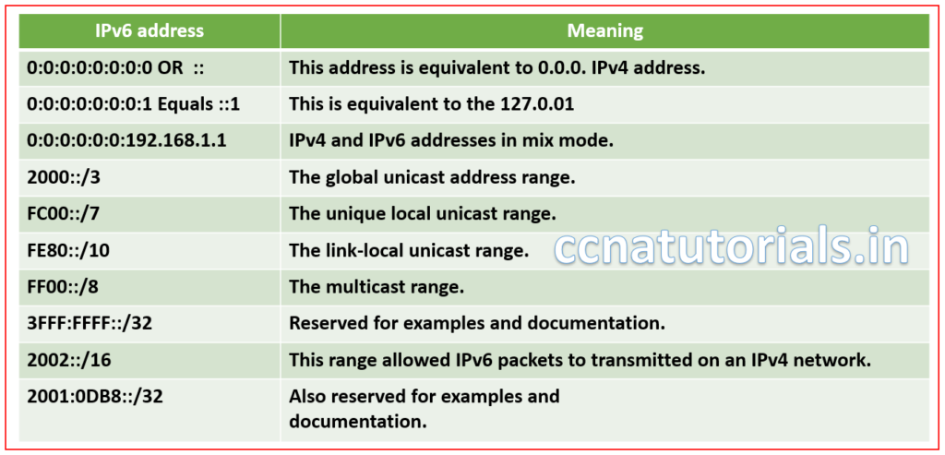
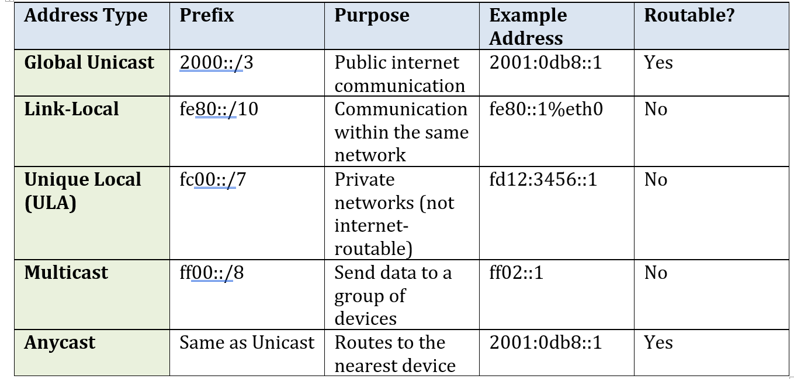
Prefix | Meaning | Notes
/128 | Single host | Like 192.168.1.1/32 in IPv4
/64 | Standard subnet | Used for LANs, required for SLAAC
/48 | Site network | Usually for an organization
/32 | ISP allocation | Big blocks for ISPs

