**How to set up HTML and CSS**

Innhold

HTML 1

CSS 2

# HTML

HTML stands for HyperText Markup Language and you can use it when you want to make a website.

***First you will need a HTML editor, example like Notepad++***

The first thing you are going to start with is by writing <!DOCTYPE html>.

As you see those two sign <> are used. In the beginning < and at the end >. Those two sign are always used in the beginning and at the end, also in other words which I am going to show you later. After <!DOCTYPE html> you are going to write <html> and <body>. Those two words are always used at the beginning and at the end.

**It will look like this when you set it up toghter.**

<!DOCTYPE html>.

<html>   
<body>  
  
<h1>My First Heading</h1>  
  
<p>My first paragraph.</p>  
  
</body>  
</html>

Notice it start with <html> <body> and it ends</html></body>. The last ones have this / sign in it.

In the middle you can choose what you want. In the first one it is written ***<h1>My First Heading</h1>***  but you can choose what you want to write. Notice it start with <h1> and ends with </h1>. And it doesn’t have to be called ***</h1>***, you can call it ***<h2>*** or any other names you want.  
The website will look like this.

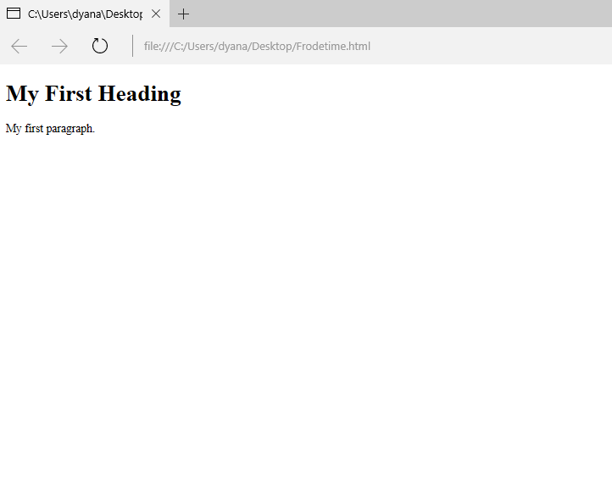

## CSS

CSS stand for *Cascading style sheets* and you can use it when you want to style HTML.

When you want to style your website with colours, pictures or something else, you have to starts with this <style>. This sign is used right after <html><head>.

Example, if I want to change the background colour, I have to write first <style> and then ***body {background-color: powderblue;*** and a the end</style>

***It will look like this.***

<!DOCTYPE html>

<html>

<head>

<style>

body {background-color: powderblue;}

<h1>This is a heading</h1>

<p>This is a paragraph.</p>

</style>

</head>

<body>

And if want to change the colour of the text, putt his sign inn.

h1 {color: blue;}

p {color: red;}

***Toghter it will look like this:***

<!DOCTYPE html>

<html>

<head>

<style>

body {background-color: powderblue;}

h1 {color: blue;}

p {color: red;}

</style>

</head>

<body>

<h1>This is a heading</h1>

<p>This is a paragraph.</p>

</body>

</html>

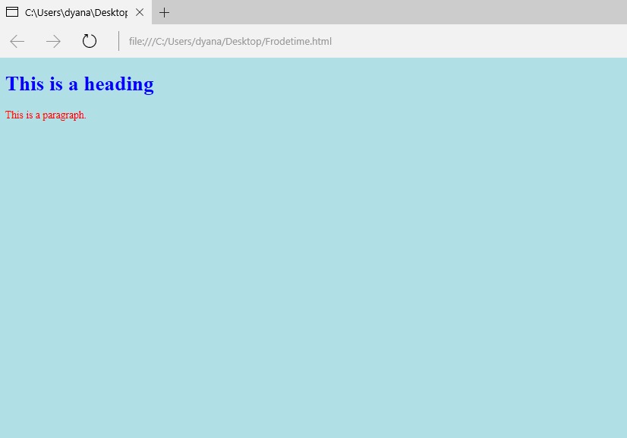**the result will look like this.**

If you want picture to you website, put this sign inn. <img src="The picture you want">

***Everything together will look like:***

<!DOCTYPE html>

<html>

<head>

<style>

body {background-color: powderblue;}

h1 {color: blue;}

p {color: red;}

</style>

</head>

<body>

<h1>This is a heading</h1>

<p>This is a paragraph.</p>

<img src="The picture you want">

</body>

</html>

***And if you put a picture inn, it will then look like this:***

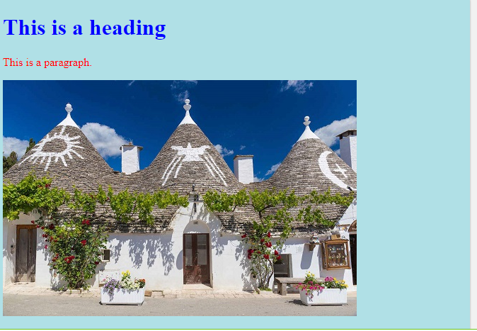

Menu

If you want a menu, all you need is to put those inns.

<a href="**Put other sit here**">***Pictures***</a>

<a href="**Put other sit here**">***Food***</a>

**All together it will look like this**

<html>

<head>

<style>

body {background-color: powderblue;}

h1 {color: blue;}

p {color: red;}

</style>

</head>

<body>

<h1>This is a heading</h1>

<p>This is a paragraph.</p>

<a href="**Put other sit here**">***Pictures***</a>

<a href="**Put other sit here**">***Food***</a>

<img src="The picture you want">

</body>

</html>