Made By: Hans Mortensen

Made 3/13/2020

Updated 4/3/2020

**Importing STEP & other non-solid works Files**

**BD edit**

Select these settings for a small number of large parts. This will not work for models with a lot of parts as matting is undone.

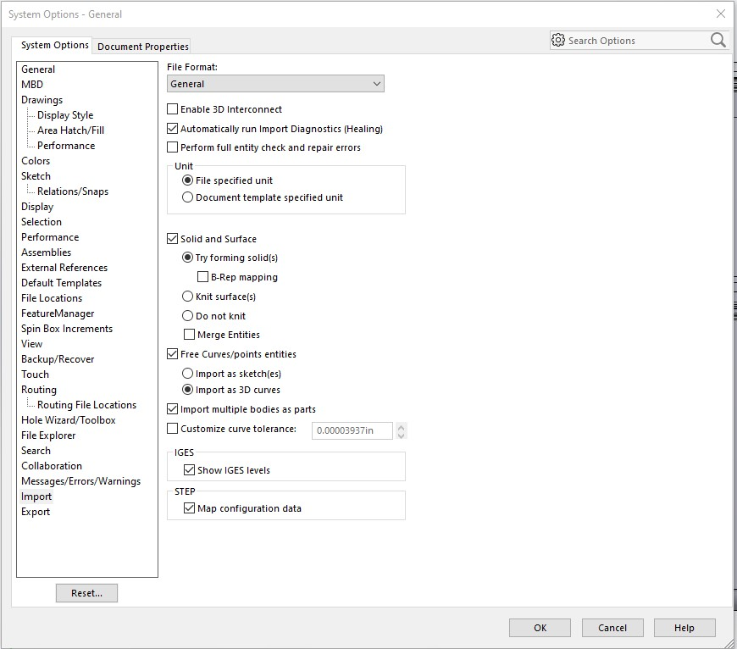

Mate the primary body to the primary planes then mate the secondary components to the primary body. Don’t forget to save 😉

Save unmodified parts files to the parts nexus file on the local drive.

When starting a new project add all parts here then pull in to the part file if you modify a part “save as” it under modified parts in it’s respective part folder.

For PCB’s or large numbers of permanently mated components use these settings when importing.

First have the Altium user export a STEP file with these settings. This box comes up after hitting export.

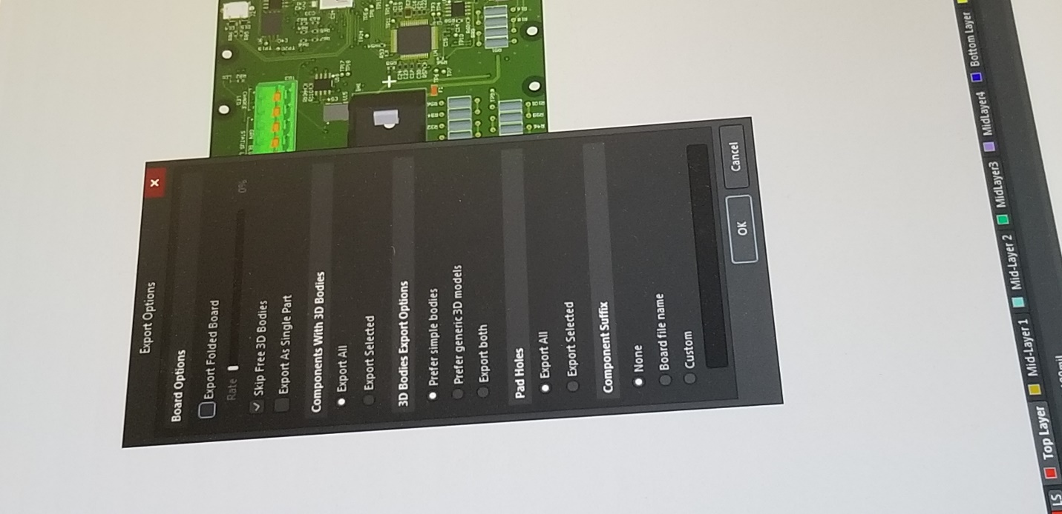

In SolidWorks use these import settings.

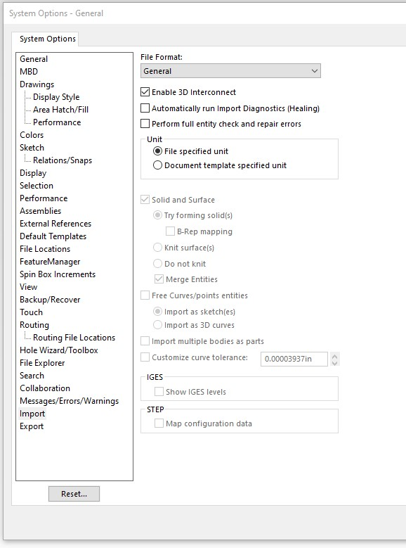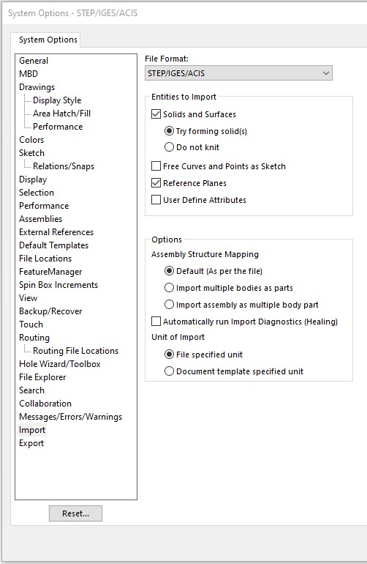

Then you must open only one file (the one you are trying to import) in Solid Works at any given time.

Save as an assembly file (SLDASM). ??

Save that file as a SolidWorks part file (SLDPRT). And use this file to add to your larger assembly

The size of the part file can be reduced if you select external geometry. ??

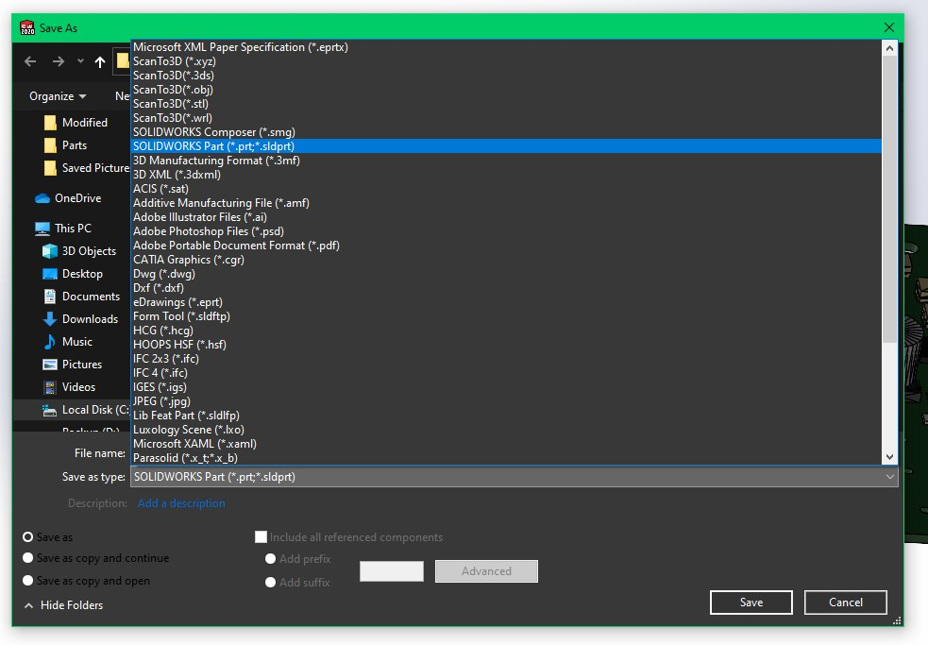

From a conversation with Heather McHale a GoEngineer (a SolidWorks value added service), the root issue and other alternat methods of dealing with this are as follows.

You are experiencing an issue with Assemblies opening parts from the incorrect file path.  This is due to SW finding a file with the same name in a different folder than the last saved location.  Here is the setting that I referenced to attempt to force SW to open the file in the original path.  I’ve had some luck with it.  (**Exclude active folders and recent save locations** is the setting)

[https://help.solidworks.com/2019/english/SolidWorks/sldworks/HIDD_OPTIONS_EXTERNAL_REFS.htm](https://help.solidworks.com/2019/english/SolidWorks/sldworks/HIDD_OPTIONS_EXTERNAL_REFS.htm%0d)

The true issue at hand is that there are parts with the same name that are unique, which is quite common with imported parts.  We discussed adding a suffix to the beginning of the files to make them unique, which can easily be done with pack and go.

[https://www.goengineer.com/videos/solidworks-pack-go/](https://www.goengineer.com/videos/solidworks-pack-go/%0d)

You do not need these files to remain as assemblies once imported, so we walked through saving the assembly as a part instead.

<https://help.solidworks.com/2019/English/SolidWorks/sldworks/r_assembly_save_as_part.htm?id=76e7145835724d648099d79a9abee344#Pg0>