Supplementary Information

Bi-functionalized ionic liquid/metal-organic framework composite for low-concentration CO₂ cycloaddition reaction under atmospheric pressure
Liwei Sun^{1,2}, Meilin Yin¹, Shaokun Tang^{1,*}
¹ Key Laboratory for Green Chemical Technology of Ministry of Education, School of Chemical Engineering & Technology, Tianjin University, Tianjin 300354, China
² State Key Laboratory for Oxo Synthesis and Selective Oxidation, Lanzhou Institute of Chemical Physics (LICP), Chinese Academy of Sciences, Lanzhou 730000, China
*Corresponding author. E-mail address: shktang@tju.edu.cn
Materials
2-Bromide alcohol, 1,4-benzenedicarboxylate acid (1,4-H₂BDC), 1-butyl-3-methyl-imidazolium bromide ([BMim][Br]) and adamantine were obtained from Aladdin (Shanghai, China). Aluminum nitrate nonahydrate [Al(NO₃)₃.9H₂O] was received from Titanchem (Shanghai, China). Absolute ethanol, sodium hydroxide, sodium tetrafluoroborate (NaBF₄) and diethyl ether were purchased from Jiangtian (Tianjin, China). N,N’-dimethylformamide (DMF) and acetonitrile were purchased from Concord (Tianjin, China). Above chemicals were analytical grade and used without additional purification. Chromatographic ethyl acetate was obtained from Komeo (Tianjin, China). CO₂ gas with 99.99% purity and N₂ gas with 99.999% purity were received from Liufang (Tianjin, China). Deionized water (H₂O, 15 MΩ/cm resistivity) was made in our laboratory by Elix Essential 5 water purification system (Millipore, U.S.). Mono-functionalized ionic liquid 1-methoxyethyl-3-methyl-imidazolium bromide [MOEMim][Br] was prepared in our laboratory with 1-methylimidazole and 1-bromo-2-methoxyethane as the starting materials^{[2]}.

Preparation of [HeMOEim][Br]/MIL-53(Al) composite
[HeMOEim][Br]/MIL-53(Al) composite was prepared using the experimental device shown in Fig. S1. In a typical synthetic procedure, 0.2 g of MIL-53(Al) was placed into 50-mL Schlenk tube (2) equipped with a constant pressure drop funnel (1). After heating to 110 ºC, the double pistons (1A and 1B) on the constant pressure drop funnel were closed and the piston (2C) on the Schlenk tube was opened to maintain the vacuum condition for 12 h. Subsequently, the piston of 2C was turned off and the Schlenk tube was cooled down to 50 ºC followed by adding 1 g [HeMOEim][Br] into the constant pressure drop funnel and opening the piston of 1B. Based on the pressure difference between the internal and external channel, small [HeMOEim][Br] molecule was incorporated into the channel of MIL-53(Al). And the rection system was maintained for 6 h to achieve uniform impregnation. Finally, the viscous material was washed twice with DMF and absolute ethanol, and dried at 70 °C for 8 h to obtain [HeMOEim][Br]/MIL-53(Al) composite.

Optimized geometry of [HeMOEim][Br]
The electronic structure, optimized geometry and frequency property of the individual cation and anion ([HeMOEim]⁺ and [Br]⁻) were computed by the density functional theory (DFT) calculations using the Gaussian 09 program package.¹ B3LYP functional combined with the 6-31+G(d,p) basis set (B3LYP/6-31+G(d,p)) was employed to conduct the structure optimization and frequency analysis. The optimal geometry was characterized to be true local-energy minima on the potential energy surface without imaginary frequencies.
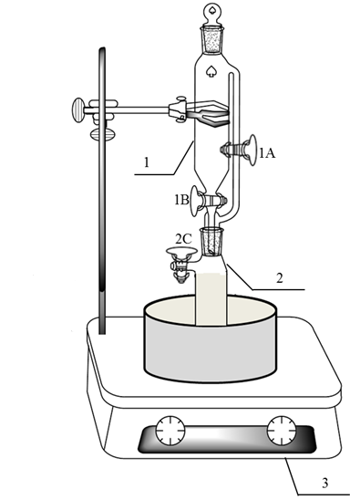
Fig. S1 Scheme of experimental device for vacuum-impregnation method: 1. Constant pressure drop funnel; 2. Schlenk tube; 3. Magnetic stirrer with temperature control.

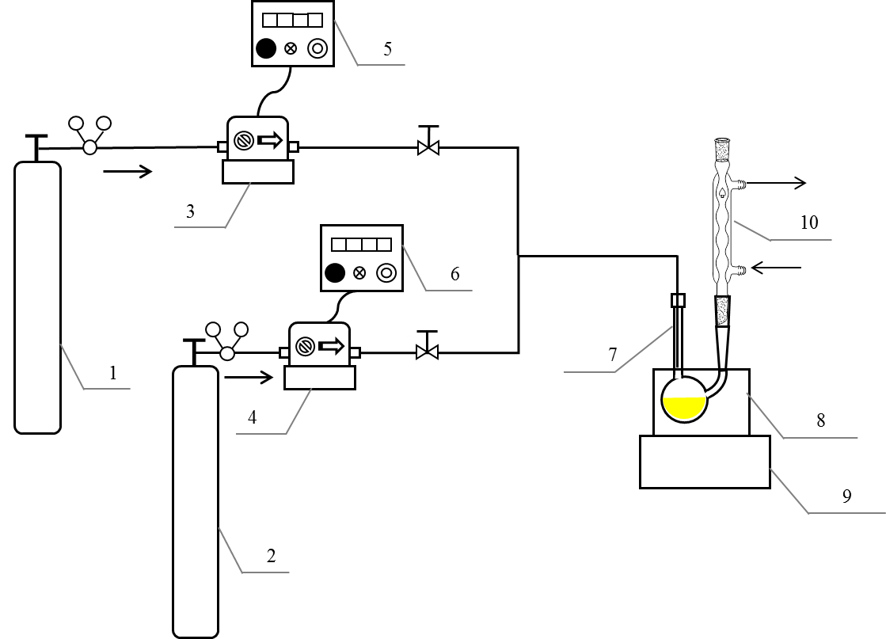
Fig. S2 Scheme of experimental device for cycloaddition of CO₂ from CO₂/N₂ mixed gas and epichlorohydrin under atmosphere pressure: 1. CO₂ cylinder; 2. N₂ cylinder; 3,4. Mass flow controller; 5,6. Flow indicator; 7. U-shaped glass tube; 8. Oil bath; 9. Magnetic stirrer with temperature control; 10. Reflux condenser.
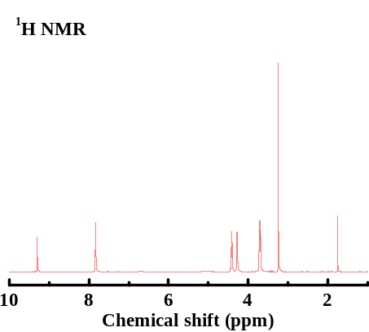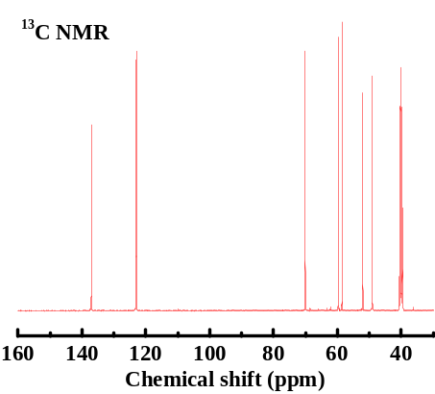
Fig. S3 ¹H NMR and ¹³C NMR spectra of [HeMOEim][Br]

¹H NMR (500 MHz, DMSO-d₆) δ ppm 9.30 (s, 1H, N=CH-N), 7.83 (d, J = 10.6 Hz, 2H, CH=CH), 4.42 - 4.39 (m, 2H, N-CH₂), 4.30 - 4.26 (m, 2H, N-CH₂), 3.71 (dd, J = 11.5, 6.6 Hz, 4H, CH₂-O), 3.24 (s, 3H, O-CH₃), 1.75 (s, 1H, -OH). ¹³C NMR (101 MHz, DMSO-d₆) δ ppm 137.02 (s, -N=CH-N-), 123.06 (s, -CH=CH-), 122.91 (s, -CH=CH-), 70.05(s, -O-CH₂-), 59.68(s, -N-CH₂-), 58.56(s, -N-CH₂-), 52.03(s, -O-CH₃), 49.05(s, -CH₂-OH).

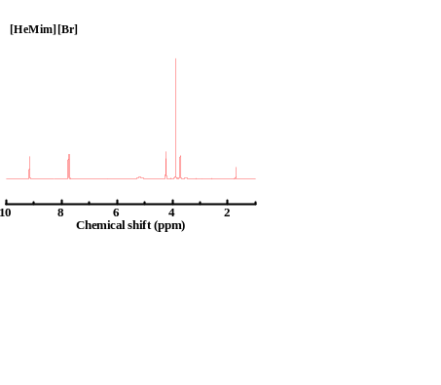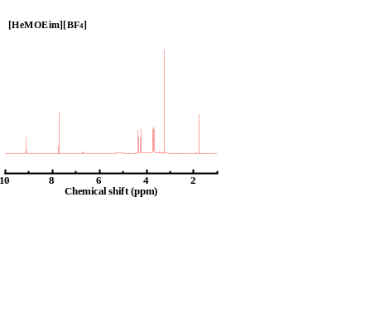
Fig. S4 ¹H NMR spectra of [HeMim][Br] and [HeMOEim][BF₄]

¹H NMR of [HeMim][Br] (500 MHz, DMSO-d₆) δ ppm 9.16 (s, 1H, N=CH-N), 7.76 (s, 1H, CH=CH), 7.72 (s, 1H, CH=CH), 4.25 - 4.17 (m, 2H, N-CH₂), 3.88 (s, 3H, N-CH₃), 3.72 (s, 3H, C-CH₂-O), 1.70 (s, 1H, -OH). ¹H NMR of [HeMOEim][BF₄] (500 MHz, DMSO-d₆) δ (ppm) 9.11 (s, 1H, N=CH-N), 7.72 (d, J = 22.8 Hz, 2H, CH=CH), 4.45–4.30 (m, 2H, N-CH₂), 4.30– 4.17 (m, 2H, N-CH₂), 3.72 (dd, J = 12.7, 7.8 Hz, 4H, CH₂-O), 3.25 (s, 3H, O-CH₃), 1.77 (s, 1H, -OH).

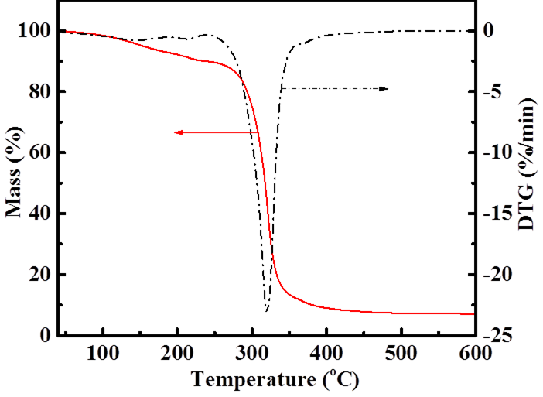
Fig. S5 TG and DTG curves of [HeMOEim][Br]

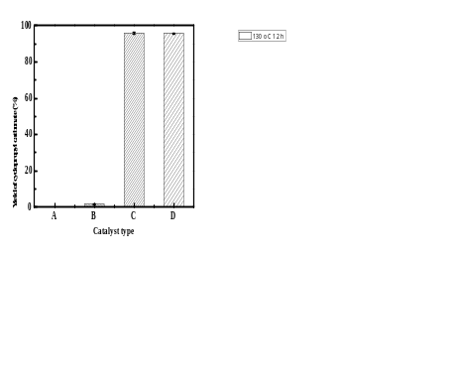
Fig. S6 Cycloaddition of CO₂ from CO₂/N₂ mixed gas and epichlorohydrin without catalyst (A) and with 4 wt% MIL-53(Al) (B), [HeMOEim][Br] (C), [HeMOEim][Br]/MIL-53(Al) composite (D) as catalyst at 130 ºC, 0.1 MPa and 12 h.
Table S1 Ideal CO₂/N₂ selectivity of different materials prepared in this work at 25 ºC and 0.1 MPa
Sample | CO₂ capture capacity (cm³ CO₂/g sorbent) | N₂ capture capacity (cm³ N₂/g sorbent) | Ideal CO₂/N₂ selectivity
[HeMOEim][Br] | 54.7 | 2.01 | 27.2
MIL-53(Al) | 55.1 | 22.7 | 2.3
[HeMOEim][Br]/MIL-53(Al) | 30.7 | 1.92 | 15.9

References
- M.J. Frisch, G.W. Trucks, H.B. Schlegel, G.E. Scuseria, M.A. Robb, J.R. Cheeseman, G. Scalmani, V. Barone, G.A. Petersson, H. Nakatsuji, X. Li, M. Caricato, A. Marenich, J. Bloino, B.G. Janesko, R. Gomperts, B. Mennucci, H.P. Hratchian, J.V. Ortiz, A.F. Izmaylov, J.L. Sonnenberg, D. Williams-Young, F. Ding, F. Lipparini, F. Egidi, J. Goings, B. Peng, A. Petrone, T. Henderson, D. Ranasinghe, V.G. Zakrzewski, J. Gao, N. Rega, G. Zheng, W. Liang, M. Hada, M. Ehara, K. Toyota, R. Fukuda, J. Hasegawa, M. Ishida, T. Nakajima, Y. Honda, O. Kitao, H. Nakai, T. Vreven, K. Throssell, J.A. Montgomery, J.E. Peralta, F. Ogliaro, M. Bearpark, J.J. Heyd, E. Brothers, K.N. Kudin, V.N. Staroverov, T. Keith, R. Kobayashi, J. Normand, K. Raghavachari, A. Rendell, J.C. Burant, S.S. Iyengar, J. Tomasi, M. Cossi, J.M. Millam, M. Klene, C. Adamo, R. Cammi, J.W. Ochterski, R.L. Martin, K. Morokuma, Ö. Farkas, J.B. Foresman, D.J. Fox, Gaussian 09, Revision A.02, Gaussian Inc, Wallingford CT, 2016.
- L.W. Sun, J.Y. Luo, S.K. Tang, Synthesis of dual-functionalized ionic liquid and application in CO₂ absorption, Chem. J. Chinese U. 38 (2017) 1578-1583.

