Task 1

We want the GPIO to switch at 2Hz with a 75% duty cycle, shown in the code below.

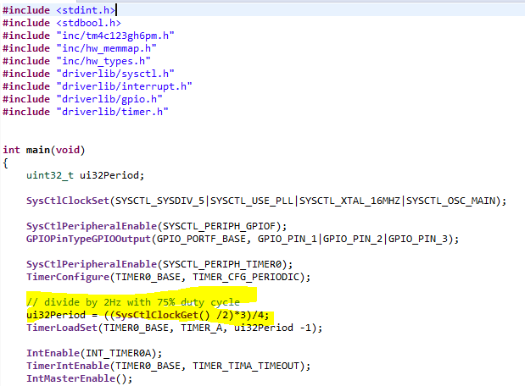

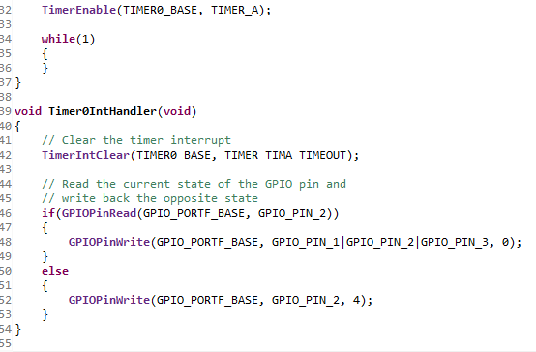

Task 2

When the button is pressed, simulating an interrupt, the light will wait for 1.5 seconds before continuing with the toggling. This was implemented by using two timers: one to control the strobbing of the LED, and the other to control the wait time.