Design of a Physically Unconstrained 3-DOF Robot for Planar Motion

Patrick Dingle
MAE 417
May 1, 2002
Abstract

This project suggests a design for a three degree-of-freedom planar robot with no constraints. The robot is not physically attached to its environment so it is free to move about its workspace as needed. At any given instant in time, the robot is able to translate in any direction at variable velocity, in addition to rotating simultaneously. In addition to a detailed mechanical design, the controls are suggested for this robot. The report provides equations that would allow a robot controller to convert desired velocities and rotational velocities to wheel velocities, and thus how much current to provide each motor. Additionally, the report explains how to use these equations for path planning.
Introduction

The most common types of robots are robot arms that provide three degrees of freedom, in addition to end effectors that provide an additional three degrees of freedom. While robotic arms are great for working in a relatively small workspace, there often is a need to have robots that move a large distance from their origins. Additionally, robotic arms often have kinematic restraints and encounter problems with singularity and workspace restrictions. Due to these complications of robotic arms, there are many cases where other types of robotic devices should be considered. For example, other types of robots would likely be considered for uses such as space exploration, dynamic environments, or complicated workspace restrictions.
For my project, I have designed a three degree-of-freedom robot chassis that can travel unrestricted on a plane. The robot is not physically connected to the environment, so it is free to move about the workspace as needed. Since the robot does move about in a plane, the robot has two prismatic degrees of freedom in addition to one rotational degree of freedom. Depending on the application, an additional arm or robotic device could be added to the top of the chassis to provide six degrees of freedom or to perform other mechanical functions. The robot can locate its position in the workspace by triangulating feedback from a set of optical sensors. In this project report I have outlined a detailed mechanical design, come up with necessary equations to control the robot, and devised techniques for moving the robot between any two orientations in the workspace.

Mechanical Design

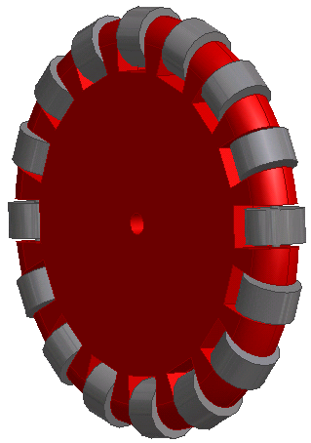
Designing a robotic drive system to have three complete degrees of freedom in a plane is not a simple task. At any given instant in time, the robot must be able to translate in any direction, in addition to rotating at the same time. This type of drive system is difficult because a simple wheel is only designed to provide one degree of freedom – forward and backwards. Most vehicles of transportation using wheels in fact only provide one degree of freedom. A car, for example, really only has one degree of freedom: forwards or backwards along some arc. A car is unable to translate sideways or rotate independently of forward motion. By the nature of its design, the wheel can only provide forwards and backwards motion. Any motion perpendicular to the wheel is resisted by contact friction. Thus, in order for a this type of robotic device to rotate or translate sideways, it must be able to rotate each wheel. In order to simultaneously rotate and translate in any given direction, the robot must be able to independently rotate and independently control the speed of each wheel. Such control would require a minimum of eight motors.
Since it is so difficult to use standard wheels to achieve three degrees of freedom on a plane, I have looked for alternatives that might make the task simpler. Based upon my experience in the F.I.R.S.T. Robotics Competition and upon ideas I got from Cornell’s Robocup team, I found that using an “omniwheel” is an elegant way to eliminate some of the problems with standard wheels. An omniwheel, unlike a standard wheel, essentially does not provide any resistance to force perpendicular to the motion of the wheel. For example, if a car had four omniwheels in place of standard wheels, and a force was applied to the side of the car, the car would accelerate sideways without affecting its forward motion. For my robot I have designed omniwheels that have small rollers around the circumference of the wheel. These rollers turn about an axis perpendicular to the axis of the wheel, allowing the wheels freedom to move with negligible friction perpendicular to the motion of the wheels.
The design of the omniwheel is not trivial. This design can be manufactured by machining two identical pieces of polycarbonate sheet in the shape shown, and placing aluminum rollers in slots milled out of the polycarbonate. The polycarbonate pieces can either be produced on a mill with a rotary table, or a CNC mill. Since there are so many aluminum rollers to produce, it is most feasible to produce them on a CNC lathe. The polycarbonate pieces are then bolted and/or epoxyed together. The end result is a wheel that is free to rotate normally with very little resistance to side forces. The wheels are approximately six inches in diameter.
An omniwheel is an ideal type of wheel to use with a three-degree-of-freedom robotic device because a wheel does not care if there are forces perpendicular to the wheel. Thus, if two wheels are oriented perpendicular to each other, the two wheels can simultaneously translate in two different axes without any interference. By placing two sets of wheels on the chassis, with the two sets perpendicular to each other and with the two wheels of each set parallel to each other, it is in fact possible to achieve three complete degrees of freedom. Translational motion in either of the two planar axes can be achieved by moving the wheels of each set at the same velocity in the desired direction. To rotate, the speeds of the opposing wheels of each set simply need to be mismatched. If they are mismatched by the same amount and in the same rotational direction, the robot will rotate.
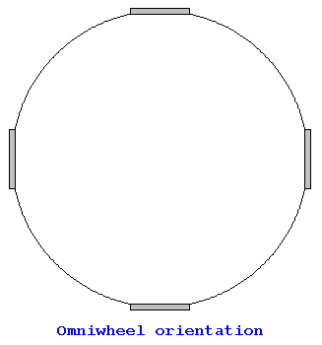
To keep my design simple, I chose to use four wheels with each wheel oriented 90 degrees from its neighbors. Each wheel is equidistant from the center of the robot, and the robot contains 180º symmetry about any line through the center of the robot. This design was chosen to make the controls simpler to derive. Since all the wheels are equidistant from the center, the robot essentially contains four wheels that are tangent to a common circle. If we want the robot to move from point A to point B and rotate by some amount, we can think of a circle translating and rotating through the plane. The wheels are simply points on this circle. For example, for the robot in the orientation shown to translate up and to the right, the top and bottom wheels move in directions that move the robot right, and the left and right wheels move in directions that move the robot up. To rotate in place, all the wheels simply move with the same velocity in the desired rotational direction. When it is desired to rotate and translate simultaneously, more complex control logic is needed. This logic is discussed in detail in the control section of this report.
For the chassis, I chose to use 30x30 IPS aluminum extrusion for the structural material. This material has many advantages. It is easy to assemble, lightweight, strong, and is easy to attach components to. In order to simplify the chassis, I chose to make it square-shaped with wheels as far as possible towards the corners. Since the wheels are as far out as possible, and the chassis is so low to the ground, it would be very difficult for a component to cause the robot to tip over. Figure one in the back of this report shows the detailed chassis layout of the robot.
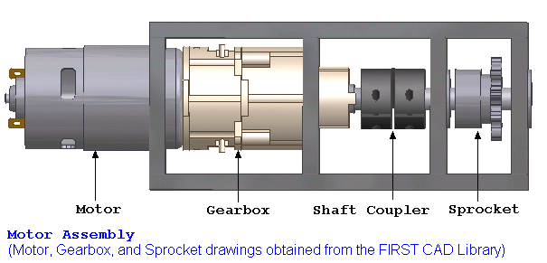
Once the chassis was laid out and the wheels were in place, the next step was to determine how to power the wheels. Since translation and rotation require different speeds to each motor, it is necessary to use four motors – one for each wheel. For motors, I used DC motors that are used in Bosch Drill Motors. These motors provide a large amount of power, are lightweight, and have gearboxes that provide appropriate gearing for a robotic drive system. The following figure illustrates setup of the drill motors:

The motor assembly is fairly simple. The actual motor press fits into the assembly box. The output shaft of the motor feeds directly into the gearbox, which provides a 64:1 gear ratio. Since the output shaft of the motor spins at 20000 RPM with no load, the rotational velocity of the output shaft of the gearbox is at approximately 300 RPM. Since the output shaft of the gearbox is so short, it was necessary to use a shaft coupler. Additionally, this particular gearbox is unable to support side loads. Thus, it was necessary to install ball bearings before and after the sprocket to insure that the loads placed on the sprocket by the chain do not place a load on the gearbox. The sprocket is a standard 38-pitch roller chain, and contains 10 teeth. In order for the shaft to engage the sprocket, it is necessary to physically connect the two to each other. There are a number of possibilities for this connection, including a standard pin, keyway, set screw, welding, or dutch key. Since a rotational velocity of 300 RPM is still a bit fast for a robot to move at a reasonable speed, there is a 2:1 gear ratio between the motor sprocket and the wheel sprocket. This causes the wheels to have a maximum possible rotational velocity of 150 RPM. For a wheel radius of 3”, this causes the robot’s maximum speed in the direction of a wheel to be about 4 feet per second. The 20-teeth sprockets can be attached to the wheels by drilling and tapping holes through the sprocket and polycarbonate, and bolting the sprocket to the wheel.
Finally, the motors assemblies must be connected to the chassis of the robot. As mentioned earlier, four assemblies are needed – one for each wheel. The assemblies can easily be connected to the chassis by drilling holes in the base plate of the assembly and bolting it to the extrusion next to each wheel. The sprockets for the wheel and the motor must be aligned. Figure one in appendix one is an image of the entire robot assembly.

Robot Control

One of the most difficult aspects of this project is devising a system to control the robot chassis. There are two main challenges. First, given a robot orientation, desired prismatic direction and velocity, and desired rotational velocity, how do I determine what value to send to the speed controller for each wheel? Second, once I know that information, how do I get the robot to move from any one point and orientation to a second point and orientation? In this section, I examine these questions in detail.
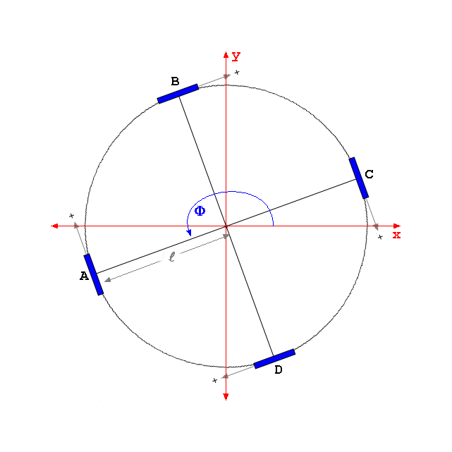
To begin my investigation into the control of this robot, I first looked back to one of my original simplifications. For all practical purposes, this robot is a circle that at any given instant is moving in a plane with some velocity and rotational velocity. Thus, if I can determine the velocity of each of the four contact points of the wheels, I can determine how fast each wheel needs to spin. This can be done by taking the dot product of the velocity with the direction of the orientation of each wheel. The figure below shows all the variables that I defined for my problem:
Given ω, the desired angular velocity, and V, the velocity vector, it should be possible to determine ω_{a}, ω_{b}, ω_{c}, and ω_{d}. To determine these formulas, I first determine the velocity of points A, B, C, and D for any given angular velocity and velocity:
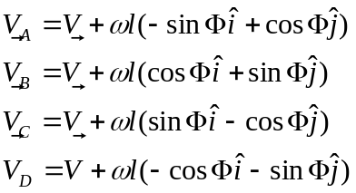
Next, I need to take the components of these velocities that point in the directions of the wheels. This will give me the velocity at which each wheel should be contacting the ground at. These velocities can be calculated by taking the dot product of each absolute point velocity with the direction of clockwise spin of each wheel.
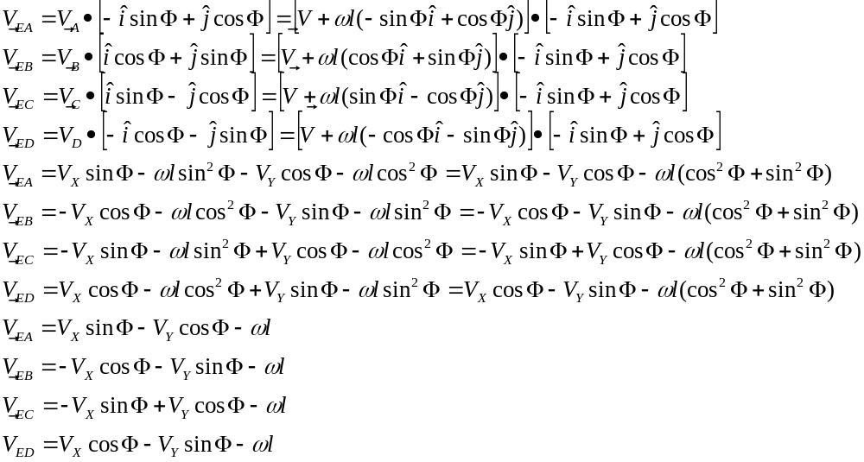
Finally, the equations for the rotational velocity of each wheel can be derived by dividing the velocity of each wheel contact by the radius of each wheel:
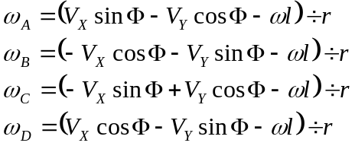

Since the Bosch Drill motors are geared at such a high ratio, the motors are going to accelerate to peak velocity and back to zero in a very short amount of time. This, in addition to the low speeds of the robot, makes the effects of inertia on the system negligible. Since we are using DC motors, the speed of the motor is going to be proportional to current. Therefore, the values we feed into the speed controller will be some constant times the desired rotational velocity of the wheel.
Now that we have formulas to convert desired angular velocity and velocity to angular velocity of wheels, we can use these formulas over time for wheel velocity vs. time. Using MATLAB, below is an example of how a robot would take 10 seconds to move from (0,0) to (10,5) over a period of ten seconds and turn around 180º in the process:
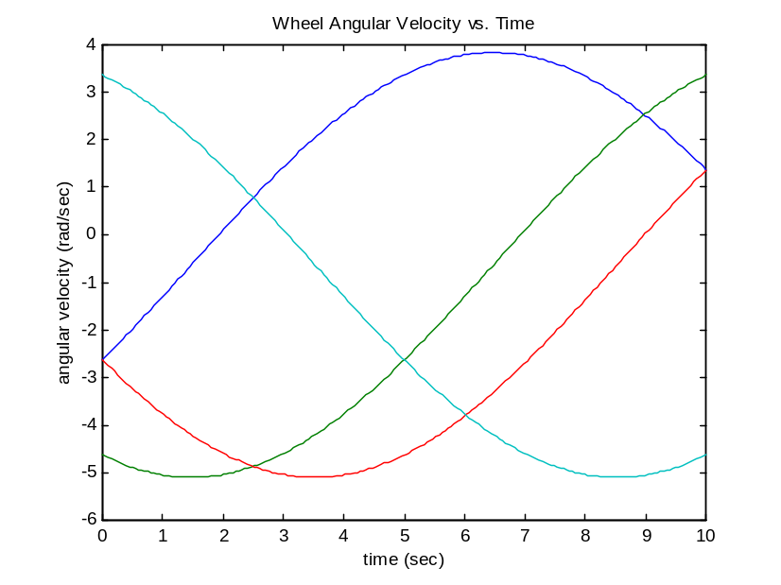

Clearly, the voltages applied to motors over time is a smooth function and thus we do not need to worry about issues such as back electromotive force and inductance.
Finally, the last issue that we need to worry about is how to ensure that the robot does not move off the intended trajectory. The above equations will only provide a rough data to move the robot over time. In reality, the robot has to have a way of checking its coordinates repeatedly and adjusting its trajectory plans if it falls off target. In my robot design, I have included a set of servos and a set of optical sensors. The purpose of these is to sweep back in forth 360º and find a pole with a strip of light-reflecting tape along it’s circumference. This will let the robot know what angle it is at with respect to its surroundings. Once it locks on to the pole, the second servo can rotate the second optical sensor downwards until it locks onto the same tape. Using the angles (provided by instructions to the servos), the position of the robot in the workspace can be triangulated.
Once the position in the workspace is calculated (every few seconds or so), the trajectory can be recalculated from scratch. As the robot gets closer, there will be less and less room for error. Thus, although the trajectory may not be perfect at first, it will approach the target more rapidly as it nears the target.
While optical sensors are what I use in my design to keep track of position, they are not the only way of accomplishing this task. The main problem with these sensors is the need to sweep them back and forth using servos to locate an object in space. Since the sensors need to move, it will take some amount of time before they locate the object. This time delay could ultimately cause the robot to overshoot its target or oscillate back and forth around the target. Another alternative to optical sensors is using an off-robot camera to locate the position of the robot in the workspace. However, this somewhat defeats the purpose of designing a robot that can move freely on its own, since the camera is not part of the “free” robot. Additionally, the camera would need to feed back into the robot controller, and thus radio communication would be an added complication to the system. One other possibility is to use infrared sensors to detect angular position. Perhaps the most elegant solution, however, is to use GPS to keep track of the robot position and a compass to keep track of orientation. This would allow the robot to in fact move freely around the surface of the earth, given that the robot is moving along relatively flat, hard land.

Bill of Materials

Below is a bill of materials for the prototype robot outlined in this report. Please note that this bill of materials does not include electronics or a control system. Through Innovation FIRST (http://www.innovationfirst.com), a pbasic-based control system can be purchased for $1145.00. Additonally, four speed controllers are needed and are sold at a price of $115 each.
Item | Unit Price | Quantity | Total
Bosch Drill Motor with Gearbox | $50 | 4 | $200
8"x8" Aluminum 1/4" Plate | $11.17 | 4 | $45
12"x12" Aluminum 1/4" Plate | $23.23 | 1 | $23
Servo Motor | $20 | 2 | $40
Optical Sensor | $50 | 2 | $100
Shaft Couplers | $20 | 4 | $80
Aluminum Extrusion | $7.99 | 8 | $64
3/8" Steel Shaft | $1.59 | 1 | $2
Lexan Sheet 12"x24" | $24.08 | 1 | $24
Aluminum Rod 6ft x 1"d | $23.65 | 1 | $24
Aluminum Stack 3ftx1"x2" | $58.54 | 1 | $59
TOTAL |  |  | $660
Works Cited

- Guide to FIRST 2002 Motors, C. Mikus; http://www.nuts4first.net/library/Motors.htm; Loaded May 1, 2002
- The FIRST CAD Library, Ed Sparks; http://www.firstcadlibrary.com; Loaded April 30, 2002; (CAD parts used include drill motors, drill motor gearbox, ball bearing, servos, optical sensors, and sprockets)
- Introduction to Robotics: Mechanics & Control, John J. Craig, Addison-Wesley Publishing Corporation, 1986; Chapter 7

Guide to FIRST 2002 Motors, C. Mikus; http://www.nuts4first.net/library/Motors.htm; Loaded May 1, 2002

