To Do: (1) Revise; (2) Add references; (3) Pending and current support (4) CVs

Looks pretty good -RJD
Title: Urbanization and the Reshaping of Plant–Insect Interactions: Reproduction, Pollination, Herbivory, and Parasitism in American Holly (Ilex opaca)

Personnel: Salvatore Agosta (PI, Associate Professor, SLSS), Andrew Eckert (Co-PI, Professor, SLSS), Rodney Dyer (Co-PI, Professor, SLSS)

ABSTRACT

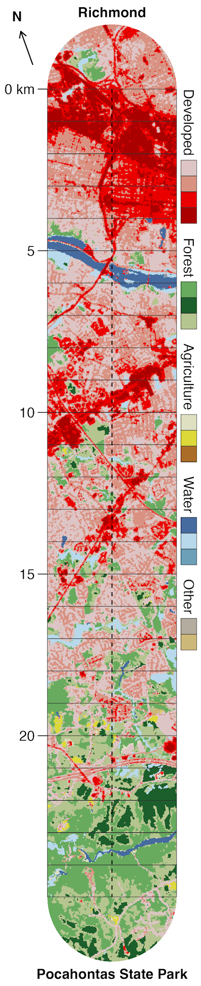
Comparing urban and rural sites can obscure how ecological and evolutionary processes change across the landscape between them. Different responses need not shift at the same point along a gradient: genetic structure may change in one place, while herbivory or leaf defenses change somewhere else. This project uses American holly (Ilex opaca) and its insect community, including generalist pollinators, the host-specific leaf miner Phytomyza ilicicola, and larval parasitoids, to ask where and how species interactions change across an urbanization gradient. Along a 25-km transect from industrial Richmond to Pocahontas State Park, we will examine how plant reproduction, leaf defenses, herbivory, and population genetic structure vary along gradients in canopy fragmentation, impervious surface cover, and microclimate. The project brings together three SLSS faculty in spatial ecology, evolutionary genomics, and thermal biology. It will inform urban landscape management and establish the preliminary dataset and reciprocal common gardens needed for an NSF proposal. This work directly addresses VCU’s Strategic Priority Plan - Advancing Societal Well-being theme; Energy, Environment, and Sustainability initiative.

BACKGROUND
Urbanization is among the most pervasive drivers of contemporary environmental change, reshaping ecosystems through habitat modification, fragmentation, and novel ecological conditions¹⁻³. These changes alter biodiversity patterns and ecosystem function while also disrupting co-evolutionary interactions among species⁴⁻⁶. As a result, urbanization influences not only ecological communities but also the evolutionary processes that shape them, making it a central focus of ecology, evolutionary biology, and conservation⁷. By examining how species and their interactions respond to human-dominated landscapes, this project directly supports VCU's Strategic Priority Plan through the Energy, Environment, and Sustainability initiative, particularly the Advancing Societal Well-being theme focused on urban ecosystems and environmental connections. The project also aligns with VCU's ongoing research strengths, including Dr. Brian Verrelli's urban evolution program⁷⁻¹⁰, and will help establish VCU as a hub for Urban Evolutionary Ecology research.
Interactions among species are fundamental to ecological and evolutionary processes, influencing how populations persist, adapt, and diversify through time. Although relatively little is known, a growing body of research shows that urbanization can substantially alter plant-insect interactions. However, the magnitude and direction of these effects vary by taxon and ecological context^{5,11,12}. Urban environments frequently modify insect abundance, diversity, behavior, and development while simultaneously altering plant distribution, performance, and resource quality^{13,14}. These changes can affect patterns of herbivory, pollination, and other ecological relationships crucial to the ecosystem services these interactions provide. For example, previous work by PI Agosta demonstrated that trees growing in regenerating forests produced less nutritious leaves for herbivores than those in mature forests¹⁵.
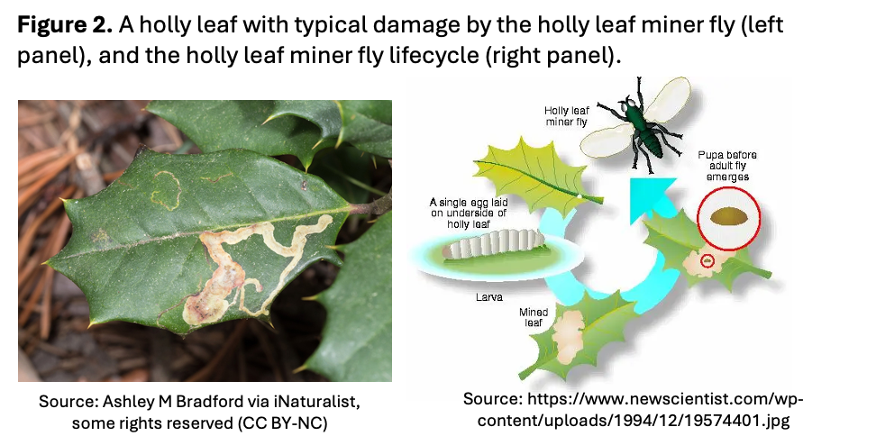
To address this gap, we will investigate plant–insect interactions in American holly (Ilex opaca) along an urbanization gradient in Richmond, VA (Fig. 1). As a dominant southeastern understory tree that thrives across varied habitats and climate gradients, holly is an Anthropocene "winner." It has evergreen, heavily defended foliage fed upon primarily by the larvae of one fly species, the native leaf miner Phytomyza ilicicola (Fig. 2). Prior work shows that holly trait variation strongly impacts P. ilicicola¹⁶⁻¹⁹, likely shifting host-plant interactions along urban gradients⁴⁻⁶. Conversely, holly relies on generalist pollinators, while its fruits provide winter food and its foliage provides shelter for native Virginia wildlife²⁰. By linking urbanization to shifts in these species interactions, this work will advance our understanding of how human-dominated landscapes alter ecological and evolutionary processes and maintain biodiversity.

SPECIFIC AIMS & RESEARCH PLAN
Our primary objective is to determine how American holly and its interactions with other species vary across the Richmond urban-to-rural gradient and leverage these data into an NSF proposal within two years. We have three specific aims. Aim 1 will quantify variation in reproduction, pollination, and population structure across the gradient. Aim 2 will measure herbivory, leaf traits influencing herbivore performance, and the performance of holly's primary insect herbivore, P. ilicicola, and its parasitoids. Aim 3 will identify the ecological and evolutionary mechanisms underlying these patterns.
Timeline: The project will run from Fall 2026 through Spring 2028, with all aims initiated during the award period (Nov 2026-July 2027) and all funds expended by June 30, 2027. The project draws on the team's complementary expertise in plant and insect ecology, genetics, and evolutionary biology.
The Gradient: We established a 25-km transect from industrial Richmond to Pocahontas State Park to quantify urbanization across a 4-km-wide development gradient (Fig. 1). This pilot system will support a future multi-city NSF proposal (e.g., Petersburg, Raleigh, Savannah) and overlaps with a flowering dogwood (Cornus florida) transect previously established by Co-PI Dyer. Using 2025 VBMP 12-inch orthoimagery and NLCD land-cover data, we divided the corridor into twenty-five 1-km windows spanning heavily developed urban landscapes to predominantly forested habitats (Fig. 1). Exploiting American holly's evergreen canopy in winter leaf-off imagery, we developed an automated crown-detection workflow that identified thousands of candidate trees across the gradient (Fig. 1). Treating urbanization as a continuous variable will allow us to identify transition points and evaluate how landscape change shapes plants and their interactions.
Implementation: For Aim 1. Reproductive Ecology & Pollination [led by Co-PI Dyer, complete by June 30, 2027], we will determine how urbanization alters holly reproduction and pollinator interactions. Because holly is dioecious, reproductive success depends on sex ratios and insect-mediated pollen movement, both of which urban disturbance and female-biased horticultural plantings may affect. We will map and sex trees, survey pollinators, quantify fruit set, seed viability, abortion, and germination, and use chloroplast DNA markers to assess cultivated-lineage introgression and population structure (see Aim 3).
For Aim 2. Tri-Trophic Interactions & Herbivory [led by PI Agosta, started during project but ongoing post-project], we will quantify urbanization effects on plant-herbivore interactions using the holly leaf miner (P. ilicicola). We will image foliage to measure damage and rear larvae to assess survival and associated parasitoid communities.
For Aim 3. Physiological Mechanisms & Evolutionary Responses [led by Co-PI Eckert, garden established during project but ongoing post-project, cpDNA finished by June 30, 2027], we will measure microclimate variation (i.e., air temperature and relative humidity using PI Agosta’s existing equipment) and its effects on plant physiological traits, including leaf toughness, gas exchange, and water-use efficiency, linking these traits to variation in pollination, herbivory, and species interactions. To separate genetic and environmental contributions to measured plant traits, we will establish reciprocal common gardens at urban and forest endpoints using offspring from 100 maternal families in a randomized block design (n = 10 offspring/tree/site²¹⁻²³). Combined with chloroplast DNA analyses of population structure and cultivated-lineage introgression (i.e., sequencing three hypervariable cpDNA regions [maternally inherited] in all maternal trees and comparing haplotypes to a reference panel of 10 cultivars and five additional Ilex species²⁴), these data will link ecological variation to evolutionary processes while establishing the experimental infrastructure and preliminary data needed for pursuing future external funding based on manipulative experiments linking insect performance to plant traits.

SIGNIFACANCE & IMPACT
Advancing Urban Evolutionary Ecology: This study will integrate quantitative and population genetics, evolutionary ecology, landscape ecology, and plant-pollinator and plant-herbivore dynamics along an urban-to-rural gradient to test how urbanization may impact forest communities. Focusing on American holly, an Anthropocene "winner," will help explain why certain species thrive in both human-dominated and more natural landscapes. The work directly supports VCU’s Strategic Priority Plan under the Energy, Environment, and Sustainability initiative, emphasizing the Advancing Societal Well-being theme (see refs 25-28 for links between urban tree health and human well-being).
Building up VCU as an Urban Evolutionary Ecology Research Hub: This project establishes a permanent urban-to-rural experimental transect and aligns with previous work on flowering dogwood by Co-PI Dyer and research by other SLSS faculty (e.g., Dr. Brian Verelli⁷⁻¹⁰), helping to solidify VCU as a premier research hub for urban evolutionary ecology.
Networking with Regional Partners: This project establishes key community partners, spanning field sites in the City of Richmond (e.g., Diamond District) to Pocahontas State Park, with experimental facilities at the VCU Rice Rivers Center.
Career Development and Synergistic Collaboration: This project brings together a team of SLSS faculty with overlapping research interests but different expertise (Agosta- insect/plant interactions and thermal biology; Eckert - plant evolutionary genetics and climate adaptation; Dyer - plant landscape ecology and population genetics). Also, PI Agosta is an Associate Professor targeting promotion to Full Professor in the next three years.
Student Education and Training Opportunities: This project provides a platform for hands-on undergraduate research while laying the foundation for long-term, cross-lab graduate training across the Agosta, Eckert, and Dyer labs.
Preliminary Foundation for External NSF Funding. Using Richmond as a model system and the VCU Rice Rivers Center as an experimental field site, this project will generate the pilot data and infrastructure needed to compete for major NSF funding to replicate transects across other medium-sized southeastern US cities.

REFERENCES

- Alberti, M. 2008. Advances in Urban Ecology: Integrating Humans and Ecological Processes in Urban Ecosystems. Boston, MA: Springer US.
- Grimm, N. B., Faeth, S. H., Golubiewski, N. E., Redman, C. L., Wu, J., Bai, X., and Briggs, J. M. 2008. Global change and the ecology of cities. Science 319: 756-760.
- Seto, K. C., Güneralp, B., and Hutyra, L. R. 2012. Global forecasts of urban expansion to 2030 and direct impacts on biodiversity and carbon pools. Proceedings of the National Academy of Sciences 109: 16083-16088.
- Turrini, T., Sanders, D., and Knop, E. 2016. Effects of urbanization on direct and indirect interactions in a tri-trophic system. Ecological Applications 26: 664-675.
- Miles, L. S., Breitbart, S. T., Wagner, H. H., and Johnson, M. T. 2019. Urbanization shapes the ecology and evolution of plant-arthropod herbivore interactions. Frontiers in Ecology and Evolution 7: 310.
- Moreno-García, P., Savage, A., Salgado, A.L., Tartaglia, E.S., Cocciardi, J.M., Aronson, M.F., Jarzyna, M.A., Alberti, M., and Li, D. 2025. The effects of urbanization on species interactions. Nature Cities 2: 693-702.
- Verrelli, B. C., Alberti, M., Des Roches, S., Harris, N. C., Hendry, A. P., Johnson, M. T., Savage, A. M., Charmantier, A., Gotanda, K. M., Govaert, L., and Miles, L. S. 2022. A global horizon scan for urban evolutionary ecology. Trends in Ecology and Evolution 37: 1006-1019.
- Savage, A. M., Willmott, M. J., Moreno‐García, P., Jagiello, Z., Li, D., Malesis, A., Miles, L. S., Román‐Palacios, C., Salazar‐Valenzuela, D., Verrelli, B. C. and Winchell, K. M., 2024. Online toolkits for collaborative and inclusive global research in urban evolutionary ecology. Ecology and Evolution 14: e11633.
- Urban, M. C., Alberti, M., De Meester, L., Zhou, Y., Verrelli, B. C., Szulkin, M., Schmidt, C., Savage, A. M., Roberts, P., Rivkin, L. R. and Palkovacs, E. P. 2024. Interactions between climate change and urbanization will shape the future of biodiversity. Nature Climate Change 14: 436-447.
- Alberti, M., Grimm, N. B., Palkovacs, E. P., Urban, M. C., Verrelli, B. C., Anderson, P., Carlen, E. J., Cocciardi, J. M., Cook, E. M., Fortin, M. J. and Gotanda, K. M. 2026. Evolving nature-based solutions for urban resilience. Science 392: 701-708.
- Liang, H., He, Y.-D., Theodorou, P., and Yang, C.-F. 2023. The effects of urbanization on pollinators and pollination: A meta-analysis. Ecology Letters 26: 1629–1642.
- Ramírez-Vieyra, L., Trujano-Ortega, M., García-Vázquez, U. O., and Ávalos-Hernández, O. 2026. Urbanization and Apis mellifera roles in plant-animal interaction networks in an urban forest. Urban Ecosystems 29: 208.
- Schmitt, L., and Burghardt, K. T. 2021. Urbanization as a disrupter and facilitator of insect herbivore behaviors and life cycles. Current Opinion in Insect Science 45: 97-105.
- Chatelain, M., Rüdisser, J., and Traugott, M. 2023. Urban-driven decrease in arthropod richness and diversity associated with group-specific changes in arthropod abundance. Frontiers in Ecology and Evolution 11: 980387.
- Agosta, S. J., Hulshof, C. M., and Staats, E. G. 2017. Organismal responses to habitat change: herbivore performance, climate and leaf traits in regenerating tropical dry forests. Journal of Animal Ecology 86: 590-604.
- Potter, D. A., and Kimmerer, T. W. 1986. Seasonal allocation of defense investment in Ilex opaca Aiton and constraints on a specialist leafminer. Oecologia 69: 217-224.
- Marino, P. C., and Cornell, H. V. 1992. Adult movement of the native holly leafminer, Phytomyza ilicicola Loew (Diptera: Agromyzidae): consequences for host choice within and between habitats. Oecologia 92: 76-82.
- Marino, P. C., and Cornell, H. V. 1993. Adult feeding and oviposition of Phytomyza ilicicola (Diptera: Agromyzidae) in response to leaf and tree phenology. Environmental Entomology 22: 1294-1301.
- Marino, P. C., Cornell, H. V., and Kahn, D. H. 1993. Environmental and clonal influences on host choice and larval survival in a leaf-mining insect. Journal of Animal Ecology 62: 503-510.
- Living, S. (2024, February 21). The holly grail of wildlife habitat. Virginia Department of Wildlife Resources. https://dwr.virginia.gov/blog/the-holly-grail-of-wildlife-habitat/
- Lynch, M., and Walsh, B. 1998. Genetics and Analysis of Quantitative Traits. Sunderland, MA: Sinauer.
- Hill, W. G. 2010. Understanding and using quantitative genetic variation. Philosophical Transactions of the Royal Society of London Series B, Biological Sciences 365: 73-85.
- Walsh, B., and Lynch, M. 2018. Evolution and Selection of Quantitative Traits. Oxford, UK: Oxford University Press.
- Xu, K., Lin, C., Lee, S. Y., Mao, L., and Meng, K. 2022. Comparative analysis of complete Ilex (Aquifoliaceae) chloroplast genomes: insights into evolutionary dynamics and phylogenetic relationships. BMC Genomics 23: 203.
- Nilsson, K., Sangster, M., and Konijnendijk, C. C. 2010. Forests, trees and human health and well-being: Introduction. In: Nilsson, K., et al. Forests, Trees and Human Health (pp. 1-19). Dordrecht: Springer Netherlands.
- Wolf, K. L., Lam, S. T., McKeen, J. K., Richardson, G. R., Van Den Bosch, M., and Bardekjian, A. C. 2020. Urban trees and human health: A scoping review. International Journal of Environmental Research and Public Health 17: 4371.
- Locosselli, G.M., and Buckeridge, M.S. 2023. The science of urban trees to promote well-being. Trees 37: 1–7.
- Krischke, J., Beckmann-Wübbelt, A., Glaser, R., Dey, S., and Saha, S. 2025. Relationship between urban tree diversity and human well-being: implications for urban planning. Sustainable Cities and Society 124: 106294.
Budget

- 100 mom trees X 12 offspring = 1,200 2 gallon pots = $1400 for potting supplies
- 1.5 x 1000 = 1500 of soil ~7.5 cubic yards = $500
- Collection consumables (e.g., collection vials, storage containers, etc.) = $500
- DNA sequencing and extraction = $1200-1500
- Lab consumables = $500
______________________________

Total:
10/29/2026: Dean’s Research Grant text for project description

From the RFP:

- Abstract (concisely convey, in lay terms, the nature of the project and its significance; 250 words maximum)
- Introduction/background
- Specific aims for the project
- Research plan to achieve aims
- Significance and impact of projectFro
submission form includes a field to list a two sentence summary of the proposal. Here is a draft:

This project investigates how urbanization reshapes interactions between American holly and the insects that pollinate, feed on, and parasitize it by studying a continuous 25-km urban-to-rural gradient across the Richmond region. By linking changes in reproduction, herbivory, genetics, and environmental conditions, the research will improve understanding of how biodiversity and species interactions respond to human-dominated landscapes while providing information relevant to urban forest management and conservation.

see: https://intranet.chs.vcu.edu/research-and-teaching/chs-funding/deans-research-grant/
Show less

Project description, CHS internal budget form, CV, current, pending and intended support. *

All files should be named "YourLastName_DocumentName".
Please combine requested document into one PDF and submit.
Please keep in mind that not all reviewers will be experts in every proposed field of study, and thus project descriptions should be written for a broad audience.
Three pages maximum, including title, abstract and project description.
The project description must address how the proposed activities are consistent with the goals of the program involving tangible outcomes, career development, and meaningful contributions to the field and CHS/university priorities as an R1 institution. The description should include sufficient detail that allows reviewers to evaluate the appropriateness, merits, requirements and feasibility of the proposal. Applicants should likewise discuss their preparedness for the project alongside the composition of their research team, where applicable. Inclusive research teams encompassing meaningful participation of all members are strongly encouraged.
The narrative should be concise, understandable by a broad audience, and organized into the following sections:
- Abstract (concisely convey, in lay terms, the nature of the project and its significance; 250 words maximum)
- Introduction/background
- Specific aims for the project
- Research plan to achieve aims
- Significance and impact of project
Use the citation format that is appropriate to your field. No page maximum, but limit to only highly relevant citations.
Please submit a detailed budget via the CHS Internal Budget Form.

Since coevolutionary relationships arise through reciprocal interactions among species, changes experienced by one species can generate evolutionary and ecological responses in others. As a result, human-driven environmental change may affect not only the distribution and abundance of species, but also the coevolutionary dynamics that contribute to the generation and maintenance of biodiversity. Plant-insect interactions, ranging from pollination to herbivory, provide particularly informative examples of how urbanization can reshape coevolutionary relationships, as ecological changes can cascade through interacting partners to influence their evolutionary trajectories.
Rough Project Timeline

Timeline

November 2026-February 2027
- Map and sex trees after leaf drop. Collect basic information on sex and size.
- Collect seeds from mother trees. Store seeds in the freezer for future germination experiments. Collect seeds for establishment of sibling arrays in reciprocal common gardens
- Photograph leaves to measure historical (previous years) levels of herbivory on target trees.
- Collect leaves to chlorotype for hybridization assessment and to measure leaf traits related to herbivory?)
- Recruit undergraduates by pitching to targeted courses: GIS/cartography for spatial work, ecology for herbivory & pollinators, and evolution for co-evolution.Formats include independent study, the new zero-credit research course, and a possible fall capstone or seminar that produces the literature review
May 2027-May 2028
**All money will be spent before June 30th**
- Chlorotyping in Spring
- Deploy temperature/relative humidity data loggers on target trees to measure microclimates.
- Collect newly matured leaves to measure herbivore-related leaf traits (toughness, thickness, water content, etc.)
- Measure current herbivory and identify newly oviposited larvae of the primary insect herbivore P. ilicicola to measure (1) survival and (2) rates of attack by parasitoids.
- Run pollinator counts in April–June.
- Germination tests, seed abortion, etc. ~ (landscape location).
- Use this data to leverage into an NSF proposal —> Richmond is test case to establish similar transects in other medium sized SE citie

