Population assignment reveals low migratory connectivity in a weakly structured songbird

Matthew G. DeSaix¹, Lesley P. Bulluck^{1,2}, Andrew J. Eckert², Catherine B. Viverette¹, Than J. Boves³, Jessica A. Reese², Christopher M. Tonra⁴, and Rodney J. Dyer¹

Supporting information

Table of Contents:

Figure S1 Principal components analysis
Figure S2 Missing loci data across sites
Figure S3 Mantel results
Figure S4 DAPC plots
Figure S5 STRUCTURE plots
Figure S6 Site-level environmental heterogeneity
Figure S7 Assignment success by sample size
Table S1 F_{ST} calculated according to Weir & Cockerham
Table S2 DAPC group membership
Table S3 RDA predictor variables
Table S4 Population assignment likelihood

Figure S1: Principal Components Analysis
(A) The initial PCA with all breeding site individuals and 26,189 SNPs, prior to the removal of outlier individuals. (B) The PCA with 600 SNPs results in the general partioning of individuals from the two breeding regions along PC1, as shown when removing outlier individuals from the PCA with all SNPs (Figure 1A). However, more fine scale structuring is revealed with the sites VA2 and LA2 clustering separately from other breeding sites. (C) PCA of Atlantic region with 600 SNPs and (D) PCA of Mississippi region with 600 SNPs.

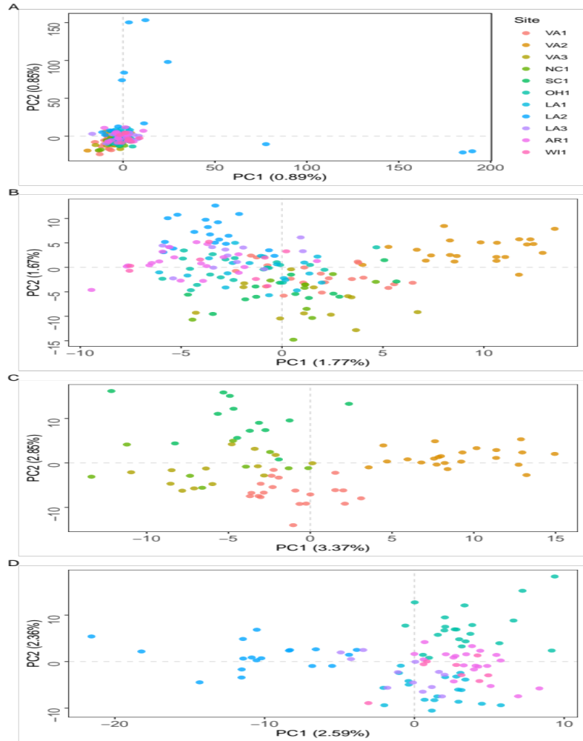

Figure S2: Missing loci data across sites
The analysis of variance showed significant difference among the breeding sites based on the proportion of missing loci data in individuals (F = 3.69_{10,164}, p < 0.001). The sites OH1 (n = 21) and SC1 (n = 13) had a larger median proportion of missing loci data within their individuals and a larger range of missing data than the other sites. PCA was conducted without these two sites but the resulting plots showed the same trends as the original PCA (Figure S1), thus, all 11 breeding sites and 175 individuals were retained for subsequent analyses.

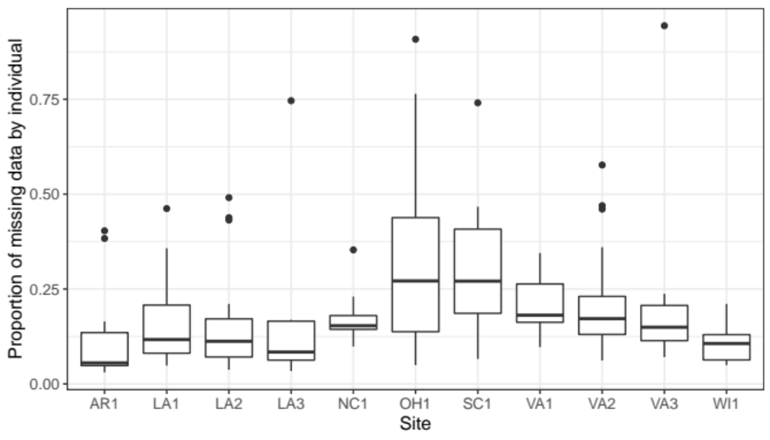

Figure S3: Mantel results
A kernel density plot of genetic distance by the geographic distance (log₁₀ transformed) revealed a center near the maximum of geographic distance on the x-axis. However, near the maximum values of geographic distance there is a wide-range of genetic distance values. The lower genetic distance values with a large geographic distance represent comparisons of widely separated sites in the Mississippi region that are genetically similar. The high genetic distance values with large geographic distances are the between-site comparisons that cross diagonally between the two regions (e.g. WI1 to SC1).

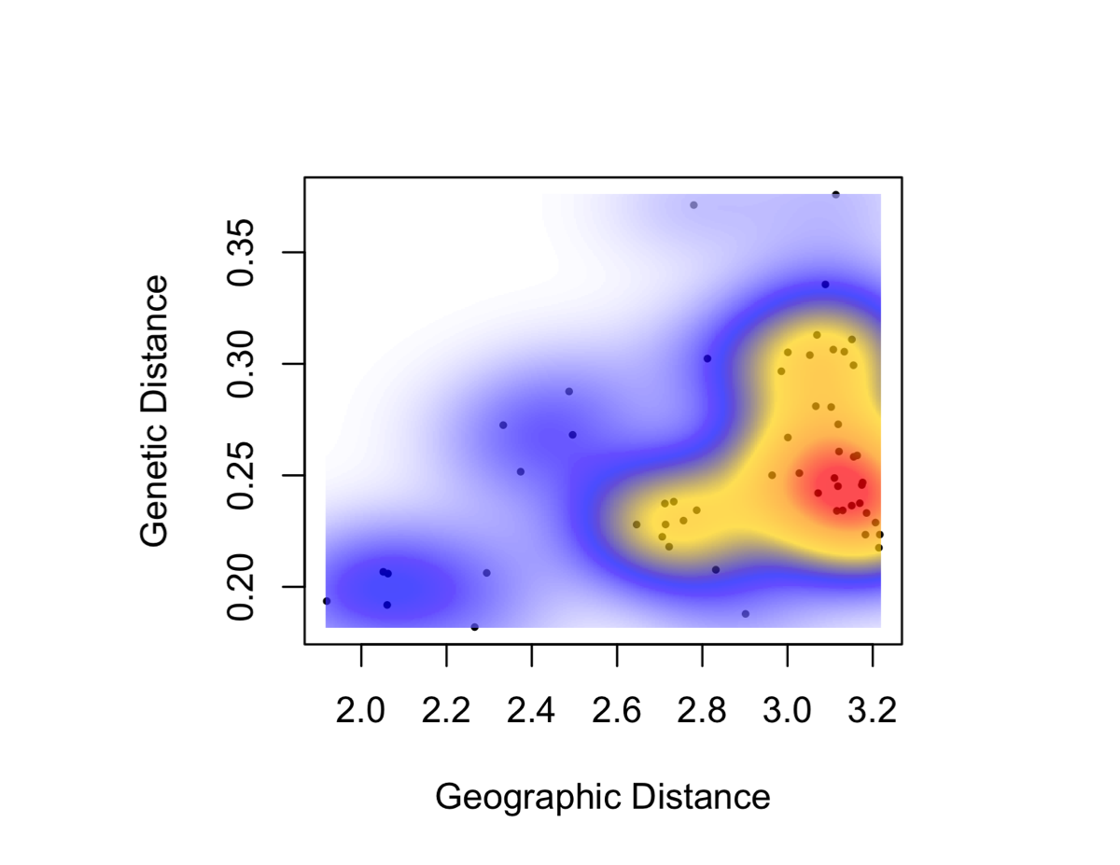

Figure S4: DAPC plots
(A) Using 26,189 SNPs, cross-validation (n = 1000) for a range of principal components (PC) in the discriminant analysis identified 60 PCs as optimal (defined by having the least mean square error). The resulting K-means clustering identified K = 1 to have the lowest bayesian information criterion (BIC). (B) Following the same procedure with the subset of 600 SNPs, 41 PCs were identified as optimal and K of 2 clusters had the lowest BIC. The resulting discriminant analysis, based on K = 2, predominantly split individuals between the breeding sites in the Atlantic and Mississippi regions.

A
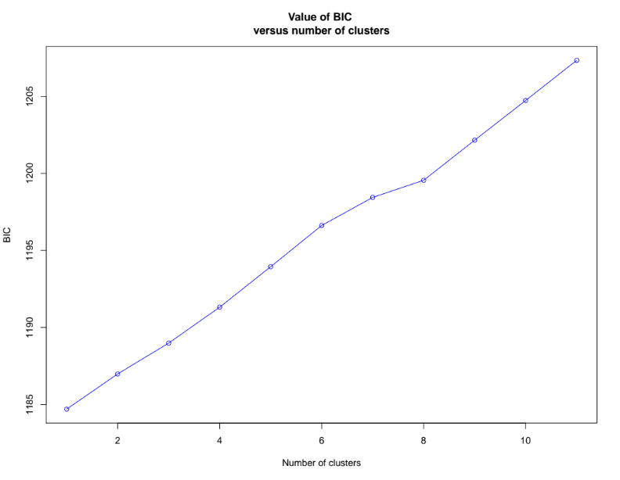
B
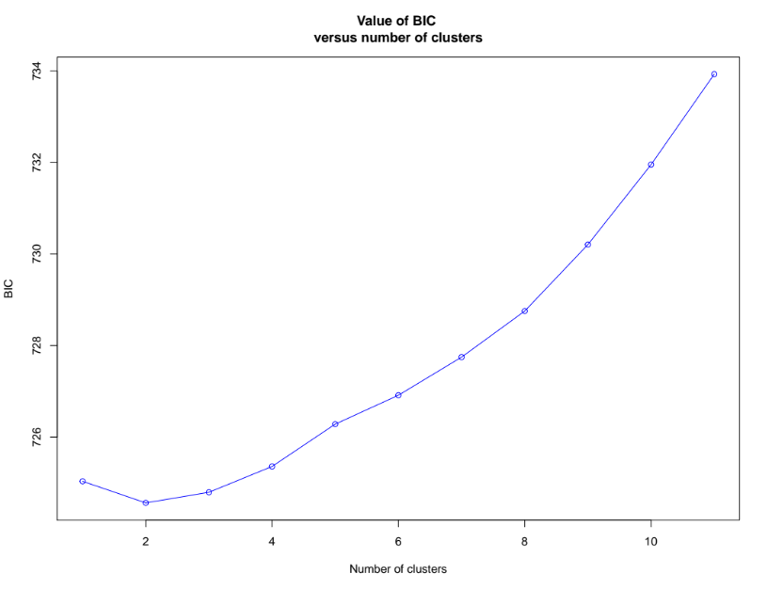
Figure S5: STRUCTURE plots
Results of the population genetic analysis for prothonotary warblers across the breeding range using STRUCTURE. Bar plots from the program CLUMPAK are provided for (A) K=2 with all SNPs and (B) K=2-4 with the subset of 600 highly-differentiated SNPs. (C) Delta K plots and (D) mean likelihood of K are provided.

A

AR1 LA1 LA2 LA3 NC1 OH1 SC1 VA2 VA1 VA3 WI1

B



AR1 LA1 LA2 LA3 NC1 OH1 SC1 VA2 VA1 VA3 WI1

C
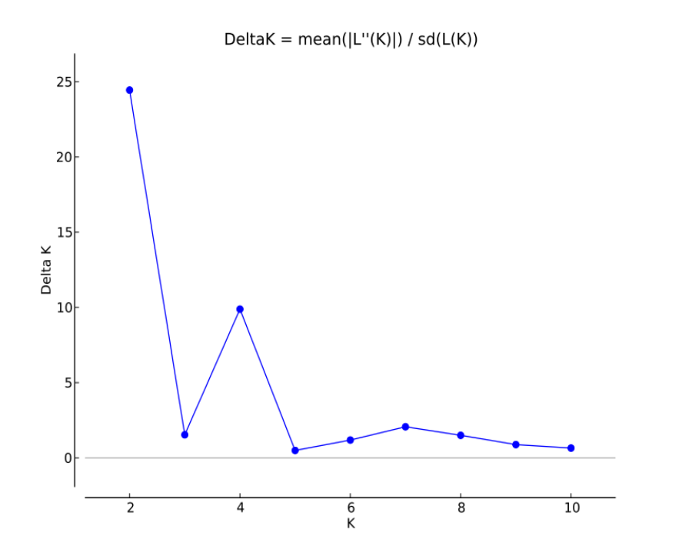
D
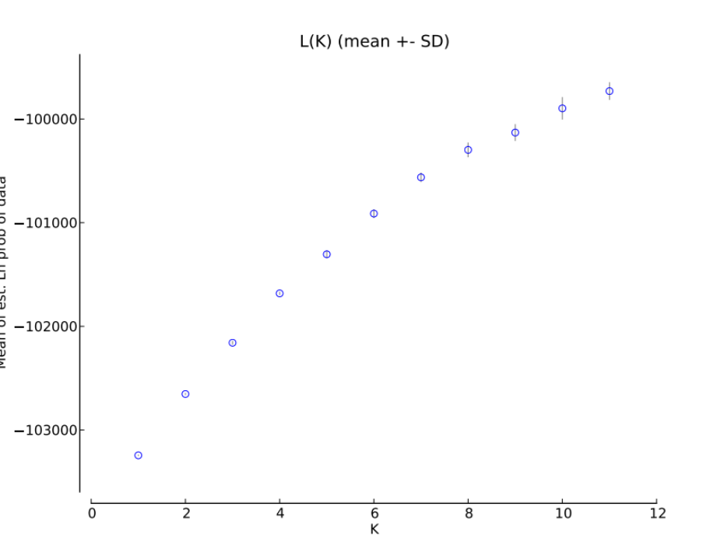

Figure S6: Site-level environmental heterogeneity
A PCA of breeding sites across all 23 annual bioclimatic variables provided from ClimateNA (Wang et al. 2016). Generally, PC1 had higher loadings of variables directly associated with temperature while PC2 had higher loadings of several variables measuring moisture, with the addition of a measurement of historical extreme temperature. ENV_PC1 was strongly correlated with latitude (r² = 0.99, F = 1206_{1,9}, p = 6.7e-11) and represented a bioclimatic gradient associated with latitudinal change in the eastern United States. ENV_PC2 was not correlated with longitude (r² = 0.01, F = 1.104_{1,9}, p = 0.32). Sites from the Atlantic Seaboard region are colored in purple and sites from Mississippi River Valley are colored in green.

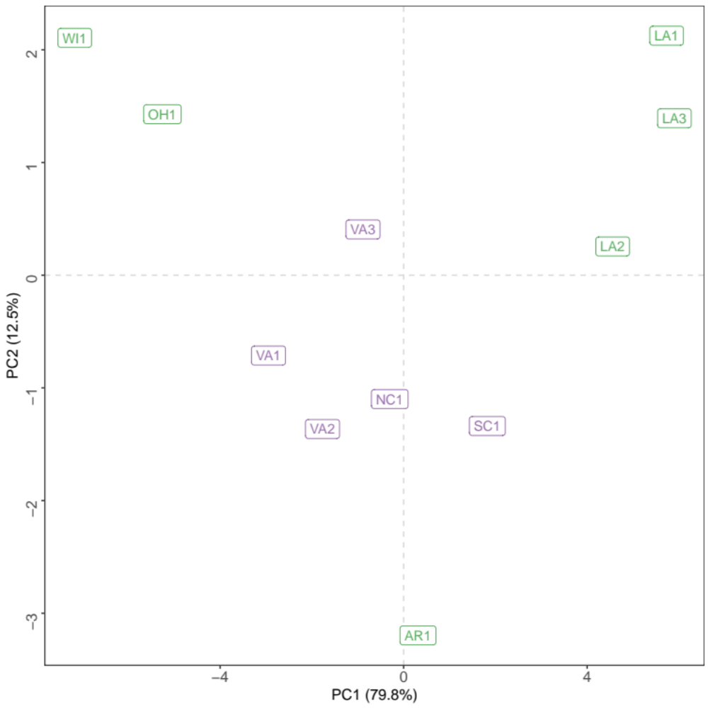

Figure S7: Assignment success by sample size
In the leave-one-out cross-validation model, the assignment success of known origin individuals to breeding site ranged from 44% to 100%. All sites represented by more than 12 samples had a greater than 90% assignment success of their individuals. These data had a significant positive correlation (r² = 0.84, F = 20.84_{2,8}, p = 0.0007).

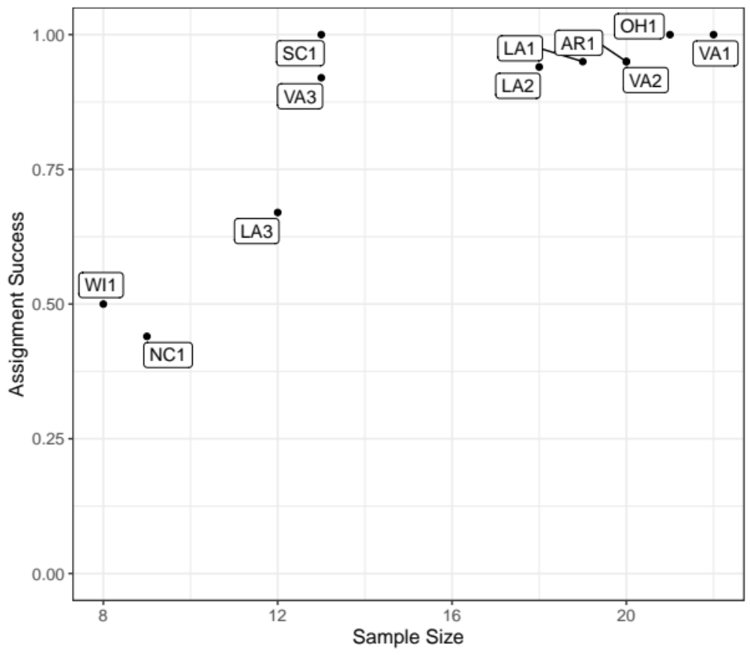

Table S1: Pairwise F_{ST}
Values below the diagonal are Weir & Cockerham (1984) F_{ST} values calculated using the hierfstat package (Goudet 2005). Significance (α = 0.05) was tested through 1000 permutations of the genotypes among populations and a Bonferroni adjustment was employed to correct for multiple tests. Values above the diagonal are bootstrapped confidence intervals of the 0.025 and 0.975 quantiles.

 | VA1 | VA2 | VA3 | NC1 | SC1 | OH1 | LA1 | LA2 | LA3 | AR1 | WI1
VA1 | - | 0.0026- 0.0046 | 0 - 0.0006 | 0.0016 - 0.0054 | 0.0014 - 0.0050 | 0.0040 - 0.0064 | 0.0021- 0.0043 | 0.0064 - 0.0083 | 0.0013 - 0.0036 | 0.0024 - 0.0042 | 0.003 - 0.0073
VA2 | 0.0035* | - | 0.0028 - 0.0047 | 0.0040 - 0.0086 | 0.0051- 0.0095 | 0.0069- 0.0097 | 0.0066-0.0089 | 0.0097 - 0.0118 | 0.0058 - 0.0086 | 0.0064 - 0.0086 | 0.0077 - 0.0120
VA3 | 0.0001 | 0.0036* | - | 0 - 0.0048 | 0.0007- 0.0049 | 0.0039- 0.0068 | 0.0035 - 0.0067 | 0.0066 - 0.0095 | 0.0021 - 0.0054 | 0.0030 - 0.0056 | 0.0046 - 0.0089
NC1 | 0.0033* | 0.0062* | 0.0017 | - | 0 - 0.0045 | 0.0028 - 0.0068 | 0.0041 - 0.0080 | 0.0075 - 0.0110 | 0.0044 - 0.0089 | 0.0056 - 0.0090 | 0.0086 - 0.0136
SC1 | 0.0033* | 0.0074* | 0.0031* | 0.0018 | - | 0.0049 - 0.0089 | 0.0051 - 0.0086 | 0.0071 - 0.0111 | 0.0037 - 0.0077 | 0.0062 - 0.0096 | 0.0069 - 0.0120
OH1 | 0.0051* | 0.0085* | 0.0053* | 0.0052* | 0.0071* | - | 0.0034 - 0.0058 | 0.0066- 0.0091 | 0.001- 0.0043 | 0.0028 - 0.0052 | 0.0001 - 0.0041
LA1 | 0.0033* | 0.0077* | 0.0050* | 0.0060* | 0.0066* | 0.0046* | - | 0.0047- 0.0070 | 0.0001- 0.0032 | 0.0018 - 0.0037 | 0.0024 - 0.0058
LA2 | 0.0074* | 0.0107* | 0.0079* | 0.0091* | 0.0092* | 0.0078* | 0.0059* | - | 0.003- 0.0065 | 0.0048 - 0.0066 | 0.0069 - 0.0110
LA3 | 0.0023* | 0.0071* | 0.0039* | 0.0066* | 0.0059* | 0.0078* | 0.0020* | 0.0050* | - | 0.0007 - 0.0029 | 0.0035 - 0.0077
AR1 | 0.0032* | 0.0074* | 0.0045* | 0.0073* | 0.0081* | 0.0026* | 0.0027* | 0.0057* | 0.0018* | - | 0.0036 - 0.0072
WI1 | 0.0052* | 0.0101* | 0.0067* | 0.0107* | 0.0093* | 0.0040* | 0.0039* | 0.0089* | 0.0055* | 0.0053* | -
* p < 0.0009

Table S2: DAPC group membership

Group membership for DAPC results using 600 SNPs and retaining an initial 41 PCs for K = 2 clusters. Individuals were mainly split between the Atlantic and Mississippi regions with 91.8% of group 1 being from Atlantic sites (VA1, VA2, VA3, NC1 and SC1) and 88.9% of individuals in group 2 being from Mississippi sites (OH1, LA1, LA2, LA3, AR1, WI1).

 | 1 | 2
VA1 | 15 | 5
VA2 | 22 | 0
VA3 | 12 | 1
NC1 | 7 | 2
SC1 | 12 | 1
OH1 | 4 | 17
LA1 | 2 | 17
LA2 | 0 | 18
LA3 | 0 | 12
AR1 | 0 | 20
WI1 | 0 | 8

Table S3: RDA predictor variables

Loadings for significant PCs for the environmental variables, provided by ClimateNA (Wang et al. 2016), in the RDA.

Environmental Variables | Description | PC1 | PC2
MAT | mean annual temperature (°C), | 0.230 | -0.091
MWMT | mean warmest month temperature (°C), | 0.218 | -0.181
MCMT | mean coldest month temperature (°C), | 0.229 | -0.085
TD | temperature difference between MWMT and MCMT, or continentality (°C), | -0.225 | 0.038
MAP | mean annual precipitation (mm), | 0.229 | 0.032
MSP | mean annual summer (May to Sept.) precipitation (mm), | 0.208 | 0.239
AHM | annual heat-moisture index (MAT+10)/(MAP/1000)) | -0.166 | -0.24
SHM | summer heat-moisture index ((MWMT)/(MSP/1000)) | -0.155 | -0.381
DD<0 | degree-days below 0°C, chilling degree-days | -0.188 | 0.26
DD5 | degree-days above 5°C, growing degree-days | 0.232 | -0.042
DD<18 | degree-days below 18°C, heating degree-days | -0.228 | 0.113
DD>18 | degree-days above 18°C, cooling degree-days | 0.23 | -0.041
NFFD | the number of frost-free days | 0.231 | 0.022
bFFP | frost-free period | -0.228 | -0.08
eFFP | the Julian date on which FFP begins | 0.232 | 0.04
FFP | the Julian date on which FFP ends | 0.23 | 0.064
PAS | precipitation as snow (mm) between August in previous year and July in current year | -0.185 | 0.283
EMT | extreme minimum temperature over 30 years | 0.233 | -0.024
EXT | extreme maximum temperature over 30 years | -0.002 | -0.449
Eref | Hargreaves reference evaporation (mm) | 0.22 | -0.172
CMD | Hargreaves climatic moisture deficit (mm) | -0.134 | -0.478
MAR | mean annual solar radiation (MJ m‐2 d‐1) | 0.222 | -0.127
RH | Relative humidity (%) | 0.196 | 0.191

Loadings for significant PCs for the geographic variables. Combinations of latitude and longitude were combined into a matrix of geographic variables following Legendre and Legendre (2012)

Geographic Variables | PC1 | PC2
Latitude | -0.412 | -0.231
Longitude | -0.029 | -0.595
Elevation | -0.402 | 0.077
Latitude^2 | -0.419 | -0.208
Longitude^2 | 0.033 | 0.594
Lat*Long | 0.432 | -0.152
Lat^2*Long | 0.447 | 0.022
Long^2*Lat | -0.324 | 0.409

Table S4: Assignment Likelihood
Results from the leave-one-out cross-validation model: likelihood of assignment to each region is listed as the product of of multilocus genotype probabilities. The numerator of the likelihood ratio is the likelihood of the assigned region.

Individual | Non-breeding Site | Assigned Region | Likelihood to Atlantic | Likelihood to Mississippi | Likelihood Ratio | Log Likelihood Ratio
PN1_01 | PN1 | Atlantic | 1.47E-170 | 2.28E-175 | 64400 | 4.81
PN1_02 | PN1 | Mississippi | 2.66E-171 | 1.28E-161 | 4.81E+09 | 9.68
PN1_03 | PN1 | Mississippi | 8.25E-166 | 2.54E-155 | 3.07E+10 | 10.5
PN1_04 | PN1 | Mississippi | 3.58E-192 | 5.42E-175 | 1.51E+17 | 17.2
PN1_05 | PN1 | Mississippi | 1.87E-179 | 1.21E-162 | 6.48E+16 | 16.8
PN1_06 | PN1 | Mississippi | 1.92E-187 | 1.32E-182 | 68900 | 4.84
PN1_07 | PN1 | Mississippi | 1.48E-179 | 1.55E-164 | 1.05E+15 | 15
PN2_01 | PN2 | Atlantic | 3.39E-184 | 4.90E-187 | 690 | 2.84
PN2_02 | PN2 | Atlantic | 3.15E-173 | 1.50E-177 | 21000 | 4.32
PN2_03 | PN2 | Mississippi | 4.93E-159 | 1.32E-158 | 2.69 | 0.429
PN2_04 | PN2 | Atlantic | 1.55E-161 | 1.93E-163 | 80.4 | 1.91
PN2_05 | PN2 | Atlantic | 8.17E-190 | 1.19E-191 | 68.6 | 1.84
PN2_06 | PN2 | Mississippi | 2.47E-159 | 5.43E-156 | 2200 | 3.34
PN2_07 | PN2 | Mississippi | 7.56E-171 | 1.73E-161 | 2.28E+09 | 9.36
PN2_08 | PN2 | Atlantic | 7.40E-135 | 4.83E-135 | 1.53 | 0.186
PN2_09 | PN2 | Mississippi | 1.16E-162 | 2.02E-146 | 1.74E+16 | 16.2
PN2_10 | PN2 | Mississippi | 2.77E-148 | 6.85E-146 | 247 | 2.39
PN2_11 | PN2 | Mississippi | 2.57E-155 | 7.98E-151 | 31000 | 4.49
PN2_12 | PN2 | Atlantic | 2.47E-94 | 1.70E-94 | 1.46 | 0.164
PN2_13 | PN2 | Mississippi | 2.36E-178 | 6.57E-178 | 2.79 | 0.445
PN2_14 | PN2 | Mississippi | 2.16E-174 | 3.64E-162 | 1.69E+12 | 12.2
PN2_15 | PN2 | Mississippi | 4.01E-168 | 8.11E-156 | 2.02E+12 | 12.3
PN2_16 | PN2 | Mississippi | 2.04E-178 | 2.43E-165 | 1.19E+13 | 13.1
PN2_17 | PN2 | Mississippi | 1.43E-182 | 1.45E-164 | 1.01E+18 | 18
CO3_01 | CO3 | Mississippi | 2.77E-165 | 2.02E-160 | 72900 | 4.86
CO3_02 | CO3 | Atlantic | 1.52E-123 | 1.61E-125 | 94 | 1.97
CO3_03 | CO3 | Atlantic | 8.44E-150 | 6.82E-158 | 1.24E+08 | 8.09
CO3_04 | CO3 | Atlantic | 5.65E-123 | 1.52E-127 | 37200 | 4.57
CO3_05 | CO3 | Atlantic | 4.83E-103 | 9.05E-104 | 5.34 | 0.728
CO3_06 | CO3 | Mississippi | 3.05E-99 | 1.74E-98 | 5.71 | 0.757
CO3_07 | CO3 | Atlantic | 4.17E-141 | 4.03E-144 | 1030 | 3.01
CO3_08 | CO3 | Mississippi | 8.96E-113 | 2.07E-110 | 231 | 2.36
CO3_09 | CO3 | Mississippi | 2.86E-118 | 1.83E-104 | 6.37E+13 | 13.8
CO3_10 | CO3 | Mississippi | 4.24E-105 | 2.72E-97 | 6.40E+07 | 7.81
CO3_11 | CO3 | Mississippi | 8.14E-127 | 2.89E-111 | 3.55E+15 | 15.6
CO3_12 | CO3 | Mississippi | 5.98E-141 | 5.15E-130 | 8.61E+10 | 10.9
CO3_13 | CO3 | Mississippi | 1.74E-171 | 1.99E-169 | 114 | 2.06
CO3_14 | CO3 | Mississippi | 1.38E-171 | 1.90E-152 | 1.37E+19 | 19.1
CO3_15 | CO3 | Mississippi | 1.75E-172 | 3.10E-163 | 1.77E+09 | 9.25
CO3_16 | CO3 | Mississippi | 1.20E-170 | 3.04E-158 | 2.54E+12 | 12.4
CO3_17 | CO3 | Atlantic | 1.57E-131 | 3.09E-133 | 50.8 | 1.71
CO3_18 | CO3 | Atlantic | 1.04E-95 | 6.24E-105 | 1.67E+09 | 9.22
CO3_19 | CO3 | Atlantic | 7.25E-48 | 1.29E-52 | 56200 | 4.75
CO3_20 | CO3 | Mississippi | 1.09E-116 | 1.54E-114 | 141 | 2.15
CO3_21 | CO3 | Mississippi | 9.58E-145 | 2.59E-134 | 2.71E+10 | 10.4
CO3_22 | CO3 | Mississippi | 1.45E-92 | 3.04E-79 | 2.09E+13 | 13.3
CO3_23 | CO3 | Mississippi | 7.68E-132 | 1.70E-131 | 2.21 | 0.344
CO3_24 | CO3 | Mississippi | 7.51E-162 | 6.12E-157 | 81400 | 4.91
CO3_25 | CO3 | Mississippi | 3.11E-173 | 6.46E-166 | 20700000 | 7.32
CO3_26 | CO3 | Mississippi | 4.65E-155 | 4.03E-152 | 867 | 2.94
CO3_27 | CO3 | Mississippi | 4.41E-152 | 5.51E-141 | 1.25E+11 | 11.1
CO2_01 | CO2 | Mississippi | 1.22E-167 | 8.14E-163 | 66800 | 4.82
CO2_02 | CO2 | Mississippi | 5.76E-162 | 5.46E-152 | 9.48E+09 | 9.98
CO2_03 | CO2 | Mississippi | 2.79E-175 | 1.64E-144 | 5.86E+30 | 30.8
CO2_04 | CO2 | Mississippi | 5.37E-132 | 1.30E-123 | 2.42E+08 | 8.38
CO2_05 | CO2 | Mississippi | 7.44E-170 | 5.26E-153 | 7.07E+16 | 16.8
CO2_06 | CO2 | Mississippi | 2.28E-182 | 1.01E-166 | 4.44E+15 | 15.6
CO2_07 | CO2 | Mississippi | 1.56E-157 | 1.19E-143 | 7.60E+13 | 13.9
CO2_08 | CO2 | Mississippi | 3.73E-198 | 1.91E-191 | 5120000 | 6.71
CO2_09 | CO2 | Mississippi | 3.43E-102 | 2.80E-96 | 816000 | 5.91
CO2_10 | CO2 | Atlantic | 4.44E-100 | 3.80E-103 | 1170 | 3.07
CO2_11 | CO2 | Mississippi | 1.82E-147 | 1.27E-133 | 6.97E+13 | 13.8
CO2_12 | CO2 | Atlantic | 0.0129 | 0.00121 | 10.6 | 1.03
CO2_13 | CO2 | Mississippi | 1.82E-142 | 6.65E-132 | 3.65E+10 | 10.6
CO2_14 | CO2 | Mississippi | 3.88E-117 | 9.34E-115 | 241 | 2.38
CO2_15 | CO2 | Mississippi | 1.23E-154 | 9.01E-143 | 7.30E+11 | 11.9
CO2_16 | CO2 | Mississippi | 7.85E-113 | 5.46E-109 | 6950 | 3.84
CO2_17 | CO2 | Mississippi | 1.85E-161 | 3.17E-160 | 17.1 | 1.23
CO2_18 | CO2 | Mississippi | 1.45E-132 | 5.75E-130 | 395 | 2.6
CO2_19 | CO2 | Atlantic | 3.28E-83 | 1.89E-83 | 1.74 | 0.24
CO2_20 | CO2 | Mississippi | 2.66E-111 | 3.47E-105 | 1310000 | 6.12
CO2_21 | CO2 | Mississippi | 9.49E-132 | 1.44E-124 | 15200000 | 7.18
CO2_22 | CO2 | Mississippi | 0.663 | 0.85 | 1.28 | 0.108
CO2_23 | CO2 | Atlantic | 2.17E-159 | 2.56E-161 | 85 | 1.93
CO2_24 | CO2 | Atlantic | 6.97E-157 | 3.57E-157 | 1.95 | 0.291
CO2_25 | CO2 | Mississippi | 1.70E-144 | 1.06E-141 | 623 | 2.79
CO2_26 | CO2 | Mississippi | 7.76E-119 | 5.39E-115 | 6950 | 3.84
CO2_27 | CO2 | Mississippi | 2.91E-89 | 3.78E-87 | 130 | 2.11
CO2_28 | CO2 | Atlantic | 2.76E-84 | 1.67E-89 | 166000 | 5.22
CO2_29 | CO2 | Mississippi | 6.18E-191 | 2.45E-180 | 3.96E+10 | 10.6
CO1_01 | CO1 | Mississippi | 4.12E-104 | 8.49E-93 | 2.06E+11 | 11.3
CO1_02 | CO1 | Mississippi | 2.51E-143 | 8.00E-142 | 31.8 | 1.5
CO1_03 | CO1 | Mississippi | 3.09E-155 | 1.44E-143 | 4.67E+11 | 11.7
CO1_04 | CO1 | Atlantic | 1.37E-121 | 1.45E-125 | 9460 | 3.98
CO1_05 | CO1 | Mississippi | 1.85E-151 | 1.68E-149 | 90.9 | 1.96
CO1_06 | CO1 | Mississippi | 9.72E-165 | 6.15E-161 | 6330 | 3.8
CO1_07 | CO1 | Mississippi | 1.99E-162 | 1.16E-140 | 5.81E+21 | 21.8
CO4_01 | CO4 | Mississippi | 1.75E-162 | 5.86E-154 | 3.35E+08 | 8.53
CO4_02 | CO4 | Mississippi | 3.49E-152 | 8.17E-147 | 234000 | 5.37
CO4_03 | CO4 | Mississippi | 4.99E-171 | 5.96E-156 | 1.19E+15 | 15.1

