Baseline:

Features: 'BloodPressure', 'SkinThickness', 'Age'

Tree Max_depth = 2

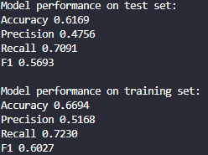

Experiment 1:

Features: 'BloodPressure', 'Age', 'Insulin', 'Glucose'

Tree Max_depth = 2

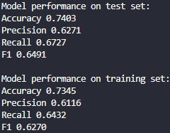

Experiment 2:

Features: 'BloodPressure', 'Age', 'Insulin', 'Glucose', 'BMI'

Tree Max_depth = 3

