My best result:
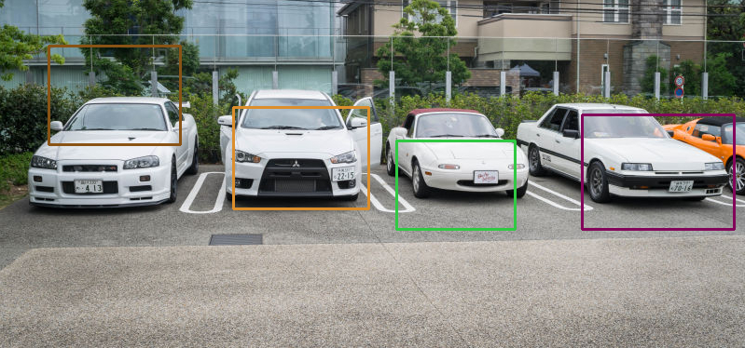
Differences along horizontal axis: (HIST_HORZ_20.png)
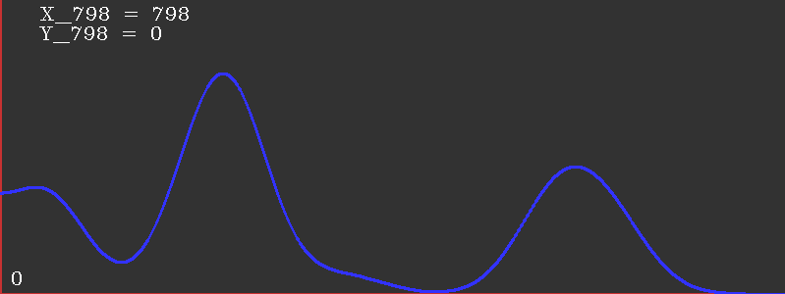
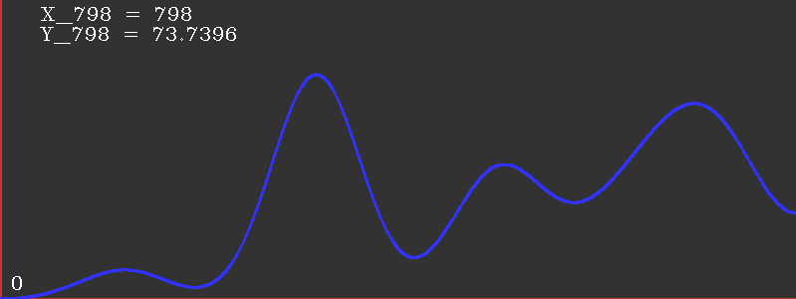
Differences along vertical axis: (HIST_VERT_20.png)
Car Locations: (HIST_CAR_20.png)
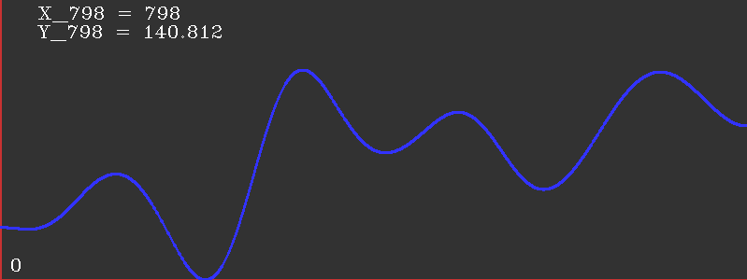

Good peaks in this histogram give us the x coordinate of the car. To get the y coordinate, I took the weighted average of the y coordinate while creating the vertical difference histogram. Basically, while summing the vertical differences up along one column, I created another histogram that gives the center of gravity of the vertical difference magnitudes.

if(abs(gy.col(i).at<double>(j)) > threshy)
{
xData.at<double>(i) += abs(gy.col(i).at<double>(j));
loc.at<double>(i) += abs(gy.col(i).at<double>(j)) * j;
}

xData is the vertical difference histogram.
j is the current y coordinate and loc is the other histogram.

To calculate the width of a car, I summed the distances from a peak to its neighboring pits.

width = steps[i+1] – steps[i];

steps is the vector of pits in the histogram.

