Names: Doyoung Kim, Rohan Tanna

UTEID: dk24338, rrt494

Section: 16185

EE422C

**Assignment 4: Word Ladder**

**Analysis**

Implement WordLadderSolver class, which finds sequence of distinct English words such that any two consecutive words in the sequence is differ by changing one letter at a time. Solver method should take two inputs and one should be the start of the sequence and other should be the end of the sequence. Both inputs needs to be a 5-letter words that are in given dictionary and program should check if inputs are correct before starting the search. Note that it is possible to not find any word ladder from one end to the other.

**Design**

**IPO**

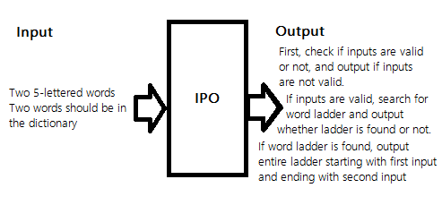

**Use Case**

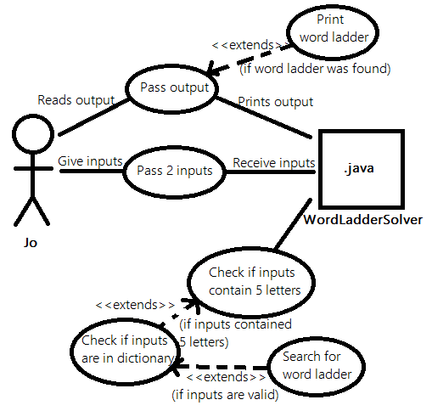

**UML**

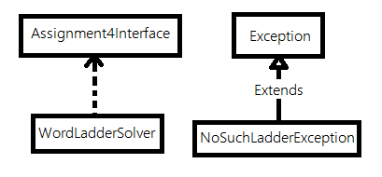

**Functional Block Diagram**

**Pseudo Code**

**A paragraph describing the rationale behind your design. This would include:  
a) How does your OOD reflect the interaction and behavior of the real-world objects that it models  
b) What alternatives did you consider? What were the advantages/disadvantages of each alternative both from a programming perspective and a user perspective?  
c) What are some expansions or possible flexibilities that your design offers for future enhancements?  
d) How does your design adhere to principles of good design: OOD, cohesion, coupling, info hiding,  
etc?**