Preliminary Report

Dylan Denner & Jackson Tucker

4/19/2021

## Preperation for Presentation

##   
## Attaching package: 'dplyr'

## The following objects are masked from 'package:stats':  
##   
## filter, lag

## The following objects are masked from 'package:base':  
##   
## intersect, setdiff, setequal, union

## -- Attaching packages --------------------------------------- tidyverse 1.3.0 --

## v ggplot2 3.3.3 v purrr 0.3.4  
## v tibble 3.0.5 v stringr 1.4.0  
## v tidyr 1.1.3 v forcats 0.5.1  
## v readr 1.4.0

## -- Conflicts ------------------------------------------ tidyverse_conflicts() --  
## x dplyr::filter() masks stats::filter()  
## x dplyr::lag() masks stats::lag()

##   
## Attaching package: 'gridExtra'

## The following object is masked from 'package:dplyr':  
##   
## combine

##   
## Attaching package: 'MASS'

## The following object is masked from 'package:dplyr':  
##   
## select

## Loading required package: carData

##   
## Attaching package: 'car'

## The following object is masked from 'package:purrr':  
##   
## some

## The following object is masked from 'package:dplyr':  
##   
## recode

## Loading required package: zoo

##   
## Attaching package: 'zoo'

## The following objects are masked from 'package:base':  
##   
## as.Date, as.Date.numeric

## Loading required package: splines

## Loading required package: foreach

##   
## Attaching package: 'foreach'

## The following objects are masked from 'package:purrr':  
##   
## accumulate, when

## Loaded gam 1.20

## Loading required package: nlme

##   
## Attaching package: 'nlme'

## The following object is masked from 'package:dplyr':  
##   
## collapse

## This is mgcv 1.8-34. For overview type 'help("mgcv-package")'.

##   
## Attaching package: 'mgcv'

## The following objects are masked from 'package:gam':  
##   
## gam, gam.control, gam.fit, s

library(tidycensus)  
  
poverty_by_sex_edu_attainment <- get_acs(  
 geography = "school district (unified)",   
 variables = c(total_population = "B17003_001",  
 below_poverty_num = "B17003_002",  
 below_poverty_num_men = "B17003_003",  
 M_below_poverty_less_than_HS = "B17003_004",  
 M_below_poverty_HS = "B17003_005",  
 M_below_poverty_some_college = "B17003_006",  
 M_below_poverty_bachelor_plus = "B17003_007",  
 below_poverty_num_women = "B17003_008",  
 W_below_poverty_less_than_HS = "B17003_009",  
 W_below_poverty_HS = "B17003_010",  
 W_below_poverty_some_college = "B17003_011",  
 W_below_poverty_bachelor_plus = "B17003_012",  
 above_poverty_num = "B17003_013",  
 above_poverty_num_men = "B17003_014",  
 M_above_poverty_less_than_HS = "B17003_015",  
 M_above_poverty_HS = "B17003_016",  
 M_above_poverty_some_college = "B17003_017",  
 M_above_poverty_bachelor_plus = "B17003_018",  
 above_poverty_num_women = "B17003_019",  
 W_above_poverty_less_than_HS = "B17003_020",  
 W_above_poverty_HS = "B17003_021",  
 W_above_poverty_some_college = "B17003_022",  
 W_above_poverty_bachelor_plus = "B17003_023"),  
 state = "OH",   
 year = 2019)

## Getting data from the 2015-2019 5-year ACS

head(poverty_by_sex_edu_attainment)

## # A tibble: 6 x 5  
## GEOID NAME variable estimate moe  
## <chr> <chr> <chr> <dbl> <dbl>  
## 1 3900094 Monroe Local School District,~ total_population 9268 352  
## 2 3900094 Monroe Local School District,~ below_poverty_num 230 133  
## 3 3900094 Monroe Local School District,~ below_poverty_num_men 60 69  
## 4 3900094 Monroe Local School District,~ M_below_poverty_less_th~ 10 15  
## 5 3900094 Monroe Local School District,~ M_below_poverty_HS 50 67  
## 6 3900094 Monroe Local School District,~ M_below_poverty_some_co~ 0 18

dim(poverty_by_sex_edu_attainment)

## [1] 14099 5

length(unique(poverty_by_sex_edu_attainment$NAME))

## [1] 613

poverty_by_sex_edu_attainment[,-c(5)]

## # A tibble: 14,099 x 4  
## GEOID NAME variable estimate  
## <chr> <chr> <chr> <dbl>  
## 1 3900094 Monroe Local School District, O~ total_population 9268  
## 2 3900094 Monroe Local School District, O~ below_poverty_num 230  
## 3 3900094 Monroe Local School District, O~ below_poverty_num_men 60  
## 4 3900094 Monroe Local School District, O~ M_below_poverty_less_than_~ 10  
## 5 3900094 Monroe Local School District, O~ M_below_poverty_HS 50  
## 6 3900094 Monroe Local School District, O~ M_below_poverty_some_colle~ 0  
## 7 3900094 Monroe Local School District, O~ M_below_poverty_bachelor_p~ 0  
## 8 3900094 Monroe Local School District, O~ below_poverty_num_women 170  
## 9 3900094 Monroe Local School District, O~ W_below_poverty_less_than_~ 10  
## 10 3900094 Monroe Local School District, O~ W_below_poverty_HS 120  
## # ... with 14,089 more rows

poverty_by_sex_edu_attainment <- spread(poverty_by_sex_edu_attainment, variable, estimate)  
  
head(poverty_by_sex_edu_attainment)

## # A tibble: 6 x 26  
## GEOID NAME moe above_poverty_n~ above_poverty_nu~ above_poverty_nu~  
## <chr> <chr> <dbl> <dbl> <dbl> <dbl>  
## 1 39000~ Monroe Loca~ 15 NA NA NA  
## 2 39000~ Monroe Loca~ 18 NA NA NA  
## 3 39000~ Monroe Loca~ 47 NA NA NA  
## 4 39000~ Monroe Loca~ 67 NA NA NA  
## 5 39000~ Monroe Loca~ 69 NA NA NA  
## 6 39000~ Monroe Loca~ 87 NA NA NA  
## # ... with 20 more variables: below_poverty_num <dbl>,  
## # below_poverty_num_men <dbl>, below_poverty_num_women <dbl>,  
## # M_above_poverty_bachelor_plus <dbl>, M_above_poverty_HS <dbl>,  
## # M_above_poverty_less_than_HS <dbl>, M_above_poverty_some_college <dbl>,  
## # M_below_poverty_bachelor_plus <dbl>, M_below_poverty_HS <dbl>,  
## # M_below_poverty_less_than_HS <dbl>, M_below_poverty_some_college <dbl>,  
## # total_population <dbl>, W_above_poverty_bachelor_plus <dbl>,  
## # W_above_poverty_HS <dbl>, W_above_poverty_less_than_HS <dbl>,  
## # W_above_poverty_some_college <dbl>, W_below_poverty_bachelor_plus <dbl>,  
## # W_below_poverty_HS <dbl>, W_below_poverty_less_than_HS <dbl>,  
## # W_below_poverty_some_college <dbl>

dim(poverty_by_sex_edu_attainment)

## [1] 13399 26

mod_poverty_by_sex_edu_attainment <- poverty_by_sex_edu_attainment %>% mutate(  
 "tot_less_than_HS" = W_below_poverty_less_than_HS + M_below_poverty_less_than_HS +   
 W_above_poverty_less_than_HS + M_above_poverty_less_than_HS,  
 "tot_HS" = W_below_poverty_HS + M_below_poverty_HS +   
 W_above_poverty_HS + M_above_poverty_HS,  
 "tot_some_college" = W_below_poverty_some_college + M_below_poverty_some_college +   
 W_above_poverty_some_college + M_above_poverty_some_college,  
 "tot_bachelor_plus" = W_below_poverty_bachelor_plus + M_below_poverty_bachelor_plus +   
 W_above_poverty_bachelor_plus + M_above_poverty_bachelor_plus,  
 "tot_HS_PLUS" = tot_HS + tot_some_college + tot_bachelor_plus,  
 "poverty_percentage" = below_poverty_num/total_population,  
 "HS_PLUS_percentage" = tot_HS_PLUS/total_population)

mod_poverty_by_sex_edu_attainment <- dplyr::select(  
 mod_poverty_by_sex_edu_attainment,  
 NAME,  
 total_population,  
 below_poverty_num,  
 above_poverty_num,  
 poverty_percentage,  
 tot_less_than_HS,  
 tot_HS,  
 tot_some_college,  
 tot_bachelor_plus,  
 HS_PLUS_percentage  
)  
  
dim(mod_poverty_by_sex_edu_attainment)

## [1] 13399 10

file_path <- "../DATA/BUILDING_OVERVIEW_1819.xlsx"  
overview_data <- read_excel(file_path, sheet = "BUILDING_OVERVIEW")  
  
file_path <- "../DATA/BUILDING_DISCIPLINE_1819.xlsx"  
discipline_data <- read_excel(file_path, sheet = "DISCIPLINE")

overview_data <- dplyr::select(  
 overview_data,  
 "Building IRN",  
 "Building Name",  
 "District Name",  
 "County",  
 "Region",  
 "Enrollment 2018-2019",  
 "Attendance Rate 2018-2019",  
 "Chronic Absenteeism Percent 2018-2019"  
)  
  
overview_data[,6:8] <- sapply(overview_data[,6:8],as.numeric)

## Warning in lapply(X = X, FUN = FUN, ...): NAs introduced by coercion  
  
## Warning in lapply(X = X, FUN = FUN, ...): NAs introduced by coercion

discipline_data[ discipline_data == "<10" ] <- "0"  
discipline_data[,8:26] <- sapply(discipline_data[,8:26],as.numeric)

## Warning in lapply(X = X, FUN = FUN, ...): NAs introduced by coercion

discipline_data <- discipline_data[,-26]  
discipline_data <- subset(discipline_data, discipline_data$`Discpline Reason Description` == "Disobedient/Disruptive Behavior")

discipline_data <- dplyr::select(  
 discipline_data,  
 "Building IRN",  
 "Students Disciplined - Expulsions",  
 "Students Disciplined - Out-of-School Suspensions",  
 "Students Disciplined - In-School Suspensions"  
)

discipline_data <- discipline_data %>% mutate(  
 "total_students_discipline" = (rowSums(discipline_data[,2:4])))  
  
joined_df <- left_join(overview_data, discipline_data, by = "Building IRN")

grouped_df <- joined_df %>%  
 group_by(`District Name`, County, Region) %>%  
 summarise(mean_enrollment = mean(`Enrollment 2018-2019`, na.rm = TRUE),  
 mean_attendence = mean(`Attendance Rate 2018-2019`, na.rm = TRUE),  
 mean_chronic_absenteesim = mean(`Chronic Absenteeism Percent 2018-2019`, na.rm = TRUE),  
 mean_expulsions = mean(`Students Disciplined - Expulsions`, na.rm = TRUE),  
 mean_out_of_school_suspensions = mean(`Students Disciplined - Out-of-School Suspensions`, na.rm = TRUE),  
 mean_in_school_suspensions = mean(`Students Disciplined - In-School Suspensions`, na.rm = TRUE),  
 mean_total_students_discipline = mean(`total_students_discipline`, na.rm = TRUE))

## `summarise()` has grouped output by 'District Name', 'County'. You can override using the `.groups` argument.

file_path <- "../DATA/model_data_3_30.csv"  
model_data <- read.csv(file_path)  
  
ggplot(model_data, aes(x=poverty_percentage, y=HS_PLUS_percentage)) + geom_point() +   
 ggtitle("Poverty % vs. Educational Attainment %") +  
 xlab("Poverty %") +   
 ylab("Educational Attainment %")

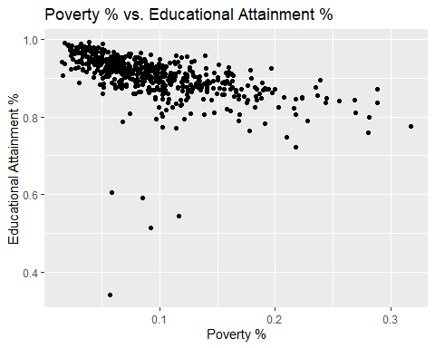

ggplot(model_data, aes(x=mean_total_students_discipline, y=HS_PLUS_percentage)) + geom_point() +   
 ggtitle("Mean Student Discipline vs. Educational Attainment %") +  
 xlab("Mean Student Discipline") +   
 ylab("Educational Attainment %")

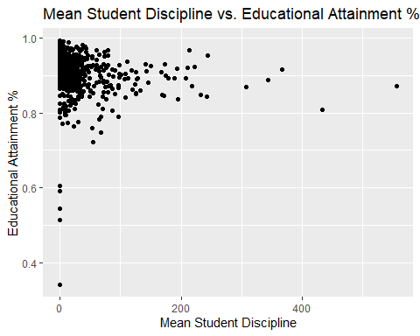

ggplot(model_data, aes(x=mean_chronic_absenteeism, y=HS_PLUS_percentage)) + geom_point() +   
 ggtitle("Mean Chronic Absenteeism % vs. Educational Attainment %") +  
 xlab("Mean Chronic Absenteeism %") +   
 ylab("Educational Attainment %")

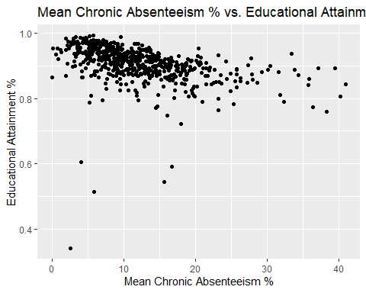

ggplot(model_data, aes(x=mean_attendance, y=HS_PLUS_percentage)) + geom_point() +   
 ggtitle("Mean Attendance % vs. Educational Attainment %") +  
 xlab("Mean Attendance %") +   
 ylab("Educational Attainment %")

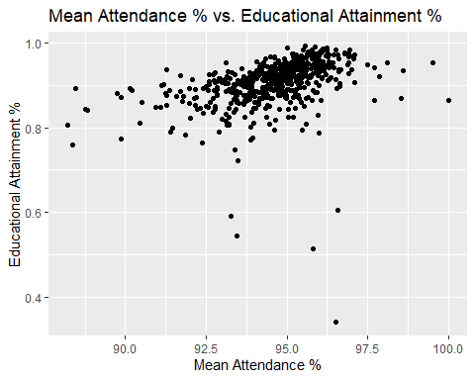

ggplot(model_data, aes(x=mean_enrollment, y=HS_PLUS_percentage)) + geom_point() +   
 ggtitle("Mean Enrollment vs. Educational Attainment %") +  
 xlab("Mean Enrollment") +   
 ylab("Educational Attainment %")

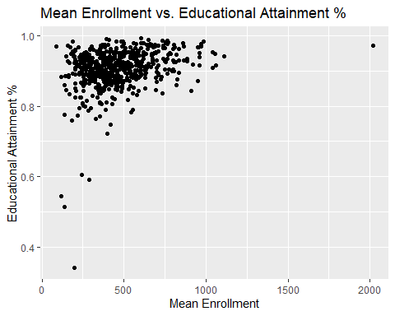

POVERTY_lm <- lm(log(HS_PLUS_percentage) ~ poverty_percentage, data = model_data)  
DISCIPLINE_lm <- lm(log(HS_PLUS_percentage) ~ mean_total_students_discipline, data = model_data)  
CHRONIC_lm <- lm(log(HS_PLUS_percentage) ~ mean_chronic_absenteeism, data = model_data)  
ATTENDANCE_lm <- lm(log(HS_PLUS_percentage) ~ mean_attendance, data = model_data)  
ENROLLMENT_lm <- lm(log(HS_PLUS_percentage) ~ mean_enrollment, data = model_data)  
  
 mod_model_data <- subset(model_data, model_data$HS_PLUS_percentage > 0.65)  
  
POVERTY_lm_mod <- lm(log(HS_PLUS_percentage) ~ poverty_percentage, data = mod_model_data)  
DISCIPLINE_lm_mod <- lm(log(HS_PLUS_percentage) ~ mean_total_students_discipline, data = mod_model_data)  
CHRONIC_lm_mod <- lm(log(HS_PLUS_percentage) ~ mean_chronic_absenteeism, data = mod_model_data)  
ATTENDANCE_lm_mod <- lm(log(HS_PLUS_percentage) ~ mean_attendance, data = mod_model_data)  
ENROLLMENT_lm_mod <- lm(log(HS_PLUS_percentage) ~ mean_enrollment, data = mod_model_data)

DISCIPLINE_sresid <- studres(DISCIPLINE_lm)  
shapiro.test(DISCIPLINE_sresid)

##   
## Shapiro-Wilk normality test  
##   
## data: DISCIPLINE_sresid  
## W = 0.58504, p-value < 2.2e-16

DISCIPLINE_sresid_mod <- studres(DISCIPLINE_lm_mod)  
shapiro.test(DISCIPLINE_sresid_mod)

##   
## Shapiro-Wilk normality test  
##   
## data: DISCIPLINE_sresid_mod  
## W = 0.94473, p-value = 5.046e-14

#heterodastic  
ncvTest(POVERTY_lm)

## Non-constant Variance Score Test   
## Variance formula: ~ fitted.values   
## Chisquare = 9.368701, Df = 1, p = 0.0022072

ncvTest(POVERTY_lm_mod)

## Non-constant Variance Score Test   
## Variance formula: ~ fitted.values   
## Chisquare = 41.32826, Df = 1, p = 1.287e-10

#homoscedastic  
ncvTest(DISCIPLINE_lm)

## Non-constant Variance Score Test   
## Variance formula: ~ fitted.values   
## Chisquare = 29.73787, Df = 1, p = 4.9459e-08

ncvTest(DISCIPLINE_lm_mod)

## Non-constant Variance Score Test   
## Variance formula: ~ fitted.values   
## Chisquare = 0.2833977, Df = 1, p = 0.59448

#heteroscedastic  
ncvTest(CHRONIC_lm)

## Non-constant Variance Score Test   
## Variance formula: ~ fitted.values   
## Chisquare = 74.68988, Df = 1, p = < 2.22e-16

ncvTest(CHRONIC_lm_mod)

## Non-constant Variance Score Test   
## Variance formula: ~ fitted.values   
## Chisquare = 11.74019, Df = 1, p = 0.00061165

#homoscedastic  
ncvTest(ATTENDANCE_lm)

## Non-constant Variance Score Test   
## Variance formula: ~ fitted.values   
## Chisquare = 68.58723, Df = 1, p = < 2.22e-16

ncvTest(ATTENDANCE_lm_mod)

## Non-constant Variance Score Test   
## Variance formula: ~ fitted.values   
## Chisquare = 1.00596, Df = 1, p = 0.31587

#heteroscedastic  
ncvTest(ENROLLMENT_lm)

## Non-constant Variance Score Test   
## Variance formula: ~ fitted.values   
## Chisquare = 208.538, Df = 1, p = < 2.22e-16

ncvTest(ENROLLMENT_lm_mod)

## Non-constant Variance Score Test   
## Variance formula: ~ fitted.values   
## Chisquare = 15.26271, Df = 1, p = 9.3545e-05

raw_lm <- lm(log(HS_PLUS_percentage) ~ poverty_percentage* mean_chronic_absenteeism + mean_enrollment, data = model_data)  
summary(raw_lm)

##   
## Call:  
## lm(formula = log(HS_PLUS_percentage) ~ poverty_percentage * mean_chronic_absenteeism +   
## mean_enrollment, data = model_data)  
##   
## Residuals:  
## Min 1Q Median 3Q Max   
## -0.98522 -0.01167 0.00930 0.02412 0.10475   
##   
## Coefficients:  
## Estimate Std. Error t value  
## (Intercept) -6.546e-02 1.264e-02 -5.177  
## poverty_percentage -6.787e-01 1.137e-01 -5.968  
## mean_chronic_absenteeism -1.782e-03 8.838e-04 -2.016  
## mean_enrollment 8.128e-05 1.389e-05 5.851  
## poverty_percentage:mean_chronic_absenteeism 8.737e-03 5.867e-03 1.489  
## Pr(>|t|)   
## (Intercept) 3.10e-07 ***  
## poverty_percentage 4.16e-09 ***  
## mean_chronic_absenteeism 0.0443 *   
## mean_enrollment 8.09e-09 ***  
## poverty_percentage:mean_chronic_absenteeism 0.1370   
## ---  
## Signif. codes: 0 '***' 0.001 '**' 0.01 '*' 0.05 '.' 0.1 ' ' 1  
##   
## Residual standard error: 0.06551 on 590 degrees of freedom  
## Multiple R-squared: 0.2545, Adjusted R-squared: 0.2494   
## F-statistic: 50.35 on 4 and 590 DF, p-value: < 2.2e-16

new_lm <- lm(log(HS_PLUS_percentage) ~ poverty_percentage* mean_chronic_absenteeism + mean_enrollment, data = mod_model_data)  
  
summary(new_lm)

##   
## Call:  
## lm(formula = log(HS_PLUS_percentage) ~ poverty_percentage * mean_chronic_absenteeism +   
## mean_enrollment, data = mod_model_data)  
##   
## Residuals:  
## Min 1Q Median 3Q Max   
## -0.157212 -0.013543 0.004167 0.019618 0.091506   
##   
## Coefficients:  
## Estimate Std. Error t value  
## (Intercept) -3.505e-02 6.587e-03 -5.321  
## poverty_percentage -7.287e-01 5.885e-02 -12.382  
## mean_chronic_absenteeism -2.534e-03 4.592e-04 -5.519  
## mean_enrollment 4.703e-05 7.238e-06 6.498  
## poverty_percentage:mean_chronic_absenteeism 1.161e-02 3.039e-03 3.819  
## Pr(>|t|)   
## (Intercept) 1.47e-07 ***  
## poverty_percentage < 2e-16 ***  
## mean_chronic_absenteeism 5.14e-08 ***  
## mean_enrollment 1.74e-10 ***  
## poverty_percentage:mean_chronic_absenteeism 0.000148 ***  
## ---  
## Signif. codes: 0 '***' 0.001 '**' 0.01 '*' 0.05 '.' 0.1 ' ' 1  
##   
## Residual standard error: 0.03386 on 585 degrees of freedom  
## Multiple R-squared: 0.5557, Adjusted R-squared: 0.5526   
## F-statistic: 182.9 on 4 and 585 DF, p-value: < 2.2e-16

new_lm_mod <- lm(log(HS_PLUS_percentage) ~ poverty_percentage* mean_chronic_absenteeism + mean_enrollment, data = mod_model_data)  
  
plot(fitted(new_lm_mod), resid(new_lm_mod))

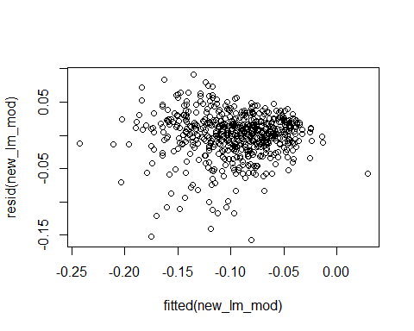

new_lm_mod2 <- lm((((HS_PLUS_percentage ^ 7) - 1) / 7) ~ poverty_percentage* mean_chronic_absenteeism + mean_enrollment, data = mod_model_data)  
summary(new_lm_mod2)

##   
## Call:  
## lm(formula = (((HS_PLUS_percentage^7) - 1)/7) ~ poverty_percentage *   
## mean_chronic_absenteeism + mean_enrollment, data = mod_model_data)  
##   
## Residuals:  
## Min 1Q Median 3Q Max   
## -0.058550 -0.008652 0.000090 0.010474 0.048104   
##   
## Coefficients:  
## Estimate Std. Error t value  
## (Intercept) -3.030e-02 3.015e-03 -10.050  
## poverty_percentage -4.029e-01 2.694e-02 -14.958  
## mean_chronic_absenteeism -1.891e-03 2.102e-04 -8.998  
## mean_enrollment 2.390e-05 3.313e-06 7.214  
## poverty_percentage:mean_chronic_absenteeism 1.022e-02 1.391e-03 7.343  
## Pr(>|t|)   
## (Intercept) < 2e-16 ***  
## poverty_percentage < 2e-16 ***  
## mean_chronic_absenteeism < 2e-16 ***  
## mean_enrollment 1.69e-12 ***  
## poverty_percentage:mean_chronic_absenteeism 7.06e-13 ***  
## ---  
## Signif. codes: 0 '***' 0.001 '**' 0.01 '*' 0.05 '.' 0.1 ' ' 1  
##   
## Residual standard error: 0.0155 on 585 degrees of freedom  
## Multiple R-squared: 0.5914, Adjusted R-squared: 0.5886   
## F-statistic: 211.7 on 4 and 585 DF, p-value: < 2.2e-16

plot(fitted(new_lm_mod2), resid(new_lm_mod2))

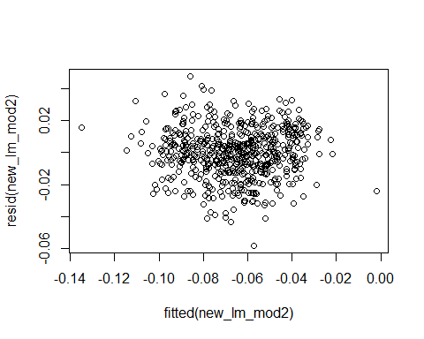

new_sresid_mod2 <- studres(new_lm_mod2)  
new_sresid_mod <- studres(new_lm_mod)  
shapiro.test(new_sresid_mod2)

##   
## Shapiro-Wilk normality test  
##   
## data: new_sresid_mod2  
## W = 0.99568, p-value = 0.1021

shapiro.test(new_sresid_mod)

##   
## Shapiro-Wilk normality test  
##   
## data: new_sresid_mod  
## W = 0.9374, p-value = 4.921e-15

attach(mod_model_data)  
smooth_spline_poverty_cv <- smooth.spline(poverty_percentage, HS_PLUS_percentage, cv=TRUE)  
  
smooth_spline_absenteeism_cv <- smooth.spline(mean_chronic_absenteeism, HS_PLUS_percentage, cv=TRUE)  
  
smooth_spline_attendance_cv <- smooth.spline(mean_attendance, HS_PLUS_percentage, cv=TRUE)  
  
smooth_spline_enrollment_cv <- smooth.spline(mean_enrollment, HS_PLUS_percentage, cv=TRUE)  
  
smooth_spline_discipline_cv <- smooth.spline(mean_total_students_discipline, HS_PLUS_percentage, cv=TRUE)  
  
smooth_spline_poverty_cv$df

## [1] 12.39204

smooth_spline_absenteeism_cv$df

## [1] 4.644571

smooth_spline_attendance_cv$df

## [1] 6.114501

smooth_spline_enrollment_cv$df

## [1] 4.820783

smooth_spline_discipline_cv$df

## [1] 4.455439

gam_model <- gam(HS_PLUS_percentage ~ s(poverty_percentage) + s(mean_chronic_absenteeism) + s(mean_attendance) + s(mean_enrollment) + s(mean_total_students_discipline), data = mod_model_data)  
summary(gam_model)

##   
## Family: gaussian   
## Link function: identity   
##   
## Formula:  
## HS_PLUS_percentage ~ s(poverty_percentage) + s(mean_chronic_absenteeism) +   
## s(mean_attendance) + s(mean_enrollment) + s(mean_total_students_discipline)  
##   
## Parametric coefficients:  
## Estimate Std. Error t value Pr(>|t|)   
## (Intercept) 0.9098 0.0012 757.9 <2e-16 ***  
## ---  
## Signif. codes: 0 '***' 0.001 '**' 0.01 '*' 0.05 '.' 0.1 ' ' 1  
##   
## Approximate significance of smooth terms:  
## edf Ref.df F p-value   
## s(poverty_percentage) 6.291 7.451 30.421 <2e-16 ***  
## s(mean_chronic_absenteeism) 2.265 2.813 2.036 0.114   
## s(mean_attendance) 2.603 3.323 1.120 0.513   
## s(mean_enrollment) 4.155 5.071 8.882 <2e-16 ***  
## s(mean_total_students_discipline) 1.457 1.786 0.301 0.744   
## ---  
## Signif. codes: 0 '***' 0.001 '**' 0.01 '*' 0.05 '.' 0.1 ' ' 1  
##   
## R-sq.(adj) = 0.58 Deviance explained = 59.2%  
## GCV = 0.00087666 Scale est. = 0.00085026 n = 590

gam_model$coefficients

## (Intercept) s(poverty_percentage).1   
## 9.098155e-01 9.446393e-03   
## s(poverty_percentage).2 s(poverty_percentage).3   
## -1.138911e-02 -7.940860e-03   
## s(poverty_percentage).4 s(poverty_percentage).5   
## 1.576313e-02 3.947602e-03   
## s(poverty_percentage).6 s(poverty_percentage).7   
## -1.112359e-02 -1.206357e-04   
## s(poverty_percentage).8 s(poverty_percentage).9   
## 3.644813e-02 -3.172598e-02   
## s(mean_chronic_absenteeism).1 s(mean_chronic_absenteeism).2   
## 2.037495e-03 -1.281603e-03   
## s(mean_chronic_absenteeism).3 s(mean_chronic_absenteeism).4   
## -6.602388e-04 6.510306e-04   
## s(mean_chronic_absenteeism).5 s(mean_chronic_absenteeism).6   
## -7.261620e-05 -8.057436e-04   
## s(mean_chronic_absenteeism).7 s(mean_chronic_absenteeism).8   
## 3.435326e-04 -5.495997e-03   
## s(mean_chronic_absenteeism).9 s(mean_attendance).1   
## -1.243316e-02 3.834296e-03   
## s(mean_attendance).2 s(mean_attendance).3   
## -3.804934e-03 3.885479e-05   
## s(mean_attendance).4 s(mean_attendance).5   
## 1.606776e-03 4.975597e-04   
## s(mean_attendance).6 s(mean_attendance).7   
## 1.604821e-03 2.999232e-04   
## s(mean_attendance).8 s(mean_attendance).9   
## 1.866085e-02 -7.320744e-03   
## s(mean_enrollment).1 s(mean_enrollment).2   
## -7.448337e-04 8.808405e-03   
## s(mean_enrollment).3 s(mean_enrollment).4   
## -2.372885e-03 1.787789e-03   
## s(mean_enrollment).5 s(mean_enrollment).6   
## 8.513674e-04 7.144315e-04   
## s(mean_enrollment).7 s(mean_enrollment).8   
## 3.675601e-04 1.062097e-03   
## s(mean_enrollment).9 s(mean_total_students_discipline).1   
## 7.686718e-04 4.129903e-04   
## s(mean_total_students_discipline).2 s(mean_total_students_discipline).3   
## -2.175084e-03 1.053924e-03   
## s(mean_total_students_discipline).4 s(mean_total_students_discipline).5   
## -1.526401e-03 -7.071597e-04   
## s(mean_total_students_discipline).6 s(mean_total_students_discipline).7   
## 1.383736e-03 -1.304242e-03   
## s(mean_total_students_discipline).8 s(mean_total_students_discipline).9   
## -5.433946e-03 3.190974e-04

gam.check(gam_model)

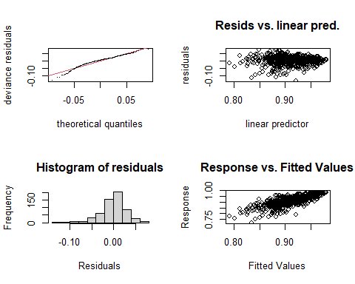

##   
## Method: GCV Optimizer: magic  
## Smoothing parameter selection converged after 5 iterations.  
## The RMS GCV score gradient at convergence was 8.983539e-08 .  
## The Hessian was not positive definite.  
## Model rank = 46 / 46   
##   
## Basis dimension (k) checking results. Low p-value (k-index<1) may  
## indicate that k is too low, especially if edf is close to k'.  
##   
## k' edf k-index p-value  
## s(poverty_percentage) 9.00 6.29 1.00 0.44  
## s(mean_chronic_absenteeism) 9.00 2.27 0.98 0.34  
## s(mean_attendance) 9.00 2.60 1.02 0.61  
## s(mean_enrollment) 9.00 4.15 1.02 0.74  
## s(mean_total_students_discipline) 9.00 1.46 1.03 0.68

plot(gam_model, se=TRUE, col="blue")

