Week 10 Markdown

Dylan Denner

3/30/2021

## R Markdown

# Simple Linear Regression Models  
  
POVERTY_lm <- lm(HS_PLUS_percentage ~ poverty_percentage, data = mod_model_data)  
DISCIPLINE_lm <- lm(HS_PLUS_percentage ~ mean_total_students_discipline, data = mod_model_data)  
CHRONIC_lm <- lm(HS_PLUS_percentage ~ mean_chronic_absenteeism, data = mod_model_data)  
ATTENDANCE_lm <- lm(HS_PLUS_percentage ~ mean_attendance, data = mod_model_data)  
ENROLLMENT_lm <- lm(HS_PLUS_percentage ~ mean_enrollment, data = mod_model_data)

Shapiro-Wilk Normality Test for Poverty %

POVERTY_sresid <- studres(POVERTY_lm)  
shapiro.test(POVERTY_sresid)

##   
## Shapiro-Wilk normality test  
##   
## data: POVERTY_sresid  
## W = 0.95023, p-value = 3.341e-13

Shapiro-Wilk Normality Test for Mean Student Discipline

DISCIPLINE_sresid <- studres(DISCIPLINE_lm)  
shapiro.test(DISCIPLINE_sresid)

##   
## Shapiro-Wilk normality test  
##   
## data: DISCIPLINE_sresid  
## W = 0.95965, p-value = 1.215e-11

Shapiro-Wilk Normality Test for Mean Chronic Absenteeism %

CHRONIC_sresid <- studres(CHRONIC_lm)  
shapiro.test(CHRONIC_sresid)

##   
## Shapiro-Wilk normality test  
##   
## data: CHRONIC_sresid  
## W = 0.94531, p-value = 6.133e-14

Shapiro-Wilk Normality Test for Mean Attendance %

ATTENDANCE_sresid <- studres(ATTENDANCE_lm)  
shapiro.test(ATTENDANCE_sresid)

##   
## Shapiro-Wilk normality test  
##   
## data: ATTENDANCE_sresid  
## W = 0.94197, p-value = 2.056e-14

Shapiro-Wilk Normality Test for Mean Enrollment

ENROLLMENT_sresid <- studres(ENROLLMENT_lm)  
shapiro.test(ENROLLMENT_sresid)

##   
## Shapiro-Wilk normality test  
##   
## data: ENROLLMENT_sresid  
## W = 0.96928, p-value = 8.867e-10

Score Test for Non-Constant Error Variance: Poverty %

#heterodastic  
ncvTest(POVERTY_lm)

## Non-constant Variance Score Test   
## Variance formula: ~ fitted.values   
## Chisquare = 26.53847, Df = 1, p = 2.5834e-07

Score Test for Non-Constant Error Variance: Mean Student Discipline

#homoscedastic  
ncvTest(DISCIPLINE_lm)

## Non-constant Variance Score Test   
## Variance formula: ~ fitted.values   
## Chisquare = 0.08208011, Df = 1, p = 0.7745

Score Test for Non-Constant Error Variance: Mean Chronic Absenteeism %

#heteroscedastic  
ncvTest(CHRONIC_lm)

## Non-constant Variance Score Test   
## Variance formula: ~ fitted.values   
## Chisquare = 6.226651, Df = 1, p = 0.012584

Score Test for Non-Constant Error Variance: Mean Attendance %

#homoscedastic  
ncvTest(ATTENDANCE_lm)

## Non-constant Variance Score Test   
## Variance formula: ~ fitted.values   
## Chisquare = 0.00171754, Df = 1, p = 0.96694

Score Test for Non-Constant Error Variance: Mean Enrollment

#heteroscedastic  
ncvTest(ENROLLMENT_lm)

## Non-constant Variance Score Test   
## Variance formula: ~ fitted.values   
## Chisquare = 11.81214, Df = 1, p = 0.00058846

BOXCOX Transformations

library(MASS)  
boxcox(ENROLLMENT_lm, lambda = seq(-0.25, 10, by = 0.05), plotit = TRUE)

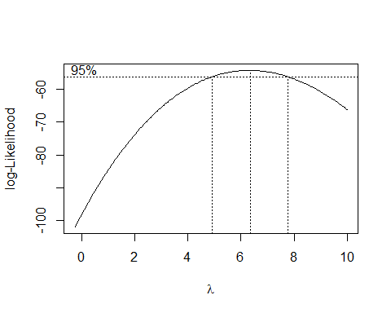

plot1 <- plot(fitted(ENROLLMENT_lm), resid(ENROLLMENT_lm))

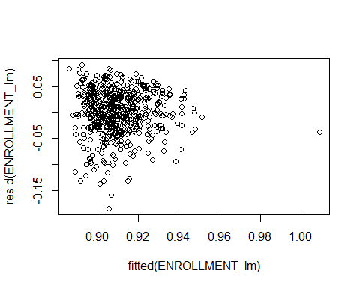

ENROLLMENT_lm2 <- lm((((HS_PLUS_percentage ^ 6) - 1) / 6) ~ mean_enrollment, data = mod_model_data)  
plot2 <- plot(fitted(ENROLLMENT_lm2), resid(ENROLLMENT_lm2))

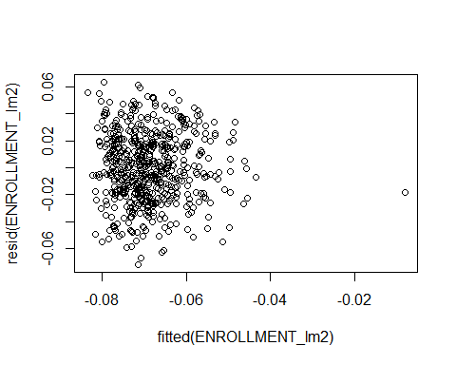

ENROLLMENT_sresid2 <- studres(ENROLLMENT_lm2)  
shapiro.test(ENROLLMENT_sresid2)

##   
## Shapiro-Wilk normality test  
##   
## data: ENROLLMENT_sresid2  
## W = 0.99584, p-value = 0.1196

#Better P-value for normality, but still significantly Different from Normal  
POVERTY_lm <- lm(HS_PLUS_percentage ~ poverty_percentage, data = mod_model_data)  
boxcox(POVERTY_lm, lambda = seq(-0.25, 10, by = 0.05), plotit = TRUE)

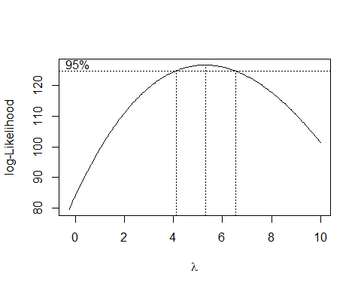

plot1 <- plot(fitted(POVERTY_lm), resid(POVERTY_lm))

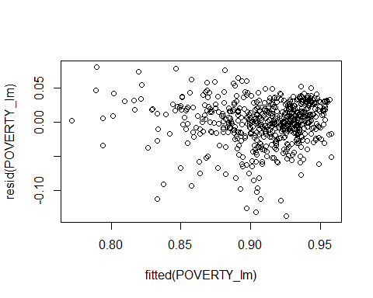

POVERTY_lm2 <- lm((((HS_PLUS_percentage ^ 6) - 1) / 6) ~ poverty_percentage, data = mod_model_data)  
plot2 <- plot(fitted(POVERTY_lm2), resid(POVERTY_lm2))

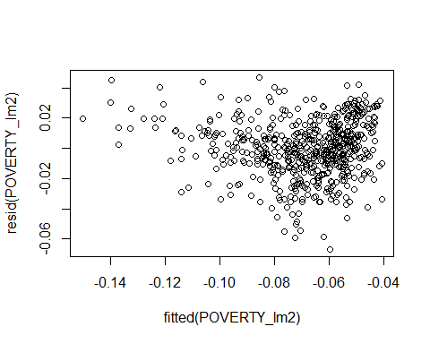

POVERTY_sresid2 <- studres(POVERTY_lm2)  
shapiro.test(POVERTY_sresid2)

##   
## Shapiro-Wilk normality test  
##   
## data: POVERTY_sresid2  
## W = 0.99205, p-value = 0.003028

#Better P-value for normality, but still significantly Different from Normal  
DISCIPLINE_lm <- lm(HS_PLUS_percentage ~ mean_total_students_discipline, data = mod_model_data)  
boxcox(DISCIPLINE_lm, lambda = seq(-0.25, 10, by = 0.05), plotit = TRUE)

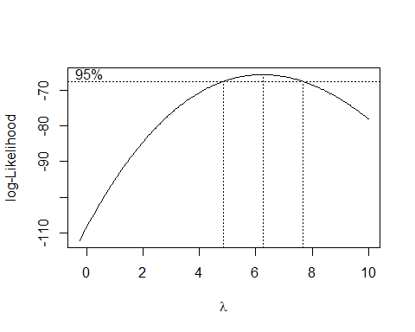

plot1 <- plot(fitted(DISCIPLINE_lm), resid(DISCIPLINE_lm))

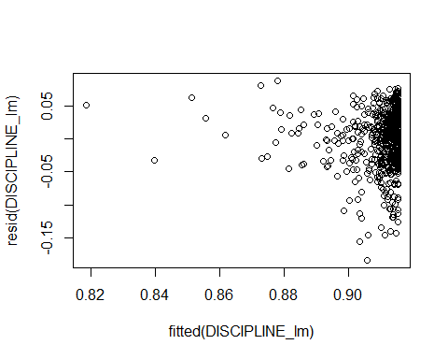

DISCIPLINE_lm2 <- lm((((HS_PLUS_percentage ^ 6) - 1) / 6) ~ mean_total_students_discipline, data = mod_model_data)  
plot2 <- plot(fitted(DISCIPLINE_lm2), resid(DISCIPLINE_lm2))

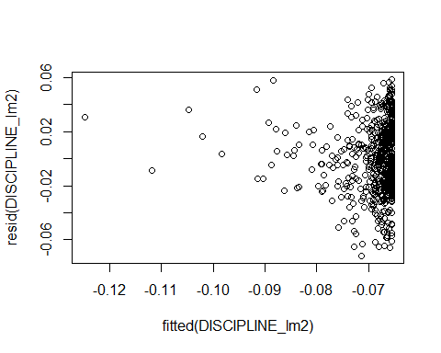

DISCIPLINE_sresid2 <- studres(DISCIPLINE_lm2)  
shapiro.test(DISCIPLINE_sresid2)

##   
## Shapiro-Wilk normality test  
##   
## data: DISCIPLINE_sresid2  
## W = 0.99339, p-value = 0.0108

#Better P-value for normality, but still significantly Different from Normal  
CHRONIC_lm <- lm(HS_PLUS_percentage ~ mean_chronic_absenteeism, data = mod_model_data)  
boxcox(CHRONIC_lm, lambda = seq(-0.25, 10, by = 0.05), plotit = TRUE)

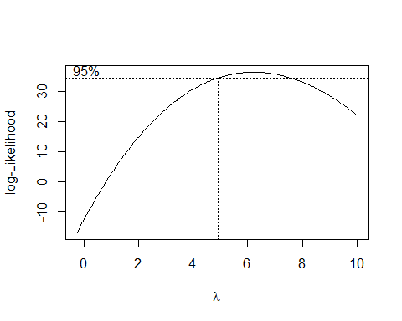

plot1 <- plot(fitted(CHRONIC_lm), resid(CHRONIC_lm))

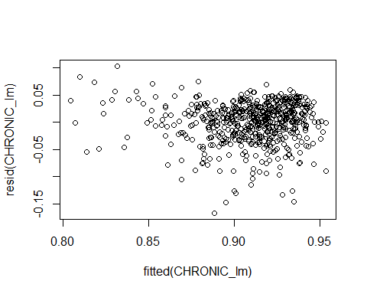

CHRONIC_lm2 <- lm((((HS_PLUS_percentage ^ 6) - 1) / 6) ~ mean_chronic_absenteeism, data = mod_model_data)  
plot2 <- plot(fitted(DISCIPLINE_lm2), resid(DISCIPLINE_lm2))



CHRONIC_sresid2 <- studres(CHRONIC_lm2)  
shapiro.test(DISCIPLINE_sresid2)

##   
## Shapiro-Wilk normality test  
##   
## data: DISCIPLINE_sresid2  
## W = 0.99339, p-value = 0.0108

#Better P-value for normality, but still significantly Different from Normal  
ATTENDANCE_lm <- lm(HS_PLUS_percentage ~ mean_attendance, data = mod_model_data)  
boxcox(ATTENDANCE_lm, lambda = seq(-0.25, 10, by = 0.05), plotit = TRUE)

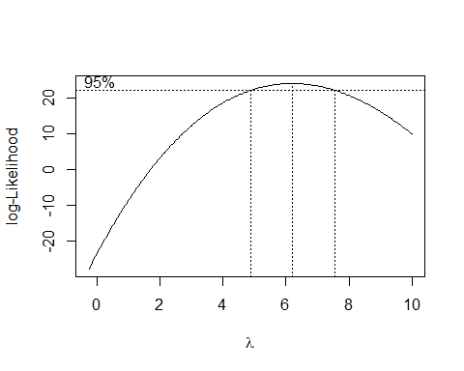

plot1 <- plot(fitted(ATTENDANCE_lm), resid(ATTENDANCE_lm))

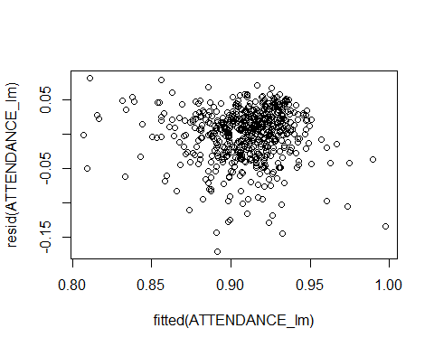

ATTENDANCE_lm2 <- lm((((HS_PLUS_percentage ^ 6) - 1) / 6) ~ mean_attendance, data = mod_model_data)  
plot2 <- plot(fitted(ATTENDANCE_lm2), resid(ATTENDANCE_lm2))

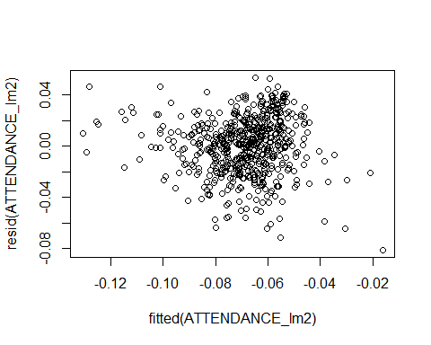

ATTENDANCE_sresid2 <- studres(ATTENDANCE_lm2)  
shapiro.test(ATTENDANCE_sresid2)

##   
## Shapiro-Wilk normality test  
##   
## data: ATTENDANCE_sresid2  
## W = 0.98915, p-value = 0.0002359