Activity 2: Propose an Improved Structure

The modules you intend to create or modify
Replace the single script with six modules - entry point, app, analysis, data loader, console and plot. The data moves to its own folder and the plot saves to an output folder.

The responsibility of each module
- Entry point - builds the real console, loader and plot and starts the app
- App - runs the steps in order: load, country total, categories, plot, comparison
- Analysis - all the calculations, never reads files or prints
- Data loader - reads the JSON and turns each record into an EVA (country, date, hours)
- Console - asks the questions, checks the answers and prints results
- Plot - the only part that uses matplotlib

The dependencies between modules
Entry point depends on everything since it sets the program up. App only depends on analysis - the console, loader and plot get passed in. The rest don’t depend on each other.

The interfaces through which modules will communicate
Modules pass plain lists, tuples and dicts - no base classes since there’s only one version of each part.
load_evas(path) -> list of Eva(country, date, hours)
country_total(evas, country) -> float
categorise(evas) -> {"Short": n, "Standard": n, "Long": n}
cumulative_series(evas) -> (dates, hours)
compare_countries(evas, a, b, start, end) -> (summary_a, summary_b, leader or None)
EvaApp(user_input, output, load_evas, plot_cumulative).run()

Produce a simple architecture diagram
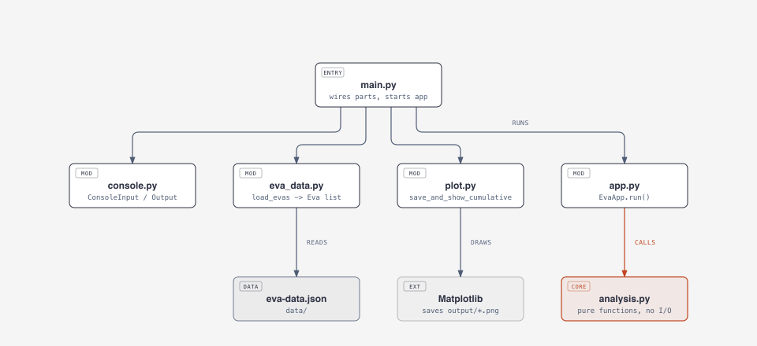
Module structure

Record your first architectural decision
See ADR-001.

