LedgerBull
Real-time Trading & Risk Platform
Project Document
Complete end-to-end reference
Concept · design · architecture · data · APIs · decisions · operations.
C++ · Java · Python | Microservices · gRPC · Event Sourcing

Table of Contents
1. What the Project Is (The Concept)
2. The Problem It Solves
3. The Proposed Solution (End-to-End Flow)
4. System Design & Architecture
5. Services & Ports Map
6. Data Model (Schema)
7. Order Lifecycle & State Machine
8. The PnL Math (Worked Examples)
9. API Reference (Key Endpoints)
10. Tech Stack & Tools
11. Key Design Decisions
12. Configuration & Environment
13. Local Run & Operational Runbook
14. Testing & Verification
15. Cost / Pricing
16. Roadmap (Phases)
17. Honest Scope & Known Limits
18. Glossary
19. What This Project Demonstrates

1. What the Project Is (The Concept)
LedgerBull is a real-time trading and risk platform. In simple words: it takes in live market prices, lets you place orders, matches those orders like a real exchange does, keeps track of every order from start to finish, and works out how much you own and how much profit or loss you have. Later it will also watch risk.
It is built the way a real trading firm would build it: as several small, independent services (microservices) that each do one job and talk to each other. This shows real system design, not a single big program.
Important: LedgerBull uses real market data and a real matching engine, but it does not place real trades. Real trading needs a broker license. This is a serious demonstration of the engineering and architecture, not a live brokerage.

2. The Problem It Solves
A real trading system has to do several hard things at once, and do them correctly:
- Take in fast-moving live prices without falling behind or crashing.
- Match buy and sell orders fairly and quickly.
- Never lose an order, and always know each order's exact state.
- Work out positions and profit or loss correctly, with no rounding errors on money.
- Stay up and behave safely when something fails.
Most demo projects skip the hard parts. LedgerBull is built to show these can be done properly: correct money math, crash recovery, exact order tracking, and clean separation between services. It also works as a portfolio piece that proves the ability to design a production-shaped distributed system across C++, Java, and (later) Python.

3. The Proposed Solution (End-to-End Flow)
- 1. Market data in — a service connects to a live crypto price feed over a secure websocket and stores prices in a time-series database, with a fast cache for the latest price.
- 2. Order placed — a user (or later, a strategy) sends an order to the execution service.
- 3. Order checked and saved — the execution service validates the order and saves it first, so it is never lost even if the next step fails.
- 4. Order matched — the order is sent to the C++ matching engine over gRPC, which holds the order book and matches buyers with sellers using price-time priority.
- 5. Fills recorded — the resulting trades are saved, and both sides of each trade have their order state updated.
- 6. Positions and PnL — a separate position service works out net position per symbol, realized profit (FIFO lots), and unrealized profit (live price).
- 7. Query — you can ask for any order, or for your positions and profit, at any time.

4. System Design & Architecture

4.1 Service Split
Each service does one job and owns its own data:
- Market Data Service (Java) — ingests live prices into TimescaleDB and Redis.
- Matching Engine (C++) — the order book and matching, exposed over gRPC.
- Execution Service (Java) — validates, saves, calls the engine, tracks order state.
- Position Service (Java) — positions, realized PnL (FIFO), unrealized PnL.
- Spring Cloud services — Eureka (discovery), Config Server, API Gateway.
- Planned — risk service, strategy/signal service, alert service (Python involved).

4.2 Why the Matching Engine Is C++
Matching must be extremely fast and predictable. C++ has no garbage-collector pauses on the hot path, so it is the right tool for the part that must be fastest. The rest of the system is Java and Spring Boot, which are excellent for web services, databases, and handling many requests safely.

4.3 The Matching Engine's Four Layers
- Order book — price-time priority; ordered maps per side, FIFO queue per price level, index for O(1) cancels. Integer tick prices (no floating point).
- Matching logic — limit and market orders, partial fills, multi-level sweeps, maker-price execution.
- Event log (crash recovery) — an append-only write-ahead log on disk; the book is rebuilt by replaying the log on startup (event sourcing).
- gRPC server — exposes the engine to the Java services.
The in-memory order book is a fast, rebuildable view. The append-only log on disk is the real source of truth. There is deliberately no database on the matching hot path — a speed choice.

4.4 Data Ownership
- Orders and fills go to PostgreSQL (execution service).
- Positions and lots go to a separate PostgreSQL database (position service).
- Market data goes to TimescaleDB. The latest price lives in a Redis cache.
Each service owns its own database. Services never reach into another service's database; they talk through APIs or the shared cache. This keeps them independent.

4.5 Architecture Diagram
The diagram below shows the whole system. Colors group components by type: blue for Java services, coral for the C++ matching engine, green for databases, gold for the Redis cache, purple for Spring Cloud infrastructure, and gray for external parties. Gold links mark the gRPC path between execution and the engine and the position service reading the latest price from Redis.
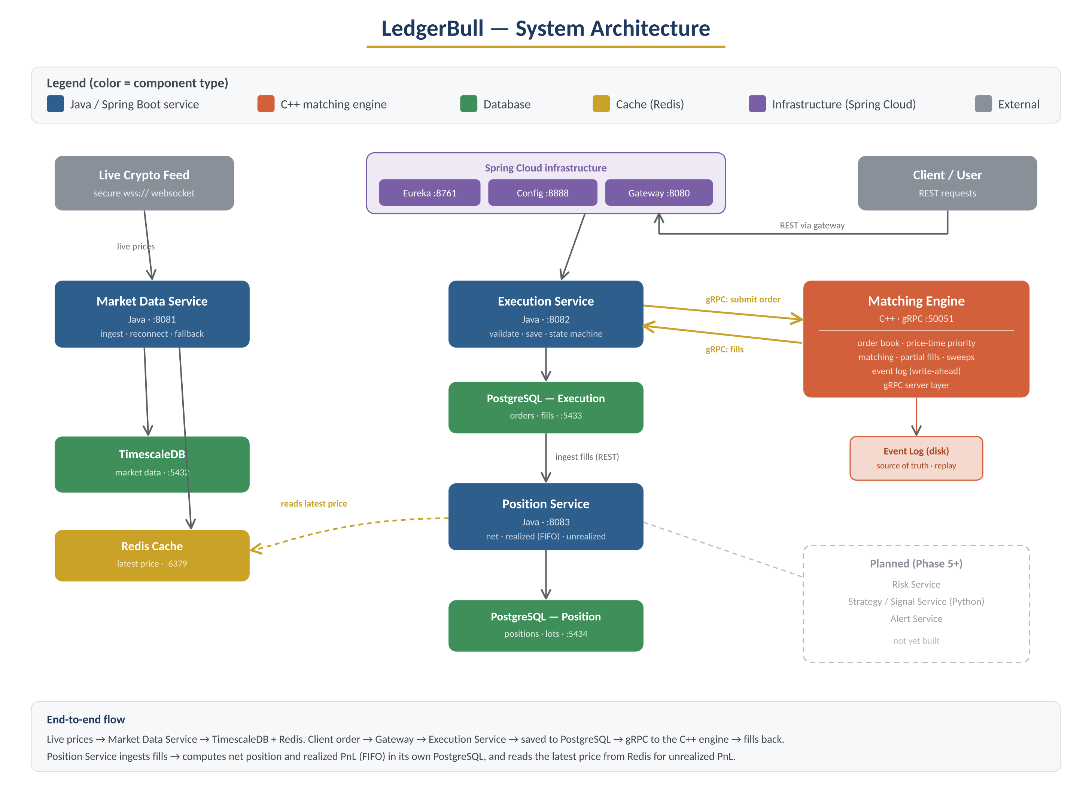

5. Services & Ports Map
Service | Language | Port | Data store
Eureka (discovery) | Java | 8761 | —
Config Server | Java | 8888 | —
API Gateway | Java | 8080 | —
Market Data Service | Java | 8081 | TimescaleDB (5432), Redis (6379)
Matching Engine | C++ | 50051 | Event log (disk)
Execution Service | Java | 8082 | PostgreSQL (5433)
Position Service | Java | 8083 | PostgreSQL (5434)

6. Data Model (Schema)

6.1 Execution database (orders, fills)
The orders table holds each order and its live state; the fills table holds each executed trade, linked back to the order. Prices and quantities are stored as integer ticks.
orders(id, order_id, symbol, side, order_type, price,
original_quantity, filled_quantity, remaining_quantity,
status, created_at, updated_at)
fills(id, taker_order_id, maker_order_id, symbol,
fill_price, fill_quantity, order_ref_id -> orders.id, created_at)

6.2 Position database (positions, lots, processed_fills)
Positions hold the net quantity and realized PnL per symbol. Lots hold each open buy batch for FIFO. Processed_fills guarantees each fill is counted only once.
positions(symbol PK, net_quantity, realized_pnl, updated_at)
lots(id, symbol, price, remaining_quantity, sequence_no, created_at)
processed_fills(source_fill_id UNIQUE, symbol, taker_side, ...)
Money rule: every price and PnL value is a scaled integer (ticks, PRICE_SCALE = 100). Human decimals are produced only for display, never stored.

7. Order Lifecycle & State Machine
Every order moves through a strict set of states. Only valid transitions are allowed.
State | Meaning | Can move to
NEW | accepted, not yet filled | PARTIALLY_FILLED, FILLED, CANCELLED, REJECTED
PARTIALLY_FILLED | some quantity filled | FILLED, CANCELLED
FILLED | fully filled | (final)
CANCELLED | cancelled by user | (final)
REJECTED | not accepted / engine failed | (final)
Save-on-accept: every accepted order is saved before the engine call. If the engine is unreachable or rejects, the order becomes REJECTED, so no accepted order is ever silently lost. Both sides tracked: when a taker hits resting makers, both the taker and the makers update their status and quantities.

8. The PnL Math (Worked Examples)

8.1 Realized PnL (FIFO lots)
Each buy opens a lot (quantity at a cost price). Each sell consumes the oldest lots first. Realized PnL = (sell price − lot price) × quantity sold.
- Example — BUY 5 @ 100 opens Lot A; BUY 10 @ 110 opens Lot B; SELL 8 @ 120.
- Sell takes 5 from Lot A: (120 − 100) × 5 = 100.
- Sell takes 3 from Lot B: (120 − 110) × 3 = 30.
- Realized PnL = 130 (13000 ticks). Remaining open lot: 7 @ 110.

8.2 Unrealized PnL (live price)
The paper profit on lots you still hold, worked out at read time. Unrealized PnL = (current price − lot price) × remaining quantity. Never stored; returns null if the live price is missing.
- Example — open lot 7 @ 110, current price 125 → (125 − 110) × 7 = 105 ($105.00).

9. API Reference (Key Endpoints)

9.1 Execution Service (8082)
- POST /api/execution/orders — submit an order; returns fills, resting quantity, accepted flag.
- GET /api/execution/orders/{id} — one order with its fills.
- GET /api/execution/orders?symbol=&status= — filtered, paginated list.
- Cancel endpoint — guarded; only NEW / PARTIALLY_FILLED → CANCELLED.

9.2 Position Service (8083)
- POST /api/positions/ingest-fills — pull new fills from execution (idempotent).
- POST /api/positions/recompute — replay all fills; rebuild positions and lots.
- GET /api/positions — all symbols: net + realized + unrealized (+ human forms).
- GET /api/positions/{symbol} — one symbol, same shape.
- GET /api/positions/{symbol}/lots — open lots for a symbol.

10. Tech Stack & Tools

Languages & Frameworks
- C++17 — matching engine core (fast, no garbage collector on the hot path).
- Java 21 + Spring Boot 3.x — the web services.
- Python — planned for AI/ML signals and risk.

Data
- PostgreSQL 16 — orders/fills; separate DB for positions/lots.
- TimescaleDB — time-series market data.
- Redis — latest-price cache (feeds unrealized PnL).
- Flyway — database schema migrations.

Communication, Build & Run
- gRPC + Protocol Buffers — fast typed link between Java and C++.
- Spring Cloud — Eureka, Config Server, API Gateway.
- Docker + Docker Compose, Maven, CMake — run and build the services.

CI/CD — GitHub Actions (two workflows on every push)
- Lint & Static Analysis — cppcheck (C++), SpotBugs (Java), ESLint (frontend).
- Security Scan — Trivy (image + filesystem CVEs), OWASP Dependency-Check (Java deps), TruffleHog (secret scanning).

Planned (later phases, not yet built)
Resilience4j (Phase 9); Prometheus, Grafana, Zipkin, Loki (Phase 10); Kubernetes + Helm (scaling). A Next.js + TypeScript + Tailwind frontend is scaffolded.

11. Key Design Decisions

Integer ticks for money
Chosen over floating point because decimals cause tiny rounding errors, and money must be exact. Rejected: double/float (drift), BigDecimal on the hot path (slower).

Event sourcing for the engine
An append-only log is the source of truth; the in-memory book is rebuilt by replay. Chosen for crash recovery and speed (no DB on the hot path). Rejected: writing every change to a database (too slow for matching).

One database per service
Each service owns its data and is reached only through its API. Chosen for independence and clean boundaries. Rejected: a shared database (tight coupling, fragile).

Taker attribution for positions
Each trade is attributed to the taker side. Chosen for a clear, consistent position model. Noted: this shaped how test trades must be built (a taker BUY crossing a resting SELL to go long).

Redis for the live price (unrealized PnL)
The position service reads the latest price from the Redis cache. Chosen because it is fast, already running, and a shared cache is meant to be read by many services. Rejected now: calling the market-data API (extra hop, more to build) and reading its database directly (tight coupling). A future upgrade path is the API if price logic grows complex.

12. Configuration & Environment
- Connections are environment-overridable with safe local defaults (for example REDIS_HOST/REDIS_PORT default to localhost:6379).
- No secrets are committed. Real values live in a gitignored .env, referenced by environment variables.
- Databases and Redis run in Docker via docker-compose for local development.

13. Local Run & Operational Runbook

Startup order (important)
Databases → matching engine (50051) → execution (8082) → position (8083). The engine must be up before execution, or the gRPC link is stale.

Recurring gotchas
- Stale gRPC — after restarting the engine, restart execution too, or fills silently stop flowing.
- Zombie ports — free a stuck port with kill -9 (a soft kill is not enough).
- Persistent engine book — for clean tests, delete the engine event log and clear execution's orders/fills, then restart engine and execution.
- Old jar — after rebuilding, kill the old process before starting the new jar, or you keep hitting old code.

14. Testing & Verification
Each phase has a verification script that checks the real behavior, not just that code exists. Examples: realized PnL is asserted to equal exactly 13000 on the worked example; unrealized PnL is checked against the invariant (current price − lot price) × quantity so it is not fooled by the live price feed; and missing-price returns null (never a wrong 0).

15. Cost / Pricing
The whole project runs on free tools and free tiers. This is on purpose — it shows production-grade engineering at zero cost.
Item | Choice | Cost
Market data | Live crypto feed over public websocket | Free
Databases (PostgreSQL, TimescaleDB) | Docker locally / free tier | Free
Cache (Redis) | Docker locally | Free
Source control + CI | GitHub + GitHub Actions | Free
Security scanning | Trivy, OWASP Dependency-Check, TruffleHog | Free / OSS
Static analysis | cppcheck, SpotBugs, ESLint | Free / OSS
Containers | Docker + Docker Compose | Free
Planned hosting | Free-tier cloud + free static host | Free tier

Trade-off of "free": a single-VM setup means the matching engine is single-threaded for now, and there is no true multi-node high-availability failover (that needs paid infrastructure). These are documented, deliberate trade-offs.

16. Roadmap (Phases)
Phase | What it covers | Status
0 | Project setup and tooling | Done
1 | Spring Cloud base + live market data | Done
2 | Matching engine + execution | Done
3 | Order lifecycle (state machine, saving, query/cancel) | Done
4 | Positions and profit (net, FIFO realized, live unrealized, query) | Done
5 | Risk engine | Planned
6 | AI/ML signals (Python) | Planned
7 | Full pipeline (data to decision to execution to risk) | Planned
8 | Security hardening (TLS/mTLS, auth, rate limiting) | Planned
9 | Reliability (circuit breakers, failover, fallback) | Planned
10 | Observability (metrics, tracing, logs, alerts) | Planned
11 | Chaos / resilience testing | Planned
12 | Deployment and backups | Planned

17. Honest Scope & Known Limits
- Real data, simulated execution — live crypto prices; no real trades placed.
- Deferred on purpose — security hardening (Phase 8), reliability (Phase 9), observability (Phase 10), backups (Phase 12).
- Free single-VM limits — single-threaded engine for now; no true HA failover; not aiming for exchange-grade microsecond latency on shared free infra.
- Not oversold — features not yet built are clearly marked planned; this document describes the real, tested state.

18. Glossary
- Lot — a batch of units you bought at one price, remembered so profit can be worked out when you sell.
- FIFO — first in, first out; the oldest lot is sold first.
- Maker / Taker — the maker's order rests in the book; the taker's order crosses it and causes the trade.
- Tick — the smallest integer unit of price; money is stored in ticks to avoid decimal errors.
- Realized vs Unrealized PnL — realized is locked-in profit from sells; unrealized is paper profit on what you still hold.
- Idempotent — doing the same operation twice has the same effect as doing it once (no double-counting).
- Event sourcing — storing every change as an append-only log and rebuilding state by replaying it.

19. What This Project Demonstrates
- Distributed system design with clean service boundaries and data ownership.
- Correct money handling (integer ticks, FIFO accounting, no floating-point drift).
- A real matching engine with price-time priority and event-sourced crash recovery.
- Cross-language integration (Java and C++ over gRPC).
- Production habits from day one: CI, static analysis, security scanning, migrations, documented trade-offs, and a troubleshooting log.

