1) a) Square off stock with cut off tool

b) cut ridge to the OD with cutoff tool

2) #2centre drill to reach OD mark

3) 29 drill to bottom of hole

4) a) find clearance with boring tool in the hole (end of compound axis

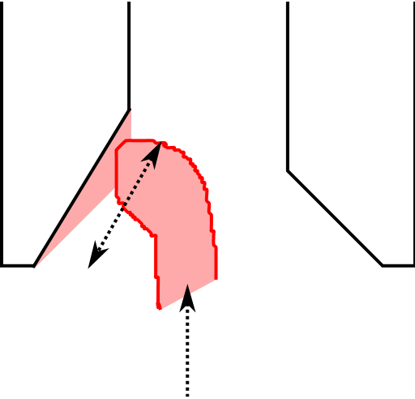 b) adjust y stage to get close to ID cut

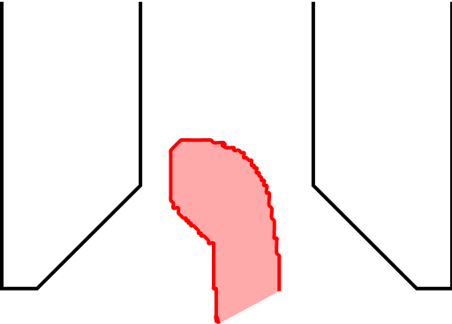 c) use compound to take passes

d) move to next pass with X stage

c) proceed to OD mark or just before

5) final cut taken at 1250rpm, slow in and out

6) clean off cutting fluid

7) with a slow chuck rotation, use a 3mm diamond polishing pin

Hold like a pen and apply a fair ammount of pressure

Blue> Red > White

8) a) polish with 3mm felt pin, and simachrome paste

b) then with a new clean 3mm felt pin

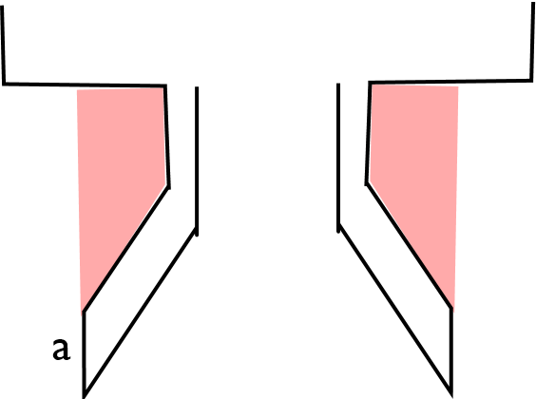9) turn OD with triangulr cutter

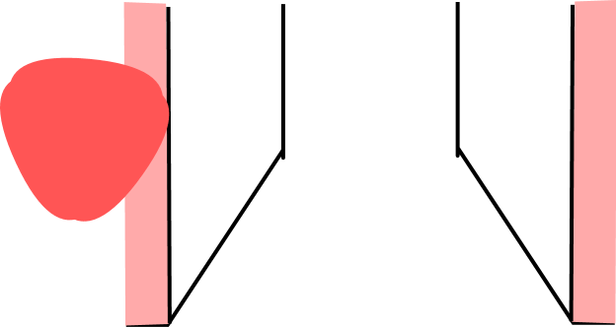Take care with sharp edge, take small passes towards end

10) profile outer (use width of **a** as a guide)

11) take a zero with the cut off tool at the open face

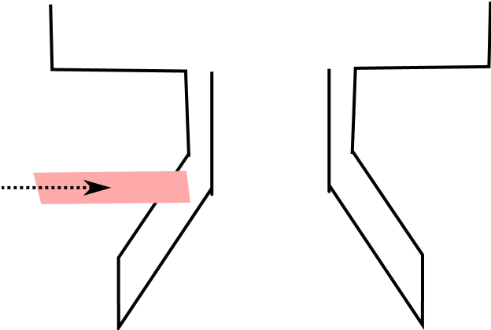 Cutter should have enough clearance so it is not going

Through a lot of stock on the left hand side

This will give a clean cut off on the internal surface