Kenneth Chen

Dylan Yates

Miguel Gonzales

5/19/2015

Serious Games Project 3

Overview

Our project will be a cooperative bullet hell that teaches basic arithmetic operations. Each individual player is assigned a random number, and the group as a whole must decide how they want to add, subtract, multiply, or divide their numbers to reach a goal number set for the match.

This game is meant for groups of around five to ten players, aged ten and over.

Technology

We will be using a system called [Happy Fun Times](http://greggman.github.io/HappyFunTimes/). This allows us to show a game on a large screen, such as a projector or a monitor, and have people connect to the game using smartphones. Each player who connects can instantiate a character into the game, which they would then control with their smartphone.

Gameplay

Players will control an onscreen character with a virtual joystick on their touchscreen device. The game will be a top-down bullet hell, with bullets constantly spawning in the center of the map. The map does not move during play.

At the start of the game, a goal number will be set. Players may manipulate a shared number, and must change it to match the goal number. They may do this with their own personal numbers, which are decided when they join into the game. When a player dies, their personal number modifies the shared number, their character dies, and they respawn a short moment later with a new personal number.

A player’s personal number affects the shared number depending on where their character is killed. The area is divided into four quadrants, representing the four basic operations (addition, subtraction, division, multiplication). If the player dies in the addition quadrant, their personal number is added to the shared number. Likewise for all other operations.

When the shared number matches the goal number, they score a point, and a new goal number will be set. The shared number will still stay the same, and players will have to modify it to match the new goal number.

Each player’s personal number is shown on their character on the shared display. When a character enters the field (whether by respawning after death, or by joining into the game for the first time), they are immune to death for a brief moment.

Players may direct their characters next to each other to average their numbers together. If two players are close to each other, every second their numbers will increment towards the other. For example, if my number is 7 and yours is 3, then after one second mine will be 6 and yours 4, and another second later both of our numbers will be 5. This connection can be broken by moving away from the other player.

Any number of players can enter or exit the game during play. Bullets are individualized and will be spawned randomly in different directions across the map, rather than being fired in prearranged patterns.

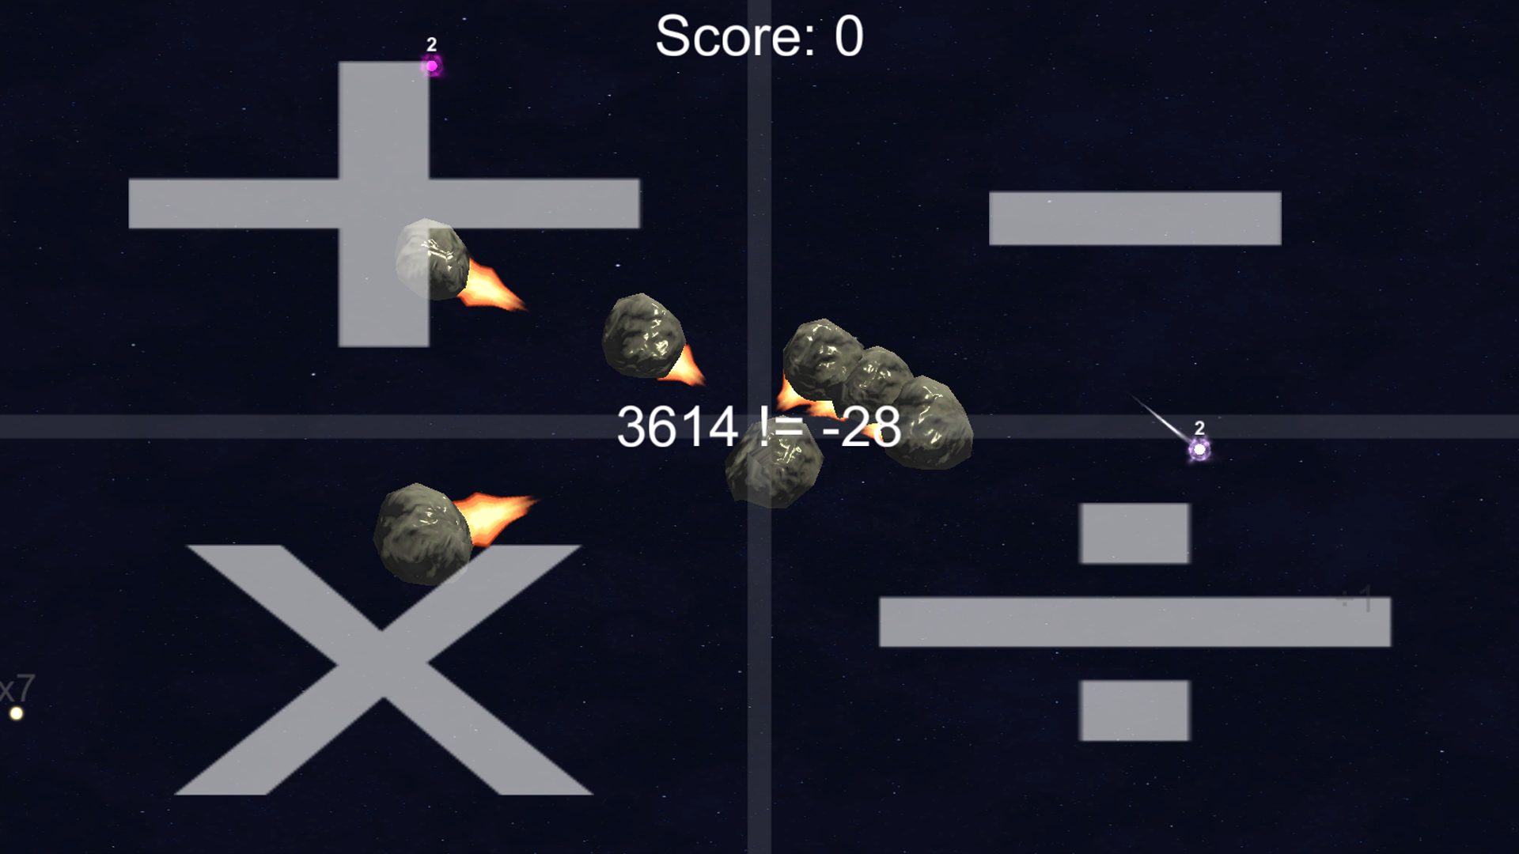

Iteration Differences

Division had been a longstanding problem, and ultimately we decided to make it so that when you divide, it rounds your shared number to the nearest integer. There were too many problems with floating point numbers and the difficulty of pulling out of that state.

The mechanic of averaging numbers between players serves two purposes: it allows players to get close to a specific number they want, and it improves player interaction. Both of these elements were requested by playtesters, and there were plenty of ideas ranging from powerups to bubble shields. However, this one was the most fun and encouraged lots of interesting plays. To maintain this style, I forced personal numbers to adhere to one of two extremes, the low end (1, 2, and 3) or the high end (7, 8, or 9).