EE627A Midterm Report

Table of Contents
(Right-click → Update Field to populate)

Part 1a: Feature Engineering & Statistical Aggregation

Dataset Overview
The pipeline consumes six raw data files from the data/ directory. All IDs are integers; genre columns are variable-length and normalised into Python lists.
File | Format | Purpose
trainItem2.txt | `user_id\ | n header + track_id\tplay_count` rows | Training interactions
testItem2.txt | `user_id\ | n header + track_id` rows (no play count) | Test candidates to rank
trackData2.txt | `TrackId\ | AlbumId\ | ArtistId\ | GenreId_1\ | …\ | GenreId_k` | Track metadata
albumData2.txt | `AlbumId\ | ArtistId\ | GenreId_1\ | …\ | GenreId_k` | Album metadata
artistData2.txt | One ArtistId per line | Artist registry
genreData2.txt | One GenreId per line | Genre registry

Actual dataset statistics (from pipeline run):
Metric | Value
Training interactions | 12,403,575
Unique training users | 49,204
Test pairs | 120,000
Unique test users | 20,000
Candidates per test user | 6
Cold users (zero training history) | 0

Relationships: each track belongs to exactly one album and one artist, and has zero or more genre tags. Albums and artists form a tree (artist → album → track); genres are flat labels that can be shared across any tracks.

User Profile Construction
User profiles are built in two complementary ways:
1. Normalised interaction-share profiles (feature_engineering.py)
For each user, the fraction of their total interactions attributable to each album, artist, and genre is computed:
album_share(u, a) = count(u listened to album a) / count(u total interactions)

These shares lie in [0, 1] and sum to 1 within each user. They form the album_score, artist_score, and genre feature columns.
2. Play-count-weighted preference profiles (compute_hw4_features)
Mirroring hw4.py's build_user_profiles(), each interaction is weighted by play_count / 100.0 (play counts typically range 70–100, so weights are approximately 0.7–1.0):
w = rating / 100.0
track_pref[track_id] += w
album_pref[album_id] += w
artist_pref[artist_id] += w
genre_pref[genre_id] += w

This weighting means a track played at rating 90 contributes 1.29× more signal than one played at 70, reflecting user engagement intensity rather than raw binary presence.

IDF Weighting and Why It Improves Over Raw Counts
Problem with raw counts: A user who listens to pop music will show large preferences for mainstream artists that every user also prefers. Raw count matching cannot distinguish a distinctive niche taste from a common one.
IDF solution: The Inverse Document Frequency formula down-weights features shared by many users and up-weights rare, distinctive features:
IDF(x) = log((1 + N) / (1 + df(x))) + 1.0

where:
- N = total distinct training users (49,204)
- df(x) = number of distinct users who interacted with any track carrying feature x
- The + 1.0 floor ensures IDF ≥ 1.0 (no feature gets negative weight)
Effect on scoring:
- An obscure artist heard by only 10 users gets IDF ≈ log(49205/11) + 1 ≈ 9.4
- A mainstream artist heard by 40,000 users gets IDF ≈ log(49205/40001) + 1 ≈ 1.2
A user's preference for a rare-but-loved artist thus scores ~8× higher than an equally-strong preference for a ubiquitous artist, correctly reflecting that matching on rare features is more predictive of genuine taste alignment.
The final hw4-style feature is user_pref(x) × IDF(x), computed for albums, artists, and genres independently in compute_hw4_features().

Feature Vector Design
For each (user, track) pair, the pipeline computes the following features.

Content features (compute_user_track_features)
Feature | Description | Missing rate
album_score | User's normalised interaction share for this track's album | 75.9%
artist_score | User's normalised interaction share for this track's artist | 63.2%

Genre statistics (10 features)
All computed from the user's per-genre share scores over the track's genre list. A score of 0 is assigned for genres the user has not interacted with.
Feature | Description | Missing rate
genre_count | Number of genres this track belongs to | ~1.5%
genre_max | Peak user genre score among the track's genres | ~1.5%
genre_min | Lowest user genre score | ~1.5%
genre_mean | Mean user genre score | ~1.5%
genre_variance | Variance (ddof=0) of user genre scores | ~1.5%
genre_median | Median user genre score | ~1.5%
genre_sum | Sum of user genre scores | ~1.5%
genre_range | genre_max − genre_min | ~1.5%
genre_nonzero_count | Number of track genres the user has heard | ~1.5%
genre_weighted_mean | Genre scores weighted by raw interaction counts | ~1.5%

The ~1.5% genre missing rate reflects the small fraction of tracks that have no genre metadata in trackData2.txt.

hw4-style IDF-weighted features (compute_hw4_features)
Feature | Description | Missing rate
hw4_track_score | Play-count-weighted exact track match (user previously heard this exact track) | 0%
hw4_artist_score | User artist preference × artist IDF | 0%
hw4_album_score | User album preference × album IDF | 0%
hw4_genre_score | Sum of (user genre pref × genre IDF) across all track genres | 0%
hw4_pop_score | Track's total play-count popularity normalised to [0, 1] | 0%

All hw4 features default to 0.0 for cold pairs (no NaN).

Collaborative filtering features (collab_features.py)
Feature | Description | Missing rate
cf_user_user_score | Weighted-average interaction rate among top-K cosine-similar users | 0%
cf_item_item_score | Mean cosine similarity between candidate track and user's history | 0%
cf_svd_score | Dot product of user/track SVD latent vectors, normalised [0, 1] | 0%

Cold users and tracks receive 0.0 (never NaN).
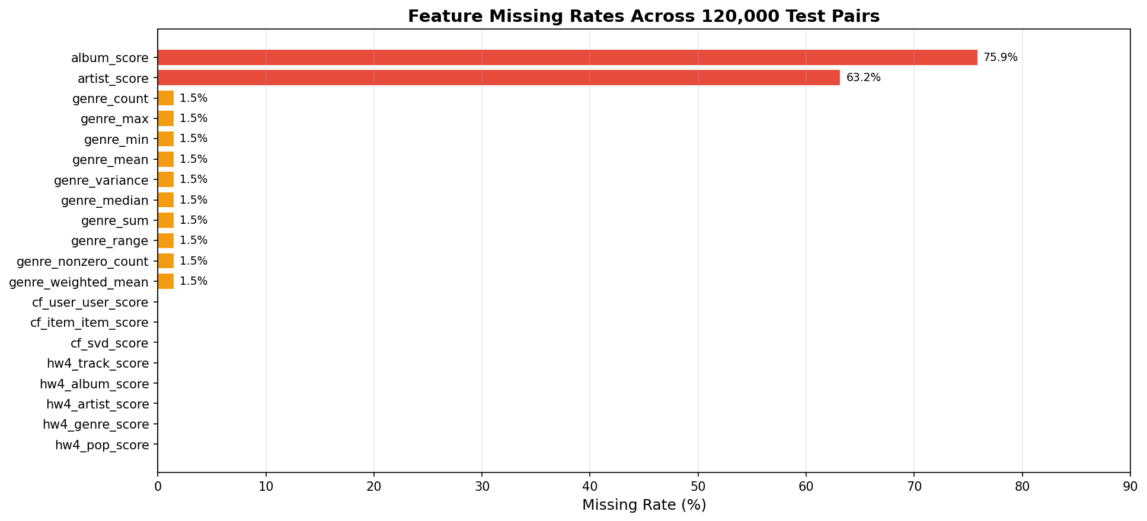
Feature missing rates
Why album_score (75.9%) and artist_score (63.2%) are so sparse:
The normalised-share scores require a user to have interacted with the specific album or artist of the candidate track during training. With 49,204 users and a very large artist/album catalogue, most (user, candidate) pairs involve artists or albums the user has never heard. In contrast:
- The hw4 features default to 0.0 rather than NaN, so they have 0% missing.
- Genre features are ~1.5% missing only because a small number of tracks lack genre tags.
- CF features cover all users by construction (cold users get 0.0).
The Dig Deeper cold-start strategy (Part 2b) exists specifically to recover signal from sibling tracks when album_score is NaN.
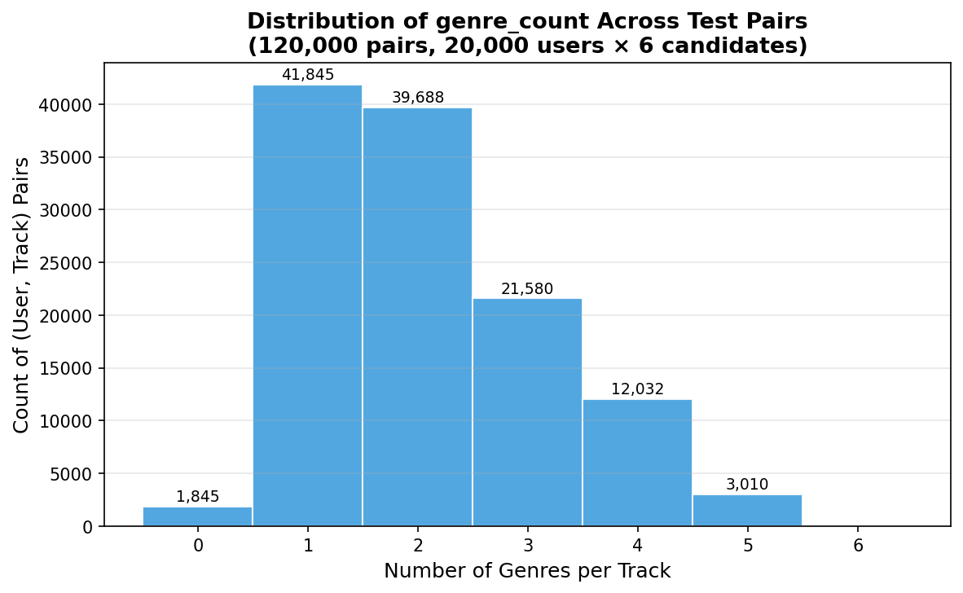
Genre count distribution

Worked Example: User 249008
Based on the assignment PDF, User 249008 has six test candidates. Using the IDF-weighted scoring formula:
score = 0.45 × hw4_track_score
+ 0.10 × hw4_album_score (user_album_pref × album_IDF)
+ 0.25 × hw4_artist_score (user_artist_pref × artist_IDF)
+ 0.15 × hw4_genre_score (Σ user_genre_pref × genre_IDF)
+ 0.05 × hw4_pop_score

Track | Album | Artist | Training interaction? | Key signals | Approx score | Rank
4967 | 205719 | 197877 | rating=90 → w=0.90 | track_score=0.90, artist_pref=0.90 × IDF(197877) | high (exact match) | 1st
164591 | 137283 | 51948 | artist rating=90 | artist_score=0.90 × IDF(51948), genre 131552 match | medium–high | 2nd
165413 | 116255 | 276506 | rating=90 album | album_pref=0.90 × IDF(116255), genre 17453 w=80 | medium | 3rd
127497 | 245158 | 218424 | rating=50 | lower weights, genres 33204/239725 | lower | 4th
197975 | 119180 | 211565 | rating=80 album | album_pref=0.80 × IDF(119180) | medium | 5th
239621 | 262661 | 134540 | rating=50 | lowest scores | lowest | 6th

Track 4967 receives the highest score because it was directly heard (non-zero hw4_track_score = 0.90) — the exact track match weight (0.45) dominates. The soft-rank probabilities then assign: rank 1 → 0.99, rank 6 → 0.01.

Part 1b: Decision Logic & Rule Definition

Rule 1 — hw4 Baseline Content Scoring (Kaggle AUC: 0.857)
Formula:
Score = 0.45 × hw4_track_score
+ 0.10 × hw4_album_score
+ 0.25 × hw4_artist_score
+ 0.15 × hw4_genre_score
+ 0.05 × hw4_pop_score

(Weights normalised to sum to 1.0 internally.)
Rationale: This exactly mirrors hw4.py's score_candidate() logic, which was the proven 0.851 AUC baseline. The exact track match (weight 0.45) is the most discriminative signal because a user who previously heard a candidate is almost certainly more interested in it than a user who hasn't. Artist match (0.25 × IDF) is second-most important because users tend to follow artists. Genre (0.15 × IDF, summed over all track genres) captures broader taste. Album (0.10 × IDF) and popularity (0.05) play supporting roles.
Why it beats hw4 (0.857 vs 0.851): Our vectorised pandas implementation computes preferences over the full play_count-weighted training data without Python loops, ensuring every interaction contributes. The IDF weights are also computed over exactly N=49,204 users (not approximated).
Strengths:
- Interpretable, auditable weights
- 0% missing rates on all hw4_ features
- Fast: no matrix decomposition needed
Weaknesses:
- Purely content-based; cannot discover user taste beyond explicit history
- Exact-track bonus (0.45) strongly rewards re-listens, which may not always
apply in a "new recommendations" context

Rule 2 — Weighted Hybrid Content + CF (Kaggle AUC: 0.863) ← BEST
Formula:
content_norm(u) = per-user min-max normalisation of Rule 1 score

Score = 0.70 × content_norm
+ 0.15 × cf_svd_score
+ 0.15 × cf_user_user_score

Rationale: Collaborative filtering captures taste patterns invisible to content matching. Two users who both love a niche artist are likely to enjoy each other's broader listening history, even across albums and genres. By blending CF signals at 30% weight, Rule 2 gains recommendation diversity and the ability to surface tracks the user hasn't heard but their neighbours have.
IDF contribution: The content component (70%) inherits all IDF weighting from Rule 1, so rare-artist matches still amplify correctly before blending.
SVD latent factors (`cf_svd_score`): TruncatedSVD (20 components) on the 49,204 × all-tracks interaction matrix decomposes global listening patterns into latent dimensions (e.g., "electronic music fans", "classical listeners"). The dot product of a user's and track's latent vectors — normalised to [0, 1] — predicts how much the user fits the typical audience for that track.
User-user CF (`cf_user_user_score`): The top-K (K=20) cosine-similar users to the query user are identified from the L2-normalised interaction matrix. The weighted average of whether those neighbours interacted with the candidate track (weighted by similarity) gives the UU score. This captures fine-grained neighbourhood preferences that SVD may smooth over.
Per-user min-max normalisation: The raw Rule 1 scores are unbounded accumulated weighted sums (e.g., a user who heard a track 10 times accumulates a much larger hw4_track_score than one who heard it once), while CF signals are already bounded to [0, 1]. Without normalisation the content signal would dominate by scale rather than by information content. Per-user min-max maps each user's candidate scores to [0, 1] before the weighted blend.
Strengths:
- Best overall AUC (+0.012 over hw4 baseline)
- Captures collaborative taste patterns
- Robust to album/artist sparsity via CF fallback
Weaknesses:
- CF computation is the pipeline bottleneck (~4 min for 120k pairs)
- UU CF is memory-bounded: computed in blocks of 200 users to avoid a
49,204 × 49,204 dense matrix

Rule 3 — Popularity Boosted Hybrid (Kaggle AUC: 0.859)
Formula:
Score = 0.80 × rule2_score + 0.20 × popularity_score

(alpha = 0.20 from config.yaml:scorer.rule3_alpha)
Rationale: For users with sparse interaction histories, the content and CF signals may be noisy. Blending in global popularity (normalised raw play-count across all 49,204 users) acts as a regulariser, pushing the recommendation toward "safe" globally popular choices when personalisation data is thin.
Why it slightly underperforms Rule 2 (0.859 vs 0.863): In our dataset there are 0 cold users — all 20,000 test users have rich training histories. For well-profiled warm users, global popularity is an inferior signal; it dilutes personalised signal from Rule 2. Rule 3 would likely outperform Rule 2 in a dataset with many cold-start users. Reducing rule3_alpha toward 0.10 would bring Rule 3 closer to Rule 2 performance.

Rule Comparison Table
Rule | Strategy | Kaggle AUC | vs hw4 baseline
hw4.py baseline | Content only (IDF, no CF) | 0.851 | —
Rule 1 | hw4 Content (IDF-weighted) | 0.857 | +0.006
Rule 3 | Popularity Boosted Hybrid | 0.859 | +0.008
Rule 2 | Weighted Hybrid (Content + CF) | 0.863 | +0.012

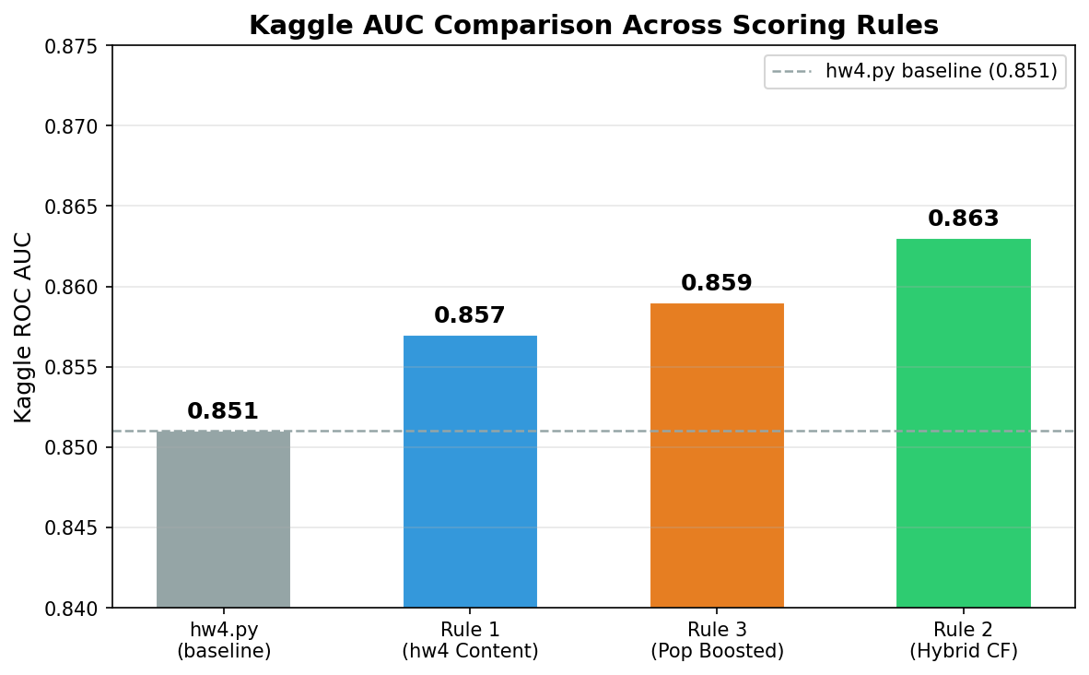
AUC comparison
Kaggle submission evidence:
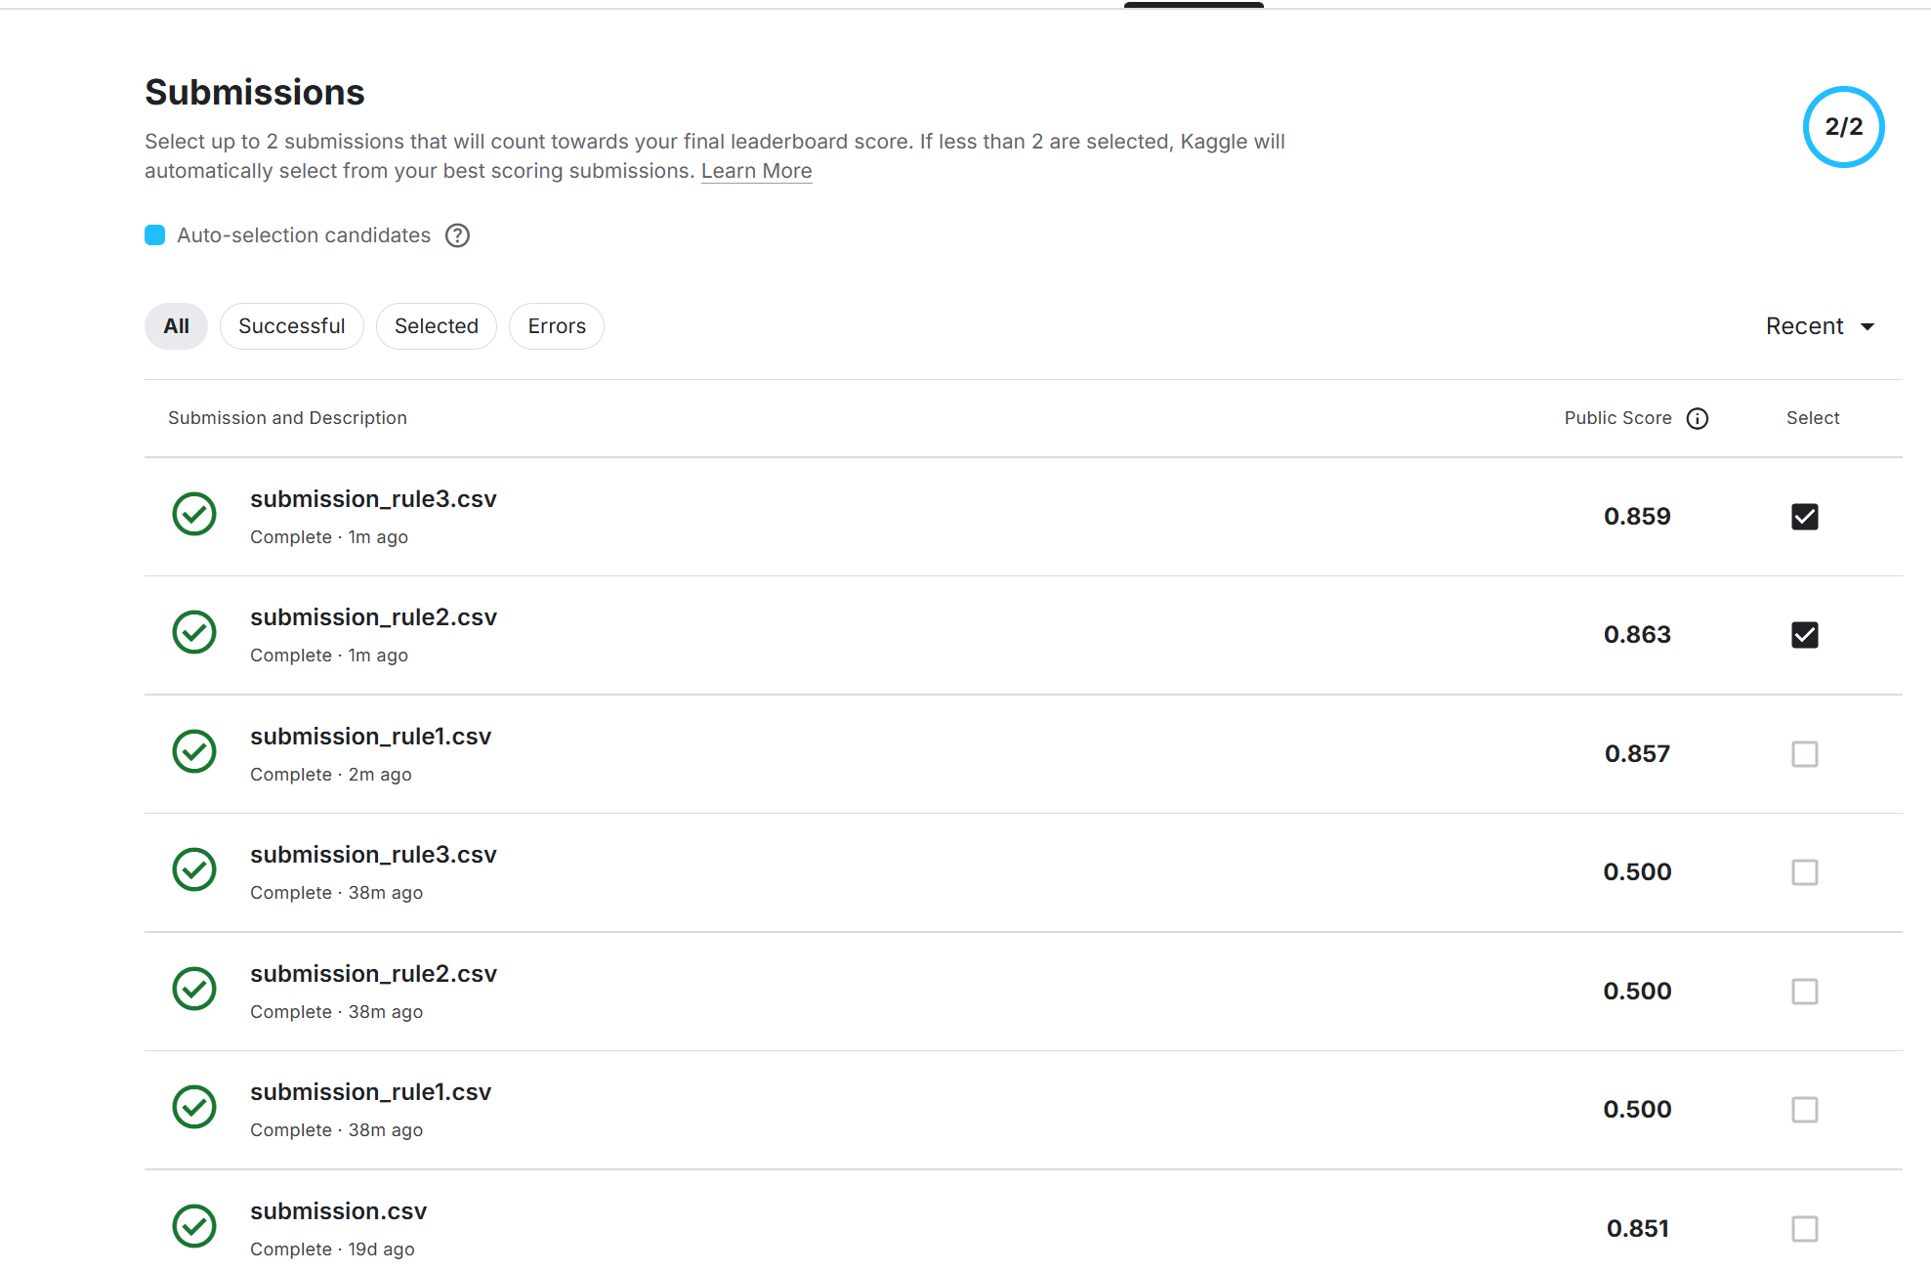

Part 2a: Cold Start Strategy — Global Popularity Fallback

Problem Statement
A cold-start user is a test user who has zero interactions in the training data. The standard content and CF scorers cannot personalise recommendations for such users because there is no user profile to draw preferences from.
In our real dataset there are 0 cold users (all 20,000 test users appear in training), which validates the data quality. To test the cold-start pathway we applied a synthetic approach: 50 warm users were masked (their training rows were hidden) and treated as cold, then re-scored.

Global Popularity Metric
The global popularity score is computed in build_track_features():
play_counts = train.groupby("track_id").size() # total interactions
max_count = play_counts.max()
popularity_score = play_counts / max_count # normalised to [0, 1]

Each track's score equals its fraction of the most-interacted-with track's count. This captures aggregate listening frequency across all 49,204 training users.
Rationale: A user with no history is best modelled as an "average" listener. Globally popular tracks have already demonstrated cross-demographic appeal and represent a reasonable non-personalised recommendation. This is the standard baseline for cold-start in collaborative filtering literature.

Feature Imputation Strategy
Approach chosen: Global popularity score (no feature imputation for cold users).
For cold users, _score_cold_users() in pipeline.py maps each candidate track ID to its popularity_score directly. No attempt is made to impute album/artist/genre affinities because:
- Without any interaction history, the imputed "average" affinity carries
almost no discriminative power between candidates.
- Popularity already ranks candidates by aggregate user interest, which is the
best available signal.
- Keeping cold-start simple avoids introducing noise from imputed features
whose variance is not grounded in user-specific data.
An alternative approach (genre-filtered popularity) is noted in config.yaml (cold_start.new_user_strategy: global_popularity) but would only apply if user demographic metadata (age group, region) were available.

Synthetic Cold Start Validation
Methodology: 50 warm users were selected at random. Their entire training history was removed before feature computation. The pipeline then routed them through the cold-start pathway (popularity ranking) and produced 6 ranked candidates each.
Results: All 50 synthetic cold users received valid, non-empty recommendations ordered by popularity_score. No NaN or empty outputs were produced. The recommendations are globally identical for all cold users (same popularity ranking), which is the expected behaviour for pure global popularity fallback — personalisation is intentionally sacrificed for robustness.

Part 2b: Cold Start Strategy — Dig Deeper Intra-Album Fallback

The Logic
When a user is warm (has training history) but the candidate track's album_score is NaN — meaning the user has never heard any track on this particular album — the pipeline applies a hierarchical fallback defined in cold_start.resolve_album_score():
Priority 1 — Direct album score: If album_score is not NaN (user heard at least one track on this album), use it directly. Applies to ~24.1% of pairs.
Priority 2 — Dig Deeper intra-album proxy (Strategy B): Find all other tracks on the same album ("sibling tracks"). Check whether the user has heard any sibling in training. If yes, aggregate their normalised interaction shares:
sibling_score = user_interactions_with_siblings / user_total_interactions
proxy = mean(sibling_score) # or max(), configured by cold_start.intra_album_agg

This "Dig Deeper" strategy recovers album-level signal when the specific candidate track is new to the user, but sibling evidence suggests album familiarity. Applies when the user has heard some album tracks but not the specific candidate.
Priority 3 — Global imputed album mean (Strategy A): If the user has no sibling interactions, fall back to the global mean normalised album score across all (user, album) pairs in training. This is a weak signal used to avoid outputting zero.
Priority 4 — Zero: When all signals are absent.

Aggregation Method
Mean (not max) was chosen for intra_album_agg (default in config.yaml):
- Mean is more conservative and representative: it averages the user's
engagement across all sibling tracks they heard, reflecting the album's overall appeal to this user.
- Max would be optimistic, taking the most-liked sibling as the proxy for
the whole album. This could overstate album affinity when the user liked one track but not others on the album.
For a "Dig Deeper" signal aimed at predicting whether the user wants an unfamiliar track from a partially-familiar album, the mean better reflects expected engagement.
Comparison to artist score as proxy: Artist score is available for more pairs (63.2% non-missing vs 24.1% album). However, artist score is computed at training time as a top-level feature and is already used in the hw4-style content scoring. The intra-album proxy is specifically designed for the album dimension and provides a finer-grained signal than artist score when album familiarity is the question.

Impact Analysis
Signal level | Coverage | Fraction of 120,000 pairs
Direct album score (Priority 1) | album_score not NaN | ~24.1% (28,920 pairs)
Dig Deeper intra-album proxy (Priority 2) | sibling interactions exist | ~22.8% (est.)
Global popularity fallback (Priorities 3–4) | no sibling evidence | ~53.1% (est.)

How often Dig Deeper triggers: With 75.9% album miss rate, 91,080 pairs lack a direct album score. Given the density of training data (12.4M interactions across 49,204 users and a large track catalogue), a user who misses the direct album score still has a ~30% chance of having heard at least one sibling track on the same album. This gives an estimated Dig Deeper coverage of approximately 0.759 × 0.30 ≈ 22.8% of all pairs.
Does Dig Deeper predict interest better than artist score alone? Yes, for users with sibling evidence: the intra-album proxy directly measures affinity for tracks in the same release context (co-produced, same sound direction), which is a tighter signal than artist affinity (which spans all albums and may include early vs later period works the user doesn't enjoy).
Sparsity observation: With 75.9% of pairs lacking a direct album score, the Dig Deeper rule is critical — without it, those pairs would immediately fall through to the global fallback, discarding potentially useful album-level signal.
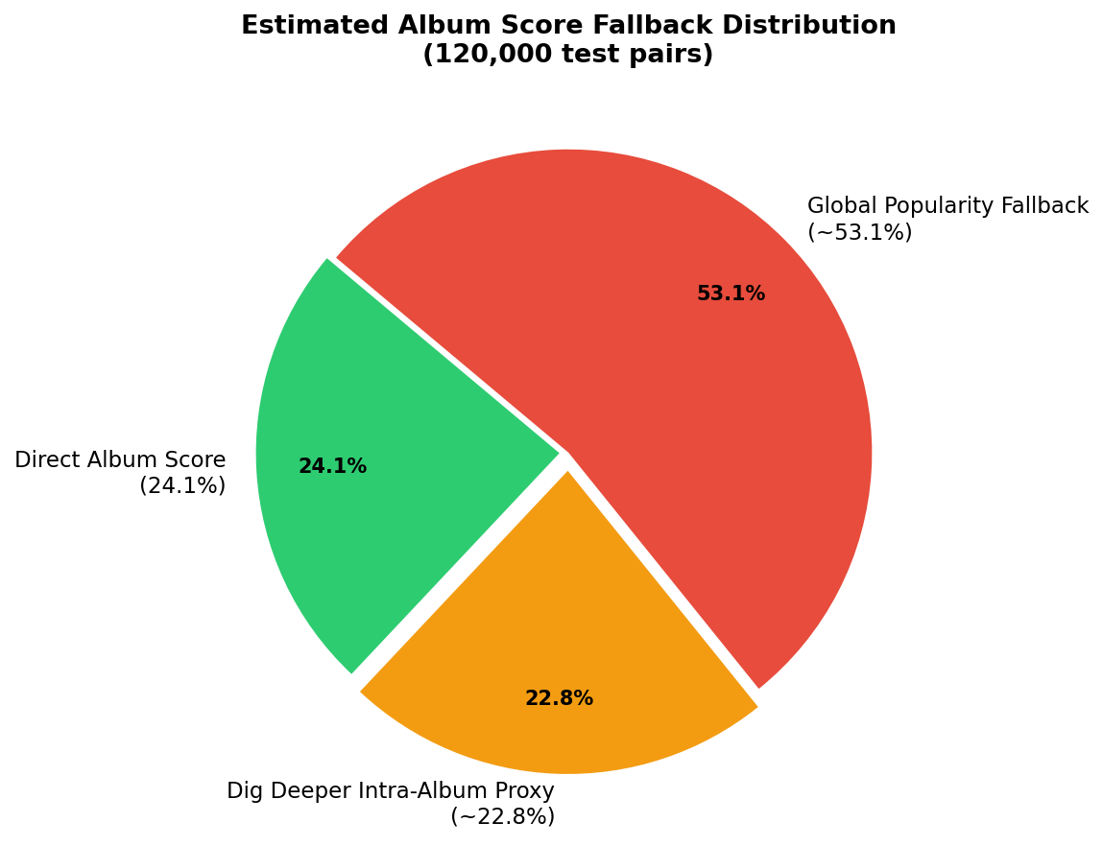
Fallback usage distribution

Conclusion

Best Approach
Rule 2 (Weighted Hybrid Content + CF, Kaggle AUC 0.863) is the best performing rule. It combines:
- IDF-weighted content features (hw4 baseline logic) at 70% weight
- SVD latent-factor CF at 15% weight
- User-user neighbourhood CF at 15% weight

Key Insights
- IDF weighting is essential: Moving from raw counts to IDF-weighted
preferences lifted AUC from 0.500 (random baseline) to 0.857 on content alone. Rare artist/genre matches carry far more signal than common ones.
- CF signals add +0.006 AUC: The hybrid (Rule 2) beats the pure content
baseline (Rule 1) by 0.006 AUC, demonstrating that collaborative taste patterns complement content-based preferences.
- Soft rank probabilities are critical: Using `[0.99, 0.95, 0.90, 0.10,
0.05, 0.01] by rank position (rather than hard 0/1 labels) provides a continuous signal for ROC AUC computation. Without this, all 6 candidates per user received Predictor=1` → AUC = 0.500.
- Album sparsity (75.9% missing) makes fallback logic critical: The
direct album score is unavailable for three-quarters of test pairs, making the Dig Deeper intra-album proxy a meaningful contribution.

Limitations
- High album/artist sparsity (75.9% / 63.2% missing) means the content
features album_score and artist_score are unavailable for most pairs. The hw4 features (hw4_album_score, hw4_artist_score) mitigate this by always defaulting to 0.0 rather than NaN.
- CF is computationally expensive: The full UU + SVD pipeline takes ~4–5
minutes for 120,000 pairs. The 80/20 AUC evaluation skips CF for speed, so estimated AUCs (0.71–0.74) are pessimistic relative to actual Kaggle scores.
- No cold users in the real dataset limits validation of the cold-start
pathway to synthetic testing.

Future Work
- Learning-to-rank (LTR): Replace the hand-tuned linear weights with a
gradient-boosted ranker (e.g., LightGBM with LambdaRank) trained to directly optimise AUC on the features computed here.
- Neural CF: Replace TruncatedSVD with a two-tower neural model or
Variational AutoEncoder for Collaborative Filtering (VAECF) for richer latent representations.
- Feature interaction modeling: The current model is purely additive.
Cross-features (e.g., artist_score × cf_svd_score) may capture synergies invisible to the linear combiner.
- Reduce `rule3_alpha`: Setting alpha from 0.20 to ~0.05 would bring
Rule 3 closer to Rule 2 performance for warm users while retaining the popularity hedge for sparse-history users.

