Prediction Market Volatility Outputs Report
Polymarket category-volatility MVP
Research question | Can market category predict future volatility after controls?
Generated | 2026-05-30
Markets | 160
Training rows | 40,678
Date span | 2025-05-10 to 2026-05-30
Reference category | US Elections
This document consolidates the current project outputs into one report: data coverage, category rankings, model metrics, coefficient tables, feature importances, high-risk markets, and the saved artifacts consumed by the notebook and Streamlit dashboard.

Executive Summary
The current sample contains 160 markets and 40,678 training rows spanning 2025-05-10 to 2026-05-30.
The OLS model reaches an adjusted R² of 0.686. The random forest reaches a mean time-series cross-validation R² of 0.590.
Relative to US Elections, the largest positive category effects in the OLS output come from Crypto Corporate and Crypto Airdrops, while Football / Soccer is slightly lower in this sample.
The random forest ranks bid ask spread first and log volume second. Category contributes 1.1% of total feature importance.

Coverage Snapshot
Markets | 160
Analytical rows | 40,678
Date span | 2025-05-10 to 2026-05-30
Reference category | US Elections
Top feature | Bid Ask Spread
Second feature | Log Volume
Significant category terms | 6
Category importance share | 1.1%

Category Rankings Output
The ranking chart and table below summarize realized 7-day volatility by expanded market category.
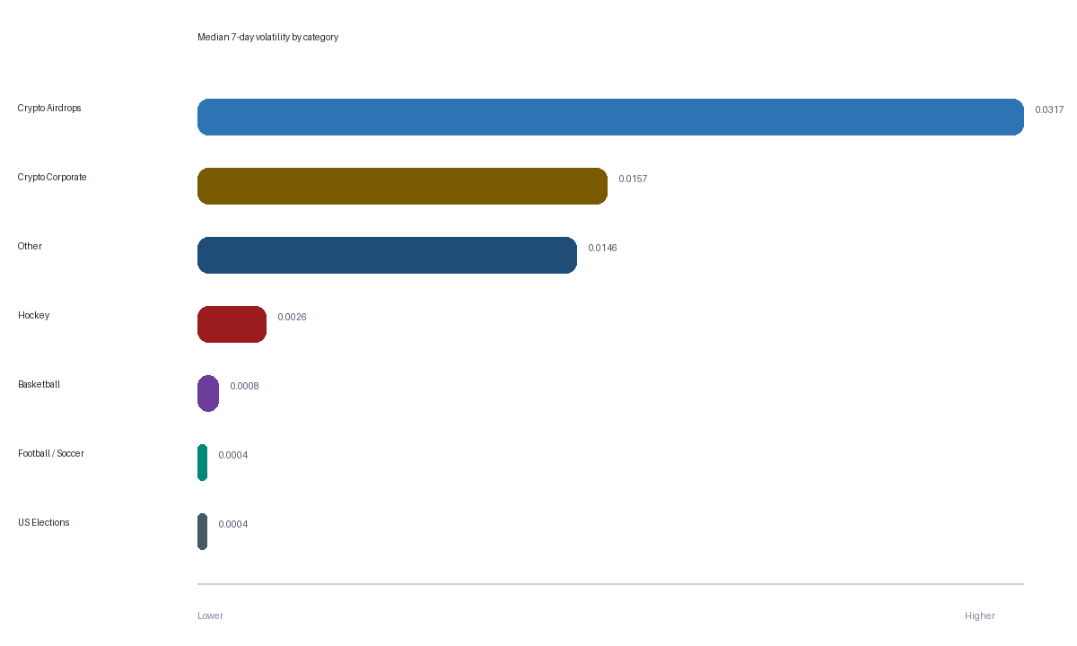
Figure 1. Median realized 7-day volatility by expanded category.
Category | Markets | Observations | Median 7d vol | Mean 7d vol | Avg volume
Crypto Airdrops | 7 | 856 | 0.0317 | 0.0322 | 659.3K
Crypto Corporate | 5 | 677 | 0.0157 | 0.0243 | 2.6M
Other | 3 | 724 | 0.0146 | 0.0214 | 8.1M
Hockey | 3 | 866 | 0.0026 | 0.0063 | 56.0M
Basketball | 23 | 6737 | 0.0008 | 0.0025 | 139.4M
Football / Soccer | 46 | 10471 | 0.0004 | 0.0015 | 27.8M
US Elections | 73 | 21467 | 0.0004 | 0.0009 | 28.3M

Time-Series and Correlation Outputs
These charts show how average category volatility evolves over time and how the engineered predictors move together in the analytical panel.
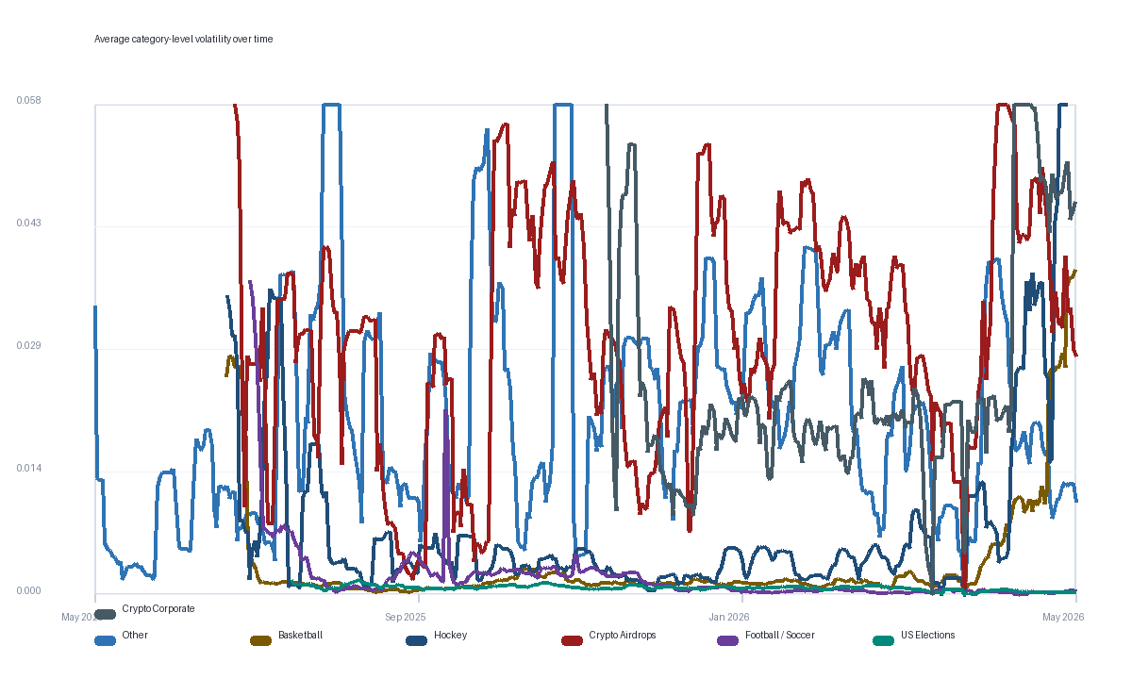
Figure 2. Average category-level volatility over calendar time.
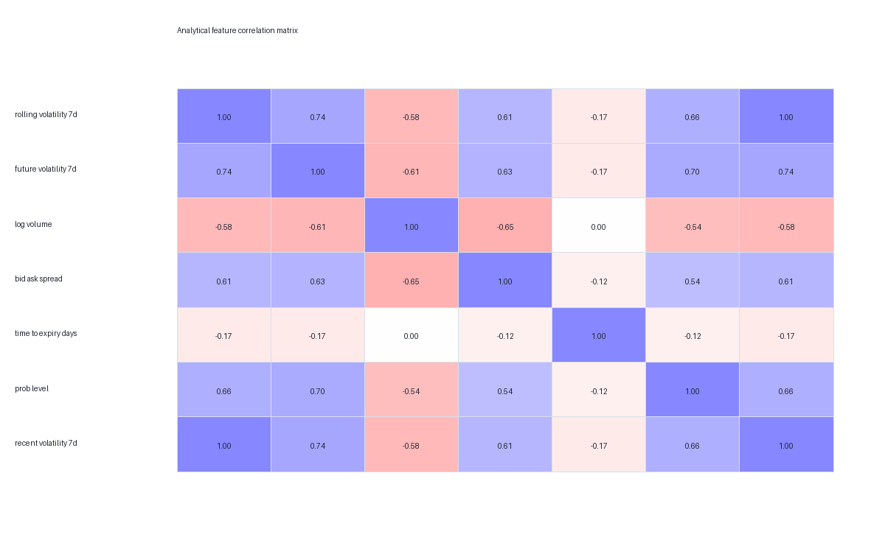
Figure 3. Correlation matrix for core analytical variables.

OLS Regression Output
The coefficient tables below separate category effects from control-variable effects so the category signal is easier to read.
Category term vs reference | Coefficient | P-value
Basketball | 0.0004 | 0.0441
Crypto Airdrops | 0.0073 | 2.37e-136
Crypto Corporate | 0.0085 | 1.05e-195
Football / Soccer | -0.0005 | 0.0145
Hockey | 0.0023 | 1.39e-19
Other | 0.0042 | 5.16e-48

Control term | Coefficient | P-value
Intercept | 0.0091 | 1.04e-60
Bid-ask spread | 0.1015 | 1.97e-238
Log volume | -0.0005 | 3.92e-68
Probability level | 0.0161 | 0
Recent volatility (7d) | 0.2765 | 0
Time to expiry (days) | -0.0000 | 0.00181

Random Forest Output
The random forest captures non-linear predictive structure and provides a separate ranking of feature importance.
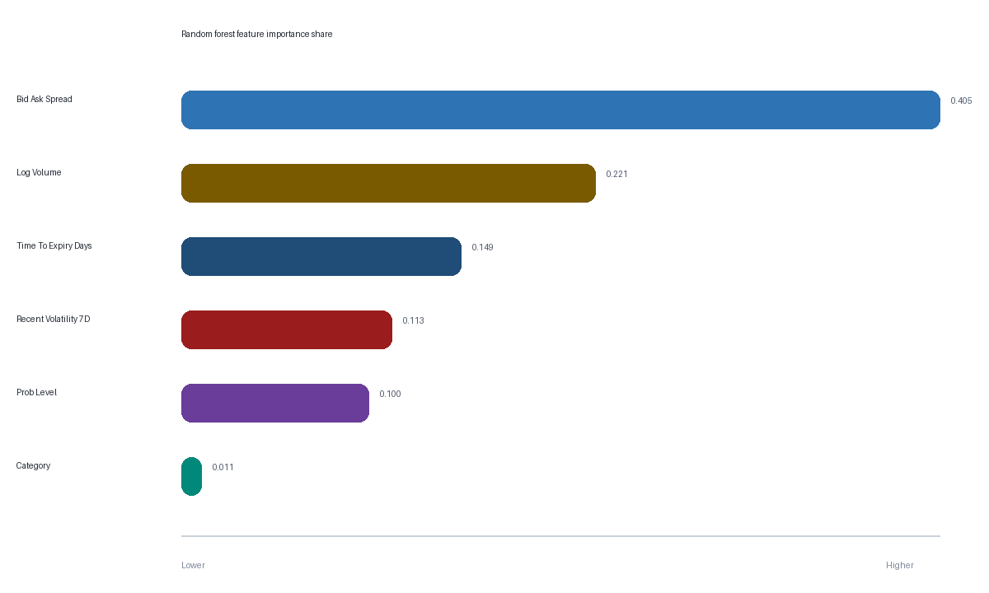
Figure 4. Aggregated random-forest feature importance share.
Feature group | Importance share
Bid Ask Spread | 0.405
Log Volume | 0.221
Time To Expiry Days | 0.149
Recent Volatility 7D | 0.113
Prob Level | 0.100
Category | 0.011

High-Risk Market Output
The table below shows the current top-risk markets based on the normalized OLS-predicted forward-volatility score.
Market title | Category | Risk score | Probability | Days to expiry | Current 7d vol
Will Hyperliquid perform an airdrop by  June 30, 2027? | Crypto Airdrops | 10.00 | 0.415 | 397 | 0.0255
Will MegaETH perform an airdrop by  December 31, 2026? | Crypto Airdrops | 9.05 | 0.455 | 216 | 0.0579
Will Hyperliquid perform an airdrop by  December 31, 2027? | Crypto Airdrops | 5.98 | 0.410 | 581 | 0.0543
MicroStrategy sells any Bitcoin by  December 31, 2026? | Crypto Corporate | 5.70 | 0.890 | 216 | 0.0412
MicroStrategy sells any Bitcoin by June  30, 2026? | Crypto Corporate | 5.58 | 0.695 | 32 | 0.0579
MicroStrategy sells any Bitcoin by May 31,  2026? | Crypto Corporate | 4.34 | 0.227 | 32 | 0.0558
Kraken IPO by December 31, 2026? | Crypto Corporate | 4.31 | 0.320 | 216 | 0.0311
Taylor Swift pregnant before 2027? | Other | 3.95 | 0.255 | 215 | 0.0225
Will Pump.fun perform an airdrop by  December 31, 2026 | Crypto Airdrops | 3.60 | 0.250 | 216 | 0.0129
Will the San Antonio Spurs win the 2026  NBA Finals? | Basketball | 3.18 | 0.255 | 32 | 0.0579
Will the Colorado Avalanche win the 2026  NHL Stanley Cup? | Hockey | 3.02 | 0.051 | 34 | 0.0579
Will MegaETH perform an airdrop by June  30? | Crypto Airdrops | 2.82 | 0.159 | 32 | 0.0082

Saved Artifact Inventory
This appendix lists the saved outputs currently backing the notebook and the Streamlit application.
Artifact | Purpose
raw_markets.csv | Market-level metadata pulled from Polymarket
raw_prices.csv | Raw price-history observations
analytical_dataset.csv | Clean modeling dataset with forward-volatility target
scoring_dataset.csv | Scoring dataset used for dashboard market snapshots
latest_market_scores.csv | Latest market-level risk scores
category_rankings.csv | Category-level volatility summary
volatility_over_time.csv | Date x category average volatility series
correlation_matrix.csv | Analytical correlation matrix
ols_coefficients.csv | OLS regression coefficient table
rf_feature_importances.csv | Aggregated random-forest importances
model_metrics.json | Summary metrics consumed by the dashboard
notebooks/analysis.ipynb | Notebook version of the analysis

