Prediction Market Volatility Outputs Report (Crypto Excluded)
Polymarket category-volatility MVP | non-crypto slice
Research question | Can market category predict future volatility after controls?
Generated | 2026-05-30
Markets | 148
Training rows | 39,229
Date span | 2025-05-10 to 2026-05-30
Reference category | US Elections
Excluded categories | Crypto Airdrops, Crypto Corporate
Excluded markets | 12
Excluded observations | 1,533
This document recomputes the analysis after excluding categories whose labels contain the requested token(s): Crypto Airdrops, Crypto Corporate. All tables, charts, OLS coefficients, random-forest importances, and market-risk rankings in this report are derived from the filtered non-crypto subset.

Executive Summary
The current sample contains 148 markets and 39,229 training rows spanning 2025-05-10 to 2026-05-30.
This slice excludes 12 markets across the category bucket(s) Crypto Airdrops, Crypto Corporate, removing 1,533 daily scoring observations from the report scope.
The OLS model reaches an adjusted R² of 0.589. The random forest reaches a mean time-series cross-validation R² of 0.228.
Relative to US Elections, the strongest positive category effect is Other (0.0047, p=1.53e-94), while the lowest category effect is Football / Soccer (0.0011, p=2.43e-12).
The random forest ranks log volume first and time to expiry days second. Category contributes 1.3% of total feature importance.

Coverage Snapshot
Markets | 148
Analytical rows | 39,229
Date span | 2025-05-10 to 2026-05-30
Reference category | US Elections
Top feature | Log Volume
Second feature | Time To Expiry Days
Significant category terms | 4
Category importance share | 1.3%
Excluded categories | Crypto Airdrops, Crypto Corporate
Excluded markets | 12

Category Rankings Output
The ranking chart and table below summarize realized 7-day volatility by expanded market category.
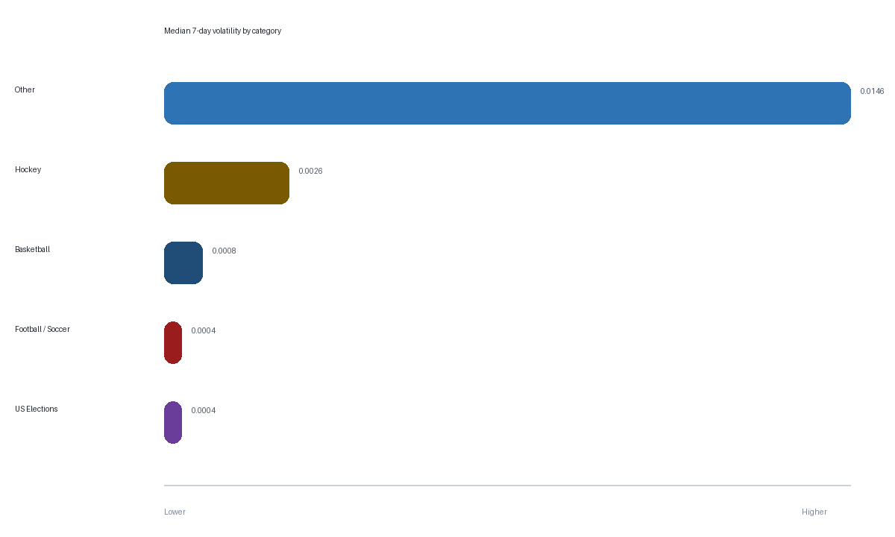
Figure 1. Median realized 7-day volatility by expanded category.
Category | Markets | Observations | Median 7d vol | Mean 7d vol | Avg volume
Other | 3 | 724 | 0.0146 | 0.0214 | 8.1M
Hockey | 3 | 866 | 0.0026 | 0.0063 | 56.0M
Basketball | 23 | 6737 | 0.0008 | 0.0025 | 139.4M
Football / Soccer | 46 | 10471 | 0.0004 | 0.0015 | 27.8M
US Elections | 73 | 21467 | 0.0004 | 0.0009 | 28.3M

Time-Series and Correlation Outputs
These charts show how average category volatility evolves over time and how the engineered predictors move together in the analytical panel.
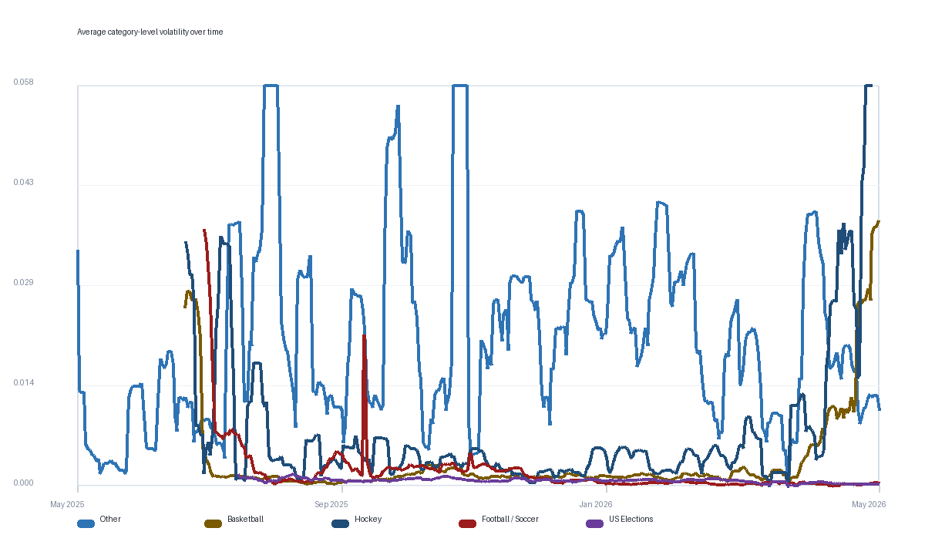
Figure 2. Average category-level volatility over calendar time.
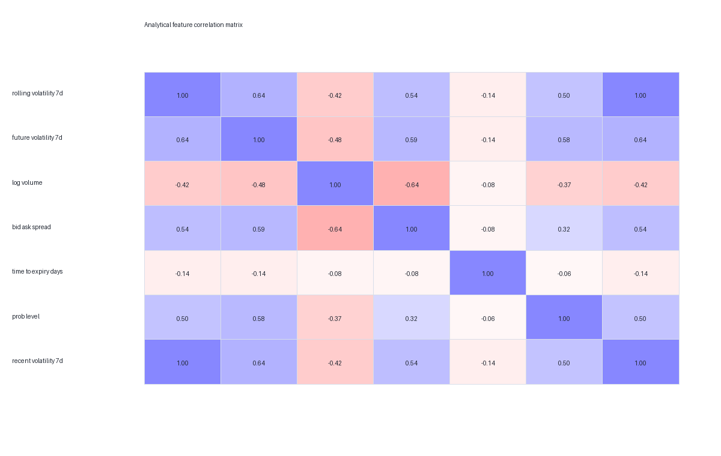
Figure 3. Correlation matrix for core analytical variables.

OLS Regression Output
The coefficient tables below separate category effects from control-variable effects so the category signal is easier to read.
Category term vs reference | Coefficient | P-value
Basketball | 0.0020 | 3.2e-38
Football / Soccer | 0.0011 | 2.43e-12
Hockey | 0.0041 | 8.41e-109
Other | 0.0047 | 1.53e-94

Control term | Coefficient | P-value
Intercept | 0.0071 | 2.21e-65
Bid-ask spread | 0.1783 | 0
Log volume | -0.0005 | 1.4e-99
Probability level | 0.0153 | 0
Recent volatility (7d) | 0.2259 | 0
Time to expiry (days) | 0.0000 | 5.98e-10

Random Forest Output
The random forest captures non-linear predictive structure and provides a separate ranking of feature importance.
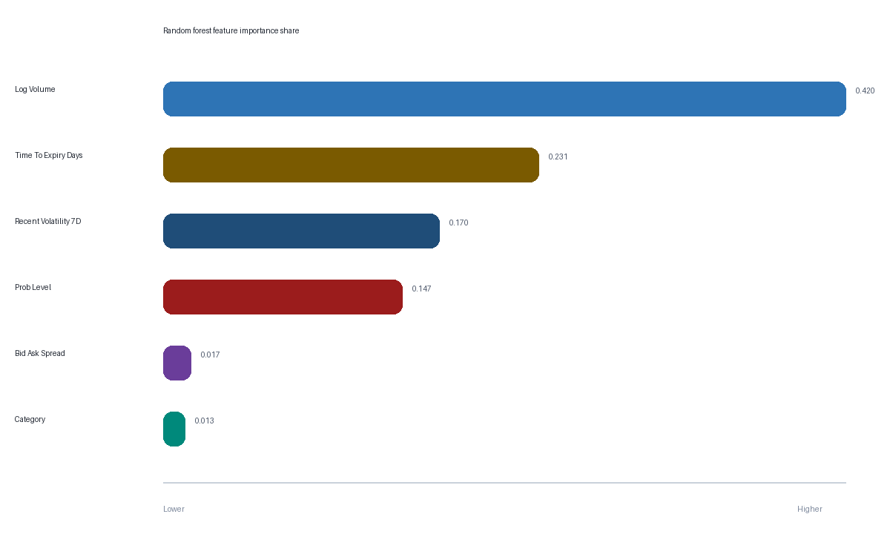
Figure 4. Aggregated random-forest feature importance share.
Feature group | Importance share
Log Volume | 0.420
Time To Expiry Days | 0.231
Recent Volatility 7D | 0.170
Prob Level | 0.147
Bid Ask Spread | 0.017
Category | 0.013

High-Risk Market Output
The table below shows the current top-risk markets based on the normalized OLS-predicted forward-volatility score.
Market title | Category | Risk score | Probability | Days to expiry | Current 7d vol
Taylor Swift pregnant before 2027? | Other | 10.00 | 0.255 | 215 | 0.0225
Will OpenAI launch a new consumer hardware  product by December 31, 2026? | Other | 6.81 | 0.155 | 215 | 0.0096
Will the San Antonio Spurs win the 2026  NBA Finals? | Basketball | 5.96 | 0.255 | 32 | 0.0579
Will the Colorado Avalanche win the 2026  NHL Stanley Cup? | Hockey | 5.73 | 0.051 | 34 | 0.0579
Will the New York Knicks win the 2026 NBA  Finals? | Basketball | 3.50 | 0.321 | 32 | 0.0191
Will J.D. Vance win the 2028 Republican  presidential nomination? | US Elections | 2.17 | 0.324 | 892 | 0.0050
GTA VI released before June 2026? | Other | 1.51 | 0.001 | 1 | 0.0007
Will the Detroit Pistons win the 2026 NBA  Finals? | Basketball | 1.48 | 0.038 | 44 | 0.0111
Will Gavin Newsom win the 2028 Democratic  presidential nomination? | US Elections | 1.41 | 0.237 | 892 | 0.0019
Will JD Vance win the 2028 US Presidential  Election? | US Elections | 1.29 | 0.183 | 892 | 0.0026
Will Alexandria Ocasio-Cortez win the 2028  Democratic presidential nomination? | US Elections | 1.17 | 0.090 | 892 | 0.0072
Will Spain win the 2026 FIFA World Cup? | Football / Soccer | 1.13 | 0.168 | 51 | 0.0021

Saved Artifact Inventory
This appendix lists the saved outputs backing the notebook and Streamlit application.
Artifact | Purpose
raw_markets.csv | Market-level metadata pulled from Polymarket
raw_prices.csv | Raw price-history observations
analytical_dataset.csv | Clean modeling dataset with forward-volatility target
scoring_dataset.csv | Scoring dataset used for dashboard market snapshots
latest_market_scores.csv | Latest market-level risk scores
category_rankings.csv | Category-level volatility summary
volatility_over_time.csv | Date x category average volatility series
correlation_matrix.csv | Analytical correlation matrix
ols_coefficients.csv | OLS regression coefficient table
rf_feature_importances.csv | Aggregated random-forest importances
model_metrics.json | Summary metrics consumed by the dashboard
notebooks/analysis.ipynb | Notebook version of the analysis

